AGRICULTURE
FORM TWO
NAME…………………………………………………CLASS ……… ADM ________
- Name FOUR main branches of Agriculture. (2mks)

- State FOUR characteristics of nitrogenous fertilizers (2mks)

- Differentiate between macro nutrient and micro nutrients (1mk)

- Diagram M, N,P and Q represents some farm tools

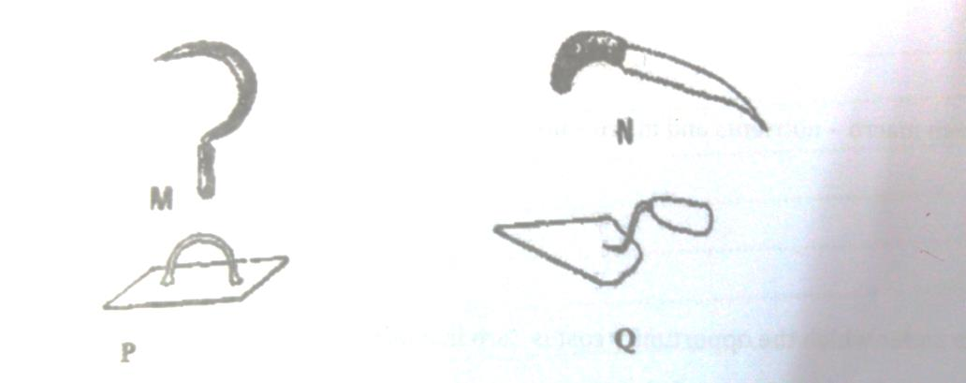

- Identify the tools , M,N,P, and Q (2mks)

- Give the uses of the tools named above (2mks)

5. Given that maize is planted at a spacing of 90 by 30 cm , calculate plant population in a plot of land measuring 4 by 3 m.

(3)
6. State two soil sampling methods (1mk)

7. Give an example of a crop in which the following vegetative propagation materials are used (4mks)

8. Name two dairy breed of goat
(1mk)
9. State four advantages of using seeds as planting materials (4mks)

10. Describe two chemical processes that are involved in soil formation (2MK)

11. Differentiate between seed dressing and seed inoculation (2mks)

12. A student was to apply a compound fertilizer 5:20:10 at the rate of 200 kg per hectare on her Agriculture project plot measuring 3 by 4 meters.

a) What do the figures 5 and 20 in the compound fertilizer above stand? (1mk)

b) Calculate the amount of fertilizer she would require for the plot (3mks)

