AGRICULTURE
FORM TWO

NAME…………………………………………………………….. CLASS ………………………………… ADM NO…………………………..
- Name FOUR main branches of agriculture (2mks)
Agricultural engineering
Crop production
Livestock production
Soil science
- State FOUR characteristics of nitrogenous fertilizers (2mks)
Easily leached
Highly soluble in water
Have short residual effects
Highly volatile
Are hygroscopic
High corrosive
- Differentiate between macro nutrient and micro nutrients (1mk)
Macro nutrients are required by plants in large quantities while micronutrients are required by plants in relatively small quantities.
- Diagram M, N,P and Q represents some farm tools

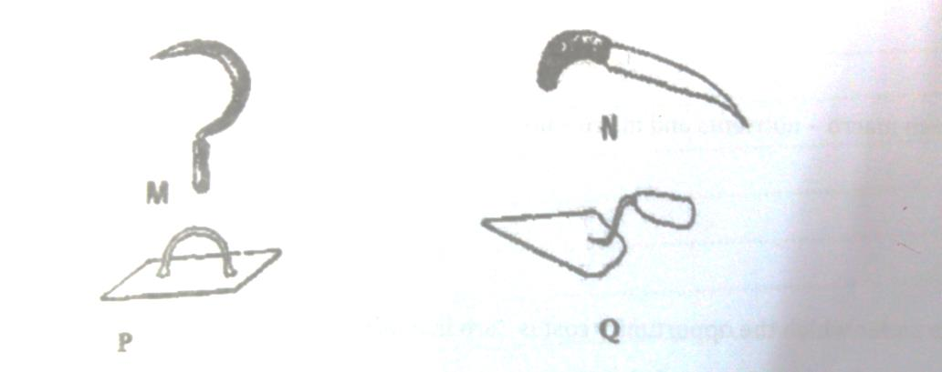

- Identify the tools , M,N,P, and Q (2mks)
M - Sickle
N-Pruning saw
P-steel float
Q-Masons trowel
- Give the uses of the tools named above (2mks)
M- Harvesting grass
N- Pruning hard branches of coffee
P- To spread screed on floors
Q- To scoop mortar during construction
5. Given that maize is planted at a spacing of 90 by 30 cm , calculate plant population in a plot of land measuring 4 by 3 m. (3)
PLANT POPULATION=Area of land
Spacing

Area of the land= 400 cm x 300cm
Spacing 90 cm x 30cm
= 44 plants 6. State two soil sampling methods (1mk)
Zigzag
Traverse
7. Give an example of a crop in which the following vegetative propagation materials are used (4mks)
a) Stem tuber – Irish potato
b) Bulbils- sisal
c) Stem cutting- cassava sugarcane
d) Splits - pyrethrum
8. Name two dairy breed of goat (1mk)
Saanen
Toggenburg
9. State four advantages of using seeds as planting materials (4mks)
Possible to develop new varieties due cross pollination
Possible to apply manure and fertilizers together with seeds
They are not bulky
Fertilizers and manure application can be easily mechanized
Easy to handle
10. Describe two chemical processes that are involved in soil formation (2mks)
Solution- the soluble minerals presents in the rocks are dissolved hence weakening the rock.
Hydration- this is process by which certain minerals absorb water and expands causing internal stress and fracturing the rock mass.
11. Differentiate between seed dressing and seed inoculation (2mks)
Seed dressing, coating of seed with fungicides or an insecticides to seedlings from soil borne diseases and pests while seed inoculation is coating of legume with right strain of rhizobium to encourage nodulation, hence nitrogen fixation.
12. A student was to apply a compound fertilizer 5:20:10 at the rate of 200 kg per hectare on her Agriculture project plot measuring 3 by 4 meters.
a) What do the figures 5 and 20 in the compound fertilizer above stand? (1mk)
5- Ratio of Nitrogen
20- Ratio of P₂O₅

b) Calculate the amount of fertiliser she would require for the plot (3mks)
1 ha =200kg
The plot thus requires; 12*200/10000=0.24kg of the compound fertilizer

