**PHYSICS FORM TWO**

**NAME………………………………...……………ADM NO….................CLASS…………**

1. Express each of the following volumes in SI unit giving your answer in standard form(2marks)
2. 25000cm3
3. 0.5675cm3
4. State the law of magnetism. (1mark)
5. The figure shows an electromagnet. State the polarities at X and Y.(2 marks)



1. Dust particles in air appear to move randomly, explain this observation.(1 marks)
2. The diagram below shows a section of a micrometer screw gauge.

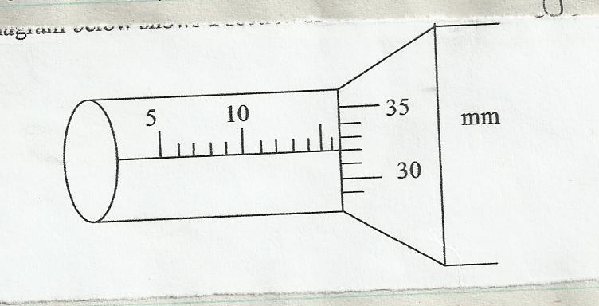

1. State the smallest measurement that can be made by the measurement that can be made by the micrometer screw gauge. (1 mark)
2. What is the correct reading of the micrometer screw gauge if it has an error of 0.25cm (3 marks)
3. State two properties of magnetic field lines (2marks)
4. A charge of 180coloumbs flows though a lamp every minute. Calculate the current flowing through the lamp (3marks)
5. The figure below shows part of a vernier caliper when the jaws are closed without an object between the jaws

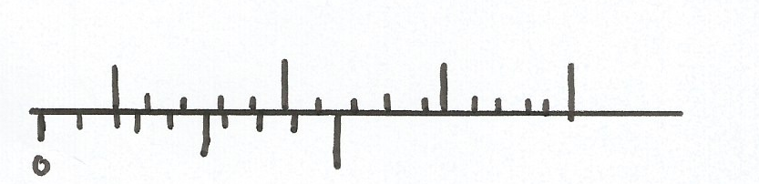

1. What is the value of the zero error of the calipers?(1mark)
2. A student used the same vernier calipers in (a) above to measure the diameter of a test tube whose actual diameter is 2.15cm. What was the reading shown by the calipers(3marks)
3. Explain why repulsion is then sure test for polarity of a magnet(1mark)
4. Explain why a gold leaf is electroscope casing is made up of metal(1mark
5. Use domain theory to explain the difference between magnetic and non magnetic materials (2marks)
6. On the graph provided, sketch a graph of density against Temperature of a given mass of water(2 marks)

Densitynsity

Temperature

1. State two properties of a good thermometric fluid (2marks)
2. State one application of magnets. (1mark)
3. State the laws of reflection (2mks)