CASPA AMUKURA PARISH JOINT EVALUATION
EXAMINATION FORM FOUR 2021 MARKING SCHEME BIOLOGY PAPER TWO

1.a) P- Stomatal pore / opening / aperture; Rj stomata
Q- Epidermal cell; Rj Epidermis.
(2mks)
- Guard cells have churoplasts hence in the presence of light/ during the day
photosynthesis occurs in guard cells; producing sugar in guard cells that increases osmotic pressure; water from epidermal cells enters into guard cells; causing turgidity of cells; the inner walls of the guard cells are thicker than outer walls; hence inner walls stretch more during turgidity; causing guard cells to bulge outer wards; (stomata open)
7mks. Max 5.
- - Reversed rhythm;
- Small stomata / stomatal pore / aperture/ opening;
2marks, max . 1mk
- (a) To investigate if Carbon (IV) Oxide is necessary for photosynthesis; (1mk)
(b) (i) A – No starch; acc Brown colour
B – Starch present; acc Blue black colour (2mks)
(ii) A – Absence of Carbon (IV) Oxide hence no photosynthesis;
B – Carbon (IV)Oxide present , the leaf photosynthesized; (2mks)
(c) Control (experiment); (1mk)
(d) Destarch the leaves /plant; OWTTE (1mk)
(e) Chloroplast; (1mk)

- (a) Anaerobic respiration; (1mk)
(b) (i) Air bubbles; Lime water turns white precipitated; (2mks)
(ii) Yeast cells respired (anaerobically); producing carbon (IV) oxide (2mks)
(c) (1mk)
(d) - Manufacture of alcoholic drinks;
- Baking of bread/ raising dough; (2mks)

- (a) X- Anther/ male part
Y – Style/ pistil/ female part
(b) Epigyneous / superior flower/ ovary above the other floral parts
(c) (i) Wind Pollinated flower;
(ii) Anthers located above the stigma;
(Rej. Brightly coloured petals/scented/nectarines)
(d) X/W;
(e) 30 chromosomes;
(f) Anthers located below the stigma;
self – sterility / incompatibility
Protandry/ male parts (stamen) maturing earlier than the female parts (pistil)
Protagyny / female parts (pistil) maturing earlier than the male parts (Stamens);
Any one stated correctly = 1mk

5.(a) (i) HH; and hh;
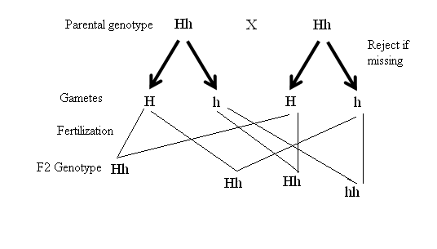
(ii) Hh
(b)

(c) The RJ if the information on the left is wrong/ if given, the gene for purple colour is dominant/ gene for white colour is recessive;

6.
See graph.
Scale = 2mks
Labeling axes = 2mks
Plot = 1mk
Curve = 1mk
(b) 34⁰C -37⁰C; (1mk)
(c) (i) Long time taken (to digest starch); because enzymes were inactivated (by low temperature below optimum); (2mks)
(ii) Long time taken (to digest starch)/75 minutes; enzyme /salivary amylase was denatured/ destroyed (by temperature above optimum); (2mks)
(d) – PH;
- Enzyme concentration;
- Substrate concentration;
- Enzyme inhibitors;
- Enzyme specificity;
- Cofactors and coenzymes (3mks)
(e) - Mouth
-Duodenum
(2mks)
- (i) - Fe/iron;
  - magnesium
  - Zinc
  - Copper
(ii) Activate enzymes; (1mk)
- Proteins; (1mk)

- Has nerve endings/ sensory cells; which are sensitive to stimuli/ heat/ cold/ touch/ pain/ pressure; Subcutaneous fat/adipose tissue; insulate body against heat loss; Sebaceous glands; secrete sebum an oily substance which is water repellant/ prevents drying/ cracking of skin/ keeping skin supple/ sebum is antiseptic which kills micro – organisms entering through the skin; Has blood vessel; that supply food/oxygen/ remove excretory products;
When temperatures are high blood vessels/ arterioles vasodilate to lose heat by convection/ radiation/ vasoconstrict when temperature are low to conserve/ reduce heat loss; (20mks)

- Broad / wide / flat lamina; to provide large S.A; for absorption of CO₂/sunlight;Thin; to ensure short distance for CO₂ to reach photosynthetic cells/palisade/mesophyll;Guard cells/ presence of stomata; for efficient diffusion of CO₂ into leaf/ oxygen out of leaf/ gaseous exchange/ water vapour/ transpiration;Transparent cuticle/epidermal cells; for penetration of light; into palisade cells/ photosynthetic cells.Palisade cells contain many chloroplasts; to trap light (for photosynthesis);Chloroplasts have chlorophyll; for trapping light energy; Leaves have veisn; Xylem to conduct water to photosynthetic cells; and phloem to translocate the photosynthates to other parts of the plant;Air spaces in spongy mesophyll; for gases to circulate/diffuse easily/ for CO₂ to diffuse into palisade cells;Mosaic arrangement of leaves; enables all leaves to trap sunlight; Palisade cells are next to upper epidermis for maximum light absorption (by chloroplasts)

(20marks)

