BURAMU I EXAMINATION-2021
Kenya Certificate of Secondary Education
SEPTEMBER-2021

231/3 - BIOLOGY- Paper 3
Marking Scheme
Question 1.(a)
Food substances | Procedures | Observations | Conclusion
Starch | On to small amount of food substance Q, add iodine solution dropwise. | The colour of iodine changes to blue-black. | Starch present
Reducing sugars | On to small amount of food substance Q,add equal amount of Benedict’s solution and heat to boil | The Colour of Benedict’s solution is retained/blue | Reducing sugars absent.

(b) (i) Colour of Benedict’s solution changes from blue-green-yellow-brown
(ii) Reducing sugars present
(iii) R- could be an enzyme or R- could be a reducing
(C) (i) Blue colour of Benedict’s retained
(ii) R is not a reducing sugar. When R was boiled, it was denatured therefore could not hydrolyse starch to reducing sugars/Maltose.
(d) Q is a polysaccharides/Starch
(e) R is an enzyme (Diastase/Amylase), because hydrolyse substance Q to reducing sugars.

2. Use the photographs provided to answer the questions that follow.

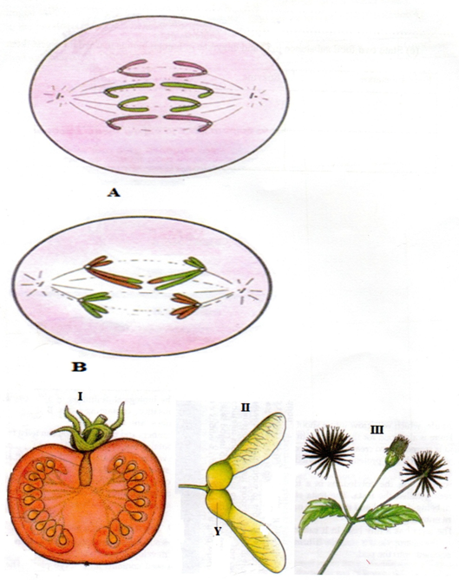

(a) (i) Identify the type of cell division represented inthe photographs A and B (2mks)
A- mitosis
B –meiosis
(ii) With a reason, name the stage of cell division represented in each case (4mks)
A anaphase
Reason
Sister chromatids have separated (and are migrating to opposite poles of spindle fibre)
B anaphase I
Reason
Homologous chromosomes have separated; and are migrating to the opposite poles of spindle.
(iii) Name the parts of human body where the process B represented above occur. (2mks)
- Testicles/testis
- Ovary
(b) (i) What type of fruits is represented by photograph I? Give two resons.
Type Berry;
Reason – presence of many seeds
Fleshy mesocarp/endocarp
(ii) Name the agent of dispersal for fruits II and III (2mks)
I wind
II animal
(iii) How are the fruits adapted for the mode of dispersal stated in (b) (ii) above? (2mks)
II has wing- like extension that increases surface area to be carried by air currents
III has hooks that make it stick onto animals fur/hair or even clothes of huma beings
(iv) Identify the type of placentation shown by photograph I (1mk)
Free central

3. (a) (i)Arthropoda;
(ii)Exoskeleton;
Jointed appendages;
Segmented body;
(b)Arachnida;
(c) B E
3 pairs of legs 4 pairs of legs
3 body parts 2 body parts
Has wings Lacks wings
Antennae No antennae

(d) A 1a, 2b, 5a Arachnida;
B 1a, 2a, 3a, 4a Diptera;
C 1b, 7b Echinodermata;
D 1a, 2b, 5b, 6a Chilopoda;
E 1a, 2b, 5a Arachnida

