**Name** …….……………………………………………..…… **Form 4** …………………………………

**231/ 3 Candidate’s Signature** ……………

**BIOLOGY**

**Paper 3**

**(Practical) Date** ………………………………..

**December, 2021**

1¾ hours

**MOMALICHE JOINT MOCK**

Kenya Certificate of Secondary Education

**231/ 3**

**BIOLOGY**

**Paper 3**

1¾ hours

***Instructions to candidates***

* *Write your name and class in the spaces provided above.*
* *Sign and write the date of examination in the spaces provided above.*
* *Answer* ***ALL*** *questions in the spaces provided.*
* *Additional pages* ***MUST NOT*** *be inserted.*
* *Candidates will be penalized for incorrect spelling especially of technical terms and for use of slovenly language*
* *You are required to spend the first* ***15 minutes*** *of the* ***1¾hours*** *allowed for this paper reading the whole paper carefully before commencing your work.*

**For Examiner’s Use Only**

|  |  |  |
| --- | --- | --- |
| **Question** | **Maximum**  **Score** | **Candidate’s**  **Score** |
| **1** | **16** |  |
| **2** | **15** |  |
| **3** | **09** |  |
| **Total score** | **40** |  |



***This paper consists of 8 printed pages.***

***Candidates should check the question paper to ascertain that ALL the pages are***

***Printed as indicated and no questions are missing***

1. **(a)**You are provided with two pieces of specimen **K** which is a plant structure, a scalpel blade and

two solutions labeled **L1** and **L2**.With one of the pieces of specimen **K** held vertically, place the

blade edge at the top centre of the specimen as illustrated below

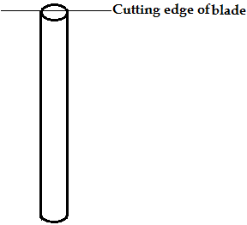

Smoothly cut the piece longitudinally **through the centre** in the direction of the arrows as illustrated above up to approximately half the length of the plant structure. Place this partially cut piece in solution **L1**. Repeat the procedure with the second piece of specimen **K** and place this second piece in solution **L2**. Allow the set ups to stand for 45 minutes and then remove the pieces of specimen **K** and wipe off excess solution using tissue paper.

1. Observe and draw illustrations showing the results of the two experimental set ups

**(2 marks)**

Piece from solution **L1**

Piece from solution **L2**

1. In **one word** in each case, describe the texture of each of the pieces of specimen **K**

**(2 marks)**

Piece from solution**L1**

……………………………………………………………………………………………………………

Piece from solution **L2**

……………………………………………………………………………………………………………

1. Account for the results of the set up in solution**L1** **(3 marks)**

……………………………………………………………………………………………………………

……………………………………………………………………………………………………………

……………………………………………………………………………………………………………

……………………………………………………………………………………………………………

……………………………………………………………………………………………………………

……………………………………………………………………………………………………………

……………………………………………………………………………………………………………

……………………………………………………………………………………………………………

……………………………………………………………………………………………………………

……………………………………………………………………………………………………………

……………………………………………………………………………………………………………

……………………………………………………………………………………………………………

1. You are provided with a solution labeled **N** which is a food sample, solution **H**- **Benedict’s solution**, solution **G**-**Iodine solution**, and solution **F** whose identity is unspecified
2. Conduct food tests using the reagents provided and complete the table below **(4 marks)**

|  |  |  |  |
| --- | --- | --- | --- |
| **Test** | **Procedure** | **Observation** | **Conclusion** |
|  |  |  |  |
|  |  |  |  |

1. Place 2cm3 of solution **N** in a test tube. Add 1cm3 of solution **F**. Place the mixture in a water bath maintained at 400C for 30 minutes and repeat Benedict’s test on the resultant mixture. State your observations and conclusions **(2 marks)**

**Observations**

……………………………………………………………………………………………………………

……………………………………………………………………………………………………………

**Conclusion**

……………………………………………………………………………………………………………

……………………………………………………………………………………………………………

1. Give the identity of solution **F (1 mark)**

……………………………………………………………………………………………………………

1. Account for the results in **(b)(ii)** above **(2 marks)**

……………………………………………………………………………………………………………

……………………………………………………………………………………………………………

……………………………………………………………………………………………………………

……………………………………………………………………………………………………………

1. **(a)** Study photograph **A** below which shows a plant specimen and an associated sisal pole and

answer the questions that follow

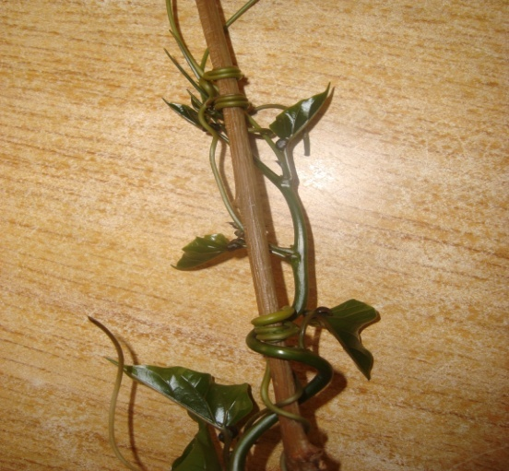

**A**

**Bamboo pole**

1. What name is given to the coiled part of the plant specimen shown in photograph**A**?

**(1 mark)**

……………………………………………………………………………………………………………

1. Name the type of response exhibited by the coiled part of the plant specimen in photograph **A** **(1 mark)**

……………………………………………………………………………………………………………

1. Specify the stimulus responsible for the response named in **(a)(ii)** above **(1 mark)**

……………………………………………………………………………………………………………

1. Explain how the response exhibited by the coiled part of the plant specimen in photograph **A** occurred **(3 marks)**

……………………………………………………………………………………………………………

……………………………………………………………………………………………………………

……………………………………………………………………………………………………………

……………………………………………………………………………………………………………

……………………………………………………………………………………………………………

……………………………………………………………………………………………………………

……………………………………………………………………………………………………………

……………………………………………………………………………………………………………

……………………………………………………………………………………………………………

……………………………………………………………………………………………………………

1. State the biological significance of the response described in **(iv)** above to the survival of the plant **(1 mark)**

……………………………………………………………………………………………………………

……………………………………………………………………………………………………………

1. Study photographs **B1** and **B2** below carefully and answer the questions that follow. The part in **B2** was extracted from the specimen in**B1**

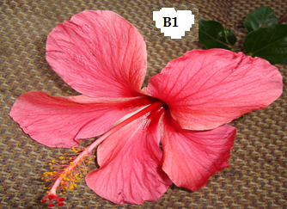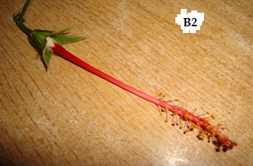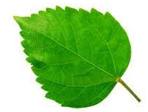

1. Identify the agent of pollination of the specimen shown in the photographs above

**(1mark)**

……………………………………………………………………………………………………………

1. Give a reason for your answer in **(b)(i)** above **(1mark)**

……………………………………………………………………………………………………………

1. Describe the pistil of specimen **B1 (2 marks)**

……………………………………………………………………………………………………………

……………………………………………………………………………………………………………

1. What is the name given to the type of pistil found in specimen **B1**? **(1 mark)**

……………………………………………………………………………………………………………

1. Describe the external features of the leaves of the plant from which specimen **B1** was obtained **(3marks)**

……………………………………………………………………………………………………………

……………………………………………………………………………………………………………

……………………………………………………………………………………………………………

……………………………………………………………………………………………………………

1. The three living organisms shown in the photographs below are often found in the same ecosystem.

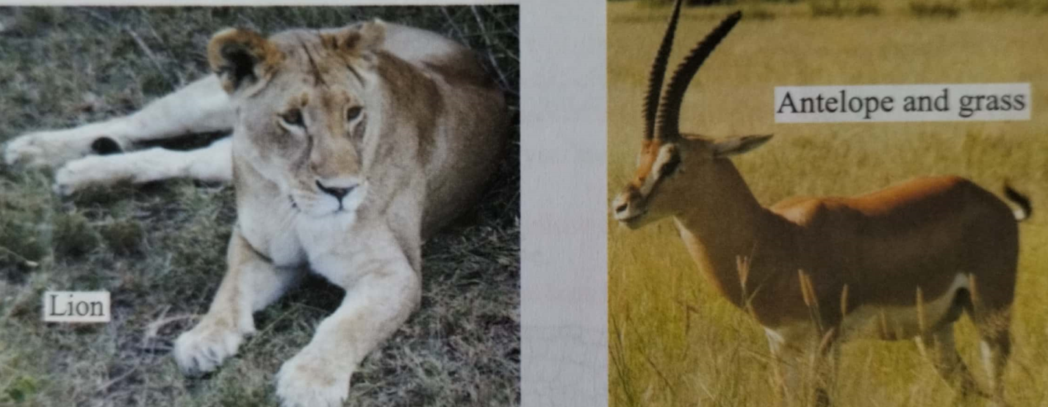

1. Name the trophic level identified by the antelope. Give a reason. **(2 marks)**
2. Draw a pyramid of biomass for the three organisms in the ecosystem **(3 marks)**
3. Explain the differences between the biomass of lions and antelopes in the ecosystem. **(2marks)**
4. Hyenas are also often found in this ecosystem. Name the trophic level (s) that they occupy. Give a reason to support your answer. **(2marks)**

………………………………………………………………………………..…………………………

………………………………………………………………………………..…………………………………..