NAMES ______________________________________REGNO.________STREAM_________
451/1
COMPUTER STUDIES
PAPER 1
JULY/AUGUST 2013
2½ HOURS

MOMALICHE FORM 4 2021 JOINT EXAMINITION
KENYA CERTIFICATE OF SECONDARY EDUCATION 2021
451/1
COMPUTER STUDIES
INSTRUCTIONS TO CANDIDATES
- This paper consists of TWO Sections A and B
- Answer all questions in Section A
- Answer question 16 (compulsory) and any other THREE question in section B
- All answers should be written in the space provided in the question paper

FOR OFFICIAL USE ONLY:
Section | Question | Candidates  Score
A | 1-15
B | 16
 | 17
 | 18
 | 19
 | 20
Total Score

SECTION A (40 Marks)

Answer ALL the questions in the spaces provided.
- Describe the following computer memories.

  - i) Register (1mk)

ii) Cache (1mk)

  - Give two differences between a compiler and an interpreter. (2mks)

- List any four threats to a computer system (2 mrks)

- In database the field properties specify finer details related to the fields and table entries expected. Explain the functions of the following

  - Caption (1mk)

  - Required (1mk)

  - Input mask (1mk)

- a) State four reasons why fibre optic is a number one choice in today’s data communication. (2mks)

b) What is meant by the term virtual reality? (1mk)

- Distinguish between relative and absolute cell references as used in spreadsheet.(2mks)

- Convert the binary number 10101111010110111.01 to its

  - Octal equivalent (show the working) (1 mark)

  - Hexadecimal equivalent (show the working) (1 mark)

- Consider the module flowchart extract below.

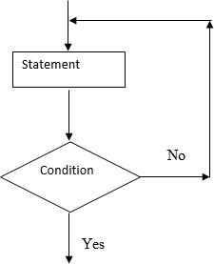
  - Name the looping structure demonstrated (1 mark)

  - After scanning images in DTP, you can either crop them or resize them. Distinguish between
cropping and resizing of images. (2 marks)

- (a) List four advantages of secondary storage devices which make them indispensable /popular
part of a computer system. (2 marks)

(b) Give two reasons why magnetic tape is not a popular secondary storage device.

- Describe the functions of the following network components.

- Router (1 mark)

- Hub (1 mark)

- State 2 reasons why an organisation may use other strategies of software acquisition other than developing their own. (2 marks)

- Given below is an algorithm that will never end.
Set count to 0
While count is non-negative
Print the count
Add 1 to count

- Explain why the loop will never end. (1 mark)

- What changes would you make to the algorithm so that it ends executing the loop once. Make changes to the statement add 1 to count to read Subtract 1 from count (1 mark)
- Consider the worksheet given below

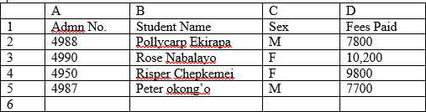
  - Give a formula that can be typed in cell D6 to return the fees paid by female students (2 marks)

  - Give a formula that can be typed in cell C6 to return the number of male students.
(1 mark)
- (a) Identify the four main application areas of artificial intelligence (2 marks)

(b) Define the following as used in word processing (1 mark)

- Word wrap

- Drop cap
- As regards database systems:

- Distinguish between a primary key and a foreign key (2 marks)

- Define the term normalization. (1 mark)
- (a) What is the difference between simplex and full –duplex transmission? (2 marks)

(b)Give any two advantages of telecommuting. (1 mark)

SECTION B (60 Marks)

Answer question 16 and any other three questions from this section in the spaces provided.
- . (a) What will be the value of product when printed in the following flow chart? Show how you arrive at your answer(2 mrk)
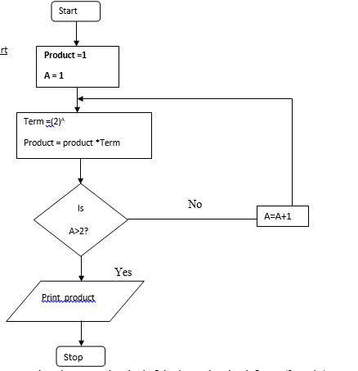

- Explain what happens when the expression A=A+1 is changed to A =A-1 (3 marks)

- Study the flowchart below and answer the questions that follow

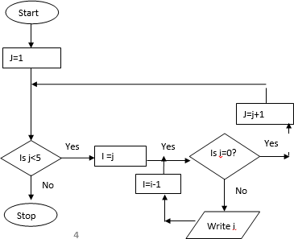

- (i) State the main type of control structure used in the flowchart (2 mark)

(ii) Dry run the above flowchart (5 marks)

- Dr. Fundi would like to demonstrate a concept using a computer program on his laptop to members of his village health committee.
Give two reasons why he would prefer a laptop to his desktop computer. (3 marks)

- (a) Describe two health issues related to working with computers and give a remedy for each. (4 marks)

- Robots are introduced into a factory which makes car engines. Describe three ways this could affect the workers. (6 marks)

- Name any two computer related courses that are offered at public universities in Kenya. (1 mark)

- List two duties performed by the following personnel

- database administrator (2 marks)

- Computer trainer (2 marks)

- (a) Give any two factors one should consider before enrolling for an ICT course in a college. (1 marks)

(b)With the aid of a sketch, explain the main stages of data processing cycle. (4 marks)

(c). State and explain any three system changeover strategies that one can use to replace on old system with a computerized system. (6 marks)

- State three reasons for developing a new system. (3 mrks)

e) Define the term feasibility study as used in system development. (1 mark)

(a) Differentiate between a database and DBMS. (1 mark)

(b)List four advantages of using electronic database systems. (2 marks)

(c) In a database system, data integrity ensures the correctness and completeness of the data in the database.

Differentiate the following types of integrity constraints:-
(i)Validity integrity (2 mark)

- Entity Integrity (2 mark)

- Referential integrity (2 mark)

(d)Briefly describe any three database models (6 marks)

- (a) Namarome a form one student out of curiosity loads three programs namely Yahoo Messenger, Ms –Word and Windows multimedia player. She realizes she can use the three programs simultaneously i.e. typing her notes, listening to her favourite song and answering incoming chat messages. She does not understand how a computer can perform such magic. She approaches you for an explanation. Explain to her how the computer does this. (2mks)

(b)(i)Define an expert system (1 mark)

- Describe the three components of an expert system (6 mrks)

- State two advantages and one disadvantage of using an expert system in passing judgement in courts of law. (3 marks)

- State two advantages of command line interface operating system over graphical user interface operating system. (2 marks)

