**Name…………………………………………………… Class Register…………..………**

**Candidate’s Signature…………**

**PHYSICS Date………………………..……**

**Theory**

**Paper 1**

*Time: 2 hours*

**PAVEMENT FORM 4 TRIAL 2 EXAMINATION 2021/2022**

**Kenya certificate of secondary education (K.C.S.E)**

**Instructions to Candidates**

1. *Write your name and class register number in the spaces provided above.*
2. *Sign and write the date of examination in the spaces provided above.*
3. *This paper consists of* ***TWO*** *sections:* ***A*** *and* ***B****.*
4. *Answer* ***ALL*** *the questions in sections* ***A*** *and* ***B*** *in the spaces provided.*
5. *ALL working* ***MUST*** *be clearly shown.*
6. *Mathematical tables and non-programmable silent electronic calculators may be used.*
7. ***This paper consists of 11 printed pages****.*

**FOR EXAMINER’S USE ONLY**

|  |  |  |  |
| --- | --- | --- | --- |
| **Section** | **Question** | **Maximum**  **Score** | **Candidate’s**  **Score** |
| **A** | 1 – 10 | 25 |  |
| **B** | 11 | 7 |  |
| 12 | 6 |  |
| 13 | 11 |  |
| 14 | 10 |  |
| 15 | 11 |  |
| 16 | 11 |  |
|  | **Total Score** | **80** |  |

*Candidates should check the question paper to ascertain that all the pages are printed as indicated and that no questions are missing*

**SECTION A (25 Marks)**

***Answer all the questions in this section in the spaces provided***

1. The level of water in a burette is at 30 cm3. 400 drops of water each of volume 0.015 cm3 was removed from the burette. Determine the new level of water in the burette **(3 marks)**

……………………………………………………………………………………………….……………………………………………………………………………………………………………………………………………………………………………………………………….…………………………………………………………………………………………………………………………………………………………………………………….…………………………………………………………………………………………………………………

1. Calculate the temperature change of water as it falls through a height of 20 m. (Take g = 10 N/kg and s.h.c of water = 4200 J/kg/K) **(3 marks)**

……………………………………………………………………………………………….……………………………………………………………………………………………………………………………………………………………………………………………………………………………………………………………………………………………………………………………………………………………………………………………

1. State the SI unit of density **(1 mark)**

……………………………………………………………………………………………….…………………………………………………………………………………………………………………………………………..…………………………………………………………………………………………………………………….

1. Give a reason why heat transfer by radiation is faster than heat transfer by conduction **(1 mark)**

……………………………………………………………………………………………….………………………………………………………………………………………………………………………………………………………………………………………………………….………………………………………………………………………………………………………………………………………………………………………………

1. A railway truck of mass 4000 kg moving at 3 m/s collides with a stationary truck of mass 2000 kg. The couplings join and the trucks move off together. Calculate their common velocity after collision. **(3 marks)**

……………………………………………………………………………………………….…………………………………………………………………………………………………………………………………………………………………………………………………………………………….……………………………………………………………………………………………………………………………………………………………

1. State the principle of moments (1 mark)

……………………………………………………………………………………………….………………………………………………………………………………………………………………………………………………………………………………………………………….………………………………………………………..……………………………………….……………………………………………………………………………

1. An air bubble with a volume of 1 cm3 escapes from the helmet of a diver at a depth of 200 m below the water surface. What will be the volume of the bubble immediately it breaks the surface of water? *(Take atmospheric pressure = 10 m of water)* **(4 marks)**

……………………………………………………………………………………………….………………………………………………………………………………………………………………………………………………………………………………………………………….………………………………………………………..…………………………………………………………………………………………………………………………………………………………………………………………….………………………………………………..………………………………………………………………………………………………………………………

1. Calculate the acceleration due to gravity on a planet where an object released from rest falls through a height of 54.2 m in 1.08 s. **(3 marks)**

……………………………………………………………………………………………….……………………………………………………………………………………………………………………………………………………………………………………………………………………………………………………………………………………………………………………………………………………………………………………………………………………………………………………………….…………………………………………………

1. State the three factors on which the rate of heat flow depends on. **(3 marks)**

……………………………………………………………………………………………….……………………………………………………………………………………………………………………………………………………………………………………………………………………………………………………………………

1. Under a driving force of 3000 N, a car of mass 1200 kg has an acceleration of 1.3 m/s2. Find the frictional resistance acting in the car. **(3 marks)**

……………………………………………………………………………………………….…………………………………………………………………………………….……………………………………………………………………………………………………………………………………………………………………………

**SECTION B (55 marks)**

*Answer ALL the questions in this section in spaces provided*

1. **(a)** The diagram below shows a set up used by a student to show variation of pressure in a liquid. The thistle funnel is wrapped with an elastic membrane. Use it to answer the question that follow.



  State and explain the effect on the height, h, when the thistle funnel is moved upwards towards the surface of the liquids. **(2 marks)**

………………………………………………………………………………………………………….………………………………………………………………………………………………………….………………………………………………………………………………………………………….……………………………………………………………………………………………………………………………….

**(b)**  Figure below shows a simple barometer.



1. What name is given to region A? **(1 mark)**

………………………………………………………………………………………………………………….

1. What keeps the mercury in the tube? **(1 mark)**

………………………………………………………………………………………………………….……………………………………………………………………………………………………………….

1. What is the value of the atmospheric pressure being shown by the barometer? **(1 mark)**

………………………………………………………………………………………………………

1. What would happen to the reading if the barometer was taken up a high mountain. **(1 mark)**

………………………………………………………………………………………………………….………………………………………………………………………………………………………………..

1. Give a reason for (d) above. **(1 mark)**

………………………………………………………………………………………………………….…..………………………………………………………………………………………………………………

1. a) In opening a door, the moment exerted about the hinges was 15Nm. If the pushing force was 25N and perpendicular to the door, what is the distance of the force from the hinges?  **(2 marks)**

………………………………………………………………………………………………………….…………………………………………………………………………………………………………………………………………………………………………………………………………………………………………………………………………………………………………………………………………………….…………………………………………………………………………………………………………………………………………………………………………………………………….…………………………………………

b) A uniform plank of wood is balanced 30cm from one end when a lead of 0.08kg is hung at one end as shown below.



Calculate the weight of the plank. **(2marks)** ……………………………………………………………………………………………….…………………………………………………………………………………………………………………………………………………………………………………………………………………….………………………………………………………………………………………………………………………………………………………………

c) State two factors that affect centre of gravity. **(2 marks)**

……………………………………………………………………………………………….………………………………….…………………………………………………………………………………………………

1. a) Sketch a velocity-time graph of a ball dropped to the ground and caught when it bounces up again. **(2 marks)**

   b) In areas of the world where a plane is unable to land free fall airdrops can be used to deliver supplies. A plane travelling at a speed of 90m/s and a height of 100m releases a load of supplies. *(g=10N/kg)*

1. Sketch the path followed by the falling load. **(1 mark)**
2. Find the horizontal distance of the load from the drop zone to where it landed. **(3 marks)**

……………………………………………………………………………………………….…………………………………………………………………………………………………………………………………………………………………………………………………….……………………………………………………………..………………………………….…………………………………………………………………………………..…………………………………………………………………………………………………

c) Define the Newton. (1 mark)

………………………………………………………………………………………………….………………………………………………………………………………………….………………….…………………………………………………………………………….……….…………………………………………………

d) The reading on a speedometer of a car of mass 1000kg is 60km/hr when the brakes are applied. The car is brought to rest in 10m. Find;

1. The retardation. **(2 marks)**

……….……………………………………………………………………………………………………………….……………………………………………………………………………………………….………………….……………………………………………………………………………………………………………………………………………………………………………………………………………………………

1. Find the average breaking force.  **(2 marks)**

……….……………………………………………………………………………………………………………….……………………………………………………………………………………………….………………….…………………………………………………………………………………………………………

1. a) The figure below shows the motion of a ticker tape through a ticker-timer whose frequency is 100Hz.





  Determine:

1. Velocity at AB and PQ **(2 marks)**

……….……………………………………………………………………………………………………………….……………………………………………………………………………………………….………………….…………………………………………………………………….………………………………………

1. Acceleration of the tape. **(2 marks)**

……….……………………………………………………………………………………………………………….……………………………………………………………………………………………….………………….…………………………………………………………………….…………………………………………………………………………………………………….……………………………………………………

**b)** Sate two factors that affect centripetal force of a body moving a circular path.  **(2 marks)**

……….……………………………………………………………………………………………………………….……………………………………………………………………………………………………….

**c)** A stone of mass 1.2 kg is tied to a rope and whirled in a vertical circle of radius 3.2m with a speed of 6.32m/s. Calculate

1. The centripetal acceleration of the stone. **(2 marks)**

……….……………………………………………………………………………………………………………….……………………………………………………………………………………………….………………….……………………………………………………………………………………………

1. The tension in the rope when the stone is at the highest point. **(2 marks)**

……….……………………………………………………………………………………………………………….……………………………………………………………………………………………….………………….……………………………………………………………………………………………

1. a) State the law of floatation. **(1 mark)**

……….……………………………………………………………………………………………………………….……………………………………………………………………………………………….………………….……………………………………………………………………………………………..

b) You are provided with the following

* A block of wood.
* A spring balance.
* A thin thread.
* Overflow can
* A small measuring cylinder.
* Some liquid.

With the aid of a labelled diagrams describe an experiment to verify the law of floatation. **(4 marks)**

c) A block of length 80cm, cross sectional area 3.0cm² and density 1300kg/m³ is completely immersed in a liquid of density 1030kg/m³. Determine

1. The mass of the block. **(1 mark)**

……….……………………………………………………………………………………………………………….……………………………………………………………………………………………….………………….………………………………………………………………………………………………………………………………………………………………………………………………………….

1. The weight of the block in the liquid.  **(3 marks)**

……….……………………………………………………………………………………………………………….……………………………………………………………………………………………….………………….…………………………………………………………………….……………………………………………………………………………………………………………….……………………………………………………………………………………………….………………….………………

d) The diagram below shows a car acid hydrometer.

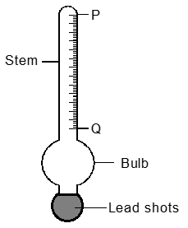

1. Indicate on the diagram the maximum and minimum measurements to be taken. **(1 mark)**
2. State the reason why the bulb is wide. **(1 mark)**

……….……………………………………………………………………………………………………………….……………………………………………………………………………………………….………………….…………………………………………………………………………………………….

1. **a)** (i) State Charles law. **(1 mark)**

……….……………………………………………………………………………………………………………….……………………………………………………………………………………………….………………….……………………………………………………………………………………………

(ii) A gas of volume 2m³ at 27°C is cooled to -123°C, at constant pressure. What is its new volume? **(2 marks)**

……….……………………………………………………………………………………………………………….……………………………………………………………………………………………….………………….…………………………………………………………………….……………………………………………………………………………………………………………….……………………………………………………………………………………………….………………….…………………………………………………………………………………….………………………………………………………………

**b)**

    The figure shown illustrates an apparatus in which a fixed mass of air was compressed in a calibrated syringe, which was approximately half full of air at atmospheric pressure and a temperature of 17°C corresponding values of volume and pressure of the trapped air as shown in the table.

|  |  |  |  |  |  |  |
| --- | --- | --- | --- | --- | --- | --- |
| Pressure (Kpa) | 50 | 60 | 75 | 90 | 105 | 120 |
| Volume (cm³) | 0.00048 | 0.00040 | 0.00032 | 0.00027 | 0.00023 | 0.00020 |
| $1/{volume}$ |  | 2500 |  | 3704 |  |  |

1. Complete the table by calculating values for $\frac{1}{Volume}$ some of the values have been entered for you. **(1 mark)**
2. On grid paper plot a graph of pressure on the y-axis against $\frac{1}{Volume}$ on the axis. **(5 marks)**

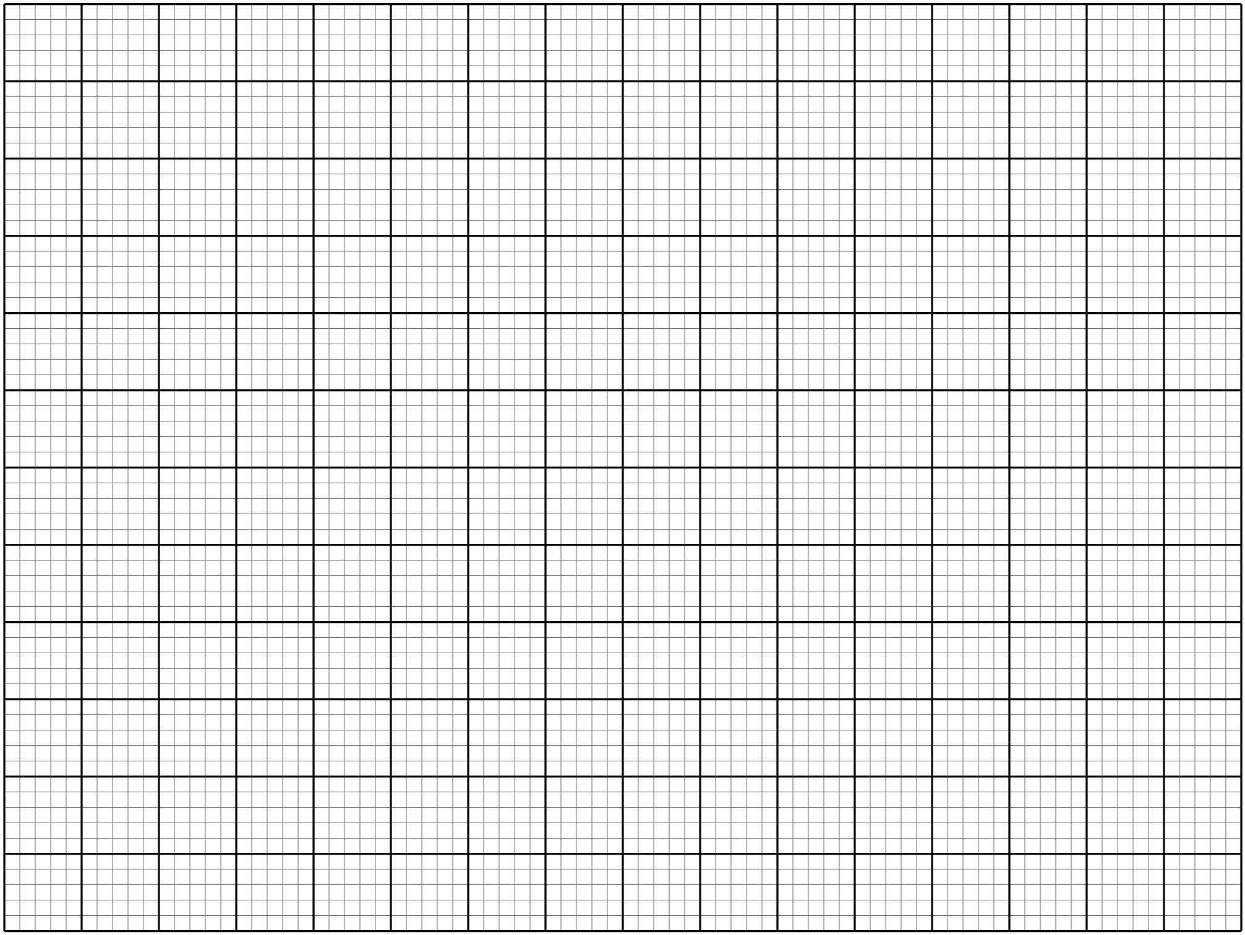

1. What relationship between pressure and volume of the trapped air can be deducted from your graph? Explain your answer. **(1 mark)**

……….……………………………………………………………………………………………………………….……………………………………………………………………………………………….………………….……………………………………………………………………………………………………

1. If the temperature of air was increased to 27°C, what would happen to the volume occupied by the air at a pressure of 100Kpa? **(1 mark)**

……….……………………………………………………………………………………………………………….…………………………………………………………………………… …………………………