Name…………………………………………………… Class Register…………..………
Candidate’s Signature…………
PHYSICS Date………………………..……
Theory
Paper 1
Time: 2 hours
OPENER EXAMINATIONS TERM 1 2021/2022
PAVEMENT NATIONAL EXAMINATION DEPARTMENT
FORM FOUR
Instructions to Candidates
- Write your name and class register number in the spaces provided above.
- Sign and write the date of examination in the spaces provided above.
- This paper consists of TWO sections: A and B.
- Answer ALL the questions in sections A and B in the spaces provided.
- ALL working MUST be clearly shown.
- Mathematical tables and non-programmable silent electronic calculators may be used.
- This paper consists of 10 printed pages.

For Examiner’s Use Only
Section | Question | Maximum  Score | Candidate’s  Score
A | 1 – 12 | 25
 | 13 | 10
 | 14 | 11
 | 15 | 12
 | 16 | 14
 | 17 | 8
Total Score |  | 80

SECTION A: (25 Marks)
Answer all the questions in this section in the spaces provide
- State the reading on the Vernier caliper shown in fig. 1 below. [1]
9
87

Fig 1.
..................................................................................................................................................................................
- A girl stands inside a lift on the second floor of an 18 storey building. If the lift is ascending upwards at an acceleration of 3ms⁻² and she weighs 60kg, determine the reaction of the lift at the girl’s feet. [3]
.................................................................................................................................................................................................................................................................................................................................................................... ....................................................................................................................................................................................................................................................................................................................................................................
- Figure 2 below represents a car hydraulic braking system.
Fluid
Force applied to brake pads
Slave piston
Master piston

Foot pedal
Fig. 2
Use the information given in the diagram above to answer questions 3(a) and 3(b).
a) State one property the fluid should have. [1]
.............................................................................................................................................................................
b) Explain briefly how the system operates. [3]
.......................................................................................................................................................................................................................................................................................................................................................................................................................................................................................................................................
- Figure 3 below shows a machine being used to raise a load. Use the information given in the figure to answer questions 4(a) and 4(b) below
Effort
Load
Fig 3
a) Determine the velocity ratio (V.R) of the machine. [1]
......................................................................................................................................................................................................................................................................................................................................................................................................................................................................................................................................
b) If a load of 800N is raised by applying an effort of 272N, determine the efficiency of the machine. [3]
......................................................................................................................................................................................................................................................................................................................................................................................................................................................................................................................................
- What happens to the motion of smoke particles in the smoke cell experiment when the setup is moved from an environment at 27⁰c to an environment at 47ºC? [1]
....................................................................................................................................................................................................................................................................................................................................................................
- State Charles’s Law. [1]
....................................................................................................................................................................................................................................................................................................................................................................
- A piece of iron is heated. Explain what happens to its density. [2]
.................................................................................................................................................................................................................................................................................................................................................................... ....................................................................................................................................................................................................................................................................................................................................................................

- Figure 4 below shows two identical beakers A and B. Beaker A contains water at OºC while B contains water and pieces of ice at OºC. Both contents have the same mass.
B
A
Fig. 4
Two identical metal blocks are removed from the same hot furnace and dropped into each of the beakers. Identify which of the two beakers would experience more evaporation and give a reason for your answer. [2]
....................................................................................................................................................................................................................................................................................................................................................................
..................................................................................................................................................................................
- A force of 7.5N stretches a certain spring by 5.0cm. How much work is done in stretching this spring by 8.0 cm? [3]
.................................................................................................................................................................................................................................................................................................................................................................... ....................................................................................................................................................................................................................................................................................................................................................................
- State the Pascal’s principle of pressure transmission in fluid. [1]
....................................................................................................................................................................................................................................................................................................................................................................
- Figure 5 below shows a velocity time graph for a car in motion. If the mass of the car is 920kg, determine the maximum kinetic energy acquired for part of the journey shown [2]
time (s)
Velocity (m/s)
Fig. 5

- A bullet is fired horizontally at a target, neglecting air resistance, give a reason why the horizontal acceleration of the bullet is zero. [1]
....................................................................................................................................................................................................................................................................................................................................................................

SECTION II ( 55 marks)
- a) Figure 6 above shows the velocity time graph of two identical spheres released from the surfaces of two fluids A and B
Velocity (ms⁻¹)
A
B
time(s)
Fig. 6
- State with reason, the fluid with a higher viscosity. [2]
................................................................................................................................................................................................................................................................................................................................................................................................................................................................................................
- Mark on the diagram the terminal velocity on the sphere in each fluid. [1]

b) Water flows through a horizontal pipe of varying cross-section area as shown in figure 7 below.
A
B
100cm²
60cm²
v = 2m/s
Pipe

Fig. 7
The velocity of water in pipe A is 2m/s
- Determine the velocity of water in pipe B. [3]
................................................................................................................................................................................................................................................................................................................................................................................................................................................................................................

- State two assumptions taken in Bernoulli’s fluid flow. [2]
.............................................................................................................................................................................................................................................................................................................................................................................................................................................................................................
- Explain why a partially inflated balloon released at sea level would become fully inflated at a higher altitude. [2]
.............................................................................................................................................................................................................................................................................................................................................................................................................................................................................................
- (a) State Boyle’s Law. [1]
................................................................................................................................................................................................................................................................................................................................................................................................................................................................................................
(b) The table below shows the results from Boyle’s law experiment.

Pressure (atmospheres) | 1.0 | 1.3 | 1.5 | 1.8 | 2.3 | 2.6 | 3.2 | 3.7
Length of air column , L(mm) | 41.0 | 30.0 | 27.5 | 22.0 | 18.0 | 16.0 | 12.5 | 11.0
^{I}/_{L} x 10⁻²(mm)⁻¹
- Complete the table by filling in the values for the row ^{I}/_{L} x 10⁻²(mm)⁻¹ [4]
- Plot a graph of pressure against ^{I} /_{L} [5]

- Estimate the pressure of the air when ^{I}/_{L} is zero. [1]
- (a) Define the terms
(i) Inelastic collisions [1]
................................................................................................................................................................................................................................................................................................................
(ii) Momentum [1]
................................................................................................................................................................................................................................................................................................................
(b) A bullet of mass 20g moving with a velocity of 1000m/s hits stationery antelope of mass 12kg. The bullet imbeds and the two move in one direction. Calculate its final velocity [2]
....................................................................................................................................................................................................................................................................................................................................................................................................................................................................................................................................................................................................................................................................................
(c) Block of mass 200g rests on a rough horizontal table. A force of 0.6N pulls the block so that it moves with a constant acceleration of 1m/s² calculate
(i) The time it takes to travel a distance of 200m [2]
................................................................................................................................................................................................................................................................................................................ ........................................................................................................................................................
(ii) The frictional force between the block and the table [2]
................................................................................................................................................................................................................................................................................................................ ........................................................................................................................................................ ........................................................................................................................................................
(iii) The coefficient of kinetic friction between the two forces [2]
................................................................................................................................................................................................................................................................................................................ ........................................................................................................................................................

- A part from the normal reaction and frictional force, name any other force [2]
........................................................................................................................................................
- (a) Define the term latent heat [1]
..........................................................................................................................................................................................................................................................................................................................................
- Figure 8 below shows a block of ice with two heavy weights hanging such that the copper wire / string connecting them passes over the block of ice.
Copper wire
weights
Wooden support
Ice block
Fig. 8
- It is observed that the wire gradually cuts its way through the ice block, but leaves it as one piece. Explain [5]
........................................................................................................................................................ ........................................................................................................................................................ ........................................................................................................................................................ ........................................................................................................................................................ ........................................................................................................................................................ ........................................................................................................................................................
- What change would be observed if the copper wire used in the experiment was replaced by a cotton thread? Explain your answer. [2]
........................................................................................................................................................ ........................................................................................................................................................ ........................................................................................................................................................
- 3kg hot water was added to 9kg of water at 10⁰C and the resulting temperature was 20⁰C. Ignoring heat gained by the container, determine the initial temperature of the hot water. (Specific heat capacity of water = 4200J/KgK). [3]
............................................................................................................................................................................................................................................................................................................................................................................................................................................................................................................... ..........................................................................................................................................................................................................................................................................................................................................
- What is the operating resistance of an electric heater rated 90W, 240V? [3]
............................................................................................................................................................................................................................................................................................................................................................................................................................................................................................................... .....................................................................................................................................................................
- a) (i) State the principle of moments. [1]
................................................................................................................................................................................................................................................................................................................
- A uniform metre rule has a mass of 300g and is pivoted freely at the 0 cm mark. Determine the force which should be applied vertically upwards at the 55cm mark to maintain the ruler horizontally. [3]
................................................................................................................................................................................................................................................................................................................
................................................................................................................................................................................................................................................................................................................
- Figure 9 below shows a piece of tape pulled through a ticker – timer by a trolley down an inclined plane. The frequency of the ticker-timer is 100Hz.
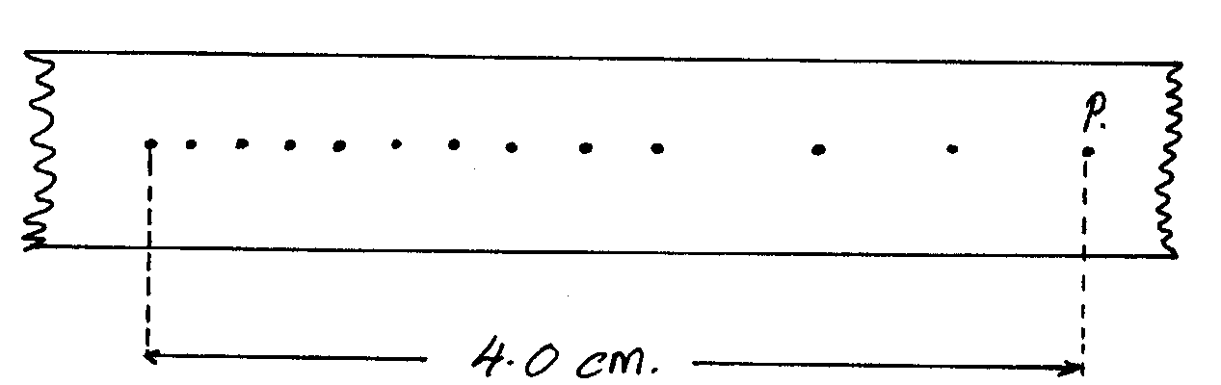
Y
4.0cm
P

Fig. 9
(i) Find the time between two dots. [1]
................................................................................................................................................................................................................................................................................................................
(ii) Determine the average velocity of the trolley between Y and P. [3]
................................................................................................................................................................................................................................................................................................................ ................................................................................................................................................................................................................................................................................................................

