NAME_________________________ADM_____________INDEX NO___________________
443/1
AGRICULTURE
PAPER 1
TIME: 2 HOURS

SAMIA SUB-COUNTY JOINT EXAMINATION MOCK 2021
Kenya Certificate of Secondary Education

Instructions:
-This paper has three sections A,B and C.
- answer all questions in sections A and B.
-Answer any two questions in section C.
For Examiners use:
SECTION | QUESTIONS | MAXIMUM SCORE | STUDENTS SCORE
A | 1-19 | 30
B | 20-23 | 20
C | 24 | 20
 | 25 | 20
 | 26 | 20
TOTAL |  | 90

1.Name two situations under which irrigation is practiced (1mk)
………………………………………………………………………………………………………………………………………………………………………………………………………………………………………………………………………………………………………………………2.Give a reason why ranching is an improvised pastoral nomadism (1mk)
………………………………………………………………………………………………………………………………………………………………………………………………………………………………………………………………………………………………………………………3.State two ways by which a soil of PH 3 can be raised to a PH of 6 (1mk)
………………………………………………………………………………………………………………………………………………………………………………………………………………………………………………………………………………………………………………………
4.Outline two effects of adding organic matter to sandy soil (1mk)
……………………………………………………………………………………………………………………………………………………………………………………………………………………………………………………………………………………………………………………………………………………………………………………………………………………………..
5.State four functions of young farmers club in schools (2mks)
………………………………………………………………………………………………………………………………………………………………………………………………………………………………………………………………………………………………………………………………………………………………………………………………………………………………
6.Distinguish between a perfect and imperfect market. (1mk)
………………………………………………………………………………………………………………………………………………………………………………………………………………………………………………………………………………………………………………………………………………………………………………………………………………………………………………………………………………………………………………………………………
……………………………………………………………………………………………………………………………………………………………………………………………………………………………………………………………………………………………………………………………………………………………………………………………………………………………..
7.Name four financial documents used in the farm (2mks)
………………………………………………………………………………………………………………………………………………………………………………………………………………………………………………………………………………………………………………………………………………………………………………………………………………………………………………………………………………………………………………………………………
8..State four factors that determine the depth of planting (2marks)
………………………………………………………………………………………………………………………………………………………………………………………………………………………………………………………………………………………………………………………………………………………………………………………………………………………………
9.State four minimum tillage practices (2marks)
………………………………………………………………………………………………………………………………………………………………………………………………………………………………………………………………………………………………………………………
10.Give four ways of improving labour productivity on a farm (2mks).
………………………………………………………………………………………………………………………………………………………………………………………………………………………………………………………………………………………………………………………………………………………………………………………………………………………………11 State four forms of agroforestry .(2mks)
……………………………………………………………………………………………………………………………………………………………………………………………………………………………………………………………………………………………………………………..
12.A farmer plants maize on his piece of land measuring 40m by 30m at a seed rate of I seed per hole. If he used a spacing of 75cm by 25cm, Calculate this plant population.(2marks).
………………………………………………………………………………………………………………………………………………………………………………………………………………………………………………………………………………………………………………………………………………………………………………………………………………………………………………………………………………………………………………………………………
13.State four reasons for conserving forage (2marks)
………………………………………………………………………………………………………………………………………………………………………………………………………………………………………………………………………………………………………………………………………………………………………………………………………………………………
14.Give four benefits of a land title deed (2mks)
………………………………………………………………………………………………………………………………………………………………………………………………………………………………………………………………………………………………………………………………………………………………………………………………………………………………
15.State four steps of gully formation (2mks)
………………………………………………………………………………………………………………………………………………………………………………………………………………………………………………………………………………………………………………………………………………………………………………………………………………………………………………………………………………………………………………………………………16.State two characteristics of a good root stock for grafting (1mk)
………………………………………………………………………………………………………………………………………………………………………………………………………………………………………………………………………………………………………………………
17.State two main causes of silage loses (1mk)
………………………………………………………………………………………………………………………………………………………………………………………………………………………………………………………………………………………………………………………………………………………………………………………………………………………………
18.State four aims of land settlement programmes in Kenya (2mks)
………………………………………………………………………………………………………………………………………………………………………………………………………………………………………………………………………………………………………………………………………………………………………………………………………………………………
19.Give two factors that influence the stage at which crop is harvested(1mks)
………………………………………………………………………………………………………………………………………………………………………………………………………………………………………………………………………………………………………………………………………………………………………………………………………………………………
SECTION B(20MARKS)
20.The illustrations below represent an experiment to compare the porosity and water holding capacity of three types of soils. Carefully study the experiment and then answer the questions that follow
(a) Identify the soil in each of the funnels labeled (3marks)
H ………………………………………..
J…………………………………………
K…………………………………………..
(b) Which of the three types of soil can be said to have the highest porosity rate?( ½ mk)
………………………………………………………………………………………………………………………………………………………………………………………………………(c) Which type of soil would be suitable for planting paddy rice? ( ½mk)

21.The diagrams below represent some panicles of varieties of Sorghum crop growing in the field. Study them carefully and answer the questions that follow.
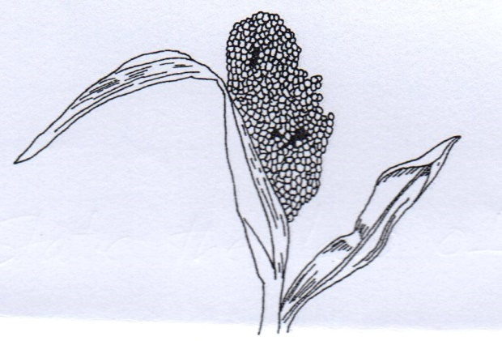

Variety A
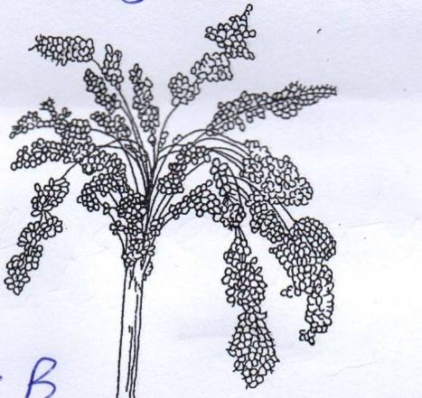

Variety B

Variety C

- Identify the types of panicles in each of the varieties represented by A,B and C
Variety A…………………………………………………….(1mark)
Variety B……………………………………………………..(1mark)
Variety C………………………………………………………(1mark)

- Which of the varieties named in (a) above is less easily damaged by bird pests(1mrk)
………………………………………………………………………………….
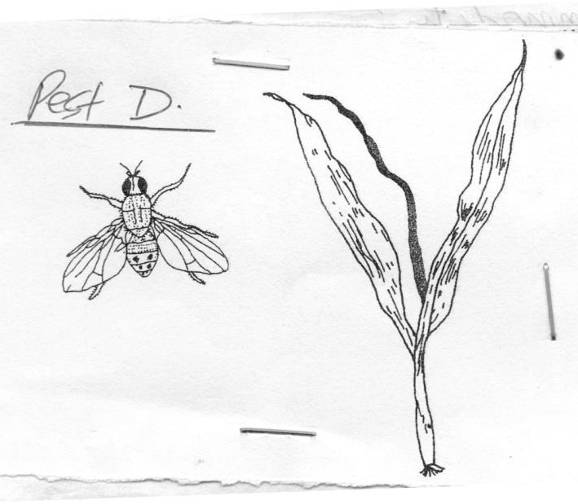
- The diagram below represents a pest labeled D that infests Sorghum plants during early stages of establishment

- Identify the pest
……………………………………………………………………….(1mark)

- State two methods of controlling the pest named in C(i) above (2marks) ………………………………………………………………………………………………………………………………………………………………………………………………………………………………………………………………………

22.Study diagram below and answer questions that follow.
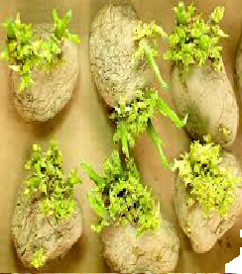
(i) Name the farming practice illustrated above.(1mark)
…………………………………………………………………………………………………
(ii) Give the procedure followed to carry out the practice you have named in (i) above (3marks)
………………………………………………………………………………………………………………………………………………………………………………………………………………………………………………………………………………………………………………………………………………………………………………………………………………………………………………………………………………………………………………………………………………………………………………………………………………………………………………
(iii) state the importance of carrying out the farming practice named above. (1 mark)
………………………………………………………………………………………………………………………………………………………………………………………………………………

23.The diagram below shows common weeds, study them and answer the questions that follow.
L
K
J
- Identify the weeds J and K. ( 2marks)
J………………………………………………………………………………..
K……………………………………………………………………………….

- State the effects of weed labeled Jto livestock. (1 mark)
………………………………………………………………………………………………………………………………………………………………………………………………………...
- Give one reason why it is difficult to control the weed labeled L? ( 1 mark)
……………………………………………………………………………………………………………………………………………………………………………………………………
SECTION C (40 MARKS)
Answer only two questions in this section in the spaces provided.
24.Describe the production of onions under the following sub headings
a.Ecological requirements (4 marks)
b.Planting (5 marks)
c. Field practices (4 marks)
d Harvesting and marketing (7 marks)

25a.Outline eight uses of farm records (8 marks)
b.Explain the various ways by which a farmer can adjust to risks and uncertainties (6 marks)
c. State precautions taken when harvesting pyrethrum (6mks)

26a.Explain five causes of land fragmentation in Kenya since independence (5 marks)
b.Describe the advantages of land consolidation and registration. (8 marks)
c.Explain the objectives of land reform under taken in Kenya. (7 marks)
…………………………………………………………………………………………………………………………………………………………………………………………………………………………………………………………………………………………………………………………………………………………………………………………………………………………………………………………………………………………………………………………………………………………………………………………………………………………………………………………………………………………………………………………………………………………………………………………………………………………………………………………………………………………………………………………………………………………………………………………………………………………………………………………………………………………………………………………………………………………………………………………………………………………………………………………………………………………………………………………………………………………………………………………………………………………………………………………………………………………………………………………………………………………………………………………………………………………………………………………………………………………………………………………………………………………………………………………………………………………………………………………………………………………………………………………………………………………………………………………………………………………………………………………………………………………………………………………………………………………………………………………………………………………………………………………………………………………………………………………………………………………………………………………………………………………………………………………………………………………………………………………………………………………………………………………………………………………………………………………………………………………………....................................................................................................................................................................................................................................................................................................................................................................................................................................................................................................................................................................................................................................................................................................................................................................................................................
…………………………………………………………………………………………………………………………………………………………………………………………………………………………………………………………………………………………………………………………………………………………………………………………………………………………………………………………………………………………………………………………………………………………………………………………………………………………………………………………………………………………………………………………………………………………………………………………………………………………………………………………………………………………………………………………………………………………………………………………………………………………………………………………………………………………………………………………………………………………………………………………………………………………………………………………………………………………………………………………………………………………………………………………………………………………………………………………………………………………………………………………………………………………………………………………………………………………………………………………………………………………………………………………………………………………………………………………………………………………………………………………………………………………………………………………………………………………………………………………………………………………………………………………………………………………………………………………………………………………………………………………………………………………………………………………………………………………………………………………………………………………………………………………………………………………………………………………………………………………………………………………………………………………………………………………………………………………………………………………………………………………………………………………………………………………………………………………………………………………………………………………………………………………………………………………………………………………………………………………………………………………………………………………………………………………………………………………………………………………………………………………………………………………………………………………………………………………………………………………………………………………………………………………………………………………………………………………………………………………………………………………………………………………………………………………………………………………………………………………………………………………………………………………………………………………………………………………………………………………………………………………………………………………………………………………………………………………………………………………………………………………………………………………………………………………………………………………………………………………………………………………………………………………………………………………………………………………………………………………………………………………………………………………………………………………………………………………………………………………………………………………………………………………………………………………………………………………………………………………………………………………………………………………………………………………………………………………………………………………………………………………………………………………………………………………………………………………………………………………………………………………………………………………………………………………………………………………………………………………………………………………………………………………………………………………………………………………………………………………………………………………………………………………………………………………………………………………………………………………………………………………………………………………………………………………………………………………………………………………………………………………………………………………………………………………………………………………………………………………………………………………………………………………………………………………………………………………………………………………………………………………………………………………………………………………………………………………………………………………………………………………………………………………………………………………………………………………………………………………………………………………………………………………………………………………………………………………………………………………………………………………………………………………………………………………………………………………………………………………………………………………………………………………………………………………………………………………………………………………………………………………………………………………………………………………………………………………………………………………………………………………………………………………………………………………………………………………………………………………………………………………………………………………………………………………………………………………………………………………………………………………………………………………………………………………………………………………………………………………………………………………………………………………………………………………………………………………………………………………………………………………………………………………………………………………………………………………………………………………………………………………………………………………………………………………………………………………………………………………………………………………………………………………………………………………………………………………………………………………………………………………………………………………………………………………………………………………………………………………………………………………………………………………………………………………………………………………………………………………………………………………………………………………………………………………………………………………………………………………………………………………………………………………………………………………………………………………………………………………………………………………………………………………………………………………………………………………………………………………………………………………………………………………………………………………………………………………………………………………………………………………………………………………………………………………………………………………………………………………………………………………………………………………………………………………………………………………………………………………………………………………………………………………………………………………………………………………………………………………………………………………………………………………………………………………………………………………………………………………………………………………………………………………………………………………………………………………………………………………………………………………………………………………………….

