Name:………………………………………………………..Index number:……………………

Candidate’s signature:………………………………………. Date:……………………………

231/1
Biology
Paper 1 (THEORY)
December 2021
2 hours.

SAMIA SUB-COUNTY JOINT EVALUATION
Kenya Certificate Of Secondary Education

INSTRUCTIONS TO CANDIDATES:

- Write your NAME and INDEX NUMBER in the spaces provided above.
- Sign and write the date of the examination in the spaces provided above.
- ALL answers must be written in the spaces provided.
- Additional pages must not be inserted.
- Candidates should check the question paper to ascertain that all the pages are printed as indicated and that no questions are missing.
- Candidates should answer all questions in English.

FOR EXAMINER’S USE ONLY:

Question | Maximum score | Candidate’s score
1-23 | 80
Total score | 80

SAMIA SUB-COUNTY JOINT EVALUATION TEST
231/1
Biology (Theory) Paper 1

- State the significance of the following characteristics of living organisms. (2marks)

- Irritability
……………………………………………………………………………………………………………………………………………………………………………………………………
- Reproduction
……………………………………………………………………………………………………………………………………………………………………………………………………
- The scientific name lantana camara refers to a green herbaceous plant. Other related plants include lantana trifoliate and vitex trifoliate. From the list, identify the plants belonging to the same genus. (2marks)

……………………………………………………………………………………………………….………………………………………………………………………………………………………

- Which cell organelle will be abundant in: (2marks)

- Skeletal muscle cell

…………………………………………………………………………………………………

- Palisade cell

…………………………………………………………………………………………………

- An experiment was set up as shown below. The set up was left for 30 minutes.
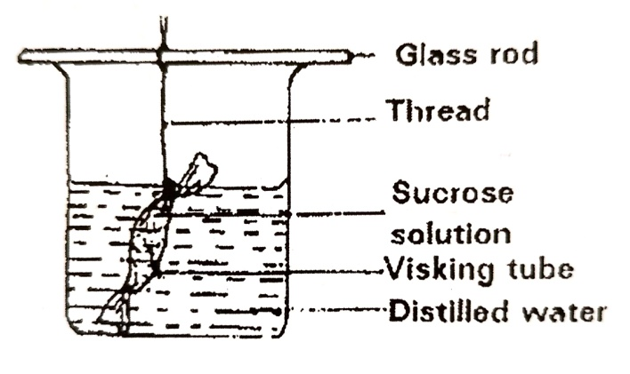

- State the observations made after 30 minutes. (1mark)
…………………………………………………………………………………………………………………………………………………………………………………………………….
- Explain the observations made in (i) above. (3marks)
………………………………………………………………………………………………………………………………………………………………………………………………………………………………………………………………………………………………………………………………………………………………………………………………………….

- The diagram below represents a section though a human tooth
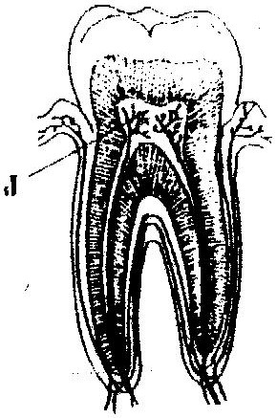

- (i) Name the type of tooth shown ( 1 mark)

………………………………………………………………………………………………

(ii) Give a reason for your answer in (a) (i) above (1 mark)

……………………………………………………………………………………………………….……………………………………………………………………………………..
- State the functions of the structures found in part labeled J (2 marks)

………………………………………………………………………………………………………..……………………………………………………………………………………..
- Describe what happens during the light stage of photosynthesis (3 marks)

………………………………………………………………………………………………………..…………………………………………………………………………………………………………..……………………………………………………………………………………………………
- The diagram below represents part of the phloem tissue.
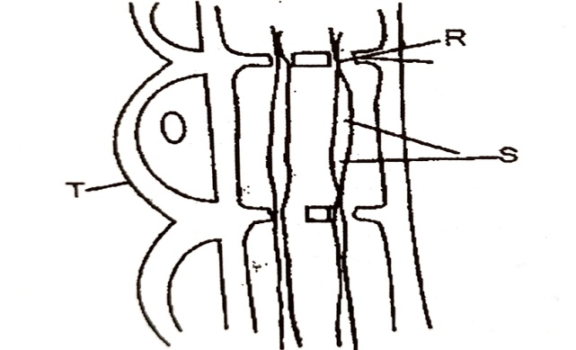

- Name the structures labeled R, S and a cell labeled T(3amrks)
R………………………………………………………………………………………............
S……………………………………………………………………………………..................
Cell T………………………………………………………………………………..................
- State the function of the structure labeled S. (1mark)
………………………………………………………………………………………………….
- a) What prevents blood in veins from flowing backwards? (1mark)
……………………………………………………………………………………………………
- State two ways in which the red blood cells are adapted to their functions. (2marks)
………………………………………………………………………………………………………..………………………………………………………………………………………………

- Differentiate between Active immunity and Passive immunity. (2marks)

………………………………………………………………………………………………………..……………………………………………………………………………………………………………………………………………………………………………………………………………………………………………………………………………………………………………………………………………………………………………………………………………………………………………………………………………………………………………………………………….

- State three gaseous exchange structures in terrestrial plants. (3marks)

…………………………………………………………………………………………………………..…………………………………………………………………………………………………………..…………………………………………………………………………………………………

- Give two reasons why accumulation of lactic acid during vigorous exercise leads to an increase in heart beat. (2marks)

………………………………………………………………………………………………………..………………………………………………………………………………………………………..………………………………………………………………………………………………………..………………………………………………………………………………………………………..

- The diagram below illustrates part of a Nephron from a mammalian kidney.

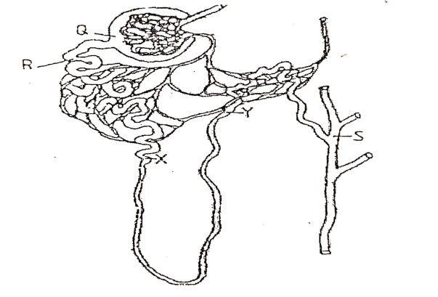
- Name the fluid in the part labeled Q (1mark)

………………………………………………………………………………………………

- Identify the process responsible for the formation of the fluid named in (a) above. (1mark)

………………………………………………………………………………………………………………………………………………………………………………………………

- Which two hormones exert their effects in the Nephron? (2marks)

………………………………………………………………………………………………………..………………………………………………………………………………………
- Give one economic importance of the following plant excretory product. (1mark)

- Tannins
…………………………………………………………………………………………………

- The diagram below represents a living organism.
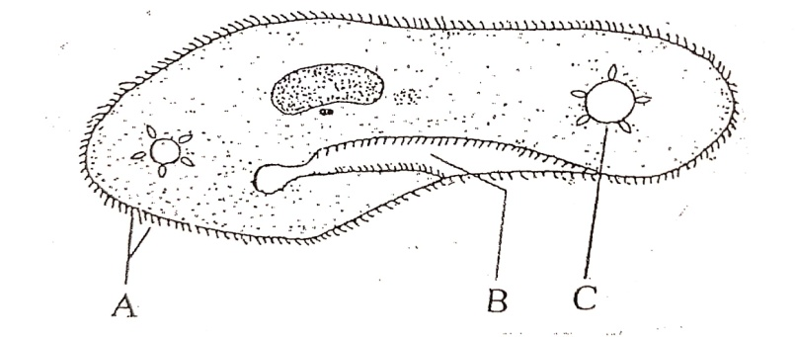

- Name the structures labeled A and C (2marks)

A…………………………………………. C………………………………………..

- Identify the kingdom of the above organism. (1mark)

…………………………………………………………………………………………………

- Give a reason for your answer in (b) above (1mark)

…………………………………………………………………………………………………

- Name the phylum, whose members posses a notochord. (1mark)

………………………………………………………………………………………………………

- Define the following terms: - (3marks)

- Ecological niche
………………………………………………………………………………………………

- Habitat
………………………………………………………………………………………………

- Carrying capacity
…………………………………………………………………………………………………

- The figure below shows the amount of DDT at different levels in a food chain in a lake.

70
40
15
0.08
Bird
Large fish
Small fish
Water plants

- At what trophic level is DDT most likely to have the highest marked effect? (1mark)
………………………………………………………………………………………………

- Suggest two ways in which the birds might have come into contact with DDT (2marks)
………………………………………………………………………………………………………..………………………………………………………………………………………
- Extract and write down a food chain from the above figure. (1mark)
……………………………………………………………………………………………………………………………………………………………………………………………………………………………………………………………………………………………………………………………………………………………………………………………….

- Study the diagram below and use it to answer the questions that follow:

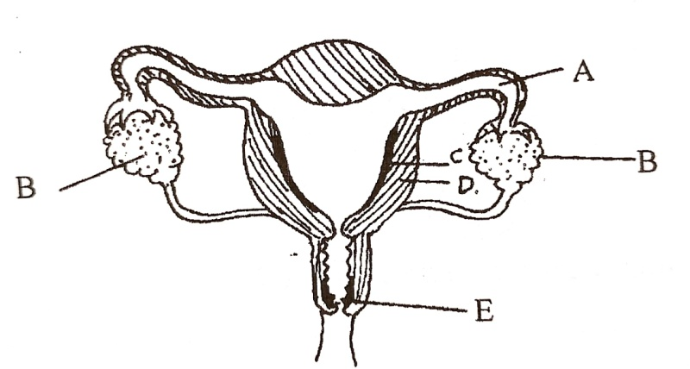
- Name the part labeled E (1mark)
…………………………………………………………………………………………………

- What are the functions of the part labeled A? (2marks)
………………………………………………………………………………………………………..……………………………………………………………………………………………………………………………………………………………………………………………………………………………………………………………………………………………….

- Explain how the following factors hinder self-pollination in plants. (2marks)

- Protogyny
……………………………………………………………………………………………………………………………………………………………………………………………………

- Dioecism
…………………………………………………………………………………………………………………………………………………………………………………………………….

- a) Name the part of the flower that develops into each of the following (2marks)

- Seed coat.
…………………………………………………………………………………………………
- Seed
…………………………………………………………………………………………………

- State two environmental conditions that can cause seed dormancy (2marks)
…………………………………………………………………………………………..…………………………………………………………………………………………………………

- State two ways of breaking seed dormancy (2marks)
………………………………………………………………………………………………………..………………………………………………………………………………………………

- Give one role of water in germination(1mark)
……………………………………………………………………………………………………

- Define the following terms as used in genetics. (3marks)

- Alleles
……………………………………………………………………………………………………………………………………………………………………………………………………

- Gene mutation
……………………………………………………………………………………………………………………………………………………………………………………………………..

- Discontinuous variation
…………………………………………………………………………………………………………………………………………………………………………………………………..

- State two sex-linked traits located on the Y- chromosome (2marks)
………………………………………………………………………………………………………..………………………………………………………………………………………………………

- State three limitations of using fossil records as an evidence for organic evolution (3marks)
………………………………………………………………………………………………………..…………………………………………………………………………………………………………..……………………………………………………………………………………………………

- State three types of neurons (3marks)
……………………………………………………………………………………………………..……………………………………………………………………………………………………………..……………………………………………………………………………………………………
- Define the following types of responses (3marks)
- Phototropism
……………………………………………………………………………………………………
- Chemotaxis
……………………………………………………………………………………………………
- Thigmotropism
……………………………………………………………………………………………………

- Differentiate between support and movement (2marks)
………………………………………………………………………………………………………..……………………………………………………………………………………………………………………………………………………………………………………………………………………………………………………………………………………………………………………………………………………………………………………………………………………………………………………………………………………………………………………………………….

THE END

