TERM 2 - 2023
AGRICULTURE
FORM TWO (2)
Time: 2 Hours
Name: …………………………………………………………. Adm No: ……………….
School: ……………………………………………………….. Class: …………………..
Signature: …………………………………………………….. Date: …………………...

INSTRUCTIONS TO CANDIDATES
- Write your name and admission number in the space provided
- Sign and write the date of examination in the space provided above
- This paper consist of three sections A, B and C (100mks)
- Answer all the questions in sections A and B and C
- All answers should be written in the spaces provided
- Candidates should check the question paper to ascertain that all the pages are printed as indicated and that no questions are missing

FOR EXAMINERS USE ONLY
SECTION | QUESTIONS | MAXIMUM SCORE | CANDIDATES SCORE
A | 1-25 | 40
B | 26-29 | 20
C | 30 | 20
 | 31 | 20
TOTAL SCORE |  | 100

SECTION A: (40 MARKS)
ANSWER ALL QUESTIONS IN THE SPACE PROVIDED
- Give two ways in which agriculture contributes to industrial development (1mark)
…………………………………………………….………………………………………
………………………………………………….…………………………………………
………………………………………………….…………………………………………
…………………………………………………….………………………………………
…………………………………………………….………………………………………
………………………………………………………….…………………………………
- Name two tertiary operations carried out during land preparation (1mark)
…………………………………………………….………………………………………
………………………………………………….…………………………………………
………………………………………………….…………………………………………
…………………………………………………….………………………………………
…………………………………………………….………………………………………
………………………………………………………….…………………………………
- Name one livestock disease transmitted by each of the following parasites (1½ marks)
- Blue tick
…………………………………………………….………………………………………
…………………………………………………….………………………………………
………………………………………………………….…………………………………

- Brown ear tick
…………………………………………………….………………………………………
…………………………………………………….………………………………………
………………………………………………………….…………………………………

- Tsetse fly
…………………………………………………….………………………………………
…………………………………………………….………………………………………
………………………………………………………….…………………………………

- Name three tools used in handling cattle during an agricultural exhibition ( 1½ mark)
…………………………………………………….………………………………………
………………………………………………….…………………………………………
………………………………………………….…………………………………………
…………………………………………………….………………………………………
- Name two ways in which proper nutrition helps to control livestock diseases (1mark)
…………………………………………………….………………………………………
………………………………………………….…………………………………………
………………………………………………….…………………………………………
…………………………………………………….………………………………………
…………………………………………………….………………………………………
………………………………………………………….…………………………………
- Name four properties of clean and safe water for domestic use on the farm (2marks)
…………………………………………………….………………………………………
………………………………………………….…………………………………………
………………………………………………….…………………………………………
…………………………………………………….………………………………………
…………………………………………………….………………………………………
………………………………………………………….…………………………………
- Name four qualities that are considered when grading tomatoes for fresh market (2marks)
…………………………………………………….………………………………………
………………………………………………….…………………………………………
………………………………………………….…………………………………………
…………………………………………………….………………………………………
…………………………………………………….………………………………………
………………………………………………………….…………………………………
- Give the correct terms used for the following routine practices (2marks)
- Removal of extra suckers in a banana stool
…………………………………………………….………………………………………
…………………………………………………….………………………………………
………………………………………………………….…………………………………

- Removal of old stems down to the level of top foliage in pyrethrum
…………………………………………………….………………………………………
…………………………………………………….………………………………………
………………………………………………………….…………………………………

- Removal of suckers in coffee bushes
…………………………………………………….………………………………………
…………………………………………………….………………………………………
………………………………………………………….…………………………………

- Removal and destruction of infected plants and plant parts
…………………………………………………….………………………………………
…………………………………………………….………………………………………
………………………………………………………….…………………………………

- Name two dual purpose breed of sheep (1mark)
…………………………………………………….………………………………………
…………………………………………………….………………………………………
………………………………………………………….…………………………………

- Name four non-pathogenic causes of diseases in livestock (2marks)
…………………………………………………….………………………………………
………………………………………………….…………………………………………
………………………………………………….…………………………………………
…………………………………………………….………………………………………
…………………………………………………….………………………………………
………………………………………………………….…………………………………
- Give four ways of applying fertilizers in the field of horticultural crops (2marks)
…………………………………………………….………………………………………
………………………………………………….…………………………………………
………………………………………………….…………………………………………
…………………………………………………….………………………………………
…………………………………………………….………………………………………
………………………………………………………….…………………………………
- Give four practices that help in achieving minimum tillage (2marks)
…………………………………………………….………………………………………
………………………………………………….…………………………………………
………………………………………………….…………………………………………
…………………………………………………….………………………………………
…………………………………………………….………………………………………
………………………………………………………….…………………………………
- State four reasons why most farmers do not use green manure in crop production (2marks)
…………………………………………………….………………………………………
………………………………………………….…………………………………………
………………………………………………….…………………………………………
…………………………………………………….………………………………………
…………………………………………………….………………………………………
………………………………………………………….…………………………………
- Outline four beneficial effects of soil organisms for plant growth (2marks)
…………………………………………………….………………………………………
………………………………………………….…………………………………………
………………………………………………….…………………………………………
…………………………………………………….………………………………………
…………………………………………………….………………………………………
………………………………………………………….…………………………………
- Give two practices that are carried out during the hardening off in tomato seedlings (1mark)
…………………………………………………….………………………………………
………………………………………………….…………………………………………
………………………………………………….…………………………………………
…………………………………………………….………………………………………
- State one use of each of the following (1mark)
- Spokeshave
…………………………………………………….………………………………………
…………………………………………………….………………………………………
………………………………………………………….…………………………………

- Plumb bob
…………………………………………………….………………………………………
…………………………………………………….………………………………………
………………………………………………………….…………………………………

- Mention four advantages of raising seedlings in polythene sleeves (2marks)
…………………………………………………….………………………………………
………………………………………………….…………………………………………
………………………………………………….…………………………………………
…………………………………………………….………………………………………
…………………………………………………….………………………………………
- List four benefits a farmer may get by practicing crop rotation (2marks)
…………………………………………………….………………………………………
………………………………………………….…………………………………………
………………………………………………….…………………………………………
…………………………………………………….………………………………………
…………………………………………………….………………………………………
………………………………………………………….…………………………………
- Name the complementary tool for each of the following (1mark)
- Trocar
…………………………………………………….………………………………………
…………………………………………………….………………………………………
………………………………………………………….…………………………………

- hand drill
…………………………………………………….………………………………………
…………………………………………………….………………………………………
………………………………………………………….…………………………………

- State two benefits of liming in crop production (1mark)
…………………………………………………….………………………………………
………………………………………………….…………………………………………
………………………………………………….…………………………………………
…………………………………………………….………………………………………
- Explain the following terms as used in fertilizers
- Fertilizer grade (1mark)
…………………………………………………….………………………………………
………………………………………………….…………………………………………
………………………………………………….…………………………………………
…………………………………………………….………………………………………
- Fertilizer ratio (1mark)
…………………………………………………….………………………………………
………………………………………………….…………………………………………
………………………………………………….…………………………………………
…………………………………………………….………………………………………
- List four predisposing factors to livestock diseases (2marks)
…………………………………………………….………………………………………
………………………………………………….…………………………………………
………………………………………………….…………………………………………
…………………………………………………….………………………………………
…………………………………………………….………………………………………
………………………………………………………….…………………………………
- Give four ways in which diseases can be passed on from one animal to another (2marks)
…………………………………………………….………………………………………
………………………………………………….…………………………………………
………………………………………………….…………………………………………
…………………………………………………….………………………………………
…………………………………………………….………………………………………
………………………………………………………….…………………………………
- Name four insect parasites that attack livestock (2marks)
…………………………………………………….………………………………………
………………………………………………….…………………………………………
………………………………………………….…………………………………………
…………………………………………………….………………………………………
…………………………………………………….………………………………………
………………………………………………………….…………………………………
- Give two conditions that encourage damping off disease in a nursery bed (1mark)
………………………………………………….…………………………………………
………………………………………………….…………………………………………
…………………………………………………….………………………………………
…………………………………………………….………………………………………
………………………………………………………….…………………………………

SECTION B: (20 MARKS)
ANSWER ALL QUESTIONS IN THE SPACE PROVIDED

- The diagram below shows livestock parasites

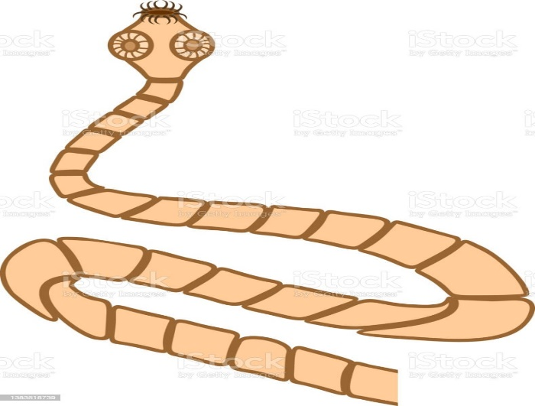 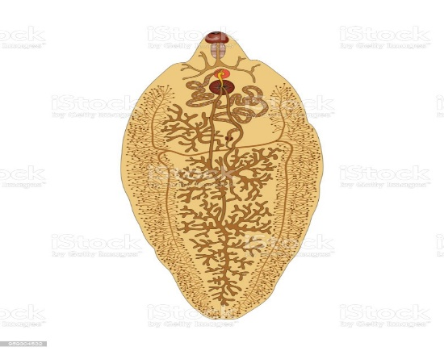
E F

- Identify the parasite labelled E and F (2marks)
………………………………………………….…………………………………………
………………………………………………….…………………………………………
…………………………………………………….………………………………………

- Name the organ where each of the parasites is commonly found (2marks)
- Parasite E
…………………………………………………….………………………………………
………………………………………………………….…………………………………

- Parasite F
…………………………………………………….………………………………………
………………………………………………………….…………………………………

- Name the intermediate host of the parasite labelled E (1mark)
………………………………………………….…………………………………………
………………………………………………….…………………………………………
- The diagram below shows a method of draining water logged soils. Study it and answer the questions that follow

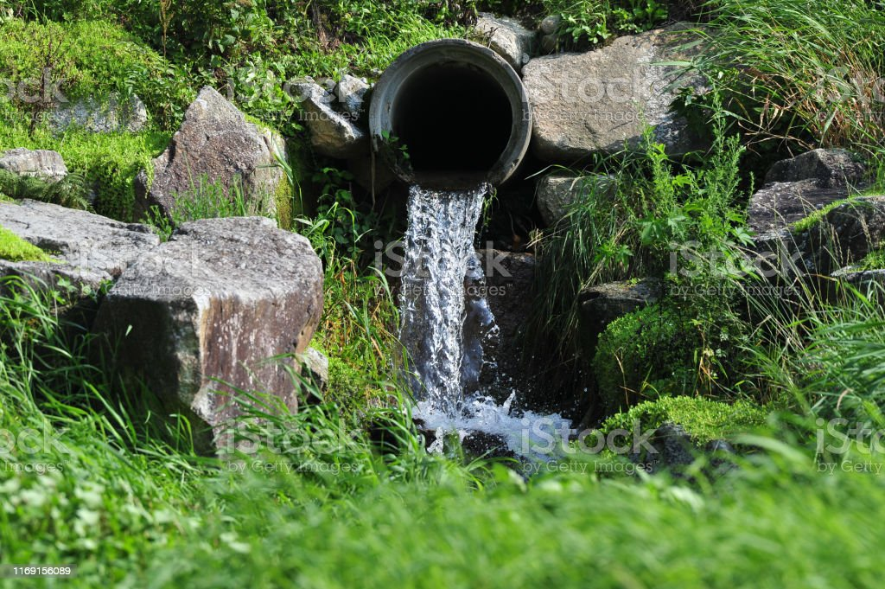

- Identify the method illustrated (1mark)
………………………………………………….…………………………………………
………………………………………………….…………………………………………
- Give two reasons for draining water logged soils (1mark)
………………………………………………….…………………………………………
………………………………………………….…………………………………………
…………………………………………………….………………………………………
- Apart from the method illustrated above name other three ways of draining water logged soils (3marks)
………………………………………………….…………………………………………
………………………………………………….…………………………………………
…………………………………………………….………………………………………
…………………………………………………….………………………………………
………………………………………………………….…………………………………

- The diagram below shows a pest and the damaged crop. study it and answer the questions that follow.

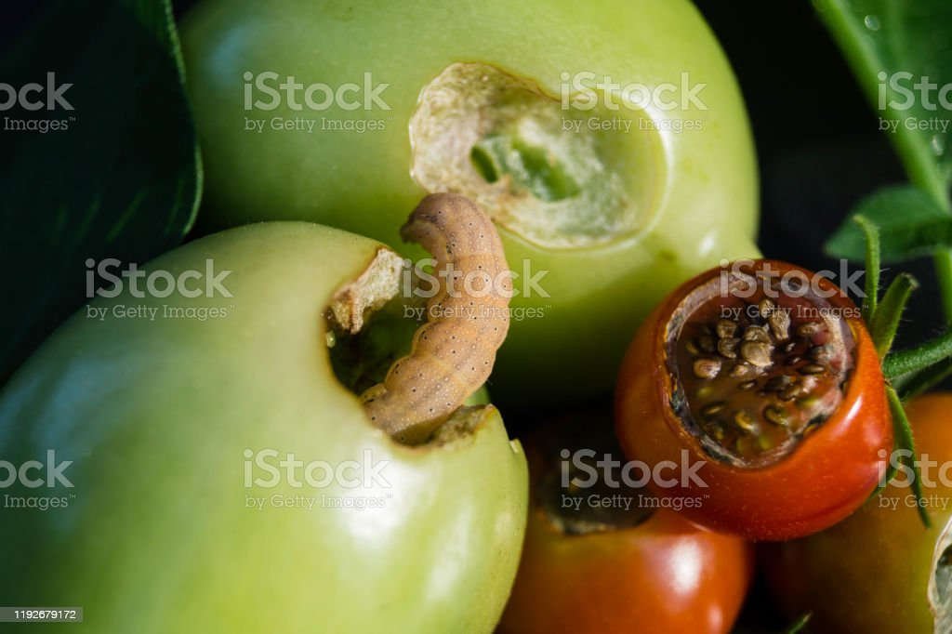

- Identify the crop pest illustrated above (1mark)
………………………………………………….…………………………………………
………………………………………………….…………………………………………

- What damage does the pest cause to the crop (1mark)
………………………………………………….…………………………………………
………………………………………………….…………………………………………
…………………………………………………….………………………………………

- State two ways of controlling the pest above (2marks)
………………………………………………….…………………………………………
………………………………………………….…………………………………………
…………………………………………………….………………………………………

- Other than the illustrated pest name other two pests that attack the crop shown (1mark)
………………………………………………….…………………………………………
………………………………………………….…………………………………………
…………………………………………………….………………………………………

- The diagram below shows vegetative propagation materials, use them to answer the questions that follow

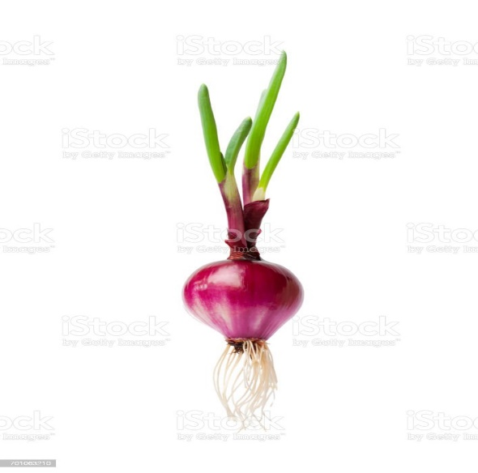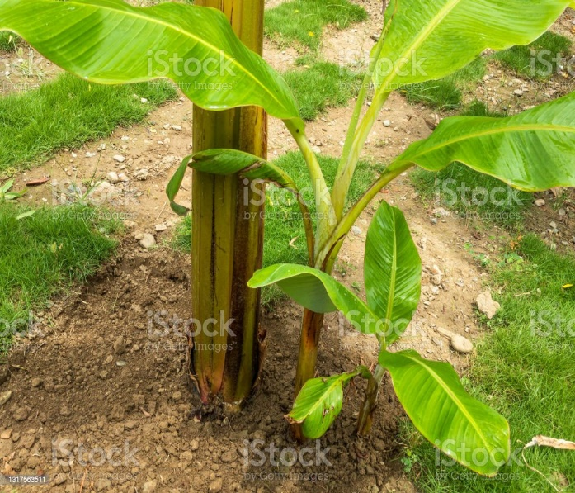

Q P

- Identify the vegetative propagation materials represented in diagrams Q and P (2marks)
………………………………………………….…………………………………………
………………………………………………….…………………………………………
…………………………………………………….………………………………………

- Name a crop that is propagated by the materials in the diagram Q and P (2marks)
………………………………………………….…………………………………………
………………………………………………….…………………………………………
…………………………………………………….………………………………………
- Other than the vegetative material labelled Q name other materials used to propagate onions (1mark)
………………………………………………….…………………………………………
………………………………………………….…………………………………………
…………………………………………………….………………………………………

SECTION C: (40 MARKS)
ANSWER ALL QUESTIONS IN THE SPACE PROVIDED

- Explain FIVE factors considered when siting a vegetable nursery bed (5marks)
………………………………………………….…………………………………………
………………………………………………….…………………………………………
…………………………………………………….………………………………………
…………………………………………………….………………………………………
………………………………………………………….…………………………………
………………………………………………….…………………………………………
………………………………………………….…………………………………………
…………………………………………………….………………………………………
…………………………………………………….………………………………………
………………………………………………….…………………………………………
………………………………………………….…………………………………………
…………………………………………………….………………………………………
…………………………………………………….………………………………………
………………………………………………………….…………………………………

- Explain how each of the following environmental factors influence crop production
- Temperature (5marks)
………………………………………………….…………………………………………
………………………………………………….…………………………………………
…………………………………………………….………………………………………
…………………………………………………….………………………………………
…………………………………………………….………………………………………
…………………………………………………….………………………………………
………………………………………………………….…………………………………
………………………………………………….…………………………………………
………………………………………………….…………………………………………
…………………………………………………….………………………………………
…………………………………………………….………………………………………
………………………………………………………….…………………………………

- Wind (5marks)
………………………………………………….…………………………………………
………………………………………………….…………………………………………
…………………………………………………….………………………………………
…………………………………………………….………………………………………
………………………………………………….…………………………………………
………………………………………………….…………………………………………
…………………………………………………….………………………………………
…………………………………………………….………………………………………
………………………………………………………….…………………………………

- Explain five advantages of mulching in crop production (5marks)
………………………………………………….…………………………………………
………………………………………………….…………………………………………
…………………………………………………….………………………………………
…………………………………………………….………………………………………
………………………………………………….…………………………………………
………………………………………………….…………………………………………
…………………………………………………….………………………………………
…………………………………………………….………………………………………
………………………………………………………….…………………………………

- Describe the production of tomatoes under the following sub headings
- Land preparation (3marks)
………………………………………………….…………………………………………
………………………………………………….…………………………………………
…………………………………………………….………………………………………
…………………………………………………….………………………………………
………………………………………………….…………………………………………
………………………………………………….…………………………………………
…………………………………………………….………………………………………
…………………………………………………….………………………………………
………………………………………………………….…………………………………

- Transplanting (7marks)
………………………………………………….…………………………………………
………………………………………………….…………………………………………
…………………………………………………….………………………………………
…………………………………………………….………………………………………
………………………………………………….…………………………………………
………………………………………………….…………………………………………
…………………………………………………….………………………………………
…………………………………………………….………………………………………
………………………………………………………….…………………………………
………………………………………………….…………………………………………
………………………………………………….…………………………………………
…………………………………………………….………………………………………
…………………………………………………….………………………………………
………………………………………………………….…………………………………

- Field management practices (7marks)
………………………………………………….…………………………………………
………………………………………………….…………………………………………
…………………………………………………….………………………………………
…………………………………………………….………………………………………
………………………………………………….…………………………………………
………………………………………………….…………………………………………
…………………………………………………….………………………………………
…………………………………………………….………………………………………
………………………………………………….…………………………………………
………………………………………………….…………………………………………
…………………………………………………….………………………………………
…………………………………………………….………………………………………
………………………………………………………….…………………………………

- Diseases that attack tomatoes (3marks)
………………………………………………….…………………………………………
………………………………………………….…………………………………………
…………………………………………………….………………………………………
…………………………………………………….………………………………………

