TERM 2 - 2023
AGRICULTURE
PAPER 2
FORM FOUR (4)
Time: 2 Hours
Name: …………………………………………………………. Adm No: ……………….
School: ……………………………………………………….. Class: …………………..
Signature: …………………………………………………….. Date: …………………...

INSTRUCTIONS TO CANDIDATES:
- Write your name and index number in the spaces provided.
- Sign and write the date in the spaces provided above
- This paper consists of three section A, B and C
- Answer all the questions in section A and B
- Answer any two questions in section C.
- Answers should be written in the spaces provided in this booklet.

For Examiner’s Use Only:
SECTION | QUESTIONS | MAXIMUM SCORE | CANDIDATES SCORE
A |  | 30
B |  | 20
C |  | 20
 |  | 20
 | TOTAL | 90

This paper consists of 9 printed pages. Candidates should check to ascertain that all papers are printed as indicated and that no questions are missing

SECTION A (30MARKS) Answer all questions in this section

- Name four dairy cattle breeds reared in Kenya. (2mks)
………………………………………………………………………………………………………………………………………………………………………………………………………………………………………………………………………………………………………………………………………………………………………………………………………………………………

2. Give four reasons for castrating male goats. (2mks)
………………………………………………………………………………………………………………………………………………………………………………………………………………………………………………………………………………………………………………………………………………………………………………………………………………………………

3. Give two parasites of cattle which are also disease vectors (1mk)
………………………………………………………………………………………………………………………………………………………………………………………………………………

4. List two possible causes of over heating in a tractor engine (1mk)
………………………………………………………………………………………………………………………………………………………………………………………………………………

5. Mention the use of the following tools. (2mks)
i) Dibber………………………………………………………………………………………….
ii) Spokeshave …………………………………………………………………………………...
iii) Tinsnips……………………………………………………………………………………….
iv) Burdizzo ………………………………………………………………………………………

6. State the importance of the following in livestock nutrition:
i) Water (1mk)
……………………………………………………………………………………………………… ……………………………………………………………………………………………………
ii) Vitamin A (1mk)
……………………………………………………………………………………………………… ………………………………………………………………………………………………………

7. State four management practices that should be carried on a fish pond in order to obtain maximum fish production. (2mks) ………………………………………………………………………………………………………………………………………………………………………………………………………………………………………………………………………………………………………………………………………………………………………………………………………………………………………………………………………………………………………………………………………
8.a) State two reasons for washing the udder of a cow with warm water before milking. (1mk)

….…………………………………………………………………………………………………………………………………………………………………………………………………………….

b) Name the hormone that causes each of the following in dairy cows:.
i) milk let down. …………………………………………………………………… (1mk)
ii) lactogenesis …………………………………………………………………… (1mk)

9. Differentiate between ‘breed’ of animal and ‘type’ of animal. (2mks)
………………………………………………………………………………………………………………………………………………………………………………………………………………

10. Name two livestock diseases that are spread through natural mating. (1mk)
………………………………………………………………………………………………………………………………………………………………………………………………………………

11. Name the compartment of the ruminant stomach where microbial digestion takes place. (1mk)
………………………………………………………………………………………………………

12. List four precautions that should be taken when using workshop tools and equipment. (2mks)
…………………………………………………………………………………………………………………………………………………………………………………………………………………………………………………………………………………………………………………………………………………………………………………………………………………………………………………………………………………………………………………………………………………..

13. State four methods of increasing the depth of penetration of a disc harrow. (2mks)
…………………………………………………………………………………………………………………………………………………………………………………………………………………………………………………………………………………………………………………………………………………………………………………………………………………………………………………………………………………………………………………………………………………...

14. List four factors considered when formulating livestock ration. (2mks)
…………………………………………………………………………………………………………………………………………………………………………………………………………………………………………………………………………………………………………………………………………………………………………………………………………………………………………

- State four conditions that necessitate the handling of farm animals (2mks)
…………………………………………………………………………………………………………………………………………………………………………………………………………………………………………………………………………………………………………………………………………………………………………………………………………………………………………

16. State four abnormalities of eggs that can be detected during egg candling. (2mks)
…………………………………………………………………………………………………………………………………………………………………………………………………………………………………………………………………………………………………………………………………………………………………………………………………………………………………………

17. List two events occur during induction stroke in a four stroke engine .(1mk)
……………………………………………………………………………………………………………………………………………………………………………………………………………………………………………………………………………………………………………………………………………………………………………………………………………………………………….…
SECTION B (20MARKS)
Answer all the questions in this section.
18.i) the diagram below shows a tractor drawn implement.
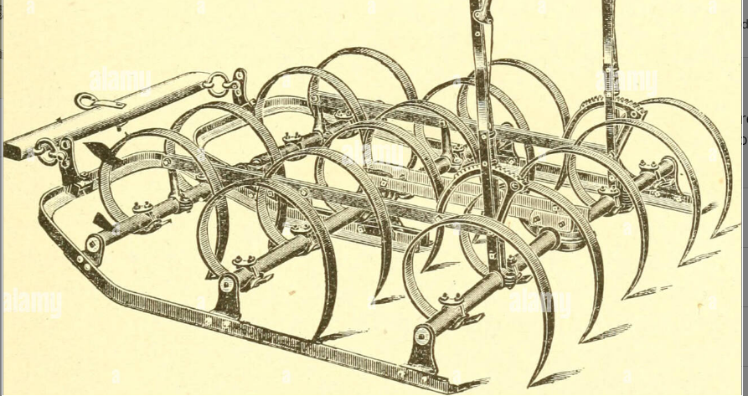

a) Name the implement…………………………………………………………………. (1mk)

b) Give two uses of the implement above (2mks

………………………………………………………………………………………………………………………………………………………………………………………………………………

c) State three maintenance practices carried out on the above implement. (3mks)
………………………………………………………………………………………………………………………………………………………………………………………………………………………………………………………………………………………………………………………

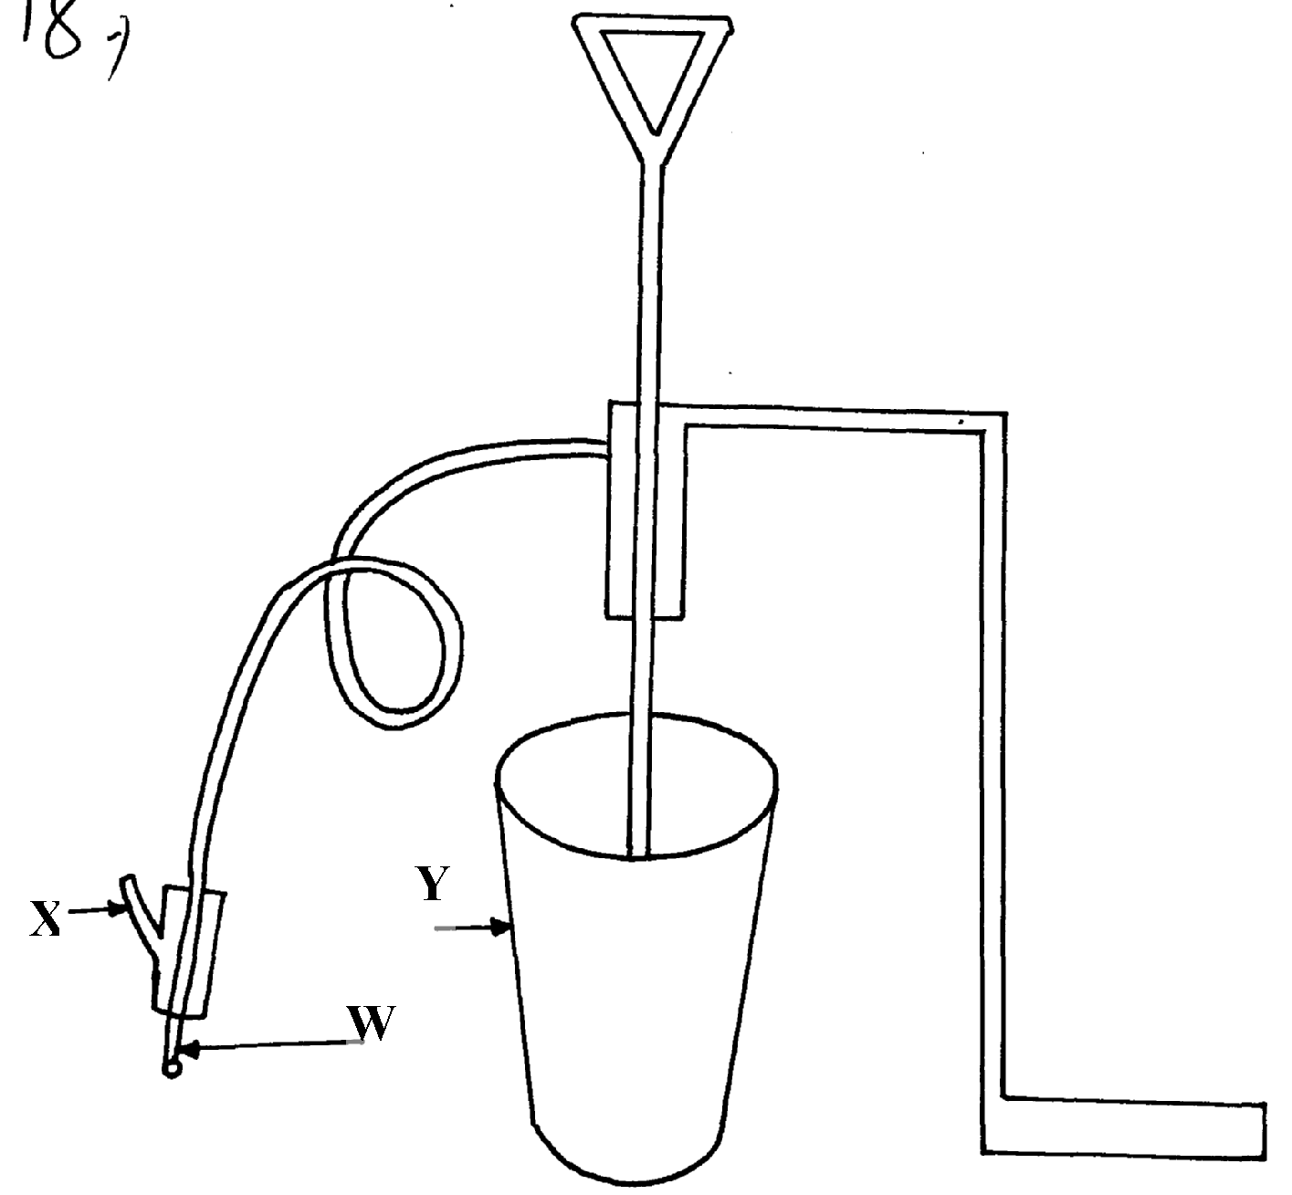
ii) Below is an illustration of a farm equipment. Study it and answer questions that follow

a) Identify the farm equipment illustrated above (1mk)
……………………………………………………………………………………………………

b) What is the use of the equipment (1mk)
………………………………………………………………………………………………………………………………………………………………………………………………………………

c) Name the parts labelled W, X and Y (3mks)
W……………………………………………………………………………………...
X……………………………………………………………………………………...
Y……………………………………………………………………………………..

d) What is the function of Y on the equipment (1mk)
………………………………………………………………………………………………………………………………………………………………………………………………………………

- Identify the above diagram (1mk)
…………………………………………………………………

ii) Name the parts labelled A and B (2mks)
A………………………………………………………………………………
B……………………………………………………..…………………………

20. A ration containing 18% protein is to be made from maize and sunflower cake. Given
that maize contains 7% protein, and sunflower seed cake 34% protein. Use Pearson square
method to calculate the value of feedstuffs to be used to prepare 100kgs of the feed (3mks)

ii) A part from Pearson square method, name two other methods that can be used to formulate
feed ration (2mks)
………………………………………………………………………………………………………………………………………………………………………………………………………………

10SECTION C (40MARKS)
Answer any two questions in this section in the spaces provided after question 23

- a) Name four notifiable diseases in livestock (4mks)
b) Discuss four ways in which livestock disease are spread in the farm (4mks)
c) Describe the methods of controlling livestock disease giving an example of different disease
in each case (12mks)

- a) Describe the management of day old chicks in a deep litter system from preparation of brooder up to eight (8) weeks old (10mks)
(b) Describe Coccidiosis disease under the following sub- headings.
- Animals attacked (2mks)
- Causal organism (1mk)
- Symptoms (4mks)
- Control measures (3mks)
- a) Explain the factors that influence the power output of farm animals (8mks)
b) State the importance of farm fences (12mks)

