TERM 2 - 2023
ART AND DESIGN
FORM ONE (1)
Time: 2 Hours

NAME....................................................................... ADMIN………………………………
DATE ………………………………CANDIDATES SIGNATURE ………..……………

Instructions
- Write your name and Admin number in the spaces provided
- This paper consists of TWO sections A, and B.
- Answer ALL the questions in both sections.
- Answers to all questions must be written in the spaces provided.

Question |  | Candidate’s score | Max Score.
SECTION A |  |  | 40mks
B |  |  | 60mks
 | TOTAL SCORE | 100 mks

SECTION A [40 Marks] Answer all questions in this section.
1 a (i) Differentiate between drawing media and drawing surfaces [2mks]
……………………………………………………………………………………………………………………………………………………………………………………………………………………………………………………………………………………………………………………………………………………………………………………………………………………………………………………………………………………………………………………………………………………………………………………………………………………………
[ii] Give two examples of each of the media and surfaces mentioned in [i] above [2mks] ……………………………………………………………………………………………………………………………………………………………………………………………………………………………………………………………………………………………………………………………………
[iii] State any three types of drawing media that are not commercially obtained [3mks] ………………………………………………………………………………………………………………………………………………………………………………………………………………………………………………………………………………………………………………………………………………………………………………………………………………………………………………………………………………………………………
b (i) Explain three approaches to drawing [6mks] ……………………………………………………………………………………………………………………………………………………………………………………………………………………………………………………………………………………………………………………………………………………………………………………………………………………………………………………………………………………………………..
[ii] Define painting[2mks] ………………………………………………………………………………………………………………………………………………………………………………………………………………………………………………………………………………………………………………
2[a].Study the artwork bellow and use it to answer the questions below: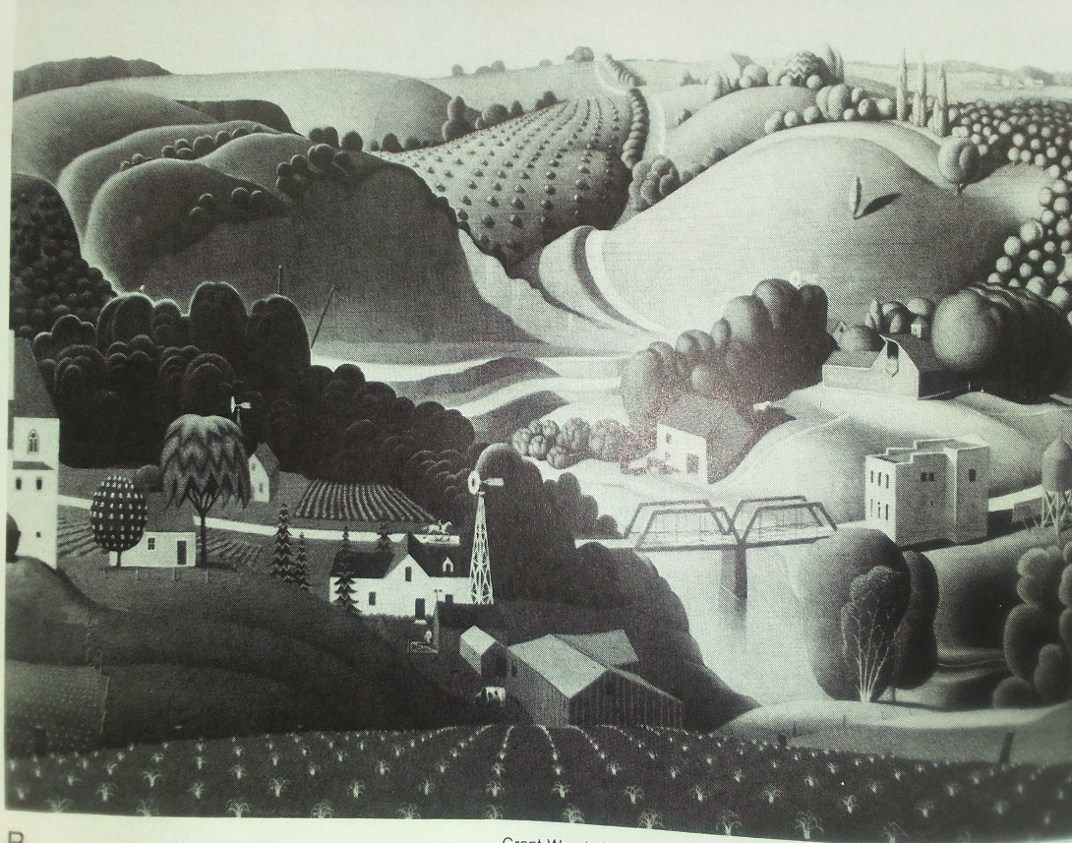
[i] Name one most outstanding element and principle in the work above.
Principle………………………………………………………………………………...(1mk)
Element ……………………………………………………………………………… (1mk)
[ii]Name the most outstanding type of shapes in the drawing
……………..…………………………………………………………………………………. (1mk)
[iii] Identify and label the horizon on the drawing above (1mk)
[iv] Using the same drawing above, name and label three parts of a land scape (3mks)
……………………………………………………………………………………………………
……………………………………………………………………………………………………
……………………………………………………………………………………………………
[b]Explain the following terms as used in texture: [2mks]
[i] Visual texture ……………………………………………………………………………………………………………………………………………………………………………………………………………………………………………………………………………………………………………………………………
[ii]Tactile texture ……………………………………………………………………………………………………………………………………………………………………………………………………………………………………………………………………………………………………………………………………
3[a] Name and explain three properties of colour [6mks] ………………………………………………………………………………………………………………………………………………………………………………………………………………………………………………………………………………………………………………………………………………………………………………………………………………………………………………………………………………………………………
[b]Name the resultant colours as a result of the following mixture [3mks]
[i] Red + Yellow …………………………………………………………………………………………………………………
[ii] Blue and Yellow …………………………………………………………………………………………………………….....
[iii] Red and orange ……..…………………………………………………………………………………………………………..
C what general term is used to describe the resultant colour in b[i]and [ii] above?
b[i] above……………………………………………………………………………………………….. [1mk]
b[iii]above…………………………………………………………………………………………………[1mk]

4 [a] what do you understand by the term texture [2mks] ……………………………………………………………………………………………………………………………………………………………………………………………………………………………………………………………………………………………………………………………………
[ii] Give any four techniques of shading that creates texture on a surface in drawing [4mks] …………………………………………………………………… …………………………………………………………………………………… …………………………………………………………………… …………………………………………………………………………………..

SECTION B [60 marks] Answer All questions in this section]
5. [a] Name any three roles of painting.(3mks)
…………………………………………………………………………………………………………………………..
…………………………………………………………………………………………………………………………..
…………………………………………………………………………………………………………………………….
[b] Explain how tone /value is achieved in a drawing [2mks] ……………………………………………………………………………………………………………………………………………………………………………………………………………………………………………………………………………………………………………………………………
[c]i Name and explain any two types of perspective as a technique of drawing [4mks] ……………………………………………………………………………………………………………………………………………………………………………………………………………………………………………………………………………………………………………………………………
[ii]Using relevant drawings, illustrate the types of perspective mentioned in c [i] above [6mks]

6. [a] Give the Importances of art and design to
[i] An individual (3mks) ……………………………………………………………………………………………………………………………………………………………………………………………………………………………………………………………………………………………………………………………………
…………………………………………………………………………………………………………………………………………………………………
(ii) To the society (3mks] ……………………………………………………………………………………………………………………………………………………………………………………………………………………………………………………………………………………………………………………………………
…………………………………………………………………………………………………………………………………………………………………
[b] Name any 5 career opportunities in art and design (5mks) …………………………………………………………………………………………………………………………………………………………………………………………………………………………………………………………………………………………………………………………………………………………………………………………………………………………………………………………………………………………………………………………………………………………………………………………………………………………………………………………………………
………………………………………………………………………………………………………………………………………………………………..
7[a] Define dominance [2mk] ……………………………………………………………………………………………………………………………………………………………………………………………………………………………………………………………………………………………………………………………………
[b] Name any two ways of creating dominance in a composition [2mks] ……………………………………………………………………………………………………………………………………………………………………………………………………………………………………………………………………………………………………………………………………
c[i]Differentiate between a dot and a line [2ms] ……………………………………………………………………………………………………………………………………………………………………………………………………………………………………………………………………………………………………………………………………
…………………………………………………………………………………………………………………………………………………………………
[ii] Name two uses of lines [2mks] ……………………………………………………………………………………………………………………………………………………………………………………………………………………………………………………………………………………………………………………………………
[iii] Mention any six characters of lines [3mks] ……………………………………………………………………. …………………………………………………………………… ……………………………………………………………………. …………………………………………………………………… ……………………………………………………………………. …………………………………………………………………… ……………………………………………………………………
8. Define and give origin of the word “Graphics” [2mks] ……………………………………………………………………………………………………………………………………………………………………………………………………………………………………………………………………………………………………………………………………
[ii]In a good calligraphic letters, rewrite the word ‘Calligraphy’ [4mks]

9. (a) Give any two was of achieving rhythm and movement (2mks)
………………………………………………………………………………………………………
……………………………………………………………………………………………………..
(b)Explain using illustrations the three types of balance under principles used in 2D art works [6mks] ……………………………………………………………………………………………………………………………………………………………………………………………………………………………………………………………………………………………………………………………………
…………………………………………………………………………………………………………………………………………………………………

10 [a] Using relevant letters as illustrations, differentiate between Ascender and descenders in lettering. [4mks]

[b] Using words of our choice, Illustrate and show the following parts in lettering Xh, and ½ Xh [3mks]

This is the last printed page.

