TERM 2 - 2023
ART AND DESIGN
FORM THREE (3)
Time: 2 Hours

Name: …………………………………………………………. Adm No: ……………….
School: ……………………………………………………….. Class: ……………………
Signature: …………………………………………………….. Date: …………………...

Instructions
- Write your name and Admin number in the spaces provided
- This paper consists of THREE sections A, B and C.
- Answer ALL the questions in section A and B.
- Answer any ONE question in section C.
- Answers to all questions must be written in the spaces provided.
- Where drawings and diagrams are appropriate, they should be included within the context of your answers.
- The candidates should ensure that the question paper has all printed pages and no missing questions.
Question |  | Candidate’s score | Max Score.
SECTION A |  |  | 25mks
B |  |  | 30mks
C |  |  | 15Mks
 | TOTAL SCORE | 70 mks

SECTION A -25 marks
[ANSWER ALL QUESTIONS FROM THIS SECTION]
1[a] Identify the most outstanding element and principle used in the illustration below (2mk) 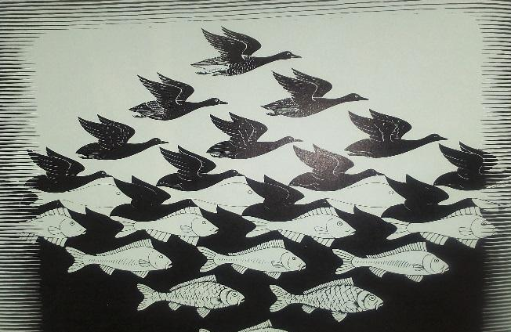
Element……………………………………………………..
Principal……………………………………………………
[b] Explain the origin of the term Graphics. [1mk]
………………………………………………………………………………………………………………………………………………………………………………………………………………………………..
[c](i) Differentiate monochromatic and achromatic colours (2mks)
……………………………………………………………………………………………………………………………………………………………………………………………………………………………………………………………………………………………………………………………………………….
(ii) Give examples of each of the colours above (2mks) ………………………………………………………………………………………………………………………………………………………………………………………………………………………………

[d]Describe symmetrical balance [2mks] ………………………………………………………………………………………………………………………………………………………………………………………………………………………………

[e]Using a proper illustration, show the levels of a composition in a landscape (3mks)

[f]Explain the term slip trailing as used in pottery [1mk] ………………………………………………………………………………………………………………………………………………………………………………………………………………………………

[g]Why do dyes run after the tie and dye process? [2mks] ………………………………………………………………………………………………………………………………………………………………………………………………………………………………

[h] Identify four basic elements of 3 dimensional art work [2mks]
………………………………………………………………………………………………………………………………………………………………………………………………………………………………………………………………………………………………………………………………………………………………………………………………………………………………………………………………………………………………………………………………………

[I]Giving alternative name and using a relevant illustration, explain the meaning of the term “informal balance” [3mks] ………………………………………………………………………………………………………………………………………………………………………………………………………………………………

[j]What is the advantage of using a double container in batik (2mks?)
…………………………………………………………………………………………………………………………………………………………………………………………………………………………………………………………………………………………………………………………………..
[k]Differentiate Dabbing from washout [2mks] ………………………………………………………………………………………………………………………………………………………………………………………………………………………………………………………………………………………………………………………………………………………………………………………………………………………………………………………………

[L]Identify and name two main types of perspective as used in art and design. [2mks] ……………………………………………………………………………………………………………………………………………………………………………………………………………………………

SECTION B (30 marks)
Answer all questions in this section
2[a] Explain the two weaving effects and the causes [4mks] ………………………………………………………………………………………………………………………………………………………………………………………………………………………………
………………………………………………………………………………………………………………………………………………………………………………………………………………………………

[b]Differentiate a pick from a salvage [2mks] ………………………………………………………………………………………………………………………………………………………………………………………………………………………………
………………………………………………………………………………………………………………
3[a] Name two most preferred natural fibers for fabric tie and dye as a fabric decoration technique [2mks] ………………………………………………………………………………………………………………………………………………………………………………………………………………………………

[b] Apart from the technique above, give any other six fabric decoration techniques [3mks]
………………………………………………………………………………………………………………………………………………………………………………………………………………………………………………………………………………………………………………………………………………………………………………………………………………………………………………………………
4[a] Define photo montage [1mk] ………………………………………………………………………………………………………………………………………………………………………………………………………………………………

[b]Give four characteristics of mosaic art works [2mks] ………………………………………………………………………………………………………………………………………………………………………………………………………………………………………………………………………………………………………………………………………………………………………………………………………………………………………………………………

5[a] using the illustration below,
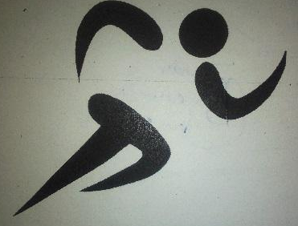
[i] Identify the graphic symbol [1mk]

[ii]The function [1mk] ………………………………………………………………………………………………………………………………………………………………………………………………………………………………
[iii]Give any other two categories of symbols apart from the one above [2mks] ………………………………………………………………………………………………………………………………………………………………………………………………………………………………

[6]What is the difference between a surface and tool as used in art? [1mk] ………………………………………………………………………………………………………………………………………………………………………………………………………………………………………………………………………………………………………………………………………………………………………………………………………………………………………………………………

[b]Why is paper preferred as suitable surface for painting? [2mks] ………………………………………………………………………………………………………………………………………………………………………………………………………………………………

[c]Differentiate between a pallet and a pellet knife [2mks] ………………………………………………………………………………………………………………………………………………………………………………………………………………………………

7. Giving two examples, define a fixative as used in fabric decoration [3mks] ………………………………………………………………………………………………………………………………………………………………………………………………………………………………
[b] What are resist methods of fabric decoration? Give any three examples [4mks] ………………………………………………………………………………………………………………………………………………………………………………………………………………………………

SECTION C- 15 marks [Answer only 0ne question]
8. Identify the tool being held in the left hand in the illustration bellow [2mks]
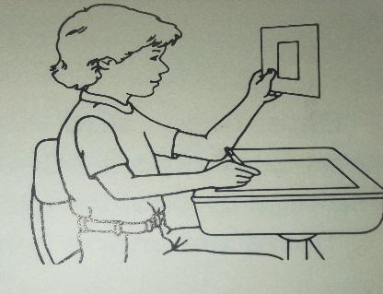
(ii) Explain how the tool named in 8(i) above is used [4ms]
[b]Using relevant illustrations, describe the three different eye levels in a drawing. [9mks]

9. Define a sculpture [2mks]
[b]Mention and describe different types of sculptures. [6mks]
[c]Explain the two main techniques of sculpturing [4mks]
[d]List the elements of a sculpture [3 mks]

10. Define weaving [2mks]
[b]Describe any three weaving techniques using illustrations [6mks]
[c]What is a loom? [1mk]
[c]ii) Name and explain an three types of looms [6mks]

…………………………………………………………………………………………………………………………………………………………………………………………………………………………………………………………………………………………………………………………………………………………………………………………………………………………………………………………………………………………………………………………………………………………………………………………………………………………………………………………………………………………………………………………………………………………………………………………………………………………………………………………………………………………………………………………………………………………………………………………………………………………………………………………………………………………………………………………………………………………………………………………………………………………………………………………………………………………………………………………………………………….
…………………………………………………………………………………………………………………………………………………………………………………………………………………………………………………………………………………………………………………………………………………………………………………………………………………………………………………………………………………………………………………………………………………………………………………………………………………………………………………………………………………………………………………………………………………………………………………………………………………………………………………………………………………………………………………………………………………………………………………………………………………………………………………………………………………………………………………………………………………………………………………………………………………………………………………………………………………………………………………………………………………….
…………………………………………………………………………………………………………………………………………………………………………………………………………………………………………………………………………………………………………………………………………………………………………………………………………………………………………………………………………………………………………………………………………………………………………………………………………………………………………………………………………………………………………………………………………………………………………………………………………………………………………………………………………………………………………………………………………………………………………………………………………………………………………………………………………………………………………………………………………………………………………………………………………………………………………………………………………………………………………………………………………………….
…………………………………………………………………………………………………………………………………………………………………………………………………………………………………………………………………………………………………………………………………………………………………………………………………………………………………………………………………………………………………………………………………………………………………………………………………………………………………………………………………………………………………………………………………………………………………………………………………………………………………………………………………………………………………………………………………………………………………………………………………………………………………………………………………………………………………………………………………………………………………………………………………………………………………………………………………………………………………………………………………………………….

