TERM 2 - 2023
BIOLOGY (231)
FORM ONE (1)
Time - 2 Hours

Name …………………………………………….……… Admission Number …………….
Candidate’s Signature ………………….…...……….. Class ……………………………

INSTRUCTIONS TO CANDIDATES
- Write your name and Adm number in the spaces provided above
- Sign and write the date of examination in the spaces provided.
- Answer all the questions in the spaces provided.
- Candidates should check the question paper to ascertain all the pages are printed as indicated and no questions are missing.

FOR EXAMINER’S USE ONLY

Question | Maximum score | Candidate’s score
1- 29 | 80

1.(a).Name the structures used for locomotion in each of the following organisms. (2mks)
i).Euglena.
………………………………………………………………………………………………………
ii).Paramecium.
………………………………………………………………………………………………………
(b)Blackjack (Bidens pilosa) belongs to the family compositae. What is the plant’s: (2mks).
i).Genus
………………………………………………………………………………………………………
ii).Species
………………………………………………………………………………………………………
2. Study the diagram of a cell below and answer the questions that follow.

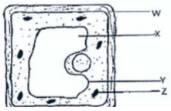
- What chemical material is part W composed of? (1mk)

………………………………………………………………………………………….
- Label on the diagram the part of the cell that controls all the cell activities (1mk)

………………………………………………………………………………………….

- Identify the parts of cell labeled Z and Y. (2mks)

Z…………………………………………………………………………………………

Y…………………………………………………………………………………………

- State two functions of the part labeled X. (2mks)

……………………………………………………………………………………………

…………………………………………………………………………………………
3. Study the diagrams of two cell organelles labeled A and B given below and answer the questions that follow.
A.

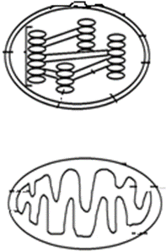 B.

- Label the following parts on the appropriate diagram:
Cristae
Matrix
Stroma

- State the function of organelle A. (1mk)

………………………………………………………………………………….

………………………………………………………………………………….

- State two way in which organelle B is suited for its function. (2mks)
……………………………………………………………………………………………………………………………………………..
………………………………………………………………………………………………………………………………………………

4. Name the parts of the microscope that determines the following; (2mks)
(a) Resolving power of a microscope
……………………………………………………………………………………………………………………………………………………………..
(b) Magnification power of a microscope
……………………………………………………………………………………………………………………………………………………………..
5. Give a reason for the following during preparation of temporary slides in microscopy.
(a) Use of stains (1mk)
………………………………………………………………………………………………………………………………………………………….
…………………………………………………………………………………………………………………………………………………………..

(b) Lowering of the cover slip gently onto the microscope slide (1mk)
…………………………………………………………………………………………………………………………………………………………..
…………………………………………………………………………………………………………………………………………………………..
(d)Use of blotting paper (1mk)
…………………………………………………………………………………………………………………………………………………………..
…………………………………………………………………………………………………………………………………………………………..

6. A form one student viewed a specimen under the eye piece lens of X10 and objective lens of X45. Calculate the total magnification of the specimen. (show your working) (3mks)

7. Below is a diagram of a specialized cell in plants under a light microscope.

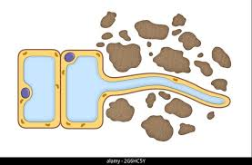
- Identify the cell. (1mk)

……………………………………………………………………………………………………………………………………………………
- Give one characteristic that adapt the cell to its function (1mk)

…………………………………………………………………………………………………………………………………………………..
…………………………………………………………………………………………………………………………………………………..
8. The graph below shows the relationship between cell size and surface area to volume ratio of different cells.
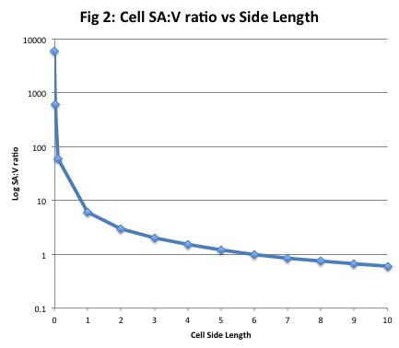
- (i) State the relationship between the surface area and volume ratio of the cells (2mks)

…………………………………………………………………………………………….

……………………………………………………………………………………………………………………………………………….
- Explain how the relationship stated above increase the rate of diffusion (2mks)

………………………………………………………………………………………………………………………………………………….
………………………………………………………………………………………………………………………………………………….
9. A group of students observed 8 cells across the diameter of the field of view of a light microscope. Work out the actual diameter of one cell given that the diameter of the field of view was 5mm. Give your answer in micrometers. (3mks)

10. Three cylinders of equal length were obtained from peeled raw pawpaw. One was placed in Solution Q1, another Cylinder in Q2 and the third one was left in the open. After 15 minutes, the three cylinders were measured and recorded as shown in the table below
Cylinder placed in: | Initial Length | Final Length
Solution Q1 | 30mm | 33mm
Solution Q2 | 30mm | 27mm
The open | 30mm | 30mm

- Determine the percentage change in length of the cylinders placed in Q1 (3mks)

- Account for change in length observed in the cylinder placed in solution Q2 (2mks)

…………………………………………………………………………………………….

……………………………………………………………………………………………

- Why was one of the paw paw cylinders placed in the open? (1mk)

………………………………………………………………………………………………………………………………………………….
11. (a) Define the term Osmosis. (1mk)
………………………………………………………………………………………………………………………………………………………..
…………………………………………………………………………………………………………………………………………………………
- Why is osmosis known as a ‘special Diffusion” (1mk)

...........................................................................................................................................................
………………………………………………………………………………………………………………………………………………………….
12. The young one of a cross between a donkey and a horse is called a mule. Why is the mule sterile? (1mk)
……………………………………………………………………………………………………………………………………………………………

13. State the functions of the following parts of a microscope (2mks)
(a) Condenser ………………………………………………………………………………………………………………………………
(b) Diaphragm …………………………………………………………………………………………………………………………….
14. Name two cells of a leaf that undertake photosynthesis. (2mks)
…………………………………………………………………………………………………………………………………………………………
………………………………………………………………………………………………………………………………………………………..
15. Differentiate between Plasmolysis and Haemolysis. (2mks)
…………………………………………………………………………………………………………………………………………………………
………………………………………………………………………………………………………………………………………………………..
16. Name the tissue in animals responsible for the following functions. (2mks)

(a) Connect and hold tissues and organs together……………………………………………………………………………….

(b) Line and protect internal and external surfaces of organs……………………………………………………………….

17. (a) Define the term Diffusion. (1mks)
……………………………………………………………………………………………………………………………………………………….
(b) Give one factors that increase the rate of diffusion. (1mk)
……………………………………………………………………………………………………………………………………………………..
……………………………………………………………………………………………………………………………………………………….
……………………………………………………………………………………………………………………………………………………….
……………………………………………………………………………………………………………………………………………………….
18. The diagram below is a structure found in cells.

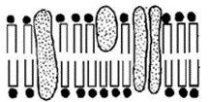
- Label on the diagram the following:
Pore
Protein molecule

- State two properties of the above structure. (2mks)

…………………………………………………………………………………………………………………………………………………
………………………………………………………………………………………………………………………………………………….

19. Identify the functions of the following specialized cells in living systems (3mks)

(a)
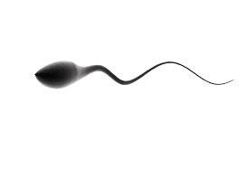 ………………………………………………………………………………………………..………………………..

(b)
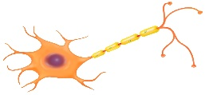………………………………………………………………………………………………………………………………
(c)
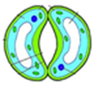 ………………………………………………………………………………………………
20. (a) State two ways the leaf veins of a leaf are important in the process of photosynthe (2mks)
………………………………………………………………………………………………………………………………………………………………
………………………………………………………………………………………………………………………………………………………………

(b)Give two reason why glucose has to be converted into starch immediately after photosynthesis. (2mks)
………………………………………………………………………………………………………………………………………………………………………………………………………………
21. Arrange the following from the most complex to the simplest. (1mk)
Organ, Organism, Cell, Organ system, Organelle, Tissue
……………………………………………………………………………………………………………………………………………………………..
22. The following is a cross section of a leaf of a plant.

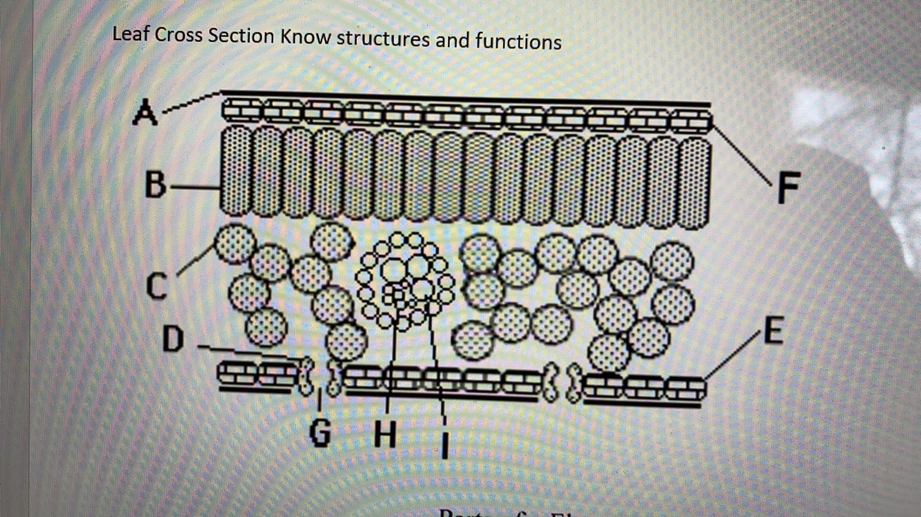

- Identify the cells labeled F and B. (2mks)

F …………………………………………………………………………………

B………...................................................................................................................
- What is the importance of region G to photosynthesis. (2mks)

…………………………………………………………………………………………….
……………………………………………………………………………………………..
- Give two reasons to show that region where cell B are, is more suited to photosynthesis than region where cell C are found. (2mks)

………………………………………………………………………………………………

……………………………………………………………………………………………..

……………………………………………………………………………………………..
- Identify the parts labeled A, E and I. (3mks)

- ……………………………………………………………………………………………

E …………………………………………………………………………………………………………………………………………………

- ……………………………………………………………………………………………

23. Identify and give the functions of the following laboratory equipment. (6mks)

Equipment | Name | Function
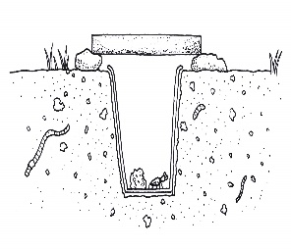

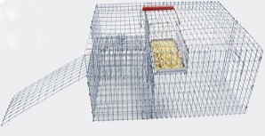

24. Study the diagram of nucleus of a cell below and answer the questions that follow.

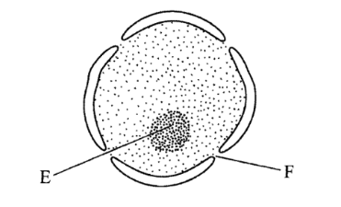
- Identify the parts labeled E and F. (2mks)

E …………………………………………………………………………………………………………………………………………………………….

F ………………………………………………………………………………………………………………………………………………………………

25. A student set up an experiment on a physiological process as shown below.

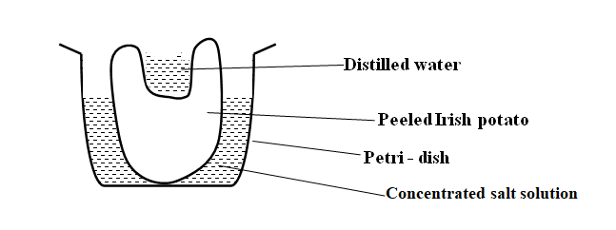
- Name the physiological process under investigation. (1mk)

……………………………………………………………………………………………………………………………………………………………

- Suggest the result at the end of the experiment. (1mk)

…………………………………………………………………………………………………………………………………………………………….
- With a reason, suggest the result of the experiment if the if the Irish potato was boiled. (1mk)

………………………………………………………………………………………….

………………………………………………………………………………………….
Reason. (2mks)

…………………………………………………………………………………………

…………………………………………………………………………………………

