TERM 2 - 2023
BIOLOGY – PAPER TWO (231/2)
FORM THREE (3)
Time - 2 Hours

Name …………………………………………….……… Admission Number …………….
Candidate’s Signature ………………….…...………... Class ……………………………

INSTRUCTIONS
- This paper has two sections: A and B.
- All Questions in Section A are compulsory.
- Question 6 is compulsory.
- Choose one question between questions 7 or 8.
- Write your answers in the spaces provided after each question.
- Wrong spelling of technical terms shall be penalized.

Section | Question | Max Score | Student’s Score
A | 1 | 8
 | 2 | 8
 | 3 | 8
 | 4 | 8
 | 5 | 8
B | 6 | 20
 | 7 or 8 | 20
TOTAL SCORE |  | 80

SECTION A (40 Marks)
- Form 2 students set out to study a physiological process by leaving set-ups A1 and B1 to stand for 30 minutes after which results were obtained as seen in A2 and B2 respectively.

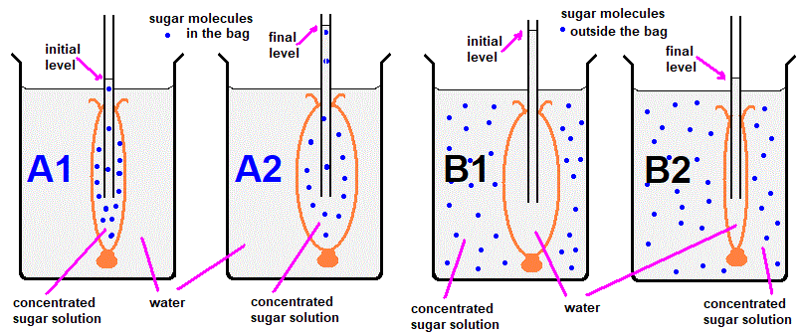

- i) Name the physiological process that was being investigated. (1 mark)
………………………………………………………………………………………………
ii) State two factors that affect the rate of the physiological process named in a (i). (2 marks)
……………………………………………………………………………………………………………………………………………………………………………………………………………………………………………….……………………………………………………………………..
- Account for the observations made in:
i) A2 (2 marks)
……………………………………………………………………………………………………………………………………………………………………………………………………
ii) B2 (2 marks)
……………………………………………………………………………………………………………………………………………………………………….……………………………
- How is the process being investigated important in ensuring support in seedlings?
(1 mark)
..…………………………………………………………………………………………………………
- The following diagram is a section of the alimentary canal and its associated organs. Use it to answer questions that follow.
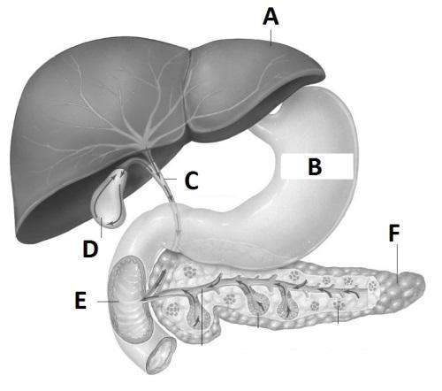
- Explain how organ A is important to the digestion processes in region E. (2 marks)
……………………………………………………………………………………………………………………………………………………………………………………………………
- State two functions of muscles in the region marked B. (2 marks)
………………………………………………………………………………………………………………………………………………………………………………………………………………………………………………………………………………………………………
- i) Name a hormone that is released by region E. (1 mark)
……………………………………………………………………………………………………………………………………………………………………………………………………
ii) What is the effect of the hormone named in c (i) on the organ labeled F? (1 mark)
……………………………………………………………………………………………………………………………………………………………………………………………………
- Explain how structure F is important in lowering sugar level in the blood. (2 marks)
………………………………………………………………………………………………………………………………………………………………………………………………………………………………………………………………………………………………………

- A feeding relationship in an ecosystem is as shown below.
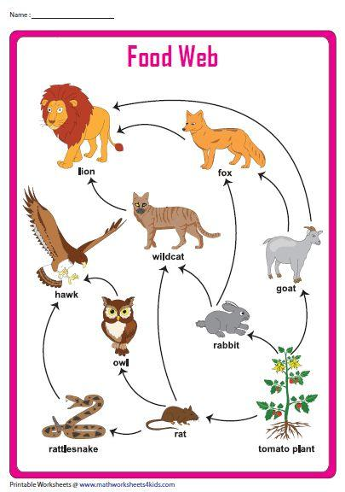
- From the diagram above, write a food chain with Lion at the third energy level (1 mark)
……………………………………………………………………………………………………………………………………………………………………………………………………
- Which two animals are the top predators from the relationship above? (2 marks)
……………………………………………………………………………………………………………………………………………………………………………………………………
- Name an important member of an ecosystem missing in the above diagram and state its role. (2 marks)
Name: ………………………………………………………………………………….
Role: ……………………………………………………………………………………
- Why is it important to have the population of tomatoes to be the highest in the ecosystem represented above? (1 mark)
……………………………………………………………………………………………………………………………………………………………………………………………………

- The following biomass was established for a few of organisms: Rat (100g/m²); Hawk (10g/m²); Tomatoes (150g/m²) and Owl (50g/m²). Construct a pyramid of biomass.
(2 marks)

- An illustration of the kidney nephron is shown below
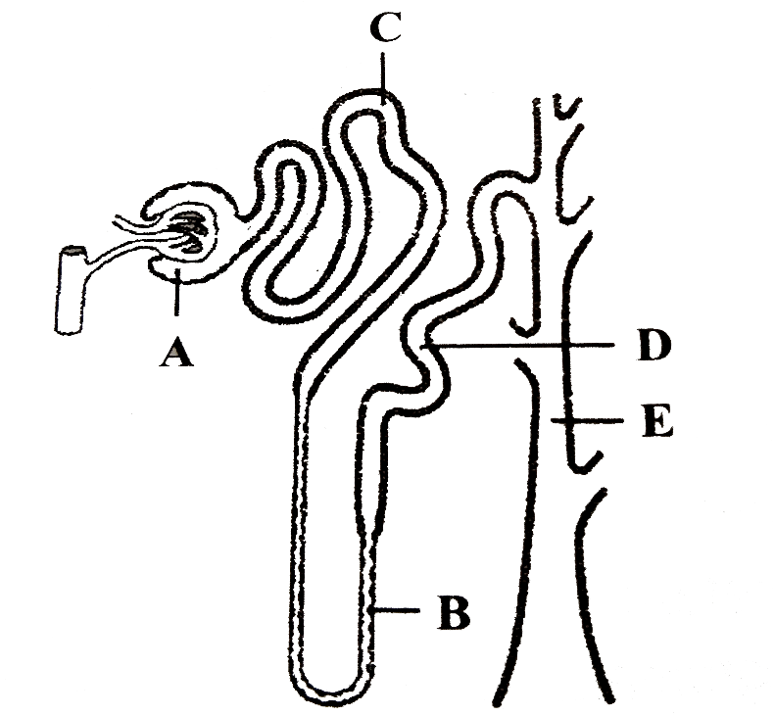
- Name the parts labeled: (2 marks)
i) A ………..……………………………………………………………………. …….
ii) C ………………………………………………………………………………….…
- i) Why is the amount of urea in the renal fluids higher in E than in B? (1 mark)
……………………………………………………………………………………………………………………………………………………………………………………………………
ii) How does the pituitary gland influence the function of part D when the osmotic pressure of blood is high above normal. (3 marks)
…………………………………………………………………………………………………………………………………………………………………………………………………………………………………………………………………………………………………………………………………………………………………………………………….……………

- State two ways in which surface area is increased in the structure labeled C for effective function (2 marks)
…………………………………………………………………………………………………………………………………………………………………………………………………………………………………………………………………………………………………………………………………………………………………………………………………………
- Use the leaf specimens provided below to answer the questions that follow
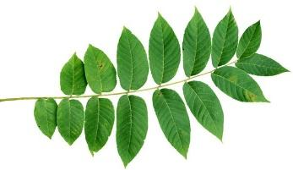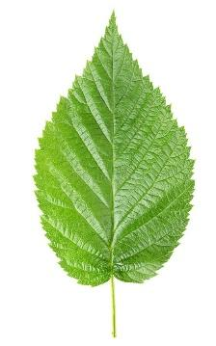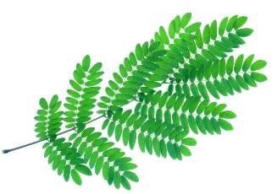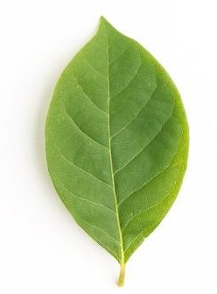
M N P Q R

- With a reason, name the class to which the plants with the leaves N and R belong:
i) N: Class …………………………………………………. …..….……. (1 mark)
Reason ……………………………………………….……….…… (1 mark)

ii) R: Class ………………………………………………...……..………. (1 mark)
Reason ……………………………………………...……………… (1 mark)

- Using the features and sequence given below, construct a dichotomous key to identify the leaf specimens above. (4 marks)
- Type of leaf
- Venation
- Leaf margin
- Type of Compound leaf
……………………………………………………………………………………………………………………………………………………………………………………………………………………………………………………………………………………………………………………………………………………………………………………………………………………………………………………………………………………………………………………………………………………………………………………………………………………………………………………………………………………………………………………………………………………………………………………………………………………

SECTION A (40 MARKS)
Question 6 is compulsory, Choose either Question 7 or Question 8.

- The table below shows the result of an experiment on an enzyme-controlled reaction.
Temperature (ºC) | Rate of Product Formation (Mg/unit Time)
5 | 2
10 | 5
15 | 8
20 | 11
25 | 15
30 | 21
35 | 30
40 | 37
45 | 34
50 | 28
55 | 21
60 | 11

- Name the enzyme formed if the following were the products from the reaction: (2 marks)
i) Fibrin …………………………….…………………………………………………..
ii) Glucose and Galactose ………………………………………………………………

- Determine the rate of product formation was at the following temperature: (2 marks)
i) 23ºC ………………………………………………………………………………….
ii) 48ºC …………………………………………………………………………………

- On the graph provided draw a graph of rate of product formation against change in temperature (6 marks)

- Account for the rate of product formation between the following temperatures:
i) 0 ºC - 5 ºC (2 marks)
………………………………………………………………………………………………………………………………………………………………………………………………………………………………………………………………………………………………………

ii) 50 ºC - 60 ºC (2 marks)
………………………………………………………………………………………………………………………………………………………………………………………………………………………………………………………………………………………………………

- State two factors that can increase the rate of product formation at 40 ºC temperature.
(2 marks)
………………………………………………………………………………………………………………………………………………………………………………………………………………………………………………………………………………………………………
- Explain four properties of enzymes that enhance efficiency in metabolic processes.
(4 marks)
……………………………………………………………………………………………………………………………………………………………………………………………………………………………………………………………………………………………………………………………………………………………………………………………………………………………………………………………………………………………………………

- a) Describe how various factors increase the rate of respiration in animals. (8 marks)
b) Describe how the dermis layer adapts the mammalian skin to its functions. (12 marks)

- a) Explain the economic importance of members of Kingdom Fungi. (14 marks)
b) Describe the various ways in which proteins are important to the functioning of the human body. (6 marks)
………………………………………………………………………………………………………………………………………………………………………………………………………………………………………………………………………………………………………………………………………………………………………………………………………………………………………………………………………………………………………………………………………………………………………………………………………………………………………………………………………………………………………………………………………………………………………………………………………………………………………………………………………………………………………………………………………………………………………………………………………………………………………………………………………………………………………………………………………………………………………………………………………………………………………………………………………………………………………………………………………………………………………………………………………………………………………………………………………………………………………………………………………………………………………………………………………………………………………………………………………………………………………………………………………………………………………………………………………………………………………………………………………………………………………………………………………………………………………………………………………………………………………………………………………………………………………………………………………………………………………………………………………………………………………………………………………………………………………………………………………………………………………………………………………………………………………………………………………………………………………………………………………………………………………………………………………………………………………………………………………………………………………………………………………………………………………………………………………………………………………………………………………………………………………………………………………………………………………………………………………………………………………………………………………………………………………………………………………………………………………………………………………………………………………………………………………………………………………………………………………………………………………………………………………………………………………………………………………………………………………………………………………………………………………………………………………………………………………………………………………………………………………………………………………………………………………………………………………………………………………………………………………………………………………………………………………………………………………………………………………………………………………………………………………………………………………………………………………………………………………………………………………………………………………………………………………………………………………………………………………………………………………………………………………………………………………………………………………………………………………………………………………………………………………………………………………………………………………………………………………………………………………………………………………………………………………………………………………………………………………………………………………………………………………………………………………………………………………………………………………………………………………………………………………………………………………………………………………………………………………………………………………………………………………………………………………………………………………………………………………………………………………………………………………………………………………………………………………………………………………………………………………………………………………………………………………………………………………………………………………………………………………………………………………………………………………………………………………………………………………………………………………………………………………………………………………………………………………………………………………………………………………………………………………………………………………………………………………………………………………………………………………………………………………………………………………………………………………………………………………………………………………………………………………………………………………………………………………………………………………………………………………………………………………………………………………………………………………………………………………………………………………………………………………………………………………………………………………………………………………………………………………………………………………………………………………………………………………………………………………………………………………………………………………………………………………………………………………………………………………………………………………………………………………………………………………………………………………………………………………………………………………

