TERM TWO EXAMINATIONS
COMPUTER STUDIES

FORM ONE
TIME – 2 ½ HOURS

Name: …………………………………………………………. Adm No: ……………….
School: ……………………………………………………….. Class: …………………..
Signature: …………………………………………………….. Date: …………………...

INSTRUCTION TO CANDIDATES
- Write your name and admission number in the spaces provided above
- Answer ALL questions
- All answers should be written in the spaces provided on the question paper

Answer all Questions

- Identify the input devices shown below (6marks)
Name: | Name: | Name:
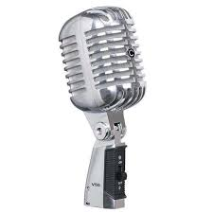 |  | 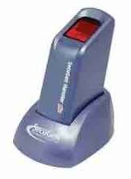
Name: | Name: | Name:
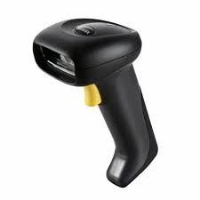 | 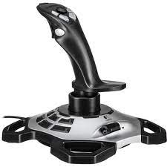 | 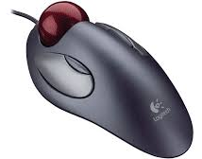
- Explain four types of Read-only Memory (4marks)
____________________________________________________________________________________________________________________________________________________________________________________________________________________________________________________________________________________________________________________________________________________________________________________________________________________________________________________________________________________________________________________________________________________________
__________________________________________________________________________________________
- List four logical operations carried out by the Arithmetic Logic Unit (4marks)

____________________________________________________________________________________________________________________________________________________________________________________
______________________________________________________________________________________________________________________________________________________________________________________________________________________________________________________________________________

- State five application areas of digital camera (5marks)

____________________________________________________________________________________________________________________________________________________________________________________________________________________________________________________________________________________________________________________________________________________________________________________________________________________________________________________________________________________________________________________________________________________________

- Name five types of keyboards (5marks)
____________________________________________________________________________________________________________________________________________________________________________________________________________________________________________________________________________________________________________________________________________________________________________________________________________________________________________________________________________________________________________________________________________________________

- Give five factors to consider when choosing an input device (5marks)
____________________________________________________________________________________________________________________________________________________________________________________________________________________________________________________________________________________________________________________________________________________________________________________________________________________________________________________________________________________________________________________________________________________________

- State five differences between Static RAM and Dynamic RAM (5marks)
____________________________________________________________________________________________________________________________________________________________________________________
__________________________________________________________________________________________________________________________________________________________________________________________________________________________________________________________________________________________________________________________________________________________________________________________________________________________________________________________________

- State five challenges experienced by Computers users who rely on Cathode Ray tube Monitors for display (5marks)
______________________________________________________________________________________________________________________________________________________________________________________________________________________________________________________________________________
____________________________________________________________________________________________________________________________________________________________________________________
- Briefly describe five reasons which make microcomputers suitable for personal computing work (5marks)
________________________________________________________________________________________________________________________________________________________________________________________________________________________________________________________________________________________________________________________________________________________________________________________________________________________________________________________________________________________________________________________________________________________________________________________________________________________________________________________________________________________________________________________________________
- Explain how computers are used in the following areas
- Universities (5marks)
____________________________________________________________________________________________________________________________________________________________________________________________________________________________________________________________________________________________________________________________________________________________________________________________________________________________________________________________________________________________________________________________________________________________
- Health facilities like Hospitals (5marks)
____________________________________________________________________________________________________________________________________________________________________________________________________________________________________________________________________________________________________________________________________________________________________________________________________________________________________________________________________________________________________________________________________________________________

- Name five activities that are likely to cause a repetitive strain injury (RSI) called eye strain. (4marks)
_____________________________________________________________________________________________________________________________________________________________________________________________________________________________________________________________________________________________________________________________________________________________________________________________________________________________________________________________
- State four differences between primary memory and secondary memory (4marks)
_____________________________________________________________________________________________________________________________________________________________________________________________________________________________________________________________________________________________________________________________________________________________________________________________________________________________________________________________
- Explain the following terms as used in computing
- POST (2marks)
____________________________________________________________________________________________________________________________________________________________________________________
- BIOS (2marks)
____________________________________________________________________________________________________________________________________________________________________________________
- Firmware(2marks)
__________________________________________________________________________________________________________________________________________________________________________________

- List five characteristics of the fifth generation computers (5marks)
______________________________________________________________________________________________________________________________________________________________________________________________________________________________________________________________________________________________________________________________________________________________________________________________________________________________________________________________________________________________________________________________________________________________________________________________________________________________________________________

- Name three examples of softcopy output devices (3marks)
________________________________________________________________________________________________________________________________________________________________________________________________________________________________________________________________________________________________________________________________________________________________________
- Kameno Construction Company intends to buy output devices they can use to produce road plans, maps, and invoices. State two output devices you would advise the company to buy (2marks)
______________________________________________________________________________________________________________________________________________________________________________________________________________________________________________________________________________
- Give a reason for each choice in (ii) above (2marks)
____________________________________________________________________________________________________________________________________________________________________________________
____________________________________________________________________________________________________________________________________________________________________________________
- Kimani bought a flash drive of 8GB to store his personal files. He used half of it to save audio files, a quarter to save video clips, and half of the remainder to keep application programs
- Work out the space used to store application programs in Megabytes (3marks)
__________________________________________________________________________________________________________________________________________________________________________________________________________________________________________________________________________________________________________________________________________________________________________________________________________________________________________________________________
- Calculate the free space in flash (3marks)
_____________________________________________________________________________________________________________________________________________________________________________________________________________________________________________________________________________________________________________________________________________________________________________________________________________________________________________________________

- On a computer, there are various ports that have various symbols which indicate where the various peripheral devices are connected. Identify the following symbols. (4marks)
Symbol | Name | Symbol | Name

- Karema and Justine wanted to acquire computers for their personal use. Karema bought a laptop at 70,000/= while Justine acquired a Desktop at 25,000. Suggest four factors that are likely to make Karema’s computer to be more expensive (4marks)
____________________________________________________________________________________________________________________________________________________________________________________________________________________________________________________________________________________________________________________________________________________________________________________________________________________________________________________________________________________________________________________________________________________________
- State the unit of measure for the following quantities in a computer.
- Monitor size_______________________________________________________
- Processor speed____________________________________________________
- Hard disk capacity ____________________________________________
- Name three devices required to be on a computer to enable it to support multimedia functions. 3mks ________________________________________________________________________________________________________________________________________________________________________________________________________________________________________________________________________________________________________________________________________________________________________

