TERM 2 - 2023
DRAWING AND DESIGN

FORM THREE (3)
Time: 2½ Hours
Name: …………………………………………………………. Adm No: ……………….
School: ……………………………………………………….. Class: …………………..
Signature: …………………………………………………….. Date: …………………...

Instructions to Candidates

(a) You should have the following materials:

Drawing instruments.
3 sheets of drawing paper size A3;
(b) This paper consists of three sections; A, B and C.
(c) Answer all the questions in sections A and B and any two questions from section C.
(d) Questions in Section A must be answered in the spaces provided.
(e) Questions in Section B and C should be answered on the A3 sheets of drawing paper provided.
(f) All dimensions are in millimeters unless otherwise stated.
(g) Candidates may be penalized for not following the instructions given in this paper.
(h) This paper consists of 8 printed pages.
(i) Candidates should check the question paper to ascertain that all the pages are printed as
Indicated and that no questions are missing.
(j) Candidates should answer the questions in English.

FOR EXAMINERS USE ONLY
1 | 2 | 3 | 4 | 5 | 6 | 7 | 8 | 9 | 10 | 11 | 12 | 13 | TOTAL

SECTION A (50 Marks)
Answer all the questions in this section in the spaces provided.
1 (a) Briefly explain why it is advisable to manufacture set squares and protractors using transparent plastics. (2mk)

(b) State two disadvantages of using tape to mount drawing paper on drawing board (2mk)

2 (a) Distinguish between a sector and a quadrant in a circle. (2mks)

- State The main function of a draughtsman. (2mks)

3 (a) State six areas to be investigated in research and analysis in design process (3mks)
(b) Define each of the following properties of materials: (4mks)
- Ductility.

- Fusibility.

4 Identify the following conventions: (2mks)
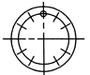……………… ………………………………………………….
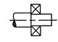…………… …………………………………………………
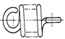………… ………………………………………………………
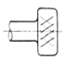………………… ………………………………………..……….

5 A piece of wire 165 mm long is bent to form a regular heptagon. Construct this heptagon. And measure the length of the sides. (7mks)

6 (a) Figure 2 shows a diagonal scale of 1: 10 to measure to a maximum length of 1m with an accuracy of 0.005m. Give the following readings. (3mks)
- A………………………………………………………………………………………….

- B…………………………………………………………………………………………..

- C…………………………………………………………………………………………..
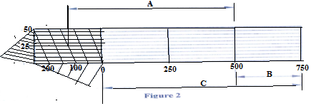
(b) Figure 3 shows an elevation of part of a hexagonal prism and an incomplete end elevation drawn in first angle projection. Draw:
- The end elevation in the direction of arrow B;
- The plan.
(6mks)
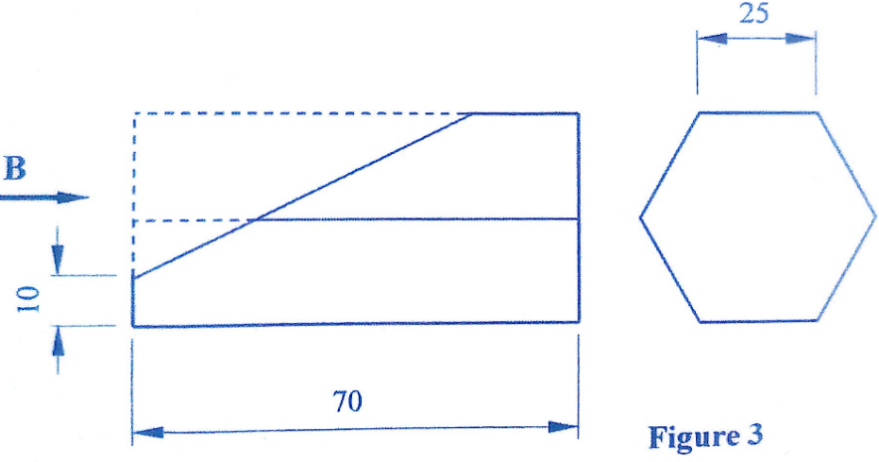
7 Figure 4 shows three views of a block drawn in first angle projection. Sketch proportionately, the isometric view of the block taking X as the lowest point. (5mks)
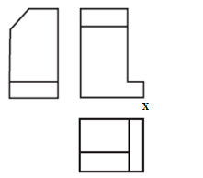
8 Figure 5 shows two orthographic views of a block. From the two views, sketch the oblique views in:
- Cavalier;
- Cabinet. (4mks)

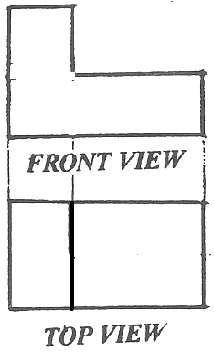
9 Sketch and show the following features in two-point perspective drawing:
- Picture plane
- Station point
- Vanishing point
- Ground level (2 mks)

10 Figure 6 shows a pictorial view of a block. Draw the three orthographic views of the block in third angle projection. (6mks)
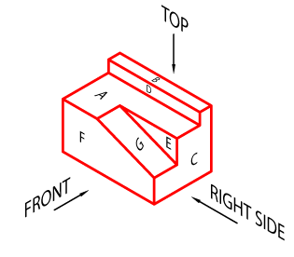

Section B (20 marks)
This question is compulsory:
It should be answered on the A3 paper provided.
Candidates are advised not to spend more than one hour on this question
11. Figure 6 shows parts of a towing device drawn in first angle projection. Assemble the parts and draw full size the following views in third angle projection:
(a) Sectional front elevation along the cutting plane T-T
(b) The Plan
(c) Insert leading dimensions
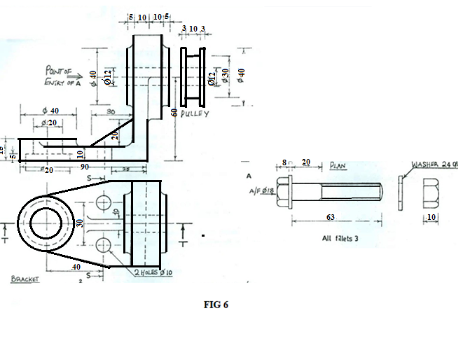

Section C (30 marks)
Answer Any Two questions from this section.
This question is compulsory.
12. Figure8 shows a crank mechanism in which point U reciprocates along XY as P rotates about O.
VT is fixed at right angle to PU at T.
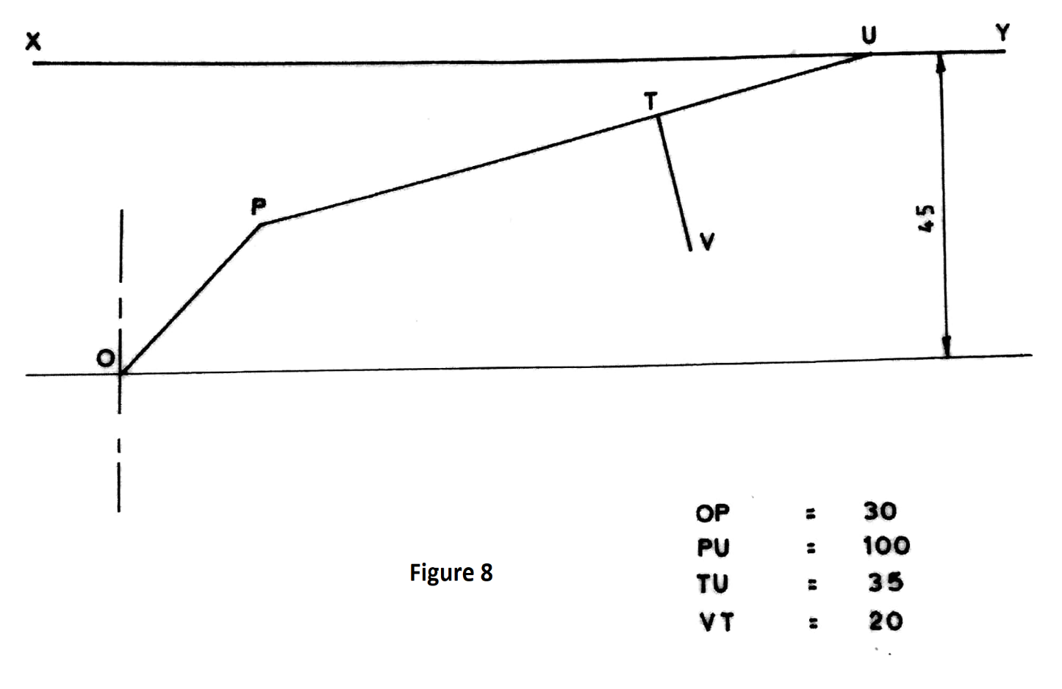
Plot the locus of point T and V for a complete revolution of OP.

13. Figure 9 shows the three orthographic views of a machined block drawn in first angle projection. Draw full size, the isometric view of the block taking corner X as the lowest point. (15mks).
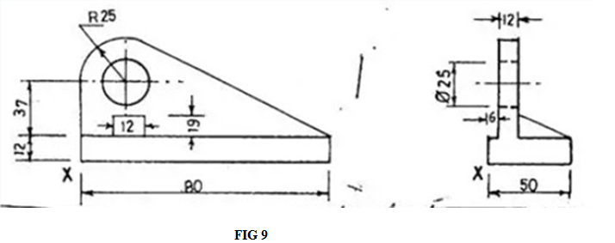
14 Figure 10 shows a block drawn in isometric projection. Draw FULL SIZE in first angle projection the three orthographic views of the block. (15mks)
