Term 2 - 2023
GEOGRAPHY 312
FORM 1
Time: 2½ Hours

Name: …………………………………………………………. Adm No: ……………….
School: ……………………………………………………….. Class: …………………..
Signature: ………………………………………..…………… Date: …..……………….

SECTION A: 25 MARKS
Answer ALL questions in this section.
1. (a) What is physical Geography? (2mks)
(b) Give three divisions of physical Geography. (2mks)
2. State four effects of rotation of the earth (4mks)
3. The diagram below shows the structure of the earth. Use it to answer the question that follows.

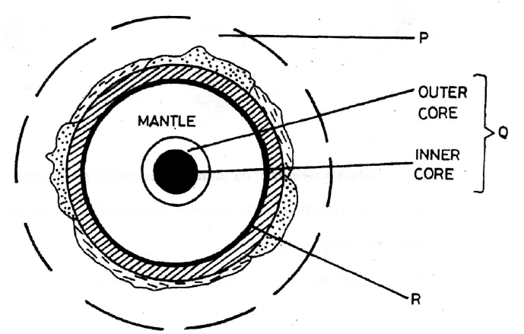
- Name the parts marked P and Q. (2mks)
(b) Describe the composition of the crust (3mks)
4. (a) Define the term solar system. (2mks)
(b) Using a well labelled diagram describe the occurrence of the solar eclipse. (5mks)
5. (a) Give two local winds that are found in Kenya. (2mks)
(b) State three conditions that are necessary for formation of dew. (3mks)

SECTION B: Answer all the questions
- a) (i) Define the term Geography (2mks)
(ii) What is the relationship between Geography and Biology. (2mks)
b) Use the diagram below to answer the following questions 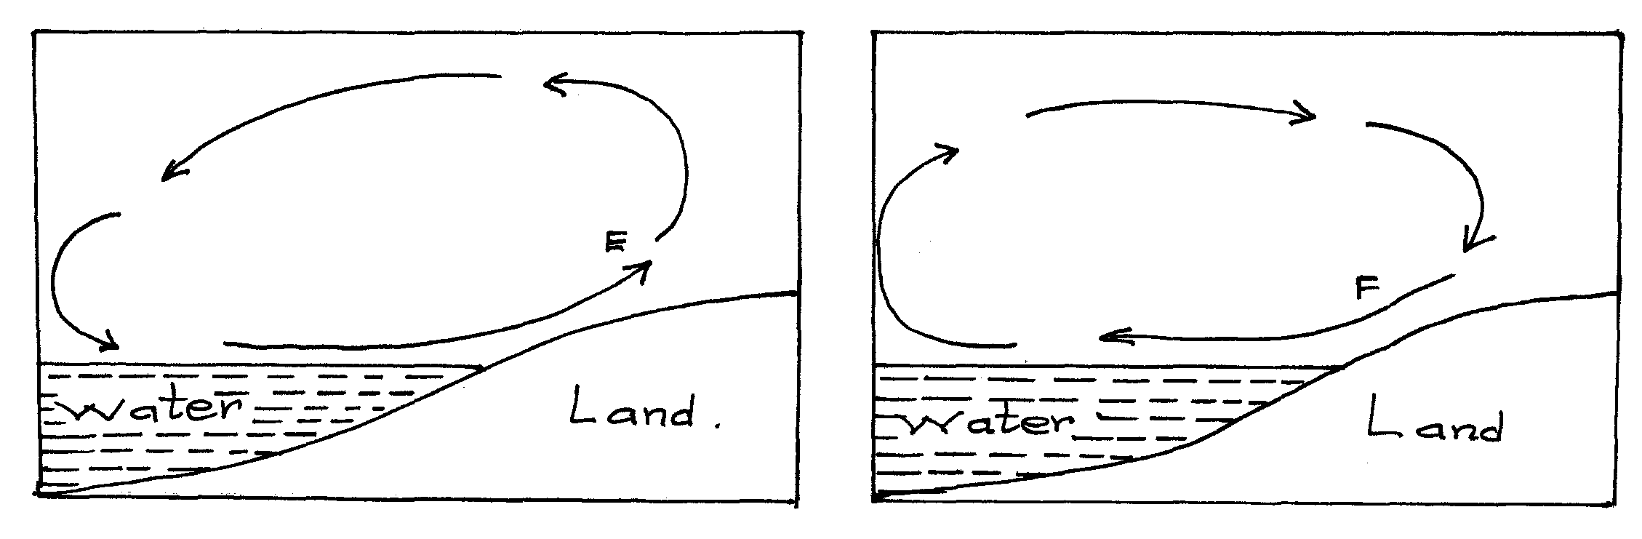
i) Name the air currents marked E. (1mk)
ii) Explain why the air current marked F flows at night. (3mks)
iii) Describe how air cools as it rises. (2mks)

(c) i) Differentiate between relative humidity and absolute humidity. (2mks)
ii) Explain four factors that influence humidity. (8mks)
(d) State five effects of weather on human activities. (5mks)

- The table below shows temperature and rainfall recorded in town X. Use it to answer the questions that follow.

Months | J | F | M | A | M | J | J | A | S | O | N | D
Temp. ⁰C | 19 | 21 | 21 | 20 | 18 | 18 | 17 | 17 | 19 | 20 | 20 | 20
Rainfall  (mm) | 55 | 47 | 119 | 207 | 168 | 35 | 27 | 27 | 14 | 75 | 164 | 66

- (i) Identify the month with the lowest rainfall. (1mk)
(ii) Calculate the mean annual rainfall. (2mks)
(iii) Determine temperature range for the year. (2mks)
- (i) Draw a simple bar graph to represent rainfall for town X. (6mks)
(ii) State four advantages of using above method to represent data. (4mks)
- (i) Define the term statistics. (2mks)
(ii) State four reasons why statistics is important. (4mks)
(iii) Name four methods of recording data. (4mks)

- (a) (i) Define the following terms:
- Map
- Plan
- Picture
(6mks)
(ii) State four qualities of a good sketch map. (4mks)
(iii) Besides sketch map name two other types of maps. (2mks)
(b) (i) Name three types of field work. (3mks)
(ii) State four reasons why fieldwork is important. (4mks)
(c) Your class intends to conduct fieldwork in a nearby urban centre.
(i) State three preparations you would make. (3mks)
(ii) Suggest any three follow up activities you would engage in. (3mks)

