Term 2 - 2023
GEOGRAPHY PAPER 2
312/2
FORM FOUR
TIME: 2 ¾ HOURS

Name: …………………………………………………………. Adm No: ……………….
School: ……………………………………………………….. Class: …………………..
Signature: …………………………………………………….. Date: …………………...
INSTRUCTIONS TO CANDIDATES
- This paper contains two sections; A and B.
- Answer all questions in section A.
- Answer question 6 and any other two questions from section B.
- All answers must be written in English.
- .
For Examiner’s use only
Section | Question | Maximum Score | Candidate’s Score
A | 1 - 5 | 25
B | 6 | 25
 |  | 25
 |  | 25
 | Total | 100

Section A.
(Answer all questions in this section).

1. a) What is nomadic pastoralism? (2marks)
(b) Name three nomadic communities in Africa. (3marks)
2. a) Distinguish between Land reclamation and Land rehabilitation. (2 marks)

b) State three methods used in reclaiming land in Kenya. (3 marks)

3. a) Define the term Eco-tourism. (2 marks)
b) List three benefits that Kenya derives from Domestic tourism (3 marks)

4. a) Define the international Trade. (2 marks)

b) State how international trade in Kenya can be improved (3 marks)

5. a) Apart from road transport, give two other forms of Land transport. (2 marks)

b) State three advantages of road transport over road transport (3 marks)

SECTION B
6. (a) The photograph below shows some mining activities. Study and use it to answer The questions that follow.
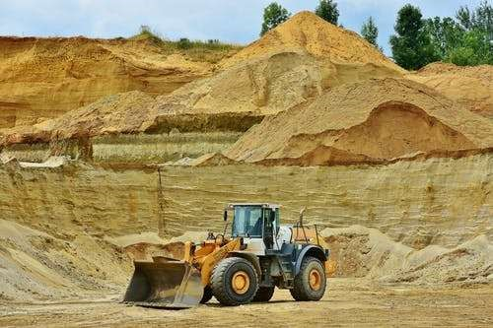
- Identify the type of photograph. (1 mark)
- Give reasons for your answer in (i) above. (3 marks)
- Draw a rectangle measuring 8cm by 10cm to represent the photograph.

(1 marks)
- On it, mark and label four main features. (4 marks)
- State three negative effects of the mining method shown in the photograph to the

physical environment. (3 marks)

(b) (i) Name two gold mining areas in South Africa. (2 marks)

(i) Describe the process of gold processing. (6 marks)

(ii) Explain three economic benefits of petroleum to the oil producing countries in
the Middle East region. (6 marks)

7. (a) (i) Define pastoral farming (2 marks)
(ii) List three counties with pastoral communities in Kenya (3 marks)
(b) (i) Identify two exotic beef cattle breeds kept in Kenya (2 marks)
(ii) state three characteristics of nomadic pastoralism (3 marks)
(c) (i) Explain three factors favoring beef farming in Kenya. (6 marks)
(ii) State four similarities between beef farming in Kenya and Argentina (6 marks)
(d) Your class carried a field study on tea processing.
(i) Outline any three stages of tea processing that the class may have observed. (3 marks)

(ii) State two methods that the class may have used to present data. (6 marks)

8. (a) The diagram below shows a fishing ground in the pacific ocean

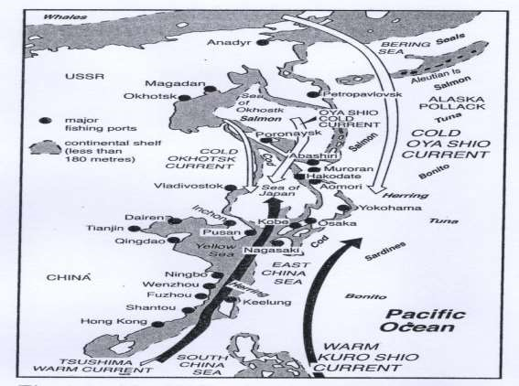
- Identify the fishing ground shown above
- Name two types of fish species found in the fishing ground above (2mks)
(b) (i) Apart from fishing , name two other economic activitiesthat arepracticed along the East African Coastal waters (2mks)
(iii) Name two inland types of fisheries in Kenya (2mks)

(c) (i)Describe the long lining fishing method (4mks)
(iii)Explain three physical factors that have influenced the development of fishing in Japan (6mks)
(d) (i) State four problems that face Marine fishing in Kenya (4mks)
(ii) Give three ways of conserving fresh water fisheries in Kenya (3mks)

9. (a)(i) Apart from sun, name three other sources of electricity (2 marks)

(ii) Name two types of renewable energy. (2 marks)
(b) Study the diagram of the seven forks dam power project provided below and use it to answer the questions that follow.
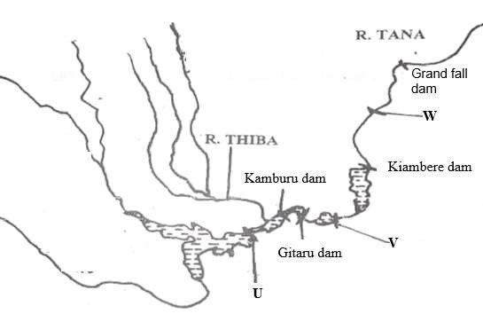

- Identify the dams labelled U and V. (2 marks)
- Explain three physical factors that favored the establishment of the seven forks

power project. (6 marks

(iii) State three benefits of the seven forks power scheme. (3 marks)

(c) (i) What is energy crisis? (2 marks)

(ii) Explain four effects of the energy crisis to the economies. (8 marks)

10. (a) (i) Name two agricultural nonfood manufacturing industries in Kenya (2 marks)

(ii) State three causes of industrial inertia. (3 marks)

(b) Name three problems facing the Jua Kali industries in Kenya. (2 marks)

(c) Explain four measures the government of Kenya is undertaking to promote Jua kali industry in Kenya. (8 marks)
(d). Study the map of Ruhr region below and use it to answer question

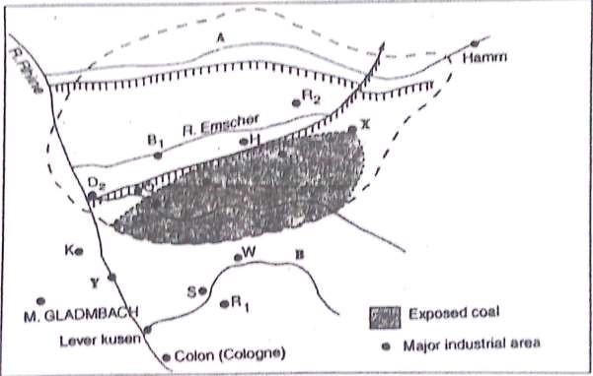

d. (i) Identify
the river marked A. (1 mark)
the canal marked H. - (1 mark)
the town marked Y. - (1 mark)

(ii) Explain three human factors that led to the growth of Ruhr industrial Region. (6 marks)

