END TERM EXAMINATIONS – TERM TWO 2023
121/1-MATHEMATICS ALT. A
Paper 1
FORM 4
2½ Hours

Name: ………………………………………………….....…… Adm No: ……….……
School: ………………………………………………………….. Class: …………………
Candidate’s Signature: …….………...................................... Date: …..…………….

INSTRUCTIONS TO CANDIDATES
- Write your name, admission number, school, and class in the spaces provided at the top of this page.
- Sign and write the date of the examination in the spaces provided above.
- This paper consists of two sections: Section I and Section II.
- Answer ALL questions in Section I and all the questions from Section II.
- Show all the steps in your calculations, giving your answers at each stage in the spaces provided below each question.
- Marks may be given for correct working even if the answer is wrong.
- Non-programmable silent electronic calculators and KNEC Mathematical Tables may be used.
- This paper consists of 18 printed pages.
- Candidates should check the question paper to ensure that all the pages are printed as indicated and no questions are missing.

For Examiners’ Use Only
SECTION I
1 | 2 | 3 | 4 | 5 | 6 | 7 | 8 | 9 | 10 | 11 | 12 | 13 | 14 | 15 | 16 | Total

SECTION II
17 | 18 | 19 | 20 | 21 | 22 | 23 | 24 | Total | Grand Total

SECTION I – 50 Marks
Answer all the questions in this section
- A transport company operates three types of trucks whose load capacities are 3.2 tonnes, 8tonnes and 10 tonnes. Calculate the least possible mass in tonnes that the company can transport with the three trucks. (3 marks)

- Use tables of square roots and reciprocals only to evaluate (3 marks)
$$\frac{3}{0.5217}-\sqrt{0.4036}$$

- A line that passes through the point $(-3, 5)$ makes an angle of ${53.13010235}^{0}$ with the x-axis. Find the equation of the line in the form $y=mx+c$, where m and c are constants. (3 marks)

- A bag of rice costs Ksh 12,500, a bag of beans costs Ksh 15,200 and a bag of maize costs Ksh 8,750. A school buys 20 bags of rice, 30 bags of beans and 45 bags of maize in a term.
- Represent
- the cost of each bought as a $3×1$ matrix (1 mark)

- the number of bags of each as a $1×3$ matrix (1 mark)

- Hence calculate the total cost that the school spent in buying the items. (2 marks)

- The figure below shows the net of a right cone. The radius of the circular bas is 10.5 cm.
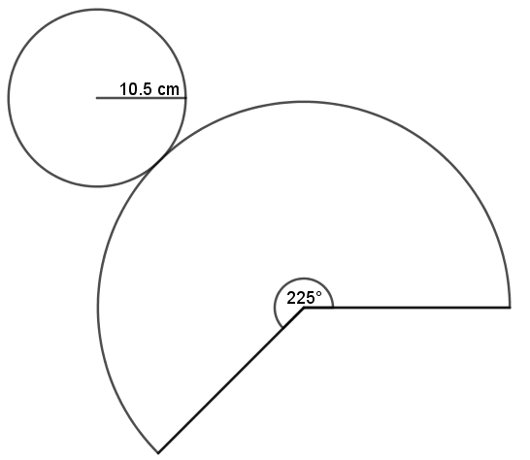
Calculate the slant height of the cone. (2 marks)

- The points M and N have coordinates $(2, -1)$ and $(-4, 3)$ respectively. A point R divides line MN externally in the ratio $3:2$. Find the of modulus of OR, correct to four significant figures. (4 marks)

- Fifteen men working for eight hours a day can complete a certain job in exactly 24 days. For how many hours a day must sixteen men work in order to complete the same job in exactly 20 days? (3 marks)

- A measuring cylinder of base diameter of 10 cm contains water whose level reads 5 cm high. A spherical solid marble is immersed in the water and the new level reads 9 cm. Calculate the radius of the marble
(3 marks)

- An irregular polygon has $n$ sides. Its interior angles are such that two of them are right angles while the exterior of each of the remaining angles is 30⁰. Find the value of $n$ and hence the sum of the interior angles of the polygon. (3 marks)

- A train moving at 120 km/h approaches a bridge 50 m long which is 120 m away. If the train takes 9 seconds to completely cross the bridge, determine the length of the train in metres. (3 marks)

- Sarah, a saleslady earns a basic salary of Ksh. 25,000 and a commission of 7.5% for the sales in excess of Ksh. 100,000. In May 2023 she earned a total of Ksh. 48,700 in salaries and commissions. Determine the amount of sales that she made in that month. (3 marks)

- The figure below shows part of a circle that touches the side LM externally and tangentially at a point T.

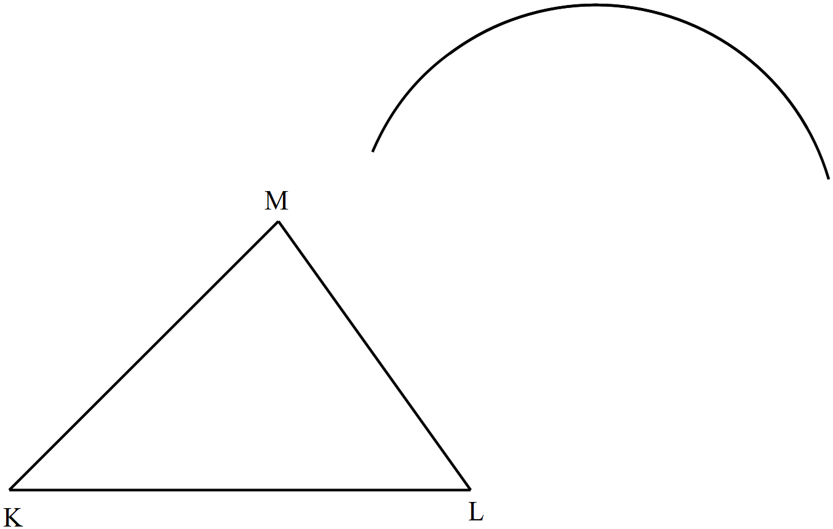

- Using a ruler and a pair of compasses only, locate the point T on LM. (2 marks)

- Measure the radius of the circle. (1 mark)

- Simplify the expression (3 marks)
$$\frac{a^{2}-b^{2}}{a^{2}+ab-a-b}$$

- Ruth paid rent which was $\frac{1}{10}$ of her net salary. She used $\frac{1}{3}$ of the remaining amount to make a down payment for a plot. She gave mother Ksh. 2,500 and did shopping worth Ksh. 7,500 herself. She saved the remainder which was Ksh. 12,500. How much was the down payment that she made? (3 marks)

- A photograph print measures 24 cm by 15 cm is enclosed in a frame. A uniform space of width $x$ cm is left between the edges of the photograph and the frame. If the area of the space is 270 cm², find the value of $x$. (4 marks)

- Solve for $x$in the equation (3 marks)
$${49}^{\left(x-3\right)}×{2401}^{\left(1-x\right)}=\frac{1}{{343}^{x}}$$

SECTION II – 50 Marks
Answer any five questions in this section.
- A school plans to construct a basketball court. The court has an area of 225 m² and a thickness of 40 cm. The court is to be made of a concrete mixture of ballast, sand and cement in the ratio of 4: 5:1 respectively. The density of the concrete is 2.4 g/cm³.
- Calculate the mass, in tonnes of cement used to make the court. (4 marks)

- If the cement is supplied in bags of 50 kg, how many bags of cement are used to make the court?
(1 mark)

- (i) Calculate the mass of ballast used to construct the court. (2 marks)

- If the ballast is charged at Ksh. 43,500 per trip of a truck that carries 25 tonnes, find the cost of ballast incurred. (3 marks)

- The histogram below represents the marks scored by learners at Zeraki School in a Mathematics contest.

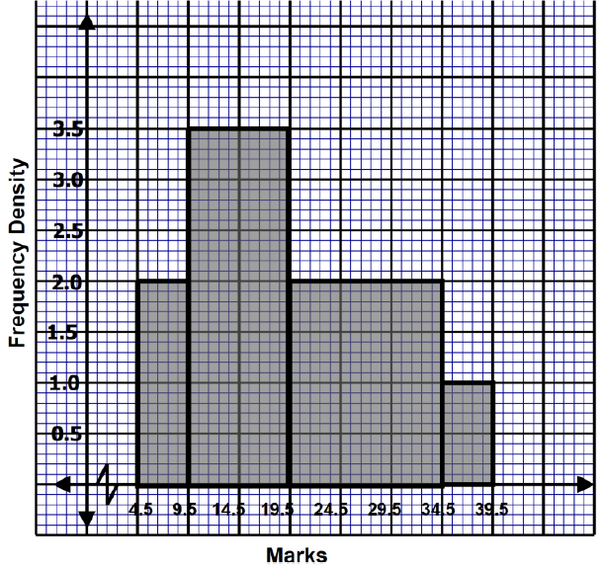

- If the frequency of the first class is 10, develop a frequency distribution table from the histogram above. (3 marks)
Marks | Frequency
5 – 9 | 10

- Find the total number of students who sat for the contest. (1 mark)

- From the histogram, determine:
- the mean mark; (3 marks)

- the median mark. (3 marks)

- The figure below shows a triangle $ABC$ and its image triangle $A'B'C'$ after a transformation M.
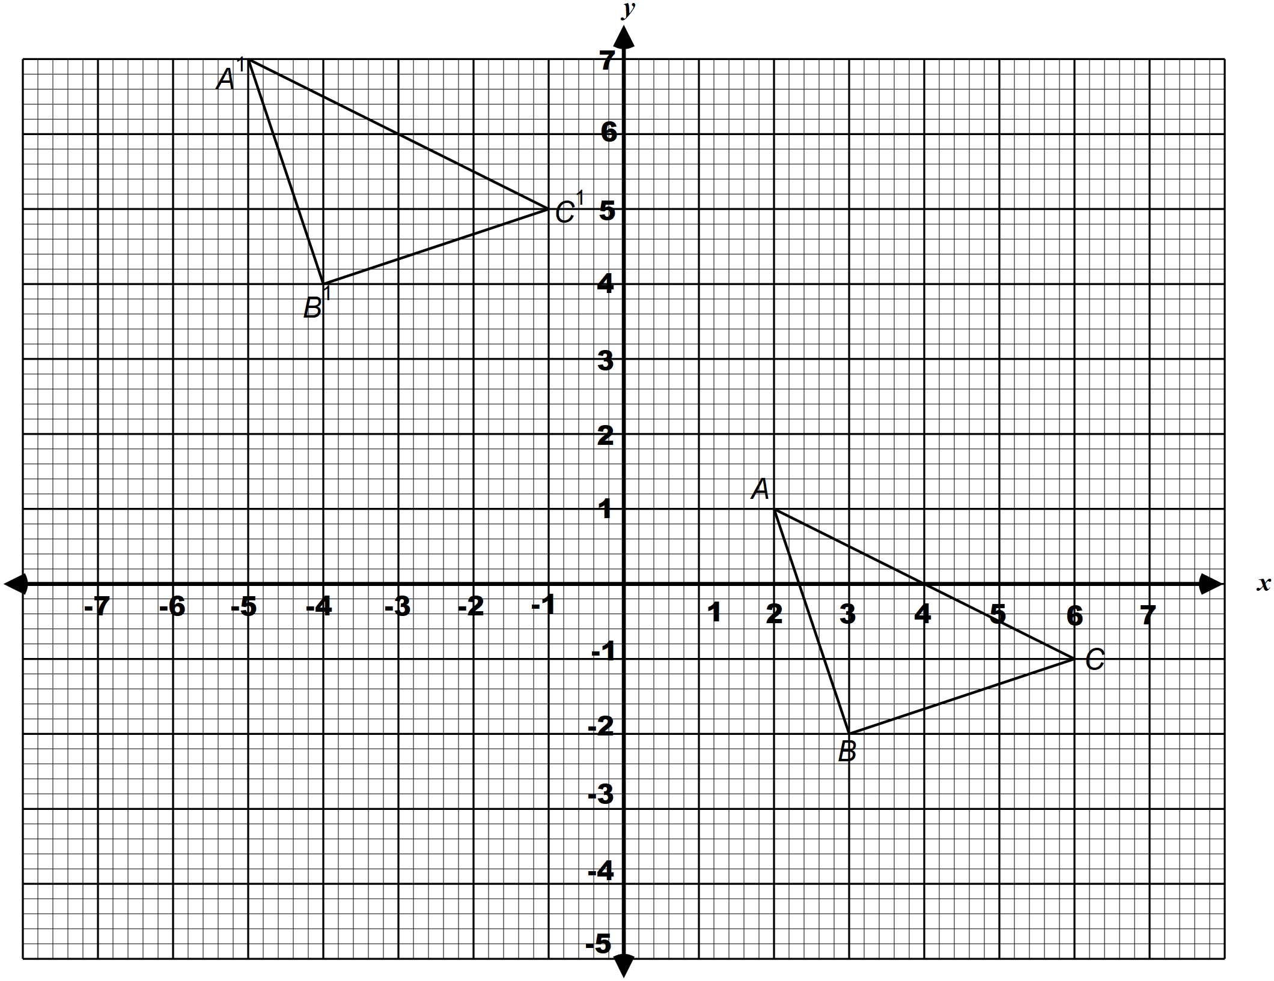

- Describe M fully. (3 marks)

- $A''B''C''$ is the image of $A'B'C'$ after a rotation of +90⁰ about (0, 0). On the same axes, draw $A''B''C''$ (2 marks)

- $A'''B'''C'''$ undergoes an enlargement, centre (0, 1) and scale factor $-1$. Draw $A'''B'''C'''$ on the same pair of axes and state its coordinates. (3 marks)

- Name the type of congruency between the following triangles (2 marks)
- $ABC$ and $A'B'C'$

- $A''B''C''$ and $A'''B'''C'''$

- Five towns A, B, C, D and E are such that B is on a bearing of 046⁰ and a distance of 8 km form A. The bearing and distance of C from B are S40⁰E and 101 km respectively. Towns D and E is 5.8 km from C and on a bearing of 125⁰ from A such that E is closer to A than D.
- Using the scale of 1: 100 000, show the relative positions of the towns A, B, C, D and E. (4 marks)

- Use the scale drawing to determine:
- the distance between A and D (2 marks)

- the compass bearing of B from E (1 mark)

- Two police patrol vehicles leave B and C simultaneously. The one from B travels due south while the one from C travels on a bearing of 270⁰. The two vehicles meet at T.
- On the scale drawing, locate the position of T. (2 marks)

- How far is D from T? (1 marks)

- An open box is to be made out of a piece of a square cardboard of sides 18 cm by cutting off equal squares of side $x$ cm from the corners and turning up the sides.
- Sketch the box formed, showing its dimensions in terms of $x$ (2 marks)

- (i) Calculate the height of the box for which the volume of the box will be maximum (4 marks)

(ii) Hence calculate the maximum volume. (2 marks)

- The box is to be filled with cubes of uniform dimension. Calculate the least number of cubes that can fill the box completely. (2 marks)

- The figure below shows the cross-section of the swimming pool at Kisumu Boys High School with the given measurements. The swimming pool is 20 m long
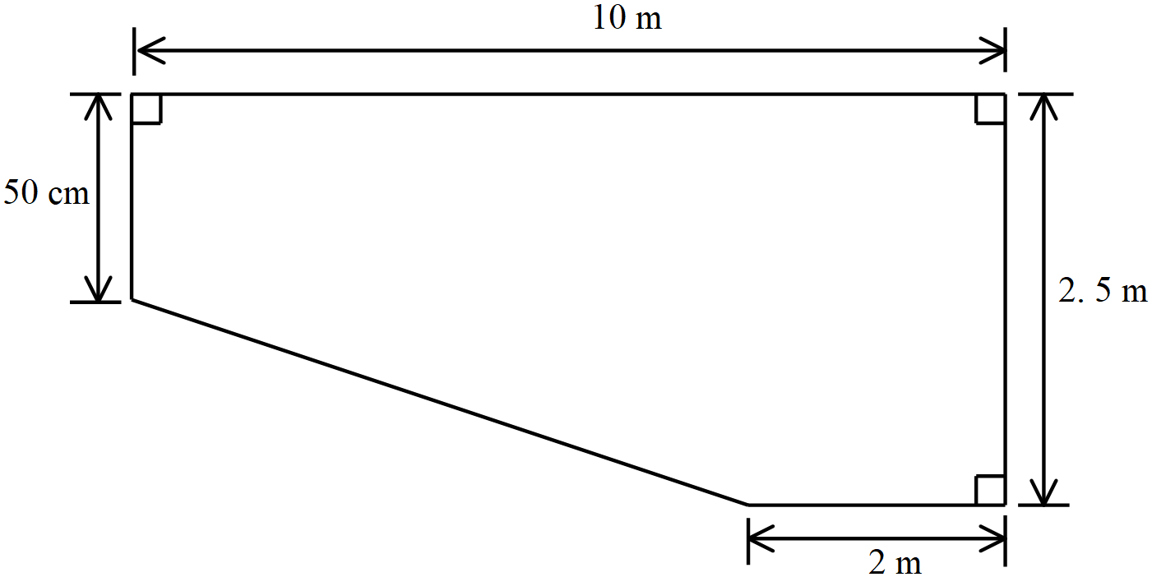

- Calculate the capacity of the swimming pool. (4 marks)

- The adult side of the pool is to be drained of the water in for maintenance. The water is pumped out through two cylindrical pipes: A and B with diameters 40 cm and 50 cm respectively. The pumps drain the water at the rates of 35 cm/minute and 42 cm/minute respectively.
- Calculate the volume of water drained by the two pipes in one minute. Use $π=\frac{22}{7}$. (3 marks)

- Find the time, to the nearest hour that its take to completely drain the pool. (3 marks)

- The figure below shows the model of a tent ABCDEFGHJK for use in a scouting camp. AB =5 m, BC = 8 m and CK = 3.5 m. GHJ and FEK are equal triangular faces such that GH = GJ = FE = FK = 3 m.
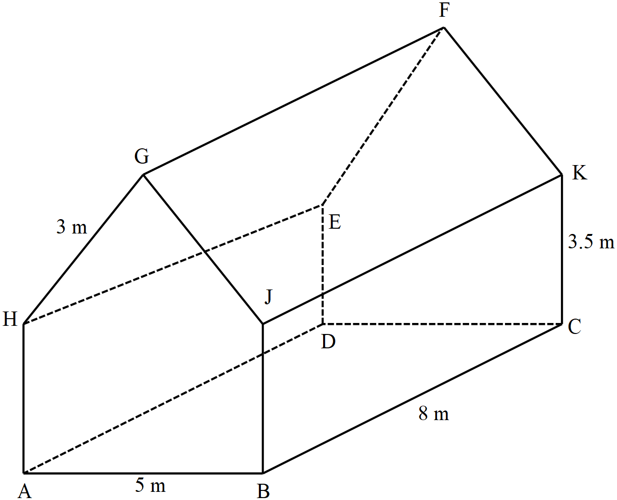

- Calculate the vertical height of the tent, correct to 2 decimal places. (3 marks)

- A lamp L is installed at the midpoint of GF. Calculate the angle of elevation of the lamp from C
(3 marks)

- Calculate the obtuse angle between the line GF and BD. (2 marks)

- Calculate the volume of the tent. (2 marks)

- In the figure below, O is the centre of the circle. Angle OQS = 46⁰ and TOQ is a straight line.
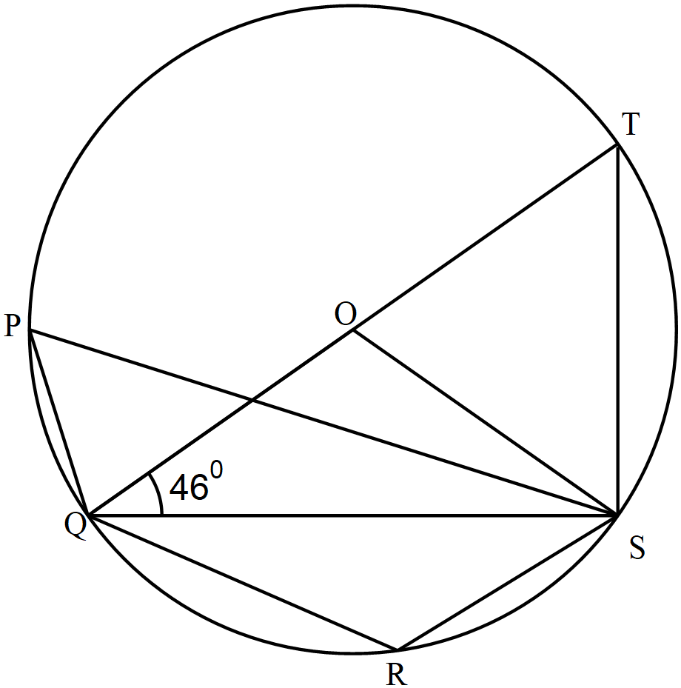

- Calculate the sizes of the following angles, give reasons in each case:
- ∠QOS (2 marks)

- ∠STQ (2 marks)

- ∠QRS (2 marks)

- If the radius of the circle is 4.5 cm, calculate the area of ΔQTS, correct to 4 significant figures.
(3 marks)

