TERM 2 - 2023
PHYSICS (232)
FORM TWO (2)
Time - 2 Hours
Name …………………………………………….……… Admission Number …………….
Candidate’s Signature ………………….…...……….. Class ……………………………
Instructions
- Write your name, admission number, class and signature in the spaces provided at the top of the page. This paper consists of two sections; A and B.
- Answer ALL the questions in the spaces provided.
- Mathematical tables and electronic calculator may be used.
- All working MUST be clearly shown.
- This paper consists of 12 printed pages.
- Candidates should answer the questions in English and check to ensure that no question(s) is missing.
FOR EXAMINER’S USE ONLY

SECTION | QUESTIONS | MAXIMUM SCORE | CANDIDATE’S SCORE
A | 1 – 12 | 25
B | 13 | 10
 | 14 | 10
 | 15 | 11
 | 16 | 14
 | 17 | 10
TOTAL SCORE |  | 80

This paper consists of 12 printed pages. Candidates should check and ascertain that all questions are printed as indicated and that no questions are missing.
TURN OVER

SECTION A (25 MARKS)
- Two metallic spheres A, B stand in contact as shown. A positively charged rod is held
near sphere A.

Figure 1

  - Show the charge on each sphere when the metallic balls are separated and the rod is removed. (2 Marks)

  - Why are the balls supported on insulated stands? (1 Mark)
………………………………………………………………………………………………..
…………………………………………………………………………………………………
- A density bottle has a mass of 45g when full of paraffin and a mass of 50g when full of water if the empty bottle weighs 25g, calculate the density of paraffin. (2 Marks)
……………………………………………………………………………………………………………..
…………………………………………………………………………………………………………………………………………………………………………………………………………………………………………..…………………………………………………………………………………………………………………………………………..………………
- State the reason why thermal conductivity of a metal increases with the increase in the cross-section area of the conductor? (1 mark)
…………………………………………………………………………………………………………………………………………..…………………………………………………………………………………………………………………………………………..……………
- Describe how you would charge a gold leaf electroscope negatively by induction method. (3 marks)

……………………………………………………………………………………………………………
…………………………………………………………………………………………………………………………………………………………………………………………………………………………………………..…………………………………………………………………………………………………

- An airtight flask containing a gas is connected to a mercury manometer. The levels of mercury in the two limbs of the manometer are as shown in the diagram below.

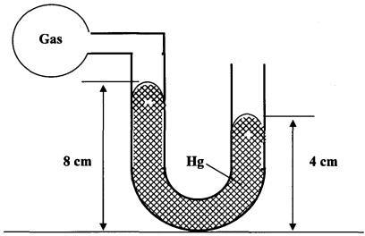
Figure
Calculate the pressure of the gas (Density of mercury = 1.36 x 10⁴ kg/m³ and atmospheric pressure = 1.0 x10⁵ N/m²) (3 marks)
…………………………………………………………………………………………………………………………………………………………………………………………………………………………………………………………………………………………………………………………………………………………………………………………………………………………………………
- Figure below shows a ray of light incident on a mirror at an angle of 45º. Another mirror is placed at an angle of 60º to the first one as shown.

Incident ray
45⁰
M1
60⁰
Figure

M2
Calculate the number of images formed when an object is placed between the two mirrors. (2mks)
………………………………………………………………………………………………

- A highly inflated balloon bursts when transferred to a hotter environment. Explain this
observation using kinetic theory of gases. (2marks)
……………………………………………………………………………………………………….……………………………………………………………………………………………………..…………………………………………………………………………………………………………………………………………………………………………………………………………………………………………………………………
- In a ball and ring experiment, the ball goes through the rings at room temperature. When it is heated it does not go through the ring, but when left on the ring for some time, it goes through. Explain this observation. (2marks)
………………………………………………………………………………………………………………………………………………………………………………………………………………………………………………………………………………………………………………………………………………………………
- A piece of metal weighs 3N in air and 2N when totally immersed in water.
- Identify the force responsible for the difference in weight of the metal. (1mark)
………………………………………………………………………………………………………………………………………………………………………………………………………………………………………..
ii. Determine the value of the force in (i) above. (2 marks)
………………………………………………………………………………………………………………………………………………………………………………………………………………………………………………………………………………………………………………………………………………………………
- Explain how a person is able to drink a soda using a drinking straw. (2 marks)
…………………………………………………………………………………………………………………………………………………………………………………………………………………………………………
- Give a reason why air is not commonly used as the fluid in a hydraulic lift. (1mark)
…………………………………………………………………………………………………………………………………………………………………………………………………………………………………………

- State one assumption made when estimating the size of an oil molecule in the oil drop experiment. (1mark)
……………………………………………………………………………………………………………………………………………………………………………………………………………………………………………………………………………………………………………………………………………..

SECTION B (55 MARKS)
- (a) State the law of moment (1 mark)
………………………………………………………………………………………………………
………………………………………………………………………………………………………
- The figure 4 below shows a uniform metre rule of mass 200g balanced at 40 cm mark by a number of forces. Calculate,
Figure
  - The force F (3 marks)
………………………………………………………………………………………………………
………………………………………………………………………………………………………
………………………………………………………………………………………………………
………………………………………………………………………………………………………

  - the reaction at R (2 marks)
………………………………………………………………………………………………………
………………………………………………………………………………………………………
- A spherical ball bearing of mass 0.0024kg is held between the anvil and spindle of a micrometer screw gauge. Use this information and the position of the scale in the figure 5 below to answer the questions (a) and (b) below:
Figure 5
- What is the diameter of the ball bearing? (1mark)
………………………………………………………………………………………………………
………………………………………………………………………………………………………
………………………………………………………………………………………………………

- Find the density of the ball bearing correct to 3 significant figures. (3marks)
………………………………………………………………………………………………………
………………………………………………………………………………………………………
………………………………………………………………………………………………………

- In an experiment to estimate the diameter of an oil molecule, an oil drop of diameter 0.05 cm spread over a circular patch whose diameter is 20cm
Determine:
- The volume of the oil drop. (2 Marks)
………………………………………………………………………………………………
………………………………………………………………………………………………
………………………………………………………………………………………………
- The area of the patch covered by the oil (2 Marks)
………………………………………………………………………………………………
………………………………………………………………………………………………
………………………………………………………………………………………………
- The thickness of the oil molecule. (3 Marks)
………………………………………………………………………………………………
………………………………………………………………………………………………
………………………………………………………………………………………………
………………………………………………………………………………………………
- State the importance of lycopodium powder in the above experiment. (1 Mark)
………………………………………………………………………………………………
………………………………………………………………………………………………
- State two possible sources or errors in this experiment. (2 Marks)
………………………………………………………………………………………………
………………………………………………………………………………………………
………………………………………………………………………………………………

- A concave mirror with a focal length of 8cm forms on upright image 15 cm from the mirror. If the object is 5 cm tall, calculate;
- The distance of the object from the mirror (3 marks)
………………………………………………………………………………………………………………………………………………………………………………………………………………………………………………………………………………………………………………………………………………………………………………………………………………………………………………………………
- Magnification. (2 marks)
………………………………………………………………………………………………………
………………………………………………………………………………………………………
………………………………………………………………………………………………………
………………………………………………………………………………………………………
- Image height (2 marks)
………………………………………………………………………………………………………
………………………………………………………………………………………………………
………………………………………………………………………………………………………
- The figure 6 below shows an object placed 10cm in front of a concave mirror whose radius of curvature is 40cm.On the same figure, draw a ray diagram to show the position of the image formed. [3 Marks]

C
F O

Figure

- Give a reason why convex mirror is preferred to plane mirror for use in supermarkets. ( 1 mark)
………………………………………………………………………………………………………
………………………………………………………………………………………………………
………………………………………………………………………………………………………
………………………………………………………………………………………………………

- a) Define magnetic field. (1 mark) ………………………………………………………………………………………………………………………………………………………………………………………………………………………………
b) The graph in the figure 7 below was obtained from an experiment.

Figure 7

i) Which material is easy to magnetize. (1 mark) ……………………………………………………………………………………………………………
ii) Using domain theory explain your answer (i) above. (2 marks) ……………………………………………………………………………………………………………………………………………………………………………………………………………………………………………………………………………………………………………………………………………….
iii) State one application of hard magnetic materials. (1 mark) ………………………………………………………………………………………………………………..
c) State two methods of magnetization. (2 marks) ………………………………………………………………………………………………………………………………………………………………………………………………………………………………………………………………………………………………………………………………………………………………
d) Why is repulsion the surest way of identifying a magnet? (2 marks) ………………………………………………………………………………………………………………
e) Figure 8 shows a magnetic material being magnetized

X
Y
Figure

Identify the polarities of X and Y (2 Marks)
X: …………………………………………………..................
Y: ………………………………………………………………
f) Suggest three ways that can be done to make the electromagnet stronger. (3 Marks)

……………………………………………………………………………………………………………………………………………………………………………………………………………………………………………………………………………………………………………………………………………………………………………………………………………………………………………………………………………………
- a) Fig. 8 shows a cylindrical can filled with a liquid of density 0.8 gcm⁻³. A hole of diameter 2.0 cm is drilled at a depth of 2.8 m from the top of the can.
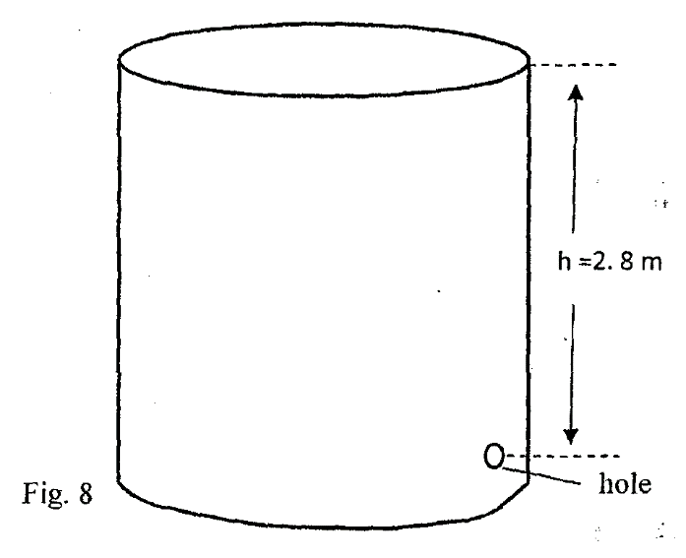
Determine:
- The cross-sectional area of the hole. (2marks)
………………………………………………………………………………………………………
………………………………………………………………………………………………………
………………………………………………………………………………………………………
- The maximum pressure exerted by the liquid at the hole. (2marks)
………………………………………………………………………………………………………
………………………………………………………………………………………………………
………………………………………………………………………………………………………
………………………………………………………………………………………………………
- The maximum force exerted on a jet of liquid through the hole. (2marks)
………………………………………………………………………………………………………
………………………………………………………………………………………………………
………………………………………………………………………………………………………
………………………………………………………………………………………………………
b) Name the states of equilibrium in the following diagrams. (2 marks)

Figure

(i) …………………………….. (ii) ………………………………………
c) State two ways to increase the stability of a body. (2 marks)
………………………………………………………………………………………………………………………………………………………………………………………………………………
#END#

