TERM 2 - 2023
PHYSICS – PRACTICAL (232/3)
FORM THREE (3)
Time – 2$\frac{1}{2}$ Hours

Name …………………………………………….……… Admission Number …………….
Candidate’s Signature ………………….…...……….. Class ……………………………

INSTRUCTIONS:
- Answer all the questions in this paper
- You are supposed to spend the first 15 minutes of the $2\frac{1}{2}$ hours allowed for this paper reading the whole paper carefully before starting your work.
- Marks are given for clear record of the observations made, their suitability and accuracy and the use made of them.
- Candidates are advised to record observations as soon as they are made
- Mathematical table and electronic calculators may be used.
- The earth’s gravitational pull, $g=10N{kg}^{-1}$

For Examiner’s use only:
QUESTION | TOTAL MARKS | CANDIDATE’S SCORE
1 | 20
2 | 20
GRAND TOTAL | 40

This paper consists of 6 printed pages. Candidates should check the question paper to ensure that all the pages are printed as indicated and no questions are missing.

QUESTION 1

You are provided with the following apparatus:
- One dry cell
- A cell holder
- A volt-meter (0-3V)
- An ammeter (0-1A)
- A switch
- Amounted resistance wire labelled AB
- Micrometer screw-gauge

PROCEED AS FOLOWS:

- Set up the apparatus as shown in the circuit below, figure 1
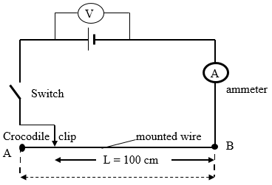
Figure 1

- Using the micrometer screw-gauge provided, measure the diameter, D of the mounted wire.

D = .................................mm D = ......................m ($1\frac{1}{2} marks$)

- Determine the cross-sectional area, A of the mounted wire given that:

$A=πR^{2}$ where, R is the radius of the wire (2 marks)

- While the switch is open, record the voltmeter reading, V₀
$V_{0}=$ ........................... ($\frac{1}{2}$ mark)

- Put on the switch. While the crocodile clip is at A (i.e. L = 100 cm) take the volt-meter reading (V) and the ammeter reading (I). Record V and I in the table, 1 below:
Table 1
Length, $L$ (cm) | 100 | 80 | 60 | 40 | 20 | 0
Voltage (V)
Current, I (A)
R = $\frac{v}{I}$ (Ω)
(10 marks)

- Repeat the procedure in (c) above for the lengths shown and complete the table 1 above.

- Determine, $R_{av}$, the average value of resistance, R (2 marks)

- The relationship between resistance, R and length, $l$ is given by the equation:
$R_{av}=\frac{ρl}{A}$ , determine the value of the constant, $ρ$ when $l=100cm$ (3 marks)

- State the significance of the constant, $ρ$ (1 mark)

QUESTION TWO

You are provided with the following:
- a metre rule
- 3 optical pins
- 2 small wooden blocks
- a stop watch
- a stand, a boss and clamp
- a piece of sello-tape

Proceed as follows:

- Using the two wooden blocks, clamp two optical pins about 4 cm apart in the stand so that they project out of the blocks in a horizontal plane.
- Using a piece of sellotape, attach the third optical pin across the metre rule at a distance x = 10 cm from the 50 cm mark. Now suspend the metre rule on the two clamped pins so that it can swing freely in a vertical plan with the third pin as the axis. (See figure 2)

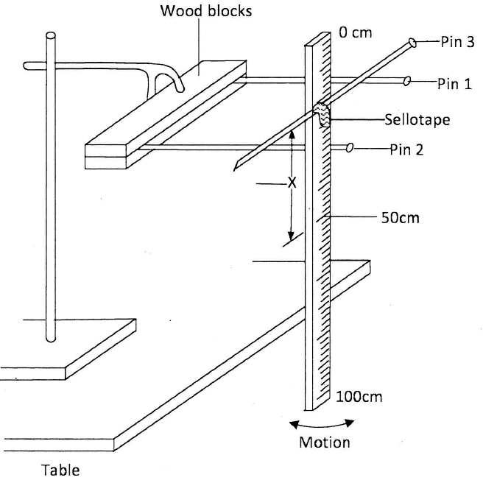
Figure 2
- Displace the lower end of the metre rule slightly and let it oscillate as shown in the figure 2. Measure and record in table 2 the time t (s) for 20 oscillations.

- Repeat the procedure in (b) and (c) for the values of x shown in table 2.

- For each value of x shown in the table, determine the period T(s), and complete the table. (The period T is the time for one complete oscillation).

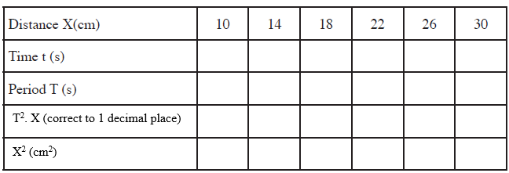
(9 marks)

- On the grid provided, plot a graph of T². X (y-axis) against X² (5 marks)

- From the graph, determine:
- the slope S of the graph. (3 marks)

- The value of constant r given that: $rS=39.5$ (3 marks)

This is the last printed page

