TERM 2 - 2023
PHYSICS – PAPER 2 (232/2)
FORM FOUR (4)

Name …………………………………………….……… Admission Number …………….
Candidate’s Signature ………………….…...……….. Class ……………………………

Instructions to Candidates
- Write your name, admission number, class and signature in the spaces provided at the top of the page. This paper consists of two sections; A and B.
- Answer ALL the questions in the spaces provided.
- Mathematical tables and electronic calculator may be used.
- All working MUST be clearly shown.
- This paper consists of 13 printed pages.
- Candidates should answer the questions in English and check to ensure that no question(s) is missing.
FOR EXAMINER’S USE ONLY

SECTION | QUESTIONS | MAXIMUM SCORE | CANDIDATE’S SCORE
A | 1 – 12 | 25
B | 13 | 11
 | 14 | 10
 | 15 | 10
 | 16 | 14
 | 17 | 10
TOTAL SCORE |  | 80

This paper consists of 13 printed pages. Candidates should check and ascertain that all questions are printed as indicated and that no questions are missing. TURN OVER

SECTION A: 25 MARKS
1.The figure below shows a ray of light incident on a plane mirror at an angle of 65º to the surface of the first mirror as shown below.

65⁰

58⁰

Sketch the path of the ray until it emerges and state the angles. (3 marks)

2. State the reason why an increase in leaf divergence is the only sure way of determining whether an object is negatively charged using a negatively charged electroscope. (1 mark)
................................................................................................................................................................................................................................................................................................................................................................................................................................................................................................................................................................................................................................................
3. State two measurements that should be taken for one to decide whether a lead acid accumulator is due for charging. (2 marks)
................................................................................................................................................................................................................................................................................................................................................................................................................................................................................................................................................................................................................................................
4. (a) State the basic law of magnetism. (1 mark)
................................................................................................................................................................................................................................................................................................................................................................................................................................................................................................................................................................................................................................................

- The figure below shows how magnets are stored in pairs with keepers at the ends.
S
N
N
S
Bar magnets
Keeper
Keeper

Explain how this method of storing helps in retaining magnetism longer. (2 marks)

................................................................................................................................................................................................................................................................................................................................................................................................................................................................................................................................................................................................................................................
5. Why is a convex mirror better than plane mirror when used as a driving mirror? (1 mark)
....................................................................................................................................................................................................................................................................................................................................................................................................................................................................................
6. You are provided with the following apparatus: connecting wires, a soft iron rod, a battery of 3 cells, a switch, a long-insulated copper wire and a rheostat.
(a) Using a suitable diagram, show how an electromagnet can be made with the given apparatus. (1mark)

(b) State two ways by which the strength of an electromagnet can be increased. (2 marks)
....................................................................................................................................................................................................................................................................................................................................................................................................................................................................................
7. (a) Distinguish between a transverse and a longitudinal wave. (1 mark)
....................................................................................................................................................................................................................................................................................................................................................................................................................................................................................

(b) Determine the frequency of the wave shown below. (2 marks)

0.5
1.0
1.5
2.0
Time(s)
Displacement (m)

....................................................................................................................................................................................................................................................................................................................................................................................................................................................................................

8. When a germanium crystal is doped with arsenic it becomes an N-type semi-conductor. Explain how this change occurs.
(Number of electrons in the outermost shell for germanium=4, arsenic=5) (2 marks)
................................................................................................................................................................................................................................................................................................................................................................................................................................................................................................................................................................................................................................................
9. A nuclide X with mass number 234 and atomic number 92 decays to nuclide Y with mass number 218 and atomic number 84. Determine the number of alpha particles emitted. (2 marks)

................................................................................................................................................................................................................................................................................................................................................................................................................................................................................................................................................................................................................................................
10. State how the intensity of x-rays in an x-ray tube can be increased. (1 mark)
....................................................................................................................................................................................................................................................................................................................................................................................................................................................................................

11.The figure below shows part of the lighting circuit in a house.
State two errors in the wiring circuit. (2 marks)
....................................................................................................................................................................................................................................................................................................................................................................................................................................................................................
12. Calculate the energy of photons associated with radiation of frequency $4.8×{10}^{14}$Hz, stating your answer in $eV$ . (3 marks)

....................................................................................................................................................................................................................................................................................................................................................................................................................................................................................

SECTION B. (55 MARKS)
Answer all questions in this section

13. a) State Lenz’s law. (1 mark)
....................................................................................................................................................................................................................................................................................................................................................................................................................................................................................
b) A magnet is driven into a coil such that the direction of flow of current in the coil.
Is as shown in the diagram below. Indicate on the diagram the polarity of the magnet, and the direction in which it is driven into the coil. (2 marks)

c) Electrical energy is transmitted at very high voltages and low current.
I. Describe how the high voltages are attained. (1 mark)
....................................................................................................................................................................................................................................................................................................................................................................................................................................................................................

II. State two reasons why thick aluminium wires are preferred to copper wires for transmission over long distances. (2 marks)

....................................................................................................................................................................................................................................................................................................................................................................................................................................................................................

d) A student has some colored bulbs rated 60W, 240V to be connected for decorations.
I. State the number of such bulbs that can be connected normally to a 240V supply through a 5A fuse. (2 marks)

....................................................................................................................................................................................................................................................................................................................................................................................................................................................................................

II. If the cost of electric energy is ksh.3.00 per kWh, determine the cost of running the bulb in (d) I above for 5hours daily for 20days. (3 marks)

....................................................................................................................................................................................................................................................................................................................................................................................................................................................................................
14. (a) State Ohms law. (1 mark)
……………………………………………………………………………………………………………………………………………………………………………………………………………………………………………………………………………………………………..
b) The cell in the figure below has an e.m.f of 2.5V and negligible internal resistance.

Determine the
- Total resistance in the circuit. (2 marks)
………………………………………………………………………………………………………………………………………………………………………………………………………………………………………………………………………………………………………

- Current in the circuit. (2 marks)
………………………………………………………………………………………………………………………………………………………………………………………………………………………………………………………………………………………………………
(iii) Reading on the voltmeter. (2 marks)

………………………………………………………………………………………………………………………………………………………………………………………………………………………………………………………………………………………………………
c) Three resistors of resistance 2.0Ω, 4.0Ω and 6.0Ω are connected together in a circuit.
Show the combination which gives;
- Effective resistance of 3.0Ω. (1 mark)
………………………………………………………………………………………………………………………………………………………………………………………………………………………………………………………………………………………………………………………………………………………………………………………………………..

- Minimum resistance. (1 mark)

………………………………………………………………………………………………………………………………………………………………………………………………………………………………………………………………………………………………………..

d) Define electrical resistance and name the S.I. unit. (2 marks)
………………………………………………………………………………………………………………………………………………………………………………………………………………………………………………………………………………………………………

15.(a) State any two uses of echoes . (2 marks)
………………………………………………………………………………………………………………………………………………………………………………………………………………………………………………………………………………………………
(b) Water waves are observed as they pass a fixed point at a rate of 30crests per minute. A particular wave crest takes 2s to travel between two fixed points 6m apart. Determine for the wave:
(i) The frequency. (3marks)

………………………………………………………………………………………………………………………………………………………………………………………………………………………………………………………………………………………………………

(ii) The wavelength. (2 marks)
………………………………………………………………………………………………………………………………………………………………………………………………………………………………………………………………………………………………………………………………………………………………………………………………………………………………

(c) The figure below shows two loud speakers L₁ and L₂ connected to a signal generator.

X
Y

C
L₂
L₁
0
(i) Why are the speakers connected to the signal generator? (1 mark)

……………………………………………………………………………………………………………………………………………………………………………………………………

(ii) An observer walks along XY. State what is observed and give reason for the observation.
(2 marks)
………………………………………………………………………………………………………………………………………………………………………………………………………………………………………………………………………………………………………
(iii) Another observer walks along OC. State what he observed. (1 mark)

………………………………………………………………………………………………………………………………………………………………………………………………………………………………………………………………………………………………………………………………………………………………………………………………………….

(iv) What is the effect on the observation if the frequency of the signal is increased? (1 mark)
………………………………………………………………………………………………………………………………………………………………………………………………………………………………………………………………………………………………………

16 (a) State the use of the eye piece lens in a compound microscope. (1 mark)
……………………………………………………………………………………………………………………………………………………………………………………………………………………………………………………………………………………………………

- Figure shows a defect of vision in a human eye
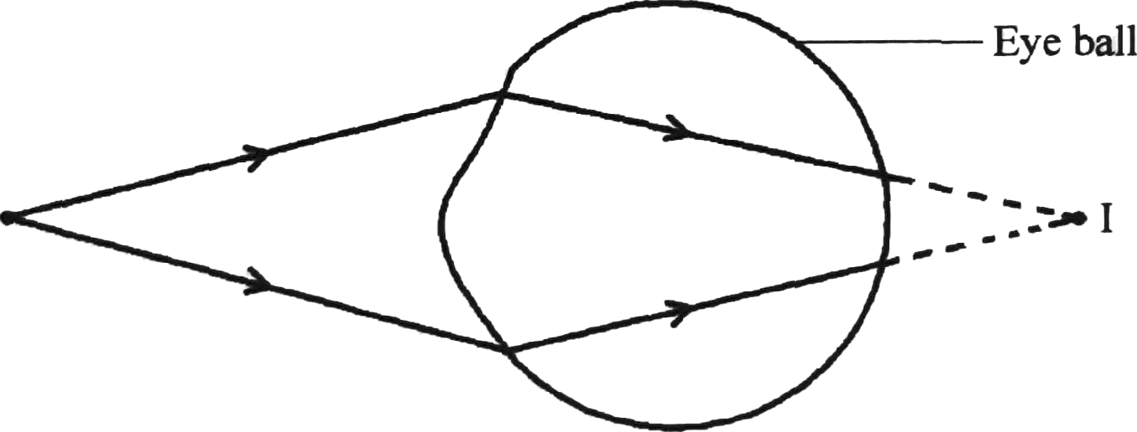

  - State the type of defect shown. (1 mark)
………………………………………………………………………………………………………………………………………………………………………………………………………………………………………………………………………………………………………

  - Identify one cause of this defect. ( 1 mark)
………………………………………………………………………………………………………………………………………………………………………………………………………………………………………………………………………………………………………

  - State the type of lens that can be used to correct this defect. ( 1 mark)
………………………………………………………………………………………………………………………………………………………………………………………………………………………………………………………………………………………………………

- Figure 11 shows a graph of image distance (V) against the object distance (U) obtained in an experiment to determine the focal length of a concave mirror

  - Identify and mark a point X on the graph where V = U.

  - Use the point X to determine:
- The radius of curvature r. (1 mark)
………………………………………………………………………………………………………………………………………………………………………………………………………………………………………………………………………………………………………

- The focal length of the lens f. (2 marks)
………………………………………………………………………………………………………………………………………………………………………………………………………………………………………………………………………………………………………

- On the space provided, draw a ray diagram to show how a convex lens forms a magnified real image. (3 marks)

17. (a) It is observed that alpha (α) particles have a lower penetrating power than beta (β) particles. Explain this observation. (2 marks)
………………………………………………………………………………………………………………………………………………………………………………………………………………………………………………………………………………………………………

(b) A radioactive substance has a half-life of 12 years. Determine the time it would take to
decay to 12.5% of its original value. (2 marks)

………………………………………………………………………………………………………………………………………………………………………………………………………………………………………………………………………………………………………

(c)A Geiger Müller (GM) tube is used for detecting radiations from a radioactive source
State the function of
    - The mica window. (1 mark)
………………………………………………………………………………………………………………………………………………………………………………………………………………………………………………………………………………………………………

    - Bromine gas in the tube. (1 mark)
………………………………………………………………………………………………………………………………………………………………………………………………………………………………………………………………………………………………………
(d)In a diffusion chamber, explain why some of the tracks formed are observed to

- Short. (2 marks)
………………………………………………………………………………………………………………………………………………………………………………………………………………………………………………………………………………………………………

- Straight. (2 marks)
………………………………………………………………………………………………………………………………………………………………………………………………………………………………………………………………………………………………………

( e) State two advantages of using a GM tube instead of a diffusion cloud chamber to detect radiations from radioactive substances (2 marks)
………………………………………………………………………………………………………………………………………………………………………………………………………………………………………………………………………………………………………

#END#

