TERM ONE FORM FOUR
AGRICULTURE PAPER 2
TIME: 2 HOURS
NAME……………………………………………….. ADM……………….. CLASS……...

SECTION A: (30 MARKS)

Answer ALL questions in this section in the spaces provided.
1. State FOUR categories of produce stores found in a farm (2mks)

2. Give TWO reasons for tooth clipping in piglets (1mk)

3. State TWO uses of a rake (1mk)

4. State TWO diseases that may affect bees in a colony (1mk)

5. Differentiate between a heifer and a cow (1mk)

6. Name FOUR species of livestock that are affected by tapeworms (2mks)

7. Name FOUR viral diseases that affect poultry (2mks)

8. State FOUR disadvantages of natural incubation in poultry production (2mks)

9. Name TWO causes of bad flavors in milk production (1mk)

10. Give TWO causes of death in cows during or after parturition (1mk)

11. Differentiate between roughages and concentrates as used in livestock nutrition (1mk)

12. List THREE zoonotic diseases that can occur on the farm (1½ mks)

13. State FOUR uses of harrows on the farm (2mks)

14. State FOUR signs of heat in pigs (2mks)

15. Name FOUR plant species that can be used to establish live fences (2mks)

16. Give TWO benefits of scattering grains in a deep litter poultry house (1mk)

17. List THREE types of lubrication systems in farm machines (1½ mks)

18. List THREE sheep breeds reared for meat production in Kenya (1½ mks)

19. List THREE farm tools used during castration of farm animals (1½ mks)

20. Give FOUR disorders associated with calcium deficiency in livestock (2mks)

SECTION B: (20 MARKS)

Answer all the questions in this section in the spaces provided.

21. The diagram below represents conditions of the tyre.

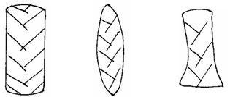
E
F
G

- Which diagram represents the correct pressure in a tractor tyre? (1 mark)

(b) Identify the mistakes with the other two tyres. (2 marks)

- Give the correct measures taken for each tyre mentioned in (b) above.(2 marks)

22. Study the diagram below of a farm structure.

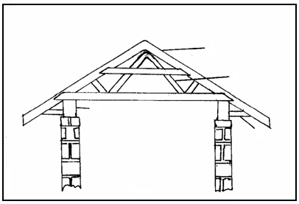
D
A
B
E

(a) Identify the structure above. (1 mark)

(b) Name the parts labeled.(4 marks)

A

B

E

D

23. Study the tools below and answer the questions below.

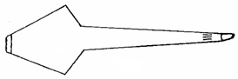
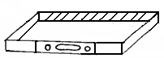
W
X
Z

(a) Identify the tools.(3 marks)

W

X

Z
(b) What are the functions of tools? (2 marks)

Z

X

24. Study the diagram below then answer the questions that follow.
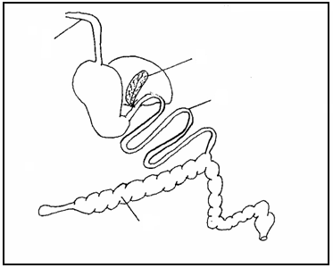
A
B
C
D

(i) Name one farm animal which has the above digestive system.(1 mark)

(ii) Label the following parts.(2 marks)

A

B
(iii) Give the functions of each of the parts named :( 2 marks)

C

D

SECTION C
Answer any two questions in this section in the spaces provided
25. (a) Give the differences between a petrol and a diesel engine (10mks)
(b) Describe the daily maintenance of a tractor (10mks)
26. (a) What are disease predisposing factors? (2mks)
(b) State five disease predisposing factors in livestock (5mks)
(c)State five predisposing factors of mastitis in dairy cattle (5mks)
(d) Explain any four general methods of disease control in livestock (8mks)
27. Discuss the management of layers from day old up to point of laying in a deep litter system. (20mks)

