NAME:…………………………………………………………………………………...…………
SCHOOL:…………………………………………………………………………………………..
A.D.M NO:……………………………………….. DATE:………………………………………
SIGNATURE:……………………………………

231/2
BIOLOGY
PAPER 2

FORM THREE
BIOLOGY P2

Instructions To Candidates
Write your name and index number in the spaces provided above.
Sign and write the date of examination in the spaces provided above.
Answer all questions in section A the spaces provided
In section B, answer question 6 (compulsory) and either question 7 or 8.
You are required to spend the first 15 minutes of the time allocated for this paper reading the whole paper carefully before commencing your work.
For examiners use only
Section | Question | Maximum Score | Candidate’s Score
A | 1
 | 2
 | 3
 | 4
 | 5
B | 6
 | 7 or 8
 | Total | 80
SECTION A (40 MARKS)
Answer ALL the questions in this section in the spaces provided

1. a) Distinguish between natural and acquired immunity (l mark)
………………………………………………………………………………………………………………………………………………………………………………………………
b) Define the term allergy (l mark)
………………………………………………………………………………………………………………………………………………………………………………………………
c) The chart below shows the blood clotting mechanism
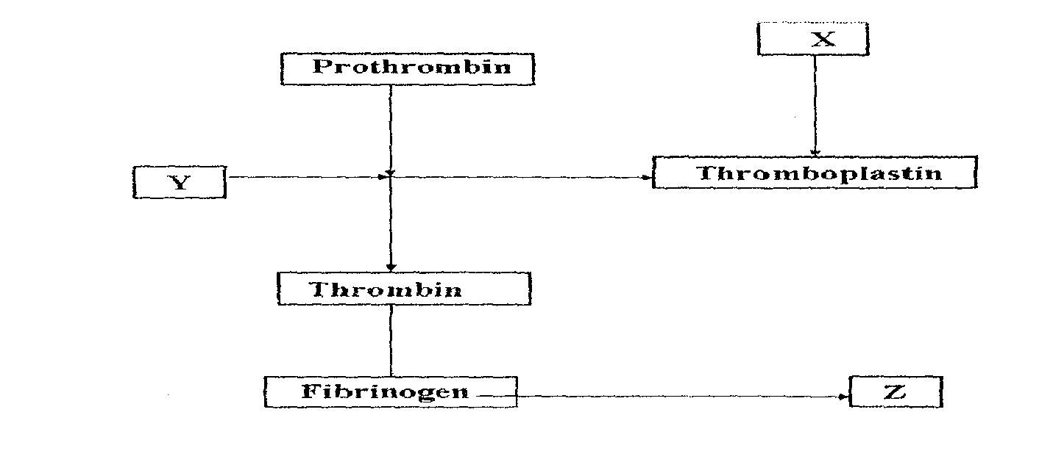
i) Name the blood cells represented by X (1mark)
………………………………………………………………………………………………………………………………………………………………………………………………
ii) The end product of the mechanism represented by Z (1 mark)
………………………………………………………………………………………………………………………………………………………………………………………………………………………………………………………………………………………………
d) Explain how the following environmental factors increase the rate of transpiration.
i) Temperature (2 marks)
………………………………………………………………………………………………………………………………………………………………………………………………………………………………………………………………………………………………
ii) Humidity (1 mark)
………………………………………………………………………………………………………………………………………………………………………………………………………………………………………………………………………………………………
iii) Atmospheric pressure (1 mark)
………………………………………………………………………………………………………………………………………………………………………………………………………………………………………………………………………………………………………………
2. A student wanted to observe human red blood cells under a light microscope. He put l0ml of
solution X,Y and Z in three boiling test tubes. The solutions were of different concentration .In
each of the test tubes he put three drops of blood sample. The experiment was left to stand for 30
minutes. He placed one drop of solution X on glass slide and observed under the microscope.
The same procedure was repeated for solutions Y and Z.
He made the following observation.
Solution | Observation
X | Normal Cells
Y | Wrinkled Cells
Z | No cells observed
(a) What was the physiological process observed. (1mk)
……………………………………………………………………………………………………..
(b) Explain why red blood cells observed in solution Y were wrinkled. (3mks)
……………………………………………………………………………………………………..
……………………………………………………………………………………………………..
……………………………………………………………………………………………………..
……………………………………………………………………………………………………..
(c) A 3cm long piece of kale (sukuma wiki) stem was cut halfway along its length as
shown below.
(i) If the piece was placed in solution Z for 30 minutes, its shape changed . Using a pencil draw a diagram in the space provided to show the expected change. (1mk)
……………………………………………………………………………………………………..
……………………………………………………………………………………………………..
……………………………………………………………………………………………………..
……………………………………………………………………………………………………..
(ii) Explain the results obtained in C(i) above. (3mks)
……………………………………………………………………………………………………..
……………………………………………………………………………………………………..
……………………………………………………………………………………………………..
……………………………………………………………………………………………………..

3. During an ecological study, students collected and marked 120 ants and released them. After
48 hours, the students captured another 90 ants, 20 of which had been marked previously.
(a) How many ants were there in the compound? Show your working. (3mks)
.........................................................................................................................................................
.........................................................................................................................................................
.........................................................................................................................................................
.........................................................................................................................................................
.........................................................................................................................................................
.........................................................................................................................................................
(b) What are the limitations of this method in sampling animal populations. (4mks)
.........................................................................................................................................................
.........................................................................................................................................................
.........................................................................................................................................................
.........................................................................................................................................................
.........................................................................................................................................................
(c) State two other methods which could be used to determine the population. (1mk)
.........................................................................................................................................................
......................................................................................................................................................... ……………………………………………………………………………………………………… 4.Examine the diagram below carefully and use it to answer the questions that follow.
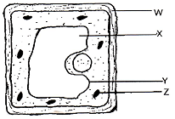

- Name the parts labeled X, Y, and Z (3marks)
X:
………………………………………………………………………………………………………………
Y:
………………………………………………………………………………………………………………
Z:
…………………………………………………………………………..………………………………….
- State the substance by which the part labeled W is made up of (1mark)
………………………………………………………………………………………………………………………………………………………………………………………………………………………………
- Name the process by which mineral salts move into the structure labeled X (1mark)
...............................................................................................................................................................................................................................................................................................................................................
- Explain what happens to a red blood cell when placed in distilled water. 3marks)
………………………………………………………………………………………………………………………………………………………………………………………………………………………………………………………………………………………………………………………………………………
5.a)Name two sites where gaseous exchange takes place in an aquatic plant. (2marks)
………………………………………………………………………………………………………………………………………………………………………………………………………………………………
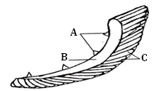The diagram below represents the gills of a bony fish. Study it and answer the questions that follow.

  - Name the parts labeled A, B, and C (3marks)
A:………………………………………………………………………………………………………………
B:………………………………………………………………………………………………………………
C:………………………………………………………………………………………………………………
  - State the function of the part labeled A (1mark)
………………………………………………………………………………………………………………
  - Explain how the part labeled C is adapted to perform its functions (2marks)
………………………………………………………………………………………………………………………………………………………………………………………………………………………………
Answer question 6 (compulsory) and either question 7 or 8 in the spaces provided after question 8
Question 6
Two individuals A and B drunk volumes of concentrated solution of glucose. The amount of glucose in their blood was determined at intervals. The results are shown in the table below.
Time (minutes) | Glucose level in blood mg / 100cm³
0  15  30  45  60  90  120  150 | A | B
 | 87  110  135  115  100  95  90  88 | 84  123  170  188  208  202  144  123
- On the grid provided, plot graph of glucose level in blood against time on the same axis. (6marks)
- What is the concentration of glucose in the blood of A and B at the 20th minute? (1mark)
………………………………………………………………………………………………………………………………………………………………………………………...…………………………………….
- Explain why the glucose level in person A stopped rising after 30minutes while it continued to rise in person B. (2marks)
………………………………………………………………………………………………………………………………………………………………………………………………………………………………………………………………………………………………………………………………………………………………………………………………………………………………………………………………
- Account for the decrease in the glucose level in person A after 30minutes and person B after 60minutes. (4marks)
…………………………………………………………………………………………………………………………………………………………………………………………………………………………………………………………………………………………………………………………………………………………………………………………………………
- Name the compound that stores energy released during oxidation of glucose. (1mark)
……………………………………………………………………………………………………………………………………………………………………………………………………
- State five factors that determine energy requirements in human (5marks)
………………………………………………………………………………………………………………………………………………………………………………………………………………………………………………………………………………………………………………………………………………………………………………………………………………………………………………………………………………………………………………………………………………………………………………………………………………………………………………………………………………………………………………………………………………………………………………………………………………
- Name the organ in which control of blood sugar level mainly takes place. (1mark)
……………………………………………………………………………………………………………………………………………………………………………………………………

7. (a) State four characteristics of gaseous exchange surfaces. (4mks)
(b) Describe the mechanism of gaseous exchange in a mammal. (l6mks)

8. (a) What is meant by the term digestion? (2mks)
(b) Explain the role of bile in the digestion of food. (4mks)
(c) Describe the digestion of protein in the human body. (l4mks)

