NAME:…………………………………………………………..ADM:…………………..CLASS:……………

TEACHER.CO.KE
CHEMISTRY
FORM 3
OPENER EXAM TERM 1, 2022

TIME: 1hr 45 min
MARKS: 70 marks

- State the types of change that take place in each of the following situations.
- Burning a piece of charcoal

- Heating copper (ii) carbonate strongly. (1mk)

- Heating Zinc (II) Oxide strongly. (1mk)

- Name another gas which is used with Oxygen in welding. (1mk)

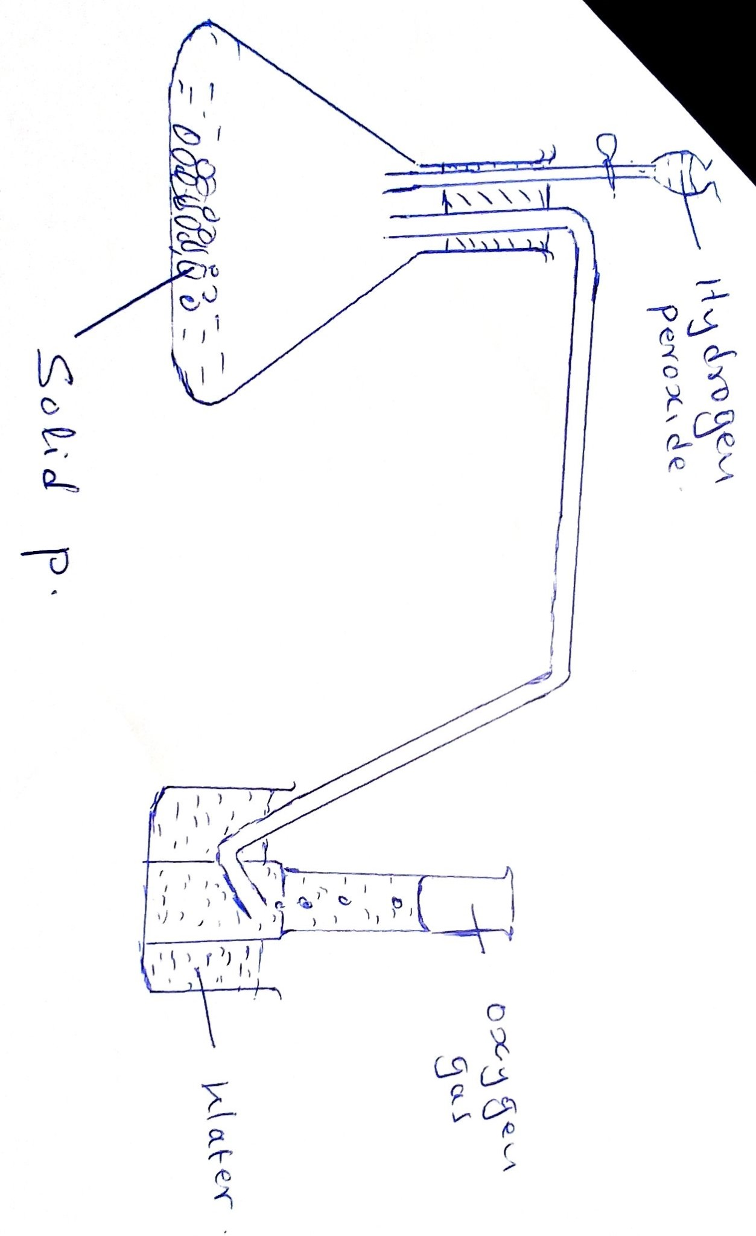

- The diagram below is a set – up for the Laboratory preparation of Oxygen gas.

- Name solid P. (1mk)

- Write an equation for the reaction that takes place in the conical flask. (2mks)

- Give two commercial uses of Oxygen. (2mk)

- State two reasons why hydrogen is not commonly used as fuel. (2mks)

- The figure shows a set – up by a form three student to prepare a certain gas.
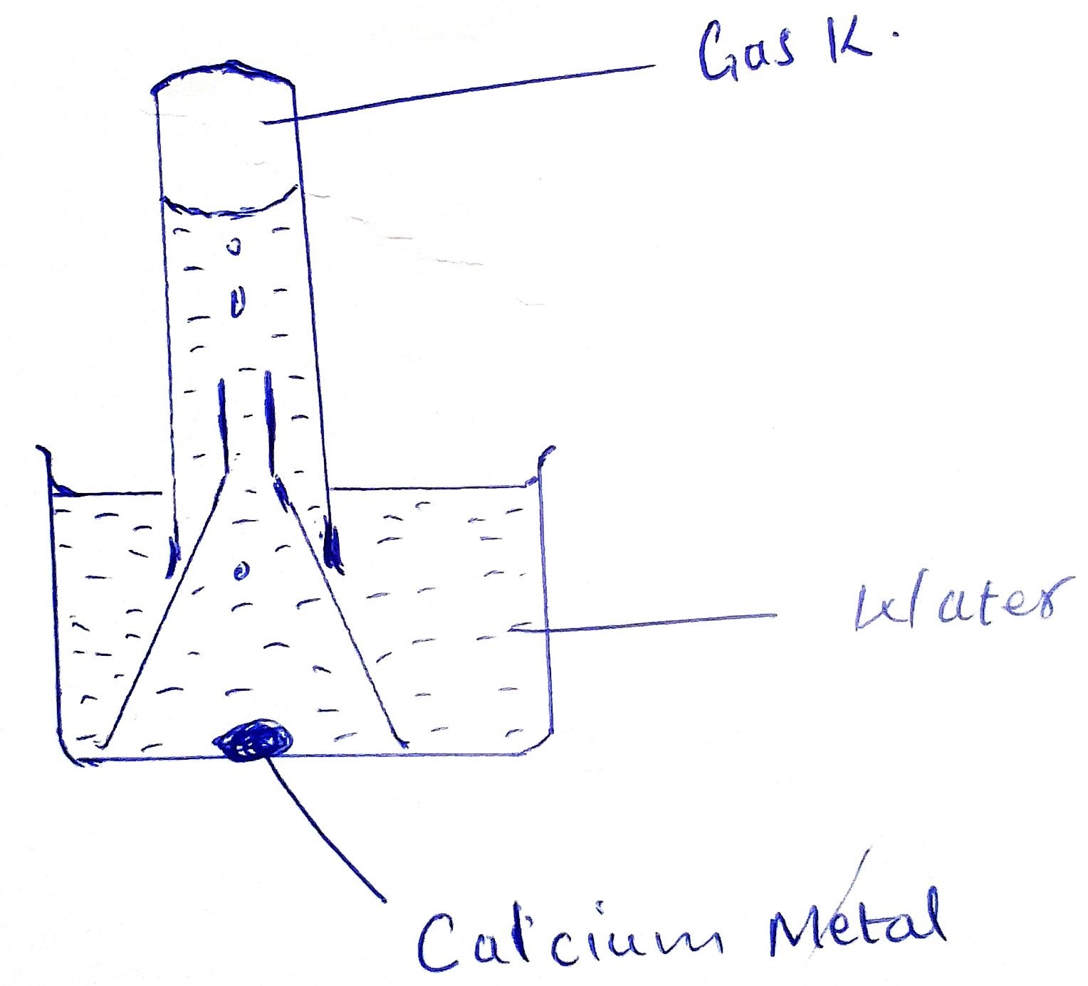

- Write an equation for the formation of gas K. (2mks)

- Give one use of gas K in the industries. (1mk)

- Give one use of the resulting solution after the metal has reacted. (1mk)

- Outline the differences between luminous and non-luminous kinds of the flames. (2mk)

- (a) What are acid-base indicators? (1mk)

(b) Outline the advantages of the universal indicator over the other acid – base indicators. (2mks)

- (a) State Charles law? (1mk)

(b) Explain why motor vehicle tyres should not be inflated hard during the dry season if the vehicle is to be driven over a long distance during the day. (2mks)

(c) A gas occupies 450cm³ at 27ºC. What volume would the gas occupy at 177⁰C; if pressure remains constant?? (3mk)

- Convert the temperature below to the absolute scale.
- 0ºC (1mk)

- 50ºC (1mk)

- -30ºC
(1mk)

- State boyle’s law of gases? (2mk)

- Describe how a solid sample of lead (II) Sulphate would be prepared using the following reagents.
- Sodium Sulphate (3mks)
- Nitric (V) acid
- Solid lead (II) Carbonate

- In the manufacture of Sodium Carbonate by Solvay process, ammoniated brine trickles down the carbonator while carbon (VI) oxide rise up the same tower.
- What is ammoniated brine? (1mk)

- What is the main source of carbon (IV) Oxide in the above process? (1mk)

- Write two equation for the reactions in the Carbonator (2mks)

- Using dots (.) and Cross (x) to represent electrons draw diagram to represent.
- NH₄⁺ (2mks)

- Mg₂N₃ (2mks)

- The grid below shows part of the periodic table, use it to answer the questions follow. The letters do not represent actual symbol of elements.

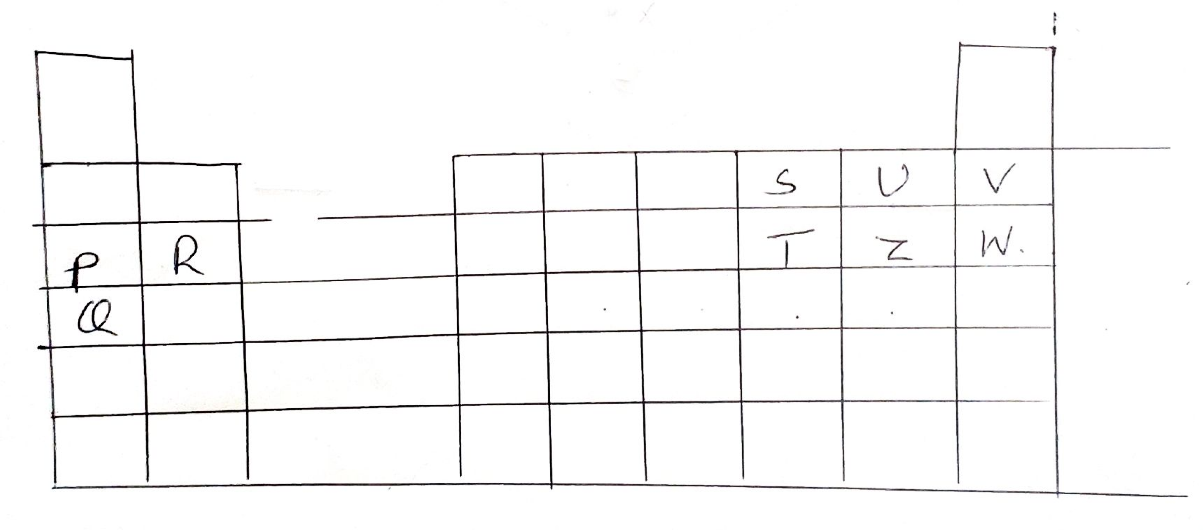

- Identify the families name to which element shown below. Belongs.
- P and Q . (1mk)

- R (1mk)

- U (1mk)

- (i) Which element is highly reactive metal? Explain 2mks)

(ii)Select the element which is highly reactive non-metal. Explain (2mks)

(ii)Which of the elements has the highest atomic radius? Explain (2mks)

- Give electron configuration of
- Element S (1mk)
- Element Q (1mk)

- Compare the atomic radius of P and R. Explain. (2mks)

- Write down the formula of the compounds formed between (2mks)
- Element P and S

- Element R and T

- Name the type of bonding and structure found in.
- Ice (2mks)

- Magnesium Chloride. (2mks)
Bonding –
Structure –
- Explain the following observations.
- Nacl allow electric current to pass through it in a molten state. (1mk)

- Graphite is a non-metal yet it is a conductor of electricity. (1mk)

- a form 2 students electrolyzed lead (II) bromide in a fume cupboard using the apparatus shown below.

- Why is heat needed for this electrolysis? (2mks)
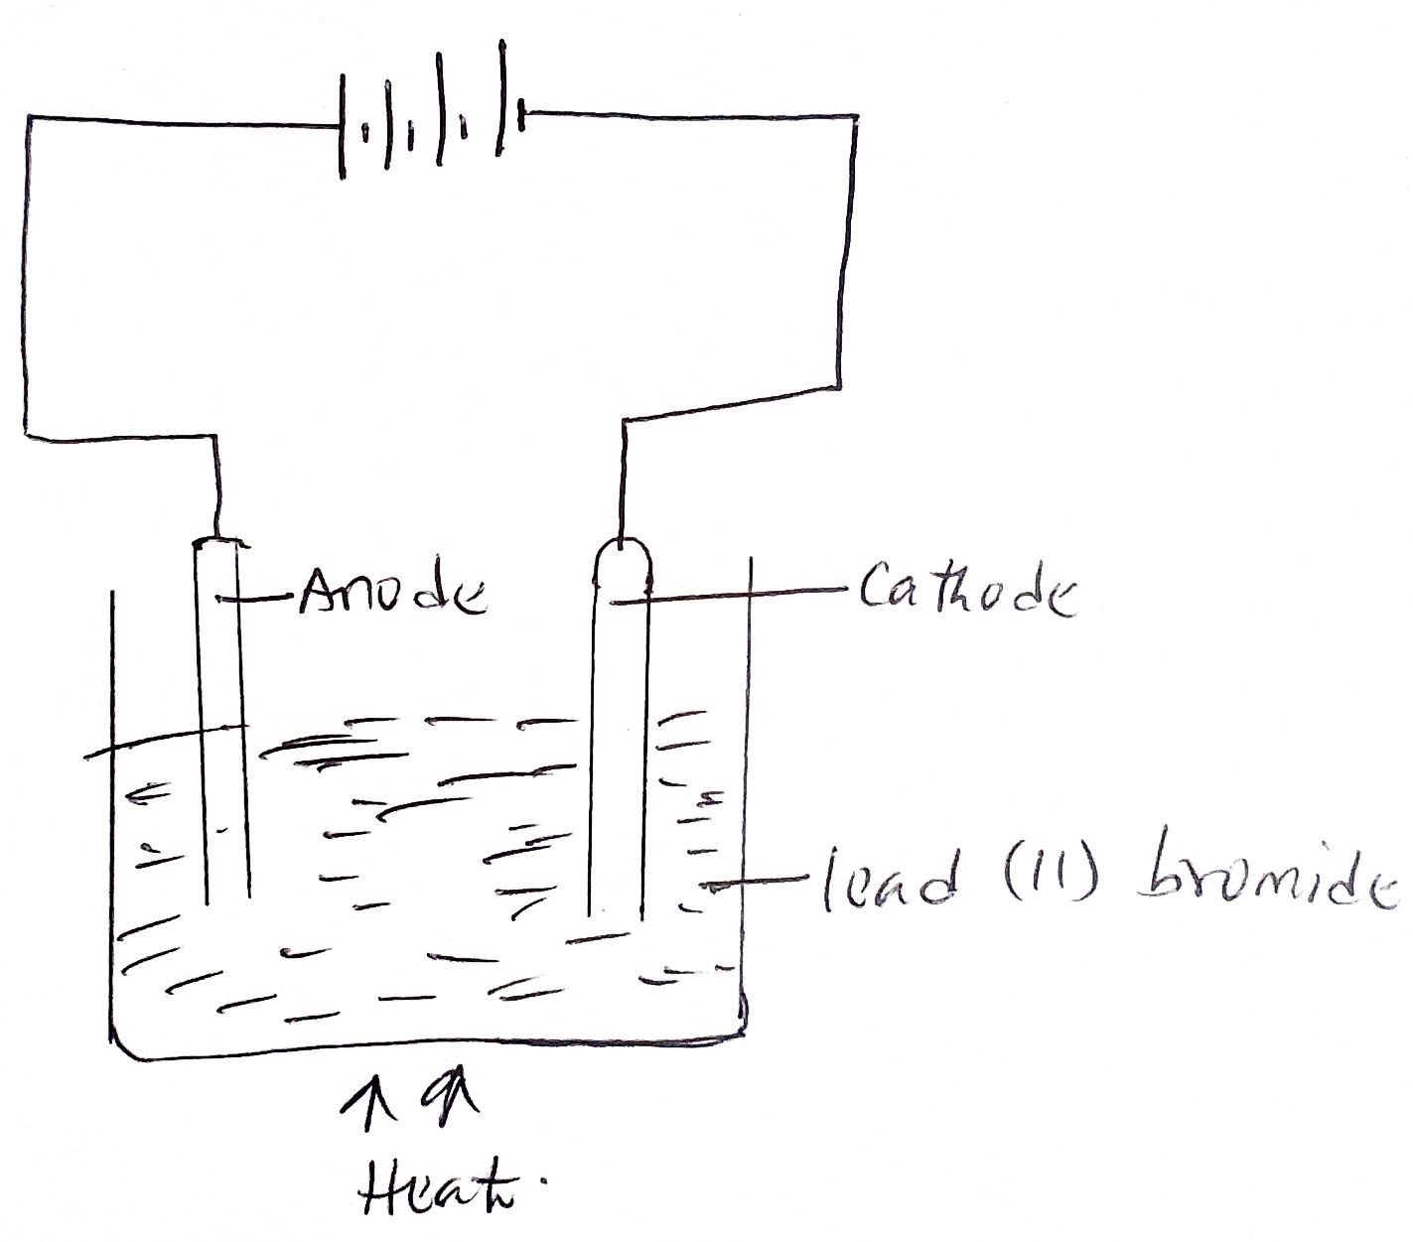

- Suggest the name of a substance that could be used for the electrodes. (1mk)

- State the name of the products of electrolysis at (2mks)
- The anode –

- The cathode-

- Element A, B, C and D are not actual symbols, have atomic number 19, 9, 12 and 10 respectively.
- Which two elements represent non- metals (1mk)

- Write down the formula of the compound formed between elements B and C and identify the bond present in the compound. 2mks)

