NAME :……………………………………………………ADM NO……………….
CANDIDATE’S SIGNATURE………………………….DATE:………………….

BIOLOGY
FORM II
TIME: 2 HOURS

JOINT EVALUATION EXAMINATION
TERM 3 2023
INSTRUCTIONS TO CANDIDATES
- Write your name and admission number in the spaces provided above.
- Answer ALL questions in the spaces provided
- All working must be clearly shown where necessary
- Students should check the question paper to ascertain that all pages are printed as indicated and that no questions are missing

This paper consists of 9 printed pages:
NB: Candidates should check the question paper to ensure that all the printed pages are printed as indicated and no question is missing.

FOR EXAMINER’S USE ONLY
QUESTIONS | MAXIMUM SCORE | CANDIDATE’S SCORE
1-19 | 80

- State the use of each of the following. (3mks)
- Ribosomes ………………………………………………………………………………………………......
- Mitochondria ………………………………………………………………………………………………......
- Lysosome …………………………………………………………………………………………………..
- A ‘dolf’ is an offspring between a wolf and a dog. This animal is infertile. Give a reason for this. (1mk)
……………………………………………………………………………………………………………………………………………………………………………………………………………………………………………………………………………………………………………………………….
- a) What is a hypotonic solution? (1mk)
……………………………………………………………………………………………………………………………………………………………………………………………………………………..
b) Explain the changes that will be observed if a drop of human blood is added to this solution. (3mks)
……………………………………………………………………………………………………………………………………………………………………………………………………………………………………………………………………………………………………………………………………………………………………………………………………………………………………………………………………………………………………………………………………………………..
c) State four importance of osmosis to plants. (3mks)
………………………………………………………………………………………………………………………………………………………………………………………………………………………………………………………………………………………………………………………………………………………………………………………………………………………………………………………………

- Give two main branches of Biology. (2mks)
……………………………………………………………………………………………………………………………………………………………………………………………………………………..
- A certain animal has no incisors and no canine but has six premolars and 6 molars in the upper jaw. In the lower jaw there are 6 incisors, 2 canines, 6 premolars and 6 molars.
- What is the dental formula of the animal? (1mk)
………………………………………………………………………………………………………………………………………………………………………………………………………………
- Calculate the total number of teeth. (1mk)
………………………………………………………………………………………………………………………………………………………………………………………………………………
- Giving reasons, state the mode of feeding. (2mks)
………………………………………………………………………………………………………………………………………………………………………………………………………………
- State and explain three environmental factors that affect transpiration. (6mks)
………………………………………………………………………………………………………………………………………………………………………………………………………………………………………………………………………………………………………………………………………………………………………………………………………………………………………………………………………………………………………………………………………………………………………………………………………………………………………………………………………………………………………………………………………………………

- A man is of group A+.
- What type of antigen does his blood have? (1mk)
………………………………………………………………………………………………………
- What types of antibodies are present in his blood? (1mk)
………………………………………………………………………………………………………
- Which blood groups can he receive blood from? (2mks)
………………………………………………………………………………………………………
- (a) How is the mitochondrion adapted to its function? (2mks)
………………………………………………………………………………………………………………………………………………………………………………………………………………………………………………………………………………………………………………………………………………………………………………………………………………………………
(b) In which part of the mitochondrion does aerobic respiration take place? (1mk)
………………………………………………………………………………………………………
- State four structural differences between arteries and veins. (4mks)
Arteries | Veins

- State three characteristics of a respiratory surface. (3mks)
………………………………………………………………………………………………………………………………………………………………………………………………………………………………………………………………………………………………………………………………………………………………………………………………………………………………………………………………………………………………………………………………………

- The diagram below illustrates the structure of a gill from a bonny fish.
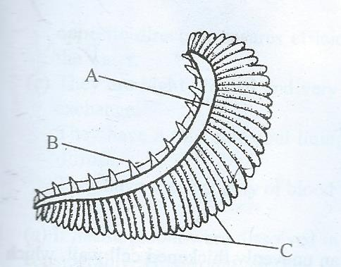
- Name the structures labelled A, B and C and give their functions. (6mks)
A……………………………………………………………………………………………………………………………………………………………………………………………………………
B……………………………………………………………………………………………………………………………………………………………………………………………………………
C……………………………………………………………………………………………………………………………………………………………………………………………………………
- How is structure labeled C adapted to its function? (1mk)
………………………………………………………………………………………………………………………………………………………………………………………………………………………………………………………………………………………………………………………

- State the functions of the following parts of a microscope. (3mks)
- Diaphragm ………………………………………………………………………………………………….
- Condenser ………………………………………………………………………………………………....
- Fine adjustment knob
………………………………………………………………………………………………

- The diagram below represents a transverse section of a part of a young plant and seen under light microscope.
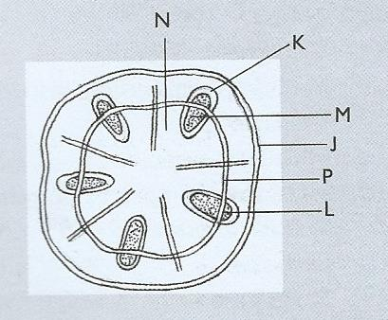
- From which part of the plant was the specimen obtained? (1mk)
………………………………………………………………………………………………………
- Name the parts labelled J,P and M. (3mks)
J……………………………………………………………………………………………………..
P…………………………………………………………………………………………………….
M……………………………………………………………………………………………………

- Name the functions of the part labelled M. (1mk)
………………………………………………………………………………………………………

- State three factors that determine the amount of energy a human requires in a day. (3mks)
………………………………………………………………………………………………………………………………………………………………………………………………………………………………………………………………………………………………………………………………………………………………………………………………………………………………
- State two defects of circulatory system. (2mks)
………………………………………………………………………………………………………………………………………………………………………………………………………………………………………………………………………………………………………………………
b) State three adaptations of erythrocytes to their functions. (3mks)
………………………………………………………………………………………………………………………………………………………………………………………………………………………………………………………………………………………………………………………………………………………………………………………………………………………………………………………………………………………………………………………………………
- A jet aeroplane is able to move and oxidise fuel to carbon (IV) oxide and water yet it is not classified as a living thing. List other characteristics of living things not shown by a jet aeroplane. (3mks)
………………………………………………………………………………………………………………………………………………………………………………………………………………………………………………………………………………………………………………………………………………………………………………………………………………………………
- Outline three applications of anaerobic respiration. (3mks)
………………………………………………………………………………………………………………………………………………………………………………………………………………………………………………………………………………………………………………………………………………………………………………………………………………………………

- Define the following terms. (3mks)
- Excretion ……………………………………………………………………………………………………………………………………………………………………………………………………
- Secretion ……………………………………………………………………………………………………………………………………………………………………………………………………..
- Homeostasis …………………………………………………………………………………………………………………………………………………………………………………………………….

- The diagram below illustrates a nephron from a mammalian kidney.
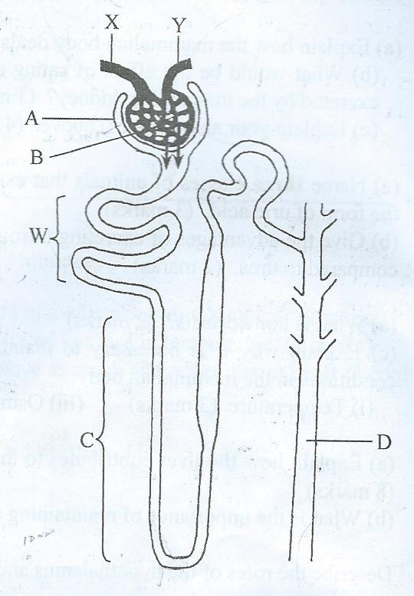

- Name the parts labelled A, B,C and D. (4mks)
A………………………………………………………………………………………………...
B………………………………………………………………………………………………...
C………………………………………………………………………………………………...
D………………………………………………………………………………………………...
- Name the process represented by arrows. (1mk)
…………………………………………………………………………………………………
- Name three substances that are completely reabsorbed in the part labelled W in a normal human being. (3mks)
…………………………………………………………………………………………………………………………………………………………………………………………………………………………………………………………………………………………………………………………………………………………………………………………………………
- Name the component of blood that do not enter the renal tubule in mammals. (1mk)
…………………………………………………………………………………………………..

- How does the part labelled C of a camel compare with that of a hippo? (2mks)
………………………………………………………………………………………………………………………………………………………………………………………………………………………………………………………………………………………………………

