Name__________________________________________ Adm No __________
Date___________________________________________ Sign______________
JOINT EVALUATION
232/2
PHYSICS
2 HOURS
END TERM III EXAM
FORM THREE

INSTRUCTIONS
- Write your name and admission number in the space provided
- This paper consists of two sections A and B.
- Answer all the questions in the spaces provided.
- All working must be clearly shown.
- Mathematical tables and electronic calculators may be used.
For Examiner’s Use Only
SECTION | QUESTION | MAXIMUM SCORE | CANDIDATE’S SCORE
A | 1-12 | 25
B | 13 | 12
 | 14 | 09
 | 15 | 10
 | 16 | 14
 | 17 | 10
 | TOTAL | 80 MARKS

SECTION A (25 MARKS)
Answer ALL the questions in this section in the spaces provided
- The figure below shows a ray of light incident on the surface of one plane mirror.
Sketch the path of the ray on the diagram after striking mirror 2 indicating all the angles. (2 marks)
- Explain why eight dry cells of 1.5V each arranged in series to give a total e.m.f of 12.0V cannot be used to start a car just like a lead-acid accumulator. (2 marks) ………………………………………………………………………………………………………………………………………………………………………………………………………………………………………………………………………………………………………………………………………………
- When a candle flame is brought near the cap of a charged electroscope, the electroscope discharges. Explain this observation. (2 marks) ………………………………………………………………………………………………………………………………………………………………………………………………………………………………………………………………………………………………………………………………………………
- The figure below shows an experiment set up used to illustrate dispersion of white light.
- Identify the colours X and Y. (1 mark)
X ________________________________________
Y ________________________________________
- What physical property changes for the colours when they enter the prism? (1 mark) ……………………………………………………………………………………………………………………………………………………………………………………………………………………

- Diffraction is not a common phenomenon in light. Explain why. (1 mark) ………………………………………………………………………………………………………………………………………………………………………………………………………………………………
- Apart from temperature, state any one other factor which affects the resistance of a metallic conductor. (1 mark) ………………………………………………………………………………………………………………………………………………………………………………………………………………………………
- a) Define the term capacitor. (1 mark) ………………………………………………………………………………………………………………………………………………………………………………………………………………………………
b) Two plates of a parallel-plate capacitor are 0.6 mm apart and each has an area of 4 cm².Given that the potential difference between the plates is 100 V, calculate the charge stored in the capacitor.
(Take ( E _{o} =8.85 * 10⁻¹²*Fm⁻¹) ( 3mks)

- A current of 0.8A flows through an electric circuit. Determine the quantity of charge that passes a point in the circuit in 6 minutes. (2 marks)

- The figure below shows an incomplete circuit of an electromagnet.
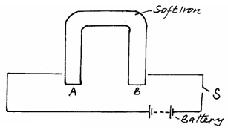
Complete the circuit by drawing the windings on the two arms of the core so that A and B are both north poles when the switch S is closed. Indicate the direction of the current of the windings drawn. (1 mark)

- A girl standing 120m away from a tall building claps her hands and hears an echo 0.75s later. Determine the speed of sound in air at this place. (3 marks)

- The figure below shows a thick copper conductor placed between two poles of a strong magnet. The wire is free to swing in between the poles.
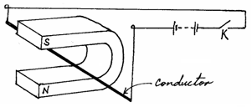
- Indicate on the same diagram the direction in which the conductor swings when the switch K is closed. (1 mark) ……………………………………………………………………………………………………………………………………………………………………………………………………………………

- State one change that can be made on the set up so that the direction of swing of the conductor is reversed. (1 mark) ……………………………………………………………………………………………………………………………………………………………………………………………………………………
- The set up in figure 4 below can be used in a laboratory for lifting and releasing a steel ball.
- State the material which is suitable for use in the core. (1mark) ……………………………………………………………………………………………………………………………………………………………………………………………………………………
- If a slightly larger ball is to be lifted, it is necessary to make an electromagnet stronger. Name two ways of increasing the strength of the magnet. (2 marks) …………………………………………………………………………………………………………………………………………………………………………………………………………………………………………………………………………………………………………………………………………………………………………………………………………………………………………

SECTION B (55 MARKS)
Answer ALL the questions in this section in the spaces provided.
- a) Sound is a mechanical longitudinal wave. Explain why sound is classified as;
- A mechanical wave. (1 mark) ………………………………………………………………………………………………………………………………………………………………………………………………………………………………………………………………………………………………………………………
- A longitudinal wave. (1 mark) ………………………………………………………………………………………………………………………………………………………………………………………………………………………………………………………………………………………………………………………

b) The diagram below shows a set up that was used to demonstrate that, sound is a mechanical wave.
- State the function of the vacuum pump. (1 mark) ………………………………………………………………………………………………………………………………………………………………………………………………………………
- When the switch is closed, state and explain what happens as the air is continuously drawn from the bell jar. (3 marks) ………………………………………………………………………………………………………………………………………………………………………………………………………………………………………………………………………………………………………………………………………………………………………………………………………………………………
- State two possible reasons why it is not possible to reduce the sound completely in this experiment. (2 marks) ………………………………………………………………………………………………………………………………………………………………………………………………………………………………………………………………………………………………………………………………………………………………………………………………………………………………
c) A fishing boat uses ultrasound to detect fish directly below. Two echoes of the ultrasound are received, one after 0.09 seconds coming from the shoal of fish and the other after 0.12 seconds coming from the sea bed. The sea bed is 84m below the ultrasound transceiver.
- State two reasons why ultrasound is preferred. (2 marks) ………………………………………………………………………………………………………………………………………………………………………………………………………………………………………………………………………………………………………………………………………………………………………………………………………………………………
- Calculate the speed of the ultrasound waves in water. (3 marks)

d) State one factor affecting velocity of sound in a solid. (1 mark) ………………………………………………………………………………………………………………………………………………………………………………………………………………………………………………………………………………………………………………………………………………
- a) The figure below shows a method of magnetization used in making magnets.
- Name the method. (1 mark) ………………………………………………………………………………………………………………………………………………………………………………………………………………
- Identify the polarities A and B of the magnet produced. (2 marks)
A ____________________________
B ____________________________
- Apart from this method, state any other method used in magnetization. (1 mark) ………………………………………………………………………………………………………………………………………………………………………………………………………………
b) In demagnetization by electrical method:
- State the type of current used. (1 mark) ………………………………………………………………………………………………………………………………………………………………………………………………………………
- Explain your answer in (i) above. (2 marks) ………………………………………………………………………………………………………………………………………………………………………………………………………………………………………………………………………………………………………………………
- Explain why when demagnetizing a magnet, the magnet should be held in the East-West direction.
(2mrks) ………………………………………………………………………………………………………………………………………………………………………………………………………………………………………………………………………………………………………………………………………………………………………………………………………………………………………………………………

- a) Define the following terms ( 3 mks)

- Principal focus ………………………………………………………………………………………………………………………………………………………………………………………………………………
- Centre of curvature ………………………………………………………………………………………………………………………………………………………………………………………………………………
- Focal plane ………………………………………………………………………………………………………………………………………………………………………………………………………………

b) An object is placed 18 cm in front of a concave mirror of focal length 12 cm. Determine the position and nature of the image formed (3mks)

c) The graph below shows variation of $\frac{1}{u}$ (cm ⁻¹) against $\frac{1}{v}$ (cm ⁻¹) with for an object placed in front of a concave mirror
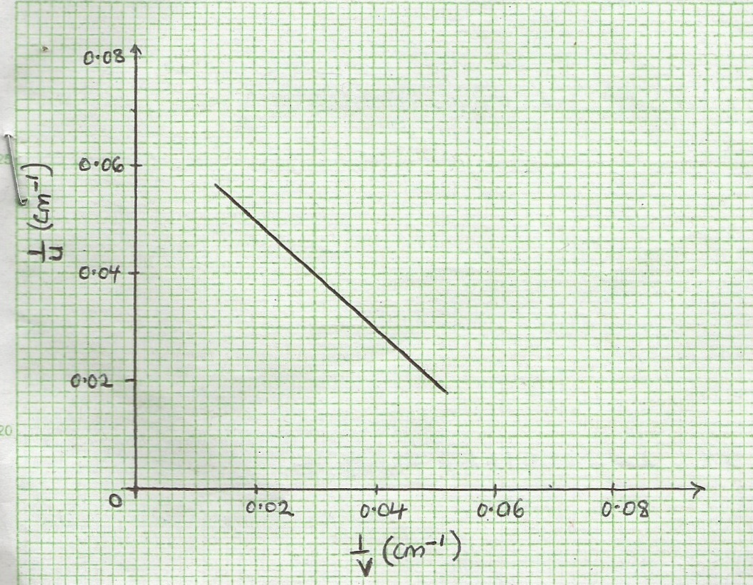

From the graph,
- Determine the focal of the mirror. (2mks)

- Determine the image distance when the object is 20cm from the mirror. (2mks)

- a) The figure below shows how a student set up a circuit using 3 identical bulbs X, Y and Z each rated “12V, 2.0A”
- When operating normally, calculate the resistance of one of the bulbs (2 Marks)

- Calculate the effective resistance of the three bulbs. (2 Marks)

- What will be reading of the ammeter? (2 Marks)

- Draw a circuit diagram showing the three bulbs connected in such a way that they would all work at the same brightness especially if they are not identical. (2 Marks)

b) When the switch S is kept open in the circuit shown below the voltmeter reads 1.5V. When the switch is closed, the readings drops to 1.3V and the current through the resistor is 0.5A.
- What is the e.m.f of the cell? (2 Marks)

- What the terminal voltage of the cell? (1 Mark)

- Calculate the value of R. (3 Marks)

- a) Sketch a graph of displacement against time for a transverse wave of frequency of 50Hz of at least two cycles with amplitude 2cm. (4marks)

b) State two factors affecting velocity of sound in air (2marks) …………………………………………………………………………………………………………………………………………………………………………………..…………………………………………..
c) State two uses of echoes. (2 marks) ………………………………………………………………………………………………………………………………………………………………………………………………………………………………

