NAME: ………………………………. ADM NO: ……….. CLASS: …………….
FORM TWO PHYSICS
MID TERM 1 EXAMS 2023
TIME: 1 ½ HOURS
Answer all the questions in the spaces provided.

1. The figure below shows the scale of a verniercallipers which was being used to measure the internal
diameter of a tin. The verniercallipers has a zero error of +0.22 cm.
6 7 8

- Record the actual diameter of the tin. (3 marks)
………………………………………………………………………………………………………………………………………………………………………………………………………………………………………………………………………………………………………………………………………
- State one advantage of the above measuring instrument over a micrometer screw gauge.(1 mark)
………………………………………………………………………………………………………………………………………………………………………………………………………………………………………………………………………………………………………………………………………
2. State the Pascal’s Principle of transmission of pressure in fluids. (2 marks)
………………………………………………………………………………………………………………………………………………………………………………………………………………………………………………………………………………………………………………
3. The figure below shows an iron bar being magnetized with a magnet.
Magnet
Y
X

N
N

S

- Identify the magnetization method being used. (1 mark)
........................................................................................................................................................................................................................................................................................................................................
- Name the polarities X and Y of the resulting magnet. (2 marks)
........................................................................................................................................................................................................................................................................................................................................
4. The diagram below shows a steel rod AB inside a solenoid.
Switch
Dry cell
B
A
steel rod

- What is the name of the above method of magnetization? (1 mark)
........................................................................................................................................................................................................................................................................................................................................
- Give the polarities of ends A and B when the switch is put on. (2 marks)
...........................................................................................................................................................................
…………………………………………………………………………………………………………………………………………………………………………………………………………………………………………………………………………………………………………………………………………………………………………………………………………………………………………………………………………………………………………………………
5. (a) A battery is rated 70AH, giving a practical example, explain the meaning of the rating?
(1 mark)
………………………………………………………………………………………………………………………………………………………………………………………………………………………………………………………………………………………………………
(b) A certain battery drives a current of 2A in a circuit for 1 hour. Calculate the quantity of charge in the circuit? (2 marks)
……………………………………………………………………………………………………………………………………………………………………………………………………………………………………………………………………………………………………………………………………………………………………………………………………………………………………………………………………………………………………………
…………………………………………………………………………………………………
6. A uniform 90cm rod AB is balanced at its center of gravity, weight Y, 1N and 2N are hung 20cm, 65cm and 85cm respectively from A. Calculate the force Y? (3 marks)
………………………………………………………………………………………………………………………………………………………………………………………………………………………………………………………………………………………………………………………………………………………………………………………………………………………………………………………………………………………………………………………………………………………………………………………………………………………………
7. The diagram below shows a simple Voltaic cell. The flow of current is represented by $i.$ Identify:
A
B

- The Zinc rod (1 mark)
…………………………………………………………………………………………………
- The Copper rod (1mark)
…………………………………………………………………………………………………

8. (a) (i) Define moment and state its SI Units. (2 mks)

(ii) Calculate the moment of the force about the fulcrum when a pet toy of mass 10kg is at a distance of 1.2m from the fulcrum. (2 mks)

(b) A uniform metre rule of mass 75g is pivoted freely at the Ocm mark. What force F, applied
vertically upwards at the 50cm mark is needed to maintain the rule horizontally? (3 mks)
F

100cm
Ocm

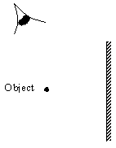
9. Using a ray diagram, locate the images formed in the figure below. (4 marks)

10. The magnetic field between the poles of two permanent bar magnets is shown below. The neutral point is marked X
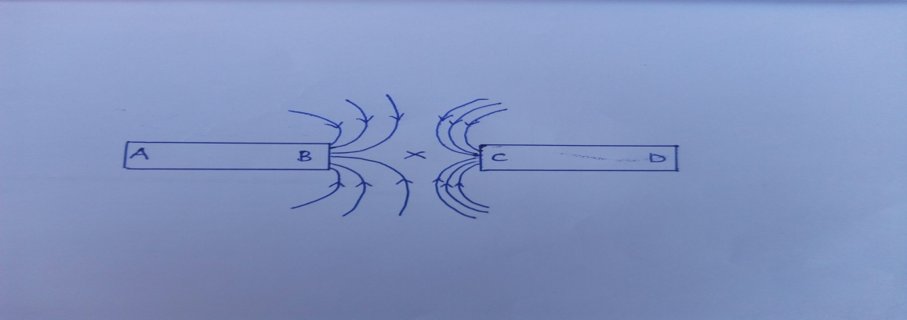
- Explain what is meant by a neutral point? (1 mark)
………………………………………………………………………………………………………………………………………………………………………………………………………………………………………………………………………………………………………
- Identify the poles marked A, B, C and D. (2 marks)
…………………………………………………………………………………………………………………………………………………………………………………………………………………………………………………………………………………………………………………………………………………………………………………………………………
- Which is the stronger pole? B or C. (1 mark)
……………………………………………………………………………………………………………………………………………………………………………………………………
- Give a reason to your answer in (c) above. (1 mark)
………………………………………………………………………………………………………………………………………………………………………………………………………………………………………………………………………………………………………
- The two magnets were prepared by a student in a college. Suggest two different methods by which she could have prepared the two magnets. (2 marks)
………………………………………………………………………………………………………………………………………………………………………………………………………………………………………………………………………………………………………
- Draw the magnetic domains in magnet AB showing clearly the north and south poles.
(2 marks)
A B

- (i) State one difference between the magnetic properties of steel and iron. (2 marks)
…………………………………………………………………………………………………………………………………………………………………………………………
- Given the two materials state which you would use to make: (2 marks)
- An electromagnet
…………………………………………………………………………………………
- A compass needle.
…………………………………………………………………………………………
11. In an experiment to determine the size of an oil molecule, clean water was placed in a large basin and then left over several minutes without any disturbance. Lycopodium powder was carefully spread on the water surface. A drop of oil was then taken from a container using a fine wire. Its diameter was measured using a millimeter scale with the aid of a hand lens and was found to be 0.35mm. The oil drop was carefully transferred onto the water surface where it spread to form a circular patch of diameter 14cm.
- Explain briefly why:
- It was important to use clean water for this experiment. (1 marks)
…………………………………………………………………………………………………………………………………………………………………………………………
- The water was held in a large basin. (1 mark)
…………………………………………………………………………………………………………………………………………………………………………………………
- The water was left undisturbed for several minutes. (1 mark)
…………………………………………………………………………………………………………………………………………………………………………………………
- Lycopodium powder was spread over the surface of the water. (1 marks)
…………………………………………………………………………………………………………………………………………………………………………………………
- Use the measurements obtained to determine:
- The volume of oil. (3 marks)
…………………………………………………………………………………………………………………………………………………………………………………………………………………………………………………………………………………………………………………………………………………………………………………………………………………………………………………………………………………
- The area of the oil patch. (3 marks)
…………………………………………………………………………………………………………………………………………………………………………………………………………………………………………………………………………………………………………………………………………………………………………………………………………………………………………………………………………………
- The approximate diameter of an oil molecule. (3 marks)
…………………………………………………………………………………………………………………………………………………………………………………………………………………………………………………………………………………………………………………………………………………………………………………………………………………………………………………………………………………
- The approximate volume of an oil molecule in mm³ (correct to 3 significant figures) (3 marks)
……………………………………………………………………………………………………………………………………………………………………………………………………………………………………………………………………………………………………………………………………………………………………………………………………………………………………………………………………………………………………………………………………………………………………………………………………………………………………………………………………………
- The number of oil molecules in the oil drop. (correct to 3 significant figures)
Take $π= {22}/7$ (3 marks)
………………………………………………………………………………………………………………………………………………………………………………………………………………………………………………………………………………………………………………………………………………………………………………………………………………………………………………………………………………………………………………………………………………………………………………

