Name: ………………………………………………..………Adm No: ….…………Class: ………… Candidate’s Sign: ………...............Date: ………………………………............................................
OPENER EXAMS
TERM 3 2023
FORM THREE CHEMISTRY

- An element K has atomic number 20 while M has atomic number 8.
- Write the electronic configuration of K and M (2 marks)
K ………………………………………………………………………………………..

M ………………………………………………………………………………………..

- Write the symbol of the most stable ion of K and M (2 marks)
K ………………………………………………………………………………………..

M ………………………………………………………………………………………..

- The diagram below shows a wooden splint that was placed horizontally across the middle part of a non-luminous flame.

- Explain the observation made. (2 marks)
………………………………………………………………………………………………………………
………………………………………………………………………………………………………………
- Give two reasons why non-luminous flame is preferred for heating over luminous flame.
(2 marks)
………………………………………………………………………………………………………………
………………………………………………………………………………………………………………

- Using dots(.) and crosses (x) show the bonding in the following compounds. (N=7, H=1, Na=11, O=6 C=12)
- Ammonia (NH₃) (2 marks)

- Sodium oxide (Na₂O) (2 marks)

- Carbon(ii) oxide (CO) (2 marks)

- Name the method that can be used to separate the following mixtures.
- Aluminium chloride and sodium chloride (1 mark)
………………………………………………………………………………………………………………
- Kerosene and paraffin (1 mark)
………………………………………………………………………………………………………………
- Obtaining oil from nuts (1 mark)
………………………………………………………………………………………………………………

- Air was passed through several reagents as shown in the flow chart below.
Concentrated KOH
Excess heated copper turnings
Excess heated Magnesium
Escaping gases
Air

- What is the purpose of concentrated potassium hydroxide? (1 mark)
………………………………………………………………………………………………………………
- Write an equation for the reaction that take place in chamber containing copper (1 mark)
………………………………………………………………………………………………………………
- Name one gas which escape from the chamber containing magnesium. Give reason. (2 marks)
………………………………………………………………………………………………………………
………………………………………………………………………………………………………………

- The figure below represents a flow chat that occurs in manufacture of nitric(v)acid. Study it and answer the questions that follow.
Ammonia
R
Nitric (V) acid
Air
Air
S
Q
P

- Name substance P,Q,R and S. (4 marks)

P……………………………………………………………………………………………………………
Q……………………………………………………………………………………………………………
R……………………………………………………………………………………………………………
S……………………………………………………………………………………………………………
- To obtain substance R, ammonia is heated at a temperature of 500c in presence of air and catalyst.
- Name the catalyst used for this reaction. (1 mark)
………………………………………………………………………………………………………………
- Write an equation for the reaction that takes place in b(i) (1 mark)
………………………………………………………………………………………………………………
- When ammonia is reacted with nitric(v) acid it produces nitrogenous fertilizer.

- Name the fertilizer produced. (1 mark)
………………………………………………………………………………………………………………

- Calculate the percentage of nitrogen in the fertilizer named in c(i) above. (2 marks)
(N=14, H=1, O=16)
………………………………………………………………………………………………………………
………………………………………………………………………………………………………………
………………………………………………………………………………………………………………
………………………………………………………………………………………………………………
- (a) Sodium chloride was found to be contaminated with copper(ii) oxide. Describe how a sample of sodium chloride can be obtained from the mixture. (3 marks)
………………………………………………………………………………………………………………
………………………………………………………………………………………………………………
………………………………………………………………………………………………………………
………………………………………………………………………………………………………………
- (a) State Charles’ law (1 mark)
………………………………………………………………………………………………………………
………………………………………………………………………………………………………………
………………………………………………………………………………………………………………
(b) A certain mass of a gas occupies 146dm3 at 291K and 98.31kpa. what will be its temperature if the volume is reduced to 133dm3 at a pressure of 101.325kpa. (3 marks)
………………………………………………………………………………………………………………
………………………………………………………………………………………………………………
………………………………………………………………………………………………………………

- (a) The grid below represents part of periodic table. Study it and answer the questions that follows. The letters do not represent actual symbols of elements.
A |  |  |  |  | B |  | C
 | D |  |  | E |  | F | G
H

- Select the most reactive metal. Explain. (2 marks)
………………………………………………………………………………………………………………
………………………………………………………………………………………………………………
- Select an element that can form an ion with a charge of 3⁻ (1 mark)
………………………………………………………………………………………………………………
- Select an alkaline metal. (1 mark)
………………………………………………………………………………………………………………
- Which group 1 has the highest ionization energy. Explain (1 mark)
………………………………………………………………………………………………………………
………………………………………………………………………………………………………………
- Indicate with a tick () an element in group (vi) and period 2 of the period table.
(1 mark)
b) (i) Write the formula of the compound formed between D and G (1 mark)
………………………………………………………………………………………………………………
(ii) Name the type of bond in the compound in b(i) above. Explain (2 marks)
………………………………………………………………………………………………………………
………………………………………………………………………………………………………………
- (a) What is isomerism? (1 mark)
………………………………………………………………………………………………………………………………………………………………………………………………………………………………

(b) Draw and name 2 isomers of C₄H₁₀. (2 marks)

- The following diagram show the structures of 2 allotropes of carbon-study them and answer the questions that follows.
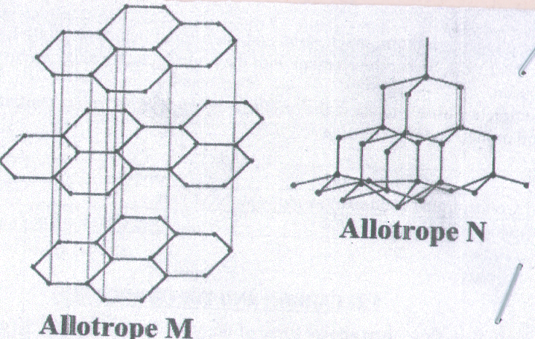

- Define the term allotropes. (1 mark)
………………………………………………………………………………………………………………
………………………………………………………………………………………………………………
- Name M and N (2 marks)
M ………………………………………………………………………………………………………
N ………………………………………………………………………………………………………
- Give 2 uses of N (2 marks)
………………………………………………………………………………………………………………
………………………………………………………………………………………………………………
- Which allotrope conduct electricity? Explain (2 marks)
………………………………………………………………………………………………………………
………………………………………………………………………………………………………………

- (a) The element sodium, magnesium and aluminium belong to period 3 of the periodic table. Select the element with the highest electrical conductivity. (2 marks)
………………………………………………………………………………………………………………
(b) Complete the table below to show the product of electrolysis of the following compound. (2 marks)
compound | anode | Cathode
Molten lead(ii) chloride
Molten magnesium bromide

