30.18 POWER MECHANICS (447)

30.18.1 Power Mechanics Paper 1 (447/1)

1. (a)
- File must have a handle.
- Must be centrally place of work piece.
- User must observe right posture. (Any 2 × ½=1 mark)

(b)
    - Auto mechanics.
    - Salesman.
    - Manager, for example:- workshop, production etc.
    - Draftsman.
    - Technical teacher.
    - Further training. (Any 4 × ½= 2 marks)

2. (a) (i) Tachometer:- used to measure speed of engine revolutions.
(ii) Stethoscope:- used to detect and locate internal engine noises. (2 marks)

(b)
- Cork.
- Copper.
- Rubber.
- Asbestos.
- Steel.
- Processed paper. (Any 4 x ½= 2 marks)

3. (a)
(i) Tab washer.
(ii) Spring washer.
(iii) Lock nut. (1½ marks)

(b)
    - Single rivet lap joint.
    - Double river lap joint.
    - Single strap butt joint.
    - Double strap butt joint. (Any 4 x ½=2 marks)

4. (a)
    - Should be fluid at soldering temperature
    - Should be able to clean the joint
    - Should be easily displaced by molten solder
    - Should form a non corrosive residue. (4 x ½=2 marks)
(b)
    - Graphite.
    - Molytidenum - disulphide.
    - Silicon. (Any 2x ½ -1 mark)

5. (a) A:- Cam lift.
B:- Nose tip apex.
C:- Heel.
D:- Base diameter. (4 x ½= 2 marks)

(b)
- Positive circulation is faster.
- Less mass of water needed.
- Smaller and lighter radiator required.
- Small bore water pipes used.
- Water level not critical.
- Engine operating temperature more accurator. (Any 2x1=2marks)

6. (a)
    - Excessive supply of engine oil.
    - Low viscosity of engine oil.
    - Late injection lining.
    - Worn piston rings. (Any 3x1=3 marks)

(b)
- Worn brake linings.
    - Air in the hydraulic system.
    - Excessive clearance between linings and drum.
    - Incorrect fluid used. (Any 2x1=2 marks)

- (a)
  - Reduces wheel scrub.
  - Eases steering effort.
  - Reduces road shock.
  - Reduces type wear.
  - Compliments caster angle. (2x1=2 marks)

(b)
- Excellent traction especially in hill climbing
    - Compact and accessible power transmission assembly
    - Large passenger space. (3x1=3 marks)

8. (a) Cross-ply tyre has its layers arranged so that each alternate ply lies at different angle to one below while in radial layers are parallel. (2 marks)

(b) (i) Channel.
(ii) Box. (2x ½ =1 mark)

9. (a) Single acting damper acts in one direction usually or rebound while double acting acts on both bump and rebound. (2x1=2 marks)

(b)
- Surface finish.
    - Load on it.
    - Tyre of material.
    - Speed between surfaces in contact. (3x ½ =1 ½ marks)

10. (a) (i)


(ii)
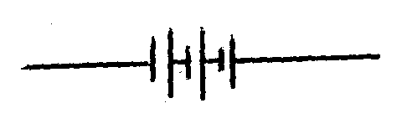

(iii)
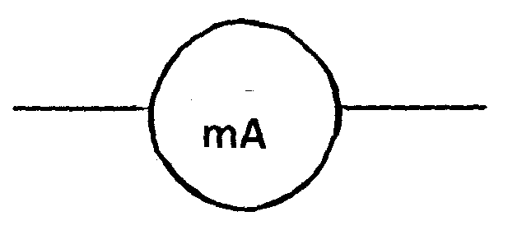 (3 marks)
(b) (i) (ii)
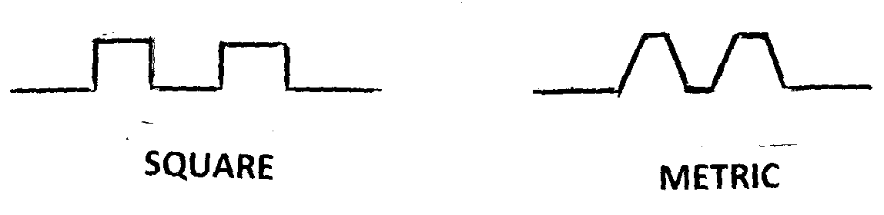 (3 marks)
11.
(a) (b)
(c)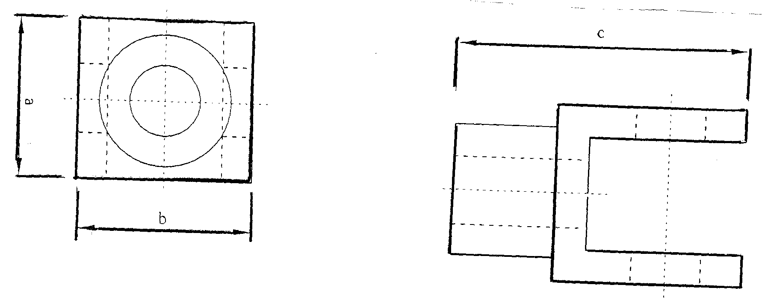
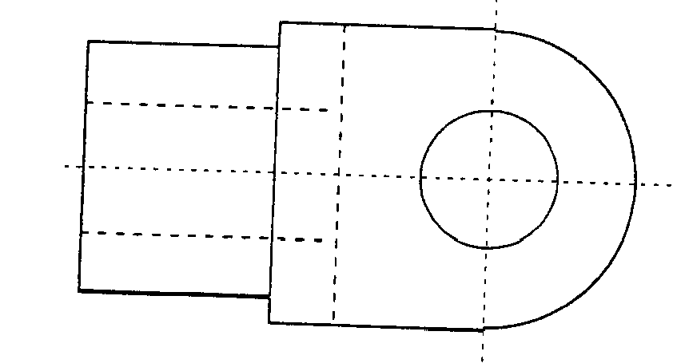 (15 marks)

12.
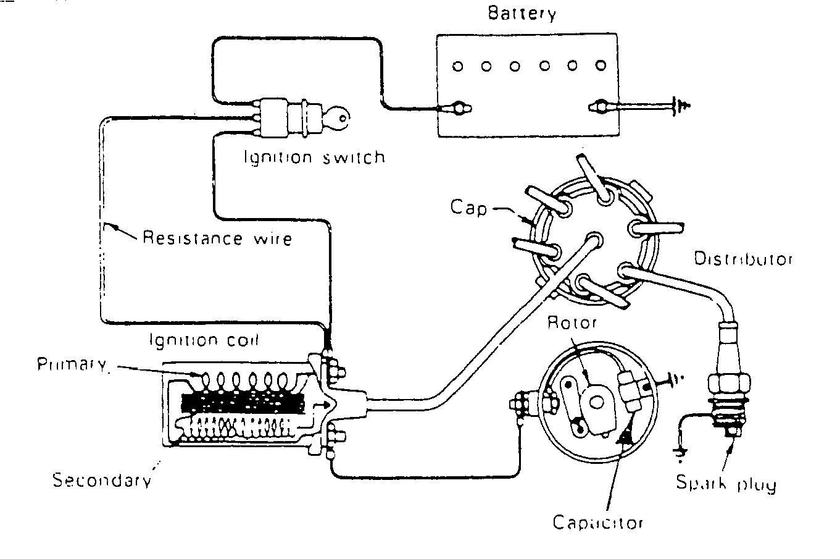
- When ignition switch is turned on, current flows through the battery (+) terminal to the earth.
- If the distributor c. b. points are open no current flows through the coil and no high voltage current is provided.
- When the starter motor is switched on the c b points will close due to crankshaft rotation and the current flows through the primary circuit of the coil causing the secondary windings to generate magnetic field.
- When the points are open the magnetic field induces a high voltage momentarily in the secondary windings
- The distributor rotor distributes this high voltage to the cylinder at the end of compression stroke thus igniting the mixture in the combustion chamber.
(15 marks)
13. (a) Advantages
- Requires less heat than fusion welding.
- Produces less distorted joint.
- Joints are easier to machine.
- Faster process.

Disadvantages
    - Ferrous metals produced a different colour from that of base metal when brazed.
    - Strength of joints deteriorate at temperatures above 250ºC.
(4 marks)
(b)
- Inadequate cleaning of the joint.
- Using wrong or insufficient flux.
- Using wrong welding rod.
- Incorrect welding temperature. (1x4=4marks)

(c)
- Obtain and set the welding equipment, clean the two parts to be joined by removing oxide and dirt.
- Place the two part on table. Hold them in position, select the correct filler rod and flux.
- Preheat the two pieces evenly, applying more heat for thicker piece.
- Heat the metal at weld start, play the torch over this part in a circular motion.
- When metal is red hot, heat rod slightly and stock it into the flux.
- Hold the end of the fluxed rod just ahead of the torch. Apply more heat to the metal until the flux and rod start to flow.
- Machine the finished joint if necessary. (7 marks)

14. (a) It is simple in construction.
It runs more smoothly because of less vibration.
It is lighter in weight. (Any 2x1=2 marks)

(b) (i) D:- Exhaust port.
E:- Transfer port.
F:- Inlet port.
G:- Crankcase.

(ii)
    - Piston is moving up.
    - Inlet port is open.
    - Further movement upwards opens the transfer port and opens the exhaust port.
    - Mixture is compressed in c.c. and then ignited to produce power.
    - In the crankcase fresh charge flows in through the intake port.
- Opens the exhaust port – exhaust gases escapes.
- Opens the transfer port to allow fresh charge into the combustion chamber.
- Deflector on piston crown direct charge in combustion chamber without mixing with exhaust gases.
- Further movement downward opens the inlet port to allow fresh charge.
- The slight compression in crankcase accelerates admission of charge in the chamber. (13 marks)
15. (a) U:-Fuel inlet
V:-Leak of return
W:-Spring
X:-Spindle
Y:-Nozzle
Z:-Seat (3 marks)

(b) Operation: When the standing pressure in the delivery pipe and the injector is exceeded by the pressure built up in the chamber of the injection pump the delivery valve of the pump is forced away from its seat. This higher pressure acts immediately.

In the Annular space of the injector, and by acting on the face of the needle value, produces a force which tends to lift the valve away from the seat. When this force exceeds that applied to the valve by the spring, the valve moves away from its seat, and atomised fuel is sprayed into the combustion chamber.

Continued movement of the pump plunger results in uncovering of its spill port. The pressure in the pump chamber collapses. The injector needle returned to its seat by its spring, and the closing of the pump delivery valve by its spring ensures that fuel under a pressure just less than that required for injection is trapped in the pipeline and injector body. (12 marks)

