**MARKING SCHEME**

**BIOLOGY - PAPER 1 2010**

1. (a) Cytology: Rej cell biology

(b) Microbiology

1. (a) Stem

(b) i) Monocotyledonae

ii) Vascular bundles scattered not arranged in a ring;

Absence of pith; Absence of vascular cambium.

(c) Epidermis

1. (a) Protein synthesis (Accept: site for protein symbiosis)

(b) Destroys worn out organelles/cells/tissues

Destroys micro-organisms.

1. (a) i) Root hair(cell)

ii) D – cell wall

E – cell sap (vacuole)

(b) Controls the functioning of the cell/ controls cell activities

1. A large surface area for efficient diffusion of gases

Moist for gases to diffuse in solution form/to dissolve gases

Thin for efficient/diffusion of gases (across a short distance)

Most be close to body cells/well supplied with blood vessel to active cells

Ventilation mechanism for bringing in air rich in O2 and expelling air rich in carbon(iv) oxide

1. (a) Maintain balance/posture/control/muscular movement

(b) Control heart beat/ blood pressure/ breathing(rate) control involuntary activities/ response

Accp. Curved examples of v.a e.g. eating, swallowing e.t.c.

1. Haemolysis – process by which red blood cells take in water till they burst; while

Plasmolysis – loss of water from plant cells until the cell membrane is detached from the cell wall/ until the cell become flaccid.

|  |  |
| --- | --- |
| Chilopoda | Diplopoda |
| * A pair of (walking)legs per segment * Body flattened dosoventrally * Body divided into head and trunk Acc. Body divided into two body parts * Posterior genital aperture * Has poisonous claws * Have long antennae | * 2 pairs of(walking)legs per segment * Body cylindrical in shape * Body divided into head thorax and trunk Acc body divided into three body parts * Anterior genital aperture * Lacks poisonous claws * Have short antennae. |

* They contain chlorophyll which traps/absorb light (energy)
* They have grana which increase surface area for accommodation of a large number of chlorophyll molecules for photosynthesis
* The stoma has enzymes for photosynthesis

1. - Resistance to diseases/pests/adverse weather conditions (Acc. Correct examples e.g. drought, very high/ low temperatures

- Increased yields

- Earlier maturity Acc. Early maturity

1. (a) Aquatic / fresh water

(b) Large air space/aerenchyma

Sclereids

Stomata on upper epidermis/absence of stomata in lower epidermis

Absence of cuticles

Poorly developed vascular bundles

1. J – sporangium

* Absorption of soluble substances/ digested food
* Secretion of digestive enzymes;
* Anchorage(of mould on substrate); anchorage must be in the right context

1. (a) Place/environment in which (specified)organism lives

(b) A natural unit with abiotic and biotic factors

1. Charcoal in limited supply of air produces carbon(ii)oxide; which combines with haemoglobin forming carboxyhaemoglobin; which is stable/ does not dissolve reducing capacity of the haemoglobin leading to suffocation/ death;
2. a)

X – Starch present

Y – Starch absent

b) X – acts as a control; Y – CO2 absent absorbed by potassium hydroxide pellets; Acc correct explanation

1. Emulsification / breaking down of fats into (tiny) droplets

Creating alkaline medium for digestive enzymes/ neutralizing acidic chyone (from the stomach)

1. (a) Herbivorous; Rej Harbivores

(b) Lack canines/ incisors on upper jaws

1. Animal form waste products more rapidly than plants/ Produce more metabolic wastes

Animals don’t reuse their waste while plans reuse some of their wastes;

1. When temperature is high they dilate; when low they constrict (Acc. Vasodilatation)
2. Higher chances of fertilization

Embryo/gamete is protected from external environment conditions

1. (a) P – sutures

(b) i) Atlas;

ii) Hinge joint

1. (a) Passage of ova/ site of fertilization

(b) Storage of sperms

(c) Hold the testis/ protect the testis

* Absence of nucleus, increase of space for packaging haemoglobin(for carrying oxygen)
* Possession of haemoglobin which has high affinity for oxygen
* Bi-concave shape creates large surface area for combining with oxygen
* Ability to change shape/flexible to enable them pass through capillaries.
* Have carbonic anhydrate which increase CO2 transportation
* Are numerous/many to be able to carry max amount of oxygen
* Has plasma membrane which allow rapid diffusion of gases

1. (a) Use and disuse

Acquired traits can be passed on to offspring

(b) Acquired characteristics cannot be inherited

No evidence to support the theory

* Overcrowding
* Accumulation of toxic wastes
* Limited resources such as nutrients

1. (a) Provide support

Enables plants to grow forward light

(b) In search of nutrients

Anchorage

1. (a) Failure of homologous chromosomes to segregate during meiosis/ anaphase I/ meiosis I

Failure of sister chromatid to segregate during meiosis/ anaphase II / meiosis II.

(b)

i) Down’s syndrome; Turner’s syndrome; Klinefelter’s syndrome

Surnerz syndrome

Acc. Mongolism for Doran’s syndrome

ii) Albinism; single cell anaemia; heamophilia; colour blindness

Chondrodytrophic dwarfism/ Achondroplasia

1. Arteries have thick muscular walls; veins have thin and less muscular walls

Arteries have narrow lumen, veins have wider lumen

Arteries have no valves except at junction with heart; veins have valves at regular intervals.

1. (a) Gymnospermae/ Gymuspermatophyta/ Gymnosperonaphyta;

(b) Needle-like leaves; thick waxy cuticle

Naked seeds; sunken stomata.

1. The inhibition of growth of lateral buds; by auxins; produced by the growing apical bud.

**MARKING SCHEME**

**BIOLOGY - PAPER 2 -2010**

1. .
2. Respiration (Rej: external respiration/ anaerobic respiration )

Acc: aerobic respiration.

1. i) Rise/ increase in thermometer / temperature reading.

ii) stored starch/ glucose/ carbohydrates in germination seeds are broken down/ oxidized to get energy. Some of the energy is released to get energy; some of the energy is released as heat.

1. To kill bacteria/ fungi/ micro-organisms; that would cause decay/ decomposition / respire. (of the bean).
2. To conserve heat/prevent heat loss to surrounding
3. Use similar set up with dead disinfected seed.

Use dead disinfected bean seed/ use of dry bean seeds; acc formaldehyde / formalin for disinfection sodium hypochlorite.

1. .
2. **P –** tissue fluid / intercellular fluid/ space.

**Q** – Venule.

1. i) Glucose, oxygen; Rej: formulae

ii) Carbon (IV) oxide, water; Rej; carbon dioxide OR Formula.

1. Blood entering the arteriole has a higher pressure; than that leaving the venule, the pressure force water and small solutes (molecules) in blood to go through capillary wall forming tissue fluid; Nutrients / oxygen in tissue fluid move into the tissue cells by diffusion; Acc. Nutrients like glucose/ mineral salts/ vitamins/ fatty acids & glycerol. ( Acc 2 nutrients)
2. Red blood cells/ proteins/platelets; Acc one example of protein e.g. globalin.
3. .
4. i) Primary consumer

ii) Primary consumer / Secondary consumers;

1. Green plants Caterpillars Small insects lizard

Decaying leaves Caterpillars Small insects lizard

1. i) Hawks;

ii) At each trophic level energy is lost as heat / respiration; and during decomposition; or lost in defecation/ feces/ waste products of metabolism/ excretion; some parts of the organism are not eaten; (hence less biomass as one moves up the tropic levels.

1. .
2. **X –** pupil

**Y –** circular muscues

1. i) Dimlight / low light intensity/ darkness/ dull light.

ii) Circular muscles in (iris) relax; while radial muscle contract; the pupil becomes bigger allowing more light to enter the eye.

iii) allow one to visualize/ see objects under dim light;

1. .
2. Parental genotype GH X GH - Genotypes

H

H

G

Gametes - Gametes

G

F2 GG GH GH HH

Genotypic ratio GG: GH: HH = 1:2:1;

Punnet Square

Parental genotype GH x GH NB: use of difference letter away 1mark for fusion lines only.

|  |  |  |
| --- | --- | --- |
|  | G | H |
| G | GG | GH |
| H | GH | HH |

1. Black : Black & white : White = 1: 2 : 1
2. i) Codominance; (Rej: incomplete dominance, partial dominance, equal dominance, blending inheritance.

ii) ABO blood group inheritance. Acc. Blood group(Rej; Rhesus factor sickle cells trait.

1. .
2. .

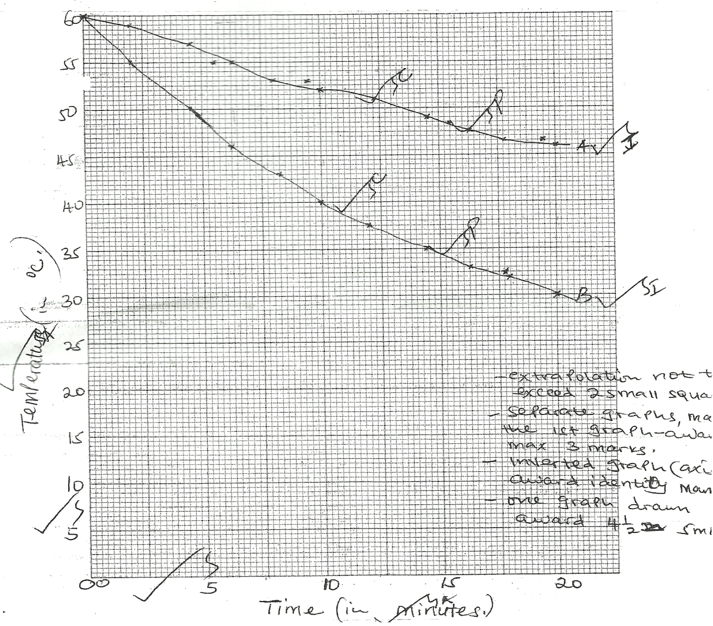

1. i) **A** 56 - 48.5 = 7.5 = 0.75 + - 0.05 per minute.

15 – 5 10

**B** 48 - 34 = 14 = 1.4 + - 0.05 per minute.

15 - 5 10

ii) B has a large surface area to volume ratio making it to lose heat to the to the surrounding faster; Acc the converse/ viceversa.

iii) A rat has a larger surface area to volume ratio compared to an elephant; making the rate to lose heat at a faster rate than an elephant; Acc: the converse/ Viceversa.

1. i) Insulate against heat loss (to surrounding)

ii) Subcutaneous fat (layer) / Adipose tissue/ Bludder; fur/ hair; Rej: wool.

1. Are active always( even under very cold conditions);

Able to escape from predators/ search for food/ mates ( because they are active always)

Can survive in (any habitat) both cold & hot habitat / wide range of habitats.

1. Pollen grains land onto the stigma and adhere to it as a result of the stigma cells secreting a sticky substance . it absorbs nutrients; & germinates forming a pollen tube; the pollen tube grows down the style to the ovary; deriving nourishment from surrounding tissue. The pollen tube has tube nucleus at the tip; and generation nucleus immediately behind it; As the tube grows downwards into the ovary the generative nucleus divided 9by mitosis) mitotically, to give rise to two nucleui; which represent the male gametes; the pollen tube penetrate the ovule/ embryo sac/ chalaza through micropyle. After the pollen tube enters the embryo sac the tube nucleus breakdown/ disintegrates/degenerates; leaving a clear passage for the entry of the male nuclei. The (two male) nuclei then enter into the embryo sac; where one fuses with the egg cell nucleus (Acc; egg cell/ ovum/ oosphere, to form a diploid zygote; which develop into an embryo. The other male nuclei fuse with the two / both polar nuclei; to form atriploid nucleus/ primary endosperm nucleus; which becomes the endosperm. This (type of fertilization) is called double fertilization; Acc vegetative nucleus for tube nucleus.
2. Movement of fish in water is by swimming. It involves forward movement and control of the body position in water. Mucus / streamline body shape reduces friction/ resistance (Acc; scale overlapping backwards) to enhance forward movement; forward movement/ propulsion is caused by the tail. The tail is long (almost half the large of the body of the fish) to enable it create enough force(to enable the fish push forward). Propulsion is achieved when the tail pushes sideways against water. Sideways movement is brought about by muscles arranged in segmented blocks/ myotomes on both sides of vertebrate column to swing sideways; when the muscle blocks on the right relax and those on the left contract; the body bends to the left side. When the muscle of the left relax and those on the right contract; the body bends to the right side; the fish uses its fins to control the position of body in water. During forward movement paired fin/ pectoral & pelvic fins). Lie flat on the body surface to reduce friction/ resistance. To change direction the fish uses the paired fins. Paired fins also are used by fish to change its level in water / control pitching. The fish spreads out the pectoral & pelvic fins at 900 to the body; to enable it brake. Fish can also use the swim bladder to change its level in water. When the bladder fills up with air the fish become less dense / lighter making it to rise in water; when the air leaves the bladder the fish becomes more dense/ heavier; making it to sink deeper in the water. Water currents may cause sideways swaying of the body of the fish/ yawing. The dorsal and ventral fins (also) prevent rolling / yawing; Acc anal fin for ventral fin.

**BIOLOGY**

**PAPER 1**

1. Name two kidney diseases.

2. (a) Write the dental formula of an adult human.

3. Give three reasons for classifying organisms.

4. State one use for each of the following apparatus in the study of living organisms.

(a) Pooter

(b) Pitfall trap

5. The figure below illustrates a food web in a certain ecosystem.

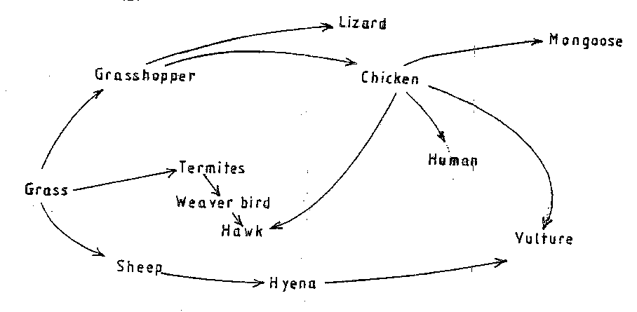

From the food web:

1. Draw the shortest food chain;
2. identify the organisms with the highest

(i) Number of predators

(ii) Biomass

6. What is meant by the following terms?

(a) Ecology

(b) Carrying capacity

7. The diagrams below show an experiment set up to investigate a certain process in a plant tissue.

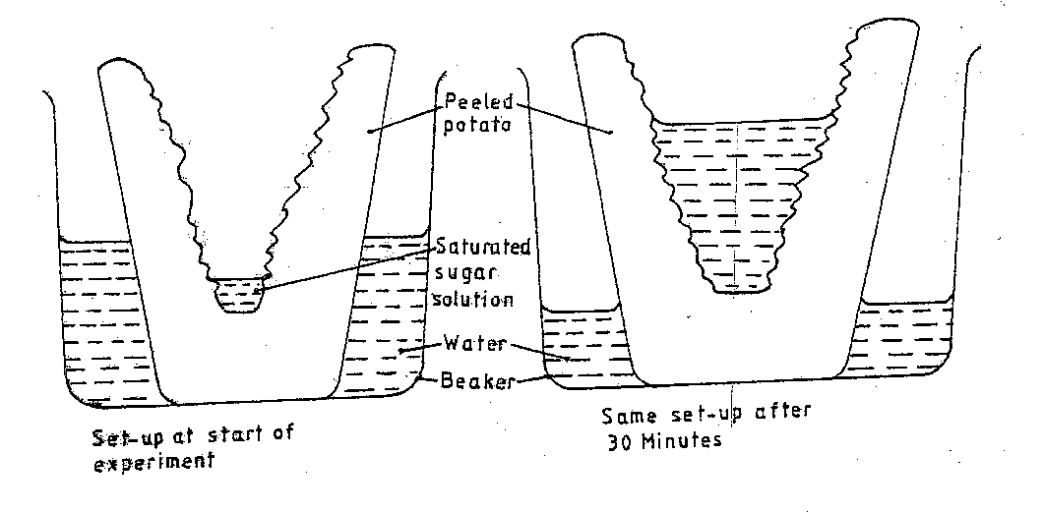

Explain the results obtained after 30 min.

8. State three characteristics of the class crustacean.

9. The diagrams below illustrate the organs of some flowering plants.

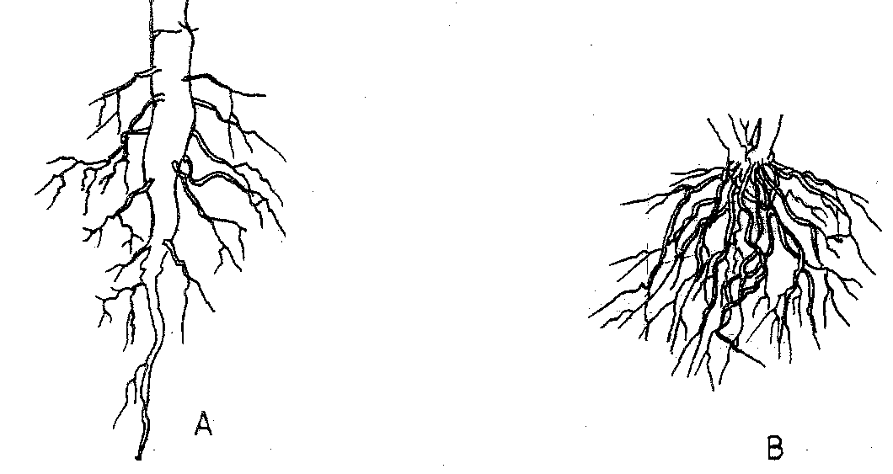

State the classes of plants to which each belong.

A

B

10. (a) give two differences in the products of anaerobic respiration between plants and animals.

(b) Name the site of anaerobic respiration in a cell.

11. State two functions of the following parts of a light microscope.

Fine adjustment knob

Stage

12. The diagram below represents a certain organism.

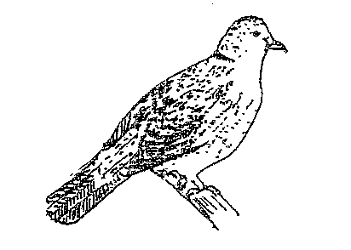

State the phylum and class of carbohydrates in the human body.

14. The diagram below represents a certain plan.

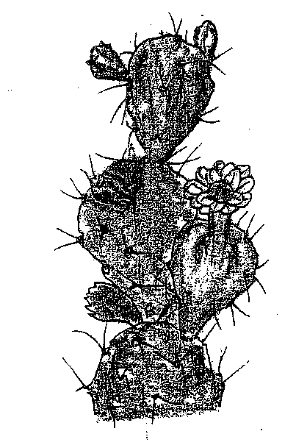

1. What is the likely habitant of the plant?
2. Give two reasons for your answer in (a) above.

15. Give reasons for carrying out the following procedures when preparing temporary wet mounts of plant tissues.

(a) Making thin plant sections

(b) Adding water on the plant section.

16. (a) describe the condition known as varicose veins.

(b) What is the role of blood platelets in the clotting process?

17. The diagram represents part of the human digestive system.

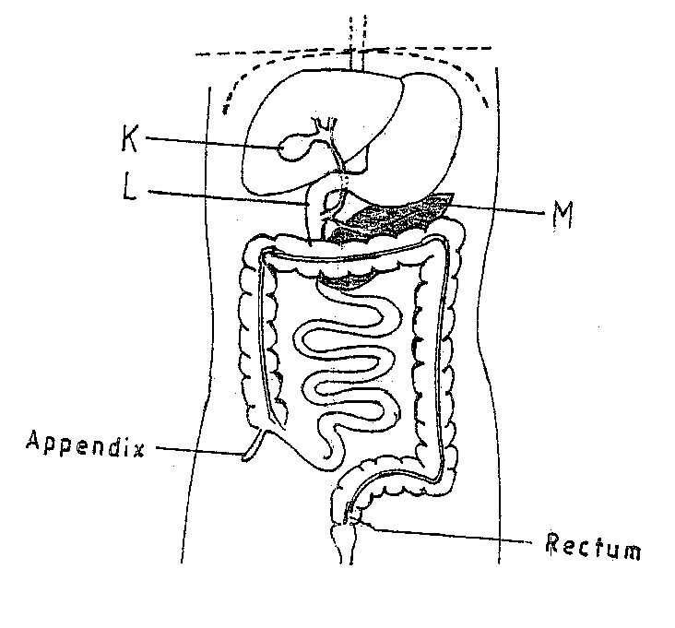

1. Name the organs labeled L and M.

L

M

1. (i) Name the substance named in b (i) above.

19. (a) Apart from the lungs, name two gaseous exchange surfaces in a frog.

(b) Write an equation that summarizes the process of aerobic respiration.

20. The number of stomata on the lower and upper surface of two leaves from plant **X** and **Y** were counted under the field of view of a light microscope. The results were as shown in the table below.

|  |  |  |
| --- | --- | --- |
| **Leaf** | Number of stomata | |
| Upper surface | Lower surface |
| **X** | 4 | 12 |
| **Y** | 20 | 23 |

1. Which of the leaves would be expected to have a lower rate of transpiration?
2. Given a reason for your answer in (a) above

21. (a) what is meant by convergent evolution?

(b) State **two** limitations of fossils as an evidence of evolution.

22. State the difference in content of oxygen and carbon (IV) oxide in the air that enters and leaves the human ling.

23. The diagram below represents a transverse section of an ovary from a certain flower.

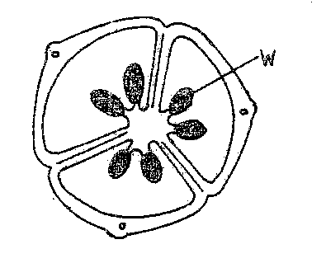

1. (i) name the structure labeled W

(ii) name the type of plantation illustrated in this diagram.

24. (a) Difference between the following terms:

(i) dominant gene and recessive gene;

(ii) continuous variation and discontinuous variation

1. What would be the expected results from a test cross?

25. State one economic importance of each of the following plant excretory products.

(a) Tannin

(b) Quinine

(c) Caffeine

26. Name the gamete cells that are produced by the ovaries.

27. The diagram below represents features of a joint mammal.

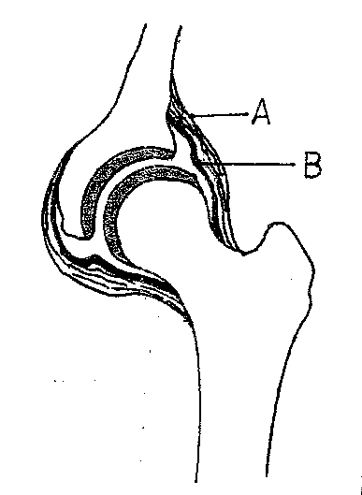

1. Name the part labeled A
2. State the function of the part labeled B

28. (a) What is a tropic response?

(b) State **two** ways by which auxins regulate growth in seedlings

29. State **four** reasons why water is significant in seed germination

**BOLOGY**

**PAPER 1**

1. Nephritis

Kidney sytones

1. i 2/2 C1/1 pm 2/2 m 3/3 or 2(i 2/2 C 1/1 pm 2/2 m 3/3) = 32
2. dental catties; periodenties/ periodontal disease/ pyorihoea
3. Identify similarities and differences between organisms;
4. Organize scientific knowledge in an orderly system
5. Monitor emergency presence and disappearance of organism in and from earth;
6. Grouping organism for easy study,
8. Sacking small insects / small animals
9. A trap into which (small) animals fall and get trapped; Acc’ examples of small animals e.g. insect / reptiles, arachnids
11. Grass grasshopper lizards.
12. i) chicken

ii) Grass

1. This is the study of the inter-relationship between organisms and their environment;
2. The maximum population of a species/ Total number of organisms that a population habitat/ area/ region/ ecosystem can support. V

**Or**

Total number of population of a species a given habitat/ region/ area/ ecosystem can support without depleting available resources; **rej.** If different species

1. Water was hypotonic to cell sap of adjacent and these cell absorb water through osmosis; and their cell sap became less conc. Than those of next cell; the process was repeated until water reached the sugar solution.

**Or**

Sugar solution was hypotonic to cell sap of adjacent cells; they lost water by osmosis; cell sap became more conc. than those of next cell; the process was repeated until water was drawn from the beaker.



* Fused head and thorax/ capholothorax (often) protected by carapace.
* Gaseous exchange through gills
* Two pairs of antennae
* Five more pairs of limbs/ five to twenty pairs of limbs; **rej** five
* A pair of compound eyes
* Three pairs of mouth parts (consisting of labial pulps / maxillae)

1. A – Dicotyledonae

B – Monocotyledonae

1. i) lactic acid in animals while plastic is ethanol / alcohol

ii) No CO2 produced in anaerobic respiration in animals while anaerobic respiration in plants produces CO2

1. Cytoplasm
2. **Fine adjustment knob**

Moves the body tube through smaller distances to bring image/ specimen/ object into sharper/ Sharpe focus.

**Stage**

Platform where specimen (on slide) is placed.

1. Pylum – Chordate

Class – Aves

1. Source of energy

Storage of materials

1. Dry /arid/ semi-arid/ desert
2. Succulent/ freshly stem; reduced leaves/ leaves reduced into throrne/ spines; **Acc.** Thick stem for storage of water.
3. (To reduce layers of cells) to allow light to pass through
4. To make the cell torpid/ prevent drying up;
5. To protect lens on objective; exclude air/ dust/ foreign particles;

Hold specimen in position/ place

1. Weakened/ defective valves in veins; causing blood/ body fluid/ tissues fluid to accumulate; (leading to swelling)
2. (when exposed to air) they disintegrate/ burst; releasing thromboplastin/ thromborinase.
3. L – Duodenum

M – Pancreace

1. i) bile

ii) emulsification/ emulsification of fat; neutralize acidic chime from stomach; provides alkaline media(for enzyme to work)

1. Sublingual; sublmaxillary/ submandibular; parotid
2. Lubricating food; digestion of starch; moistens food; provides alkaline medium; soften food; dissolves food**. Acc,** for correct component of saliva to correct function
3. Skin

Buccal cavity/ mouth cavity; **rej** mouth

1. Glucose + Oxygen Carbon IV oxide + water + enery

C6H12O6 + 6O2 6CO2 + 6H2O + ATP/ enery

1. X
2. X has fewer stomata; most stomata in leaf X are concentrated on the lower side
3. Where different structure evolve to perform different functions (e.g. wings of insect / birds, eye of human and octopus) **rej;** if wrong example given **Acc;** if no example given
4. Missing links; distoration of parts during sedimentation

Destruction of fossilsa by geolopical activities **Acc;** correct e.gs

* Air that enter the lungs has high content of oxygen than air that leaves
* Air that enter lungs has lower content of CO2 than air that leaves

**Acc;** air that enter lungs has 20% – 21% Oxygen, air that leaves has 15% - 17% Oxygen

air that enter lungs has 0.03 – 0.04% CO2, air that leaves has 4.0% CO2

1. i) Ovule; **rej;** ovules

ii) Axile

1. orange or any other citrus fruit; lemon, tangerine, grape, lime, tomato, Sodom apple, irish potato, egg plant, thorn apple, banana
2. i) dominant gene expresses itself in both its homozygous and heterozygous state whole recessive gene can only express itself in the homozygous state.

ii) continous variation is a characteristic for which there is continuum or range while discontinuous variation is a characteristic for which there are discrete/ distinct/ separate/ definite categories or units;

1. (either) all offsprings show dominant characteristics; **or** half offsprings show the recessive while the other halve show dominant characteristics.
2. **Tannin –** softening of leather/ convertion or treatment of hides or skins to leather/ tanning leather/ treatment of leather; manufacture of ink/ printing of fabrics/ dying of clothes/ printing patterns in pots
3. **Quinine –** treatment of malaria
4. **Caffeine –** stimulant in beverages/ increase mental activies/ reduce fatigue
5. Egg/ ovum/ ova; **rej;** ovula
6. Ligament
7. Secretes synovial fluid; contains/ holds the synovial fluid in place
8. It a growth movement in plastic/ part of a plant in response to a unidirectional stimulus; **rej;** unilateral
9. Accelerates growth in shouts

Can inhibit growth in roots **Acc;** High Conc

Promote growth in roots

Inhibit growth in shoots **acc;** low Conc

1. Activate enzyme; provide a medium for enzymatic activities (to break down stored foods to soluble form); Hydrolyses; dissolves food materials; a medium of transportation of dissolved food substances / Oxygen/ nutrients of growing region (of redicle and plumule); soften seed coat to facilitate emergence of radical

**BIOLOGY PAPER 2**

**MARKING SCHEMES**

1. The set-up below illustrates a procedure that was carried out in the laboratory with a leaf plucked from a green plant that had been growing in sunlight. 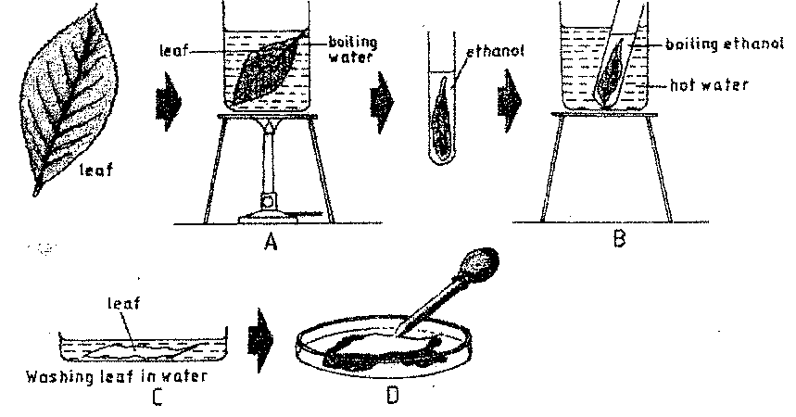
2. What was the purpose of the above procedure ?

*Testing (a leaf) the presence of starch* …………………………. . 1 (mark)

1. Give reasons for carrying out step A,B and C in this procedure. (3marks)

A. *kill the leaf /cells/ protoplasm/ breakdown starch granules/ stop enzymatic activity*

B. *Removal of chlorophyll/ dissolve chlorophyll /desclorise the leaf*

C. *Soften leaf / makes less brittle.*

(iii) Name the reagent that was used at the step labeled D . (1mark)

*Iodine solution ……………………………………………………………………………………*

*………………………………………………………………………………………………………………………..*

(iv) State the expected result on the leaf after adding the reagent named in (iii) above.

Stain dark blue/ Blue dark

1. In humans,hairly ears is controlled by agene on the Y Chromosomes .
2. Using letter YH to represents the chromosome carrying the gene for hairly ears, work out a cross between a hairy eared man and his wife.

(4 marks)

Male female

*Parent/ genotype; X YH X XX ;*

*Gametes ; X YH X X*

*Fertilization*

*F1  genotype XX XX XYH XYH*

(b) (i) What is the probability of the girls having hairly ears? (1 mark)

*0/2 = zero or nil*

(ii)Give reason for your answer in (b (i) above. (1mark)

*The gene for hairly ears is on the Y chromosome which girls do not inherit from their fathers*

………………………………………………………………………………………………………..

(c) Name two disorders in humans that are determined by sex linked genes (2marks)

Haemophilia; colour blindness ; premature boldness ;…………………………….

Duchene muscular dystrophy Award first two correctry given . Rej. colourblind

(d) Explain how comparative embryology is an evidence for organic evolution . (2marks)

Vertebrate embryo have similar morphological feature ; which suggest a common ancestry;

For vertebrates accept any 3 classes of individual s of vertebrates to mean the same as vertebrates,

For morphological features accept any two correctry given e.g viscerod /pharyngeal cleft segmented pyotomes motorchords , tail , single circulatory system ,gill slips or all

3. (a) Name the causative agent for the following respiratory diseases. (2marks)

(i) whooping cough.

Bodetella pertyssis………………………………………………………………………….

1. Pneumonia

Streptococcus pneumonia / influenza virus ; mycoplasma pneumonia 9older children pneumocytis staphylococcus aurens (in adults) chlomydophilar pneumonia

(b) Describe how oxygen in the alveolus reaches the red blood cells . (4marks)

Inhaled oxygen dissolve in moisture in the alveolus; since the oxy gen concentration in the blood is lower

Than in the alveolus; oxgen diffuses ; through the alveolus epithelium , capillary wall enter the plasma/blood /red blood cells

(c) How are the pnematophores adapted to their function ? (2marks)

Grow in to the air above mud / water ; Have lenticels (are in contact with the air ) for gaseous exchange

4. (a) the diagram below represents a section of the human brain.

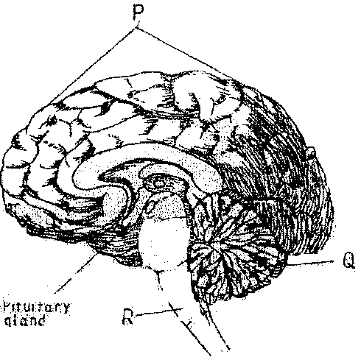

1. Name the structure labeled Pand R.

P - cerebral hemisphere /cerebrum / celebral cortex

R- medulla oblongata

1. State two functions of the part labeled Q

Muscular co-ordination /maintaining body posture/ balance

Motordexterity/skul/ and ease in using the hands

(b) (i) Name two reproductive hormones secreted by the pituitary gland in women. (2marks)

Follicle stimulating hormone ;luteinizing hormone ;oxytocin ; proloctin

(ii) State one function of each of the hormones named in (b)(i) above (2marks)

FSH- stimulates secretion of oestrogen ;stimulates developmemt of grafian follicle ;

LH- brings about ovulation ; causes devptof corpus

Luteum / stimulate production of progesterone by corpus luteum;

Oxytoxin- causes contraction of uterus /causes expulsion releases of milk from mammary glands

5.(a) The diagram below represents a flower.

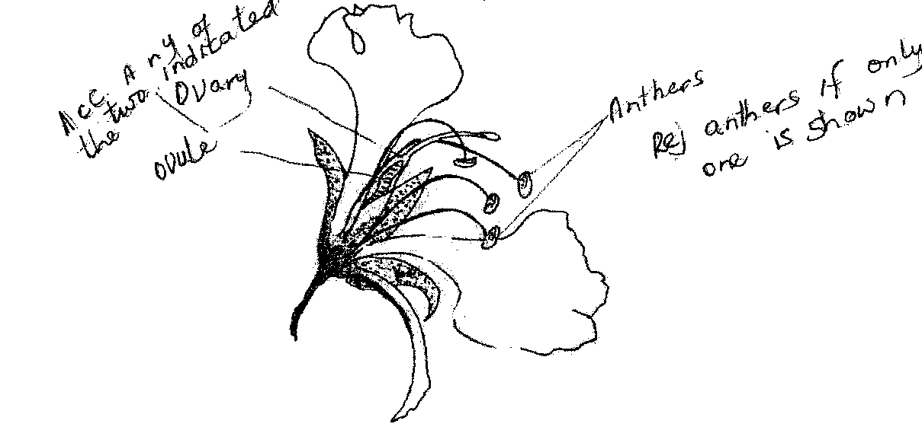

(i)On the diagram , name two structures where meosis occurs. (2 marks)

………………………………………………………………………………………………………..

…………………………………………………………………………………………………………

(ii) How is the flower adapted to prevent self-pollination?

Anthers are below the stigma ; (to minimize pollination)

Petals are large / conspicuous for insects to land on / attract insects (encourage cross pollination )

Acc. Stigma is above the anther

(b)The diagram below represents a human reproductive organ.

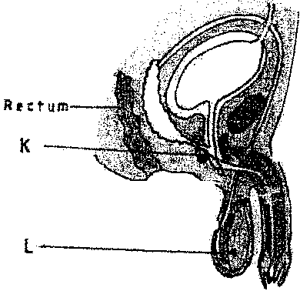

(i)Explain two adaptations of the structure labeled L to its functions (2 marks)

It is hanging outside the body to ensure optimal temperature for sperm production / spermatogenesis

It has (many long and coiled )seminiferous tubules to increase the surface area)for production of sperms

1. Explain the role of gland labeled K

Produces an alkaline fluid that neutralizes acid in the vagina / urethra; Rej. Female urethra

This fluid contains nutrients for the sperms and also activates sperms

**SECTION B** (40 MARKS)

*Answer* ***6( compulsory****) and either question 7 or 8 in the spaces provided after question 8.*

6. (a)An experiment was carried out to investigate the population of a certain micro-organism. Two

|  |  |  |  |  |  |  |  |  |  |  |  |
| --- | --- | --- | --- | --- | --- | --- | --- | --- | --- | --- | --- |
| Relative number of micri-organisms | M | 40 | 40 | 180 | 280 | 1200 | 1720 | 1600 | 1840 | 1560 | 600 |
| N | 40 | 40 | 120 | 200 | 680 | 560 | 560 | 600 | 600 | 400 |
| Time in hours | | 0 | 5 | 10 | 15 | 23 | 30 | 35 | 42 | 45 | 60 |

petri-dishes were used . into the petri-dish labeled m ,60cm3of a culture medium was placed while 30cm3 of the same culture medium was placed in petri-dish labeled N.Equal numbers of the micro- organisms were introduced in both petri-dishes . The set-ups were then incubated at 350c. The number of micro-organisms in each petri-dish was determined at irregular intervals for a period of 60 hours . The results were as shown in the table below

1. On the same axes , draw the graphs of relative number of micro-organisms against time on the grid provided. ( 7 marks)

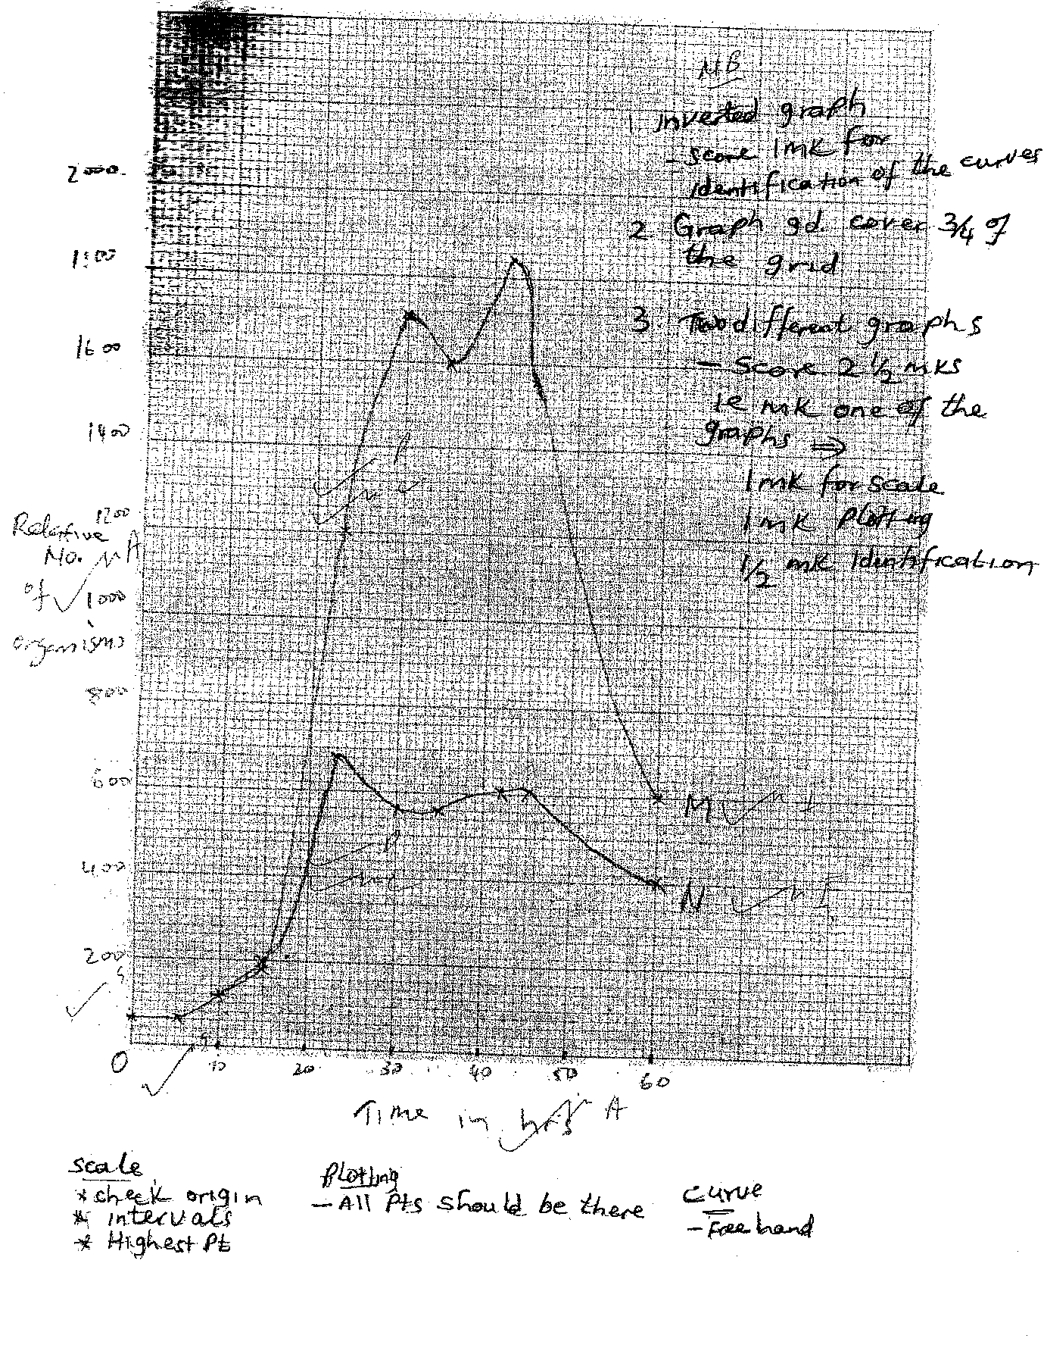

(ii)After how many hours was the difference between the two populations greatest ? (1 mark )

42 hours

(iii)Work out the difference the two populations at 50 hours (2 marks)

m-1220+20(1200-1240)

n-540 +20+(520-560)

1220-540=680+40(640-720)

1. With a reason state the effect on the population of micro-organisms in petri-dish M if the temperature

Was raised to 600c after 20 hours . (2marks)

Population (growth) decreases /reduces /cease ; High temperature kill the micro-organisms / denature enzymes

(v)Account for the shape of the curve for population in petri-dish N between 46hours and 59 hours. (3marks)

Population growth rate decreases; death rate (of micro-orgasms) is higher , than their rate of multiplication ;

Due to exhaustion of nutrients; and accumulation of toxic wastes; shortage of oxygen ; overcrowding/

Shortage of space

(b) Explain how osmotic pressure in the human blood is maintained at normal level. (5marks)

When the osmotic pressure of the blood increases beyond the normal level ( osmoreceptors)hypothalamus detects this and stimulates the pituitary gland to /secrets / release more ADH vasopressins which make kidney tubules more permeable to water ; and more water is reabsorbed into the blood ; reducing the osmotic pressure to the normal level ; Acc reverse

When osmotic presser falls below the nomal level the (osmoreptors) in the hypothalamus detect this the pitituary gland is less stimulated Non /little /less permeable to water hence less water is absorbed into the blood ; increasing the osmotic level

when op is high

when there is too much Na+(aq) – the blood adrenal cortex responds by secreting less aldosterone; which causes less Na+(aq) to be absorbed from the kidney tubules into the blood; lowering the sodium ions level

when op is low

when there is too low Na+ ions /or Na+(aq) in the blood adrenal cortex responds by secreting more adolsterone which causes more Na+ to be reabsorbed from the kidney tubules into the blood ; raising the Na+ level

7.(a) Explain how structural features in terrestrial plants affect their rate of transpiration . (13 marks)

(b)Explain how the human skin brings about cooling of the body on a hot day . (7marks)

8.(a)Describe the exoskeleton and its functions in insects . (13marks )

(b) Describe how accommodation in the human eye is brought about when focusing on a near object . (7marks)

Q7

1. plants in arid /semi arid /desert habitats have leaves covered with thick / waxy cuticles that are water proof/ impermeable to water ; allowing for reduced rate of transpiration ; sunken stomata ; in some desert/ semi arid

areas plants have water vapour accumulating in the pits is not carried away by wind ;most plants have few or no stomata on the upper surface of the leaf/ more stomata on the lower surface sheltered by from direct sunlight; the fewer the stomata the less the water loss from the plant . some plant have small stomata / small stomatas size ; thus reducing transpiration rate plants with small needle like / spine ; expose less surface area hence reduce the rate of transpiration leaves with shiny surfaces; refrect light resulting in reduce d leaf temperature thus reducing the rate of transpiration . some plant have leaves covered with hairly /scales ; which trap a layer of moisture ; (on the leaf surface ) reducing the rate of transpiration . plants growing in wet habitats / mesophyets have athin layer of cuticle which allow high rate of transpiration broad leaves ; expose a large surface area ; many stomata on both sides of the leaves ; have a large stomata.

Q7

1. Light rays from a near object are more divergent ;and need to bend more refrect ; muscles contract ; suspensory ligament slackens ; the lens become thicker / increase in curvature / becomes more convex/ reducing focal length ; light from the object is refrected more ; in order to be focused more sharply on the retina / to form an image of the object on the retina .

Q8

1. The exoskeleton 12 made up of chitin ; chitin is not evenly distributed / chitin is thin &(flexible) at joints ; hence it allows for movement ;,exoskeleton is secreted by the epidermal cells ; when still soft it allows for growth of the insect when(in contact with the air ) it hardens limiting growth ;it shed regularly ;thus regulating growth of insects it also supports the internal structure ;because it is hard it protects internal organs from mechanical damage ;it is water proof ;preventing / reducing water loss / desiccation ; of the insect it also provide a surface for attachment of muscels / apodem projection in which mulscels are attached ; it is light modified into wings / has low density ;for flight ; can be modified to form hand jaws / mouthparts ;for bitting/piercing /sucking / gliding ; it is pigmented ; for camonflage ; can be transparent in some places ; allowing entry of light into the eyes ; for camonflage in water
2. Light rays from a near object are more divergent ; and need to bend more / refrect muscels contract ;suspensory ligament slackens ; the lens becomes thicker /increase in curvature /becomes more convex / reducing focal length ; light from the object is refracted more; in order to be focused more sharply on the letina / to form an image of the object on the retina