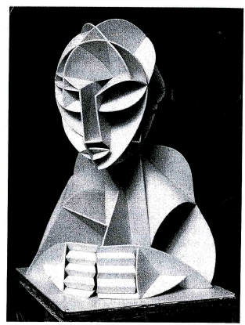
3.14 ART & DESIGN (442)

3.14.1 Art & Design Paper 1 (442/1)
SECTION A (20 marks)
Answer ALL the questions in this section in the spaces provided.
1
(a) Study the form below.

(i) Identify the material and technique used. (1 mark)
(ii) Name the style used. (1 mark)
(b) Explain the term “wash” in reference to painting technique. (2 marks)
(c) Study the visual symbol below.

(i) Identify the symbol. (1 mark)

144

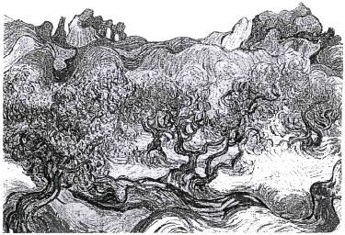
(ii) State its function. (1 mark)
(iii) Classify the symbol. (1 mark)
(d) State the distinctive characteristic of tritik technique in fabric decoration. (1 mark)
(e) Distinguish between warp faced fabric and weft faced fabric. (2 marks)
(f) State two functions of value as an element of Art and Design. (2 marks)
(g) Explain two ways in which colour can be used to create aerial perspective. (2 marks)
(h) Study the picture below.

Identify the most outstanding principle of Art and Design. (1 mark)
(i) State three factors that determine the choice of a pendant. (3 marks)
(j) Give two reasons why it is important to fire clay items. ( 2 marks)

SECTION B (25 marks)
Answer ALL the questions from this section in the spaces provided.
2
(a) Distinguish between tjap and tjanting. (2 marks)
(b) State the role of a fixative in fabric decoration. (1 mark)
(c) Give two reasons for using a double container to melt wax. (2 marks)
3
(a) Name the components of a letterhead. (3 marks)

145

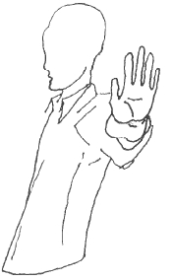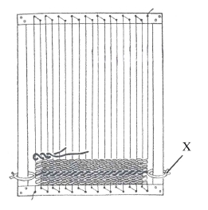
(b) Explain two functions of a letterhead. (2 marks)
4 The illustration below represents a foreshortened arm.

Draw the arm in profile when it is outstretched. (5 marks)
5 The illustration below represents a weaving process.

(a) Identify the weave structure. (1 mark)
(b) What is the main function of the part marked X on the illustration. (2 marks)

(c) Explain two ways that one can employ when weaving a mat so that it is firm.

(2 marks)

6 Outline any five factors to be considered when using lettering in graphic design. (5 marks)

146

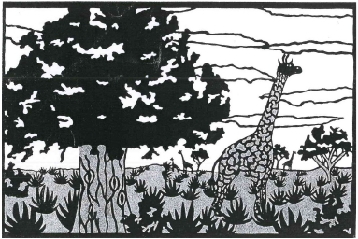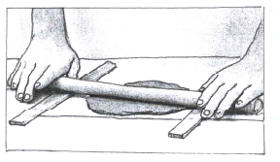
SECTION C (15 marks)
Answer any ONE question in this section. Write your answer in the space provided after question 9.
7 Study the composition below.

Describe how the following pictorial features have been portrayed.
(a) lines (3 marks)
(b) forms (3 marks)
(c) pattern (3 marks)
(d) depth (3 marks)
(e) mood (3 marks)
8 The illustration below represents an activity within the process of a technique in pottery.

(a) Study the illustration and identify the technique. (1 mark)
(b) State the activity illustrated. (1 mark)
(c) Beginning with ready prepared clay, describe the process of building up a form using
the technique. (13 marks)
9 (a) What is meant by the term design process? (1 mark)
(b) State and describe the aspects to be covered under the following sub-topics in design
process:
(i) brief; (5 marks)
(ii) research; (3 marks)
(iii) layout; (3 marks)
(iv) client presentation. (3 marks)
147

3.14.2 Art & Design Paper 2 Practical (442/2)

Answer only ONE question chosen from EITHER alternative A OR B
ALTERNATIVE A: DRAWING OR PAINTING
You are instructed that the use of rulers and other mechanical devices is forbidden in this alternative.
EITHER
1 From imagination, create a pictorial composition based on the theme “Stampede”.
The work should be in an area measuring 35 cm by 45 cm.
OR
2 Produce a pictorial composition from memory depicting “An agile basketballer”.
The work should be in an area measuring 35 cm by 45 cm.
ALTERNATIVE B: GRAPHIC DESIGN
You are instructed that the use of rulers and other mechanical devices as well as tracing paper is
allowed.
The colour of the working surface (paper) will not be considered as one of the colours required in any
question.
EITHER
3 “Uwezo Women Potters”, a local organisation for economic empowerment dealing in
production and sales of African designs requires a logo.
(a) In three colours design the logo measuring 14 cm by 16 cm for the organisation.
(b) In a space measuring 22 cm by 32 cm incorporate the logo at the back of their work
coat.
OR
4 A leading confectionery called Boflo dealing in pastries requires a wrapper with a slogan
“Fancy Bite” for its bread.
In three colours design the wrapper measuring 45 cm by 30 cm.

