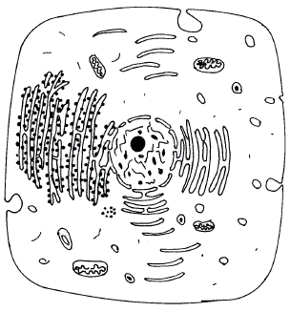
3.4 BIOLOGY (231)

3.4.1 Biology Paper 1 (231/1)

1 (a) What is meant by the term wilting? (1 mark)

(b) Explain how an increase in temperature affects the rate of active transport.

(2 marks)

2 The diagram below represents a cell as seen under an electron microscope.
(1 mark)
6 Using a microscope, a student counted 55 cells a cross a field of view whose diameter was
7 Explain how the following forces contribute to the movement of water up the xylem
(b) adhesion.

(a) Based on the diagram, state whether it represents an animal cell or a plant cell.
(b) Give two reasons for your answer in 2(a) above. (2 marks)
(c) Why is the palisade layer a tissue? (1 mark)
3 (a) State two external features found in the class Mammalia only. (2 marks)
(b) Name the taxonomic unit that comes immediately after a phylum in classification.
(1 mark)
4 (a) State two roles of mucus in the stomach. (2 marks)
(b) Explain how age determines a person’s energy requirements. (2 marks)
5 Describe how turgor pressure builds up. (3 marks)

6000µm. Calculate the average length of the cells. Show your working. (2 marks)

vessels: (2 marks)
(a) cohesion;

47

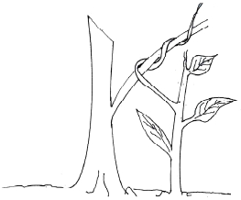
8 Construct a step in a dichotomous key using two leaves one with a serrated and the other with a
(b) mitochondrion. (2 marks)
12 (a) A student collected an organism and observed the following features: simple eyes,
(ii) Give an example of an organism in this class. (1 mark)

smooth margin. (2 marks)
9 State one way in which each of the following is structurally adapted to its function:
(a) neurone; (2 marks)

10 How are lenticels adapted for gaseous exchange? (2 marks)
11 State the advantage of possessing blood group AB. (1 mark)

four pairs of legs and two body parts.
(i) State the class to which the organism belongs. (1 mark)

(b) Name the kingdom to which plasmodium belongs. (1 mark)
13 State two characteristics of living organisms that are specific to plants. (2 marks)
14 Name the three end products of anaerobic respiration in plants. (3 marks)

15 State two reasons why accumulation of lactic acid leads to an increase in heart beat.
16 Name three mechanisms that ensure cross pollination takes place in flowering plants.

(2 marks)
(3 marks)

17 Name the flower part that produces gametes. (1 mark)
18 How is the human sperm cell structurally specialised? (2 marks)
19 State three factors in seeds that cause dormancy. (3 marks)
20 Explain the theory of evolution by natural selection. (2 marks)
21 (a) Explain the role of continental drift in evolution. (3 marks)
(b) What is meant by the term organic evolution? (1 mark)
22 The diagram below illustrates a response by a certain plant.

48

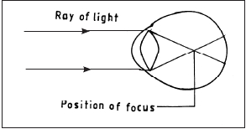
(a) Name the type of response. (1 mark)
(b) Explain how the response illustrated above occurs. (3 marks)
23 The diagram below illustrates a defect in the eye.

Explain how the defect illustrated above can be corrected. (2 marks)
24 Explain three protective functions of mammalian blood. (3 marks)
25 State one adaptation of xylem vessels to their function. (2 marks)
26 (a) What is meant by the term sex linked genes? (1 mark)
(b) Name two sex linked traits in human beings. (2 marks)
27 (a) State two differences between complete and incomplete metamorphosis. (2 marks)
(b) State the importance of moulting to an insect. (1 mark)
28 (a) State two features of a ball and socket joint. (2 marks)
(b) Name the bone that allows the head to:
(i) nod; .....................................................................................................................
(ii) turn side ways ........................................................................................................
(2 marks)
29 State two functions of pelvic girdle in mammals. (2 marks)

30 State two ways in which osmosis is significant to plants. (2 marks)

49

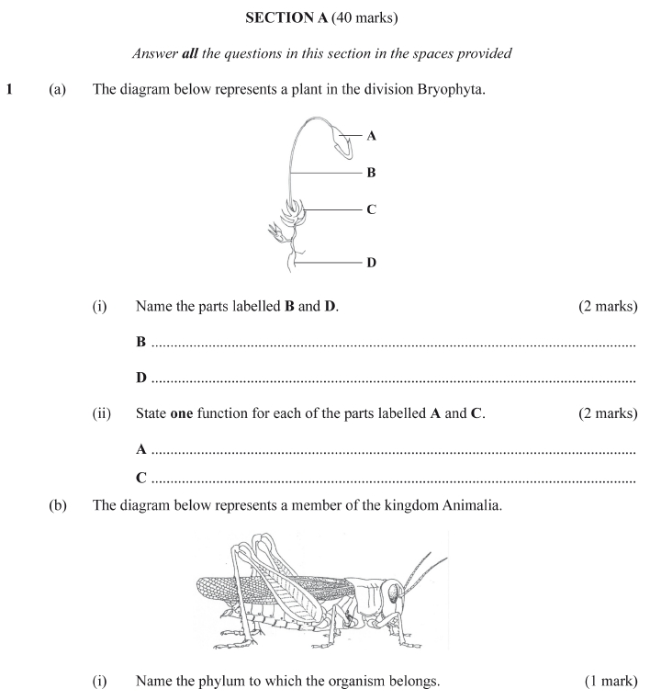
3.4.2 Biology Paper 2 (231/2)

50

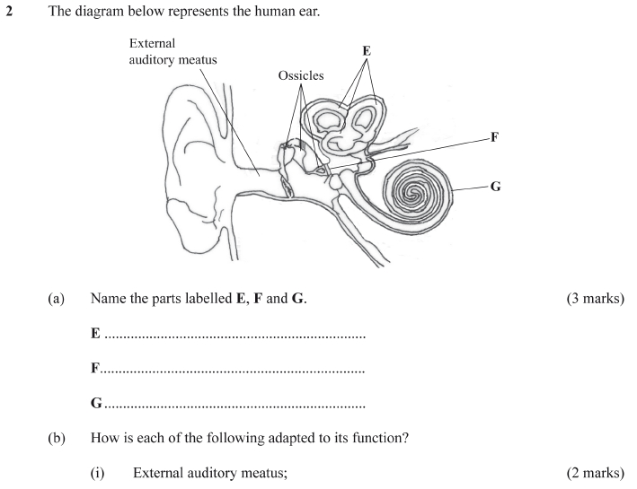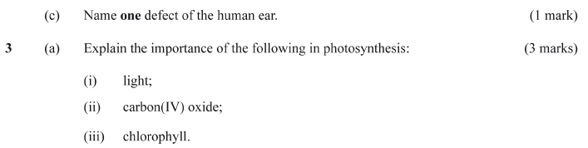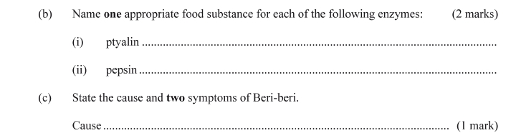

51

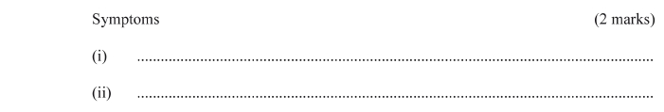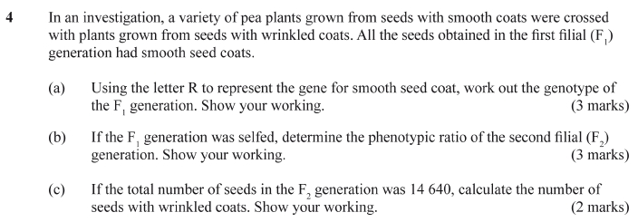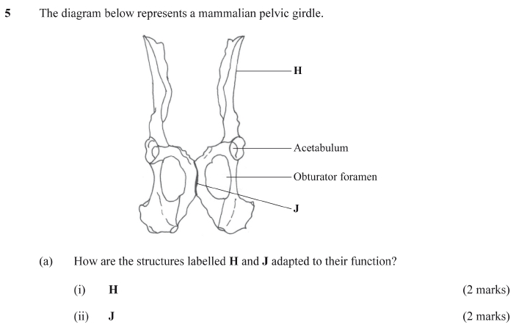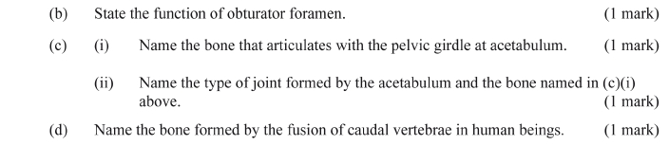

52

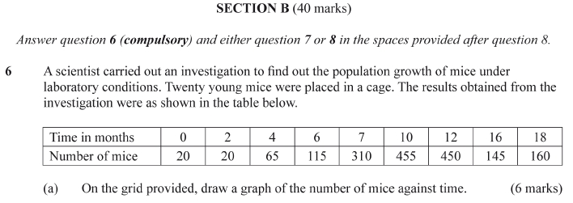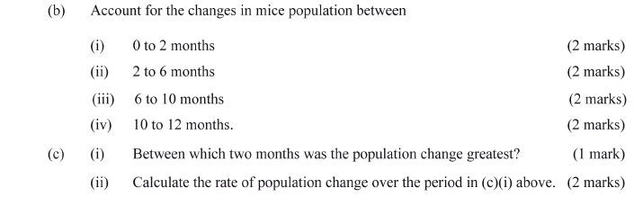

53

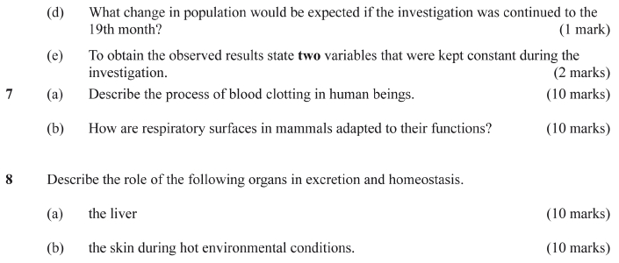

54

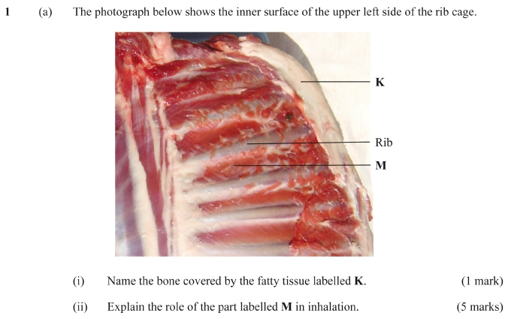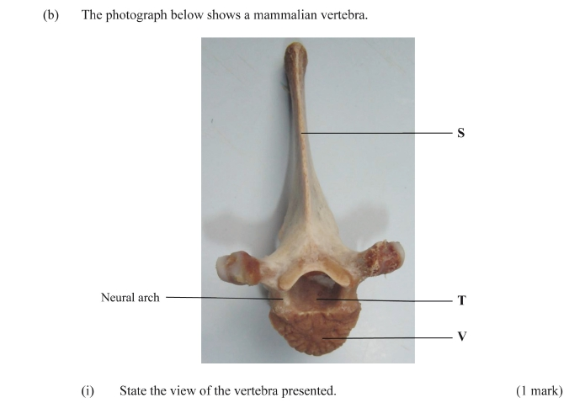
3.4.3 Biology Paper 3 (231/3)

55

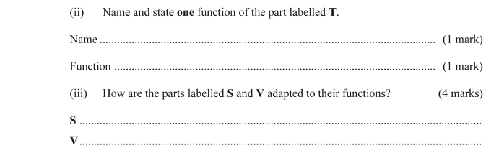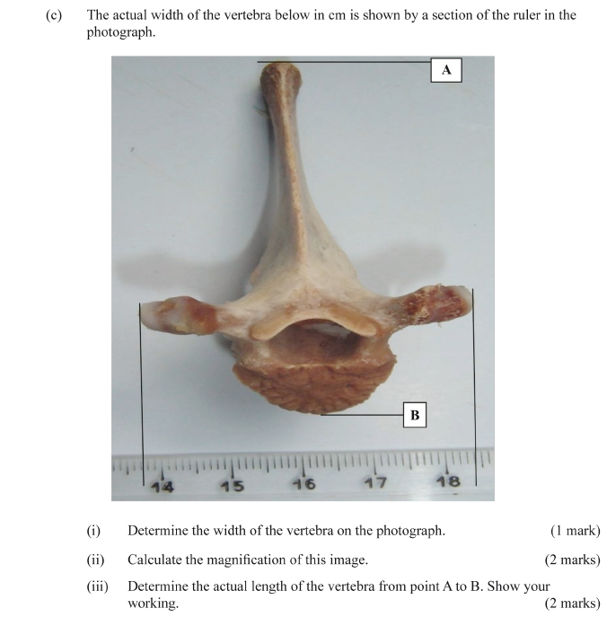

56

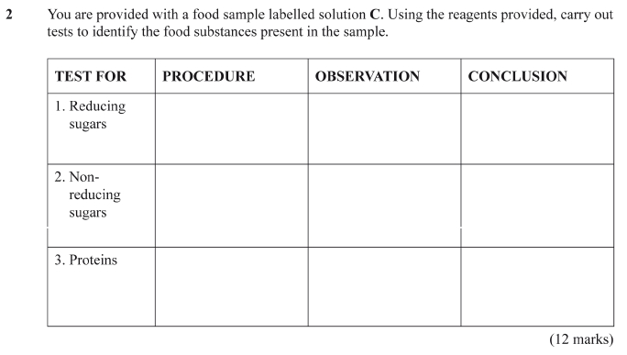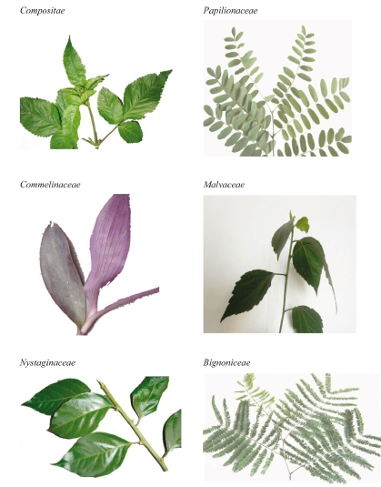

57

