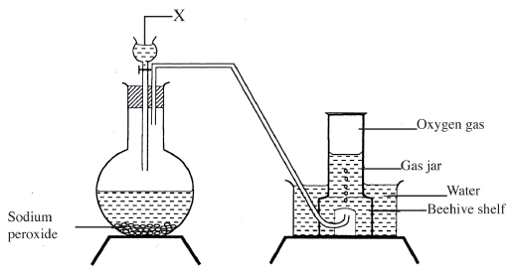3.6 CHEMISTRY (233)

3.6.1 Chemistry Paper 1 (233/1)

1 The set up below can be used to prepare oxygen gas. Study it and answer the questions that
follow.

(a) Identify X. (1 mark)
(b) What property of oxygen makes it possible for it to be collected as shown in the above
set up? (1 mark)
(c) State two uses of oxygen. (1 mark)
2 Write equations to show the effect of heat on each of the following:

(a) sodium hydrogen carbonate; (1 mark)
(b) silver nitrate; (1 mark)
(c) anhydrous iron (II) sulphate. (1 mark)

3 Describe an experimental procedure that can be used to extract oil from nut seeds.
4 In terms of structure and bonding, explain the following observations:

(2 marks)

(a) the melting point of aluminium is higher than that of sodium: (1 1 2 marks)
(b) melting point of chlorine is lower than that of sulphur. (1 1 2 marks)

82

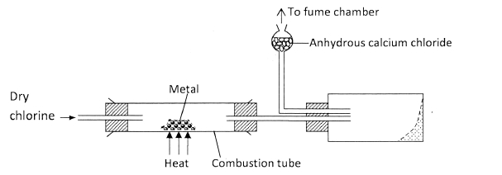
synthesis. (2 marks)
5 The diagram below illustrates a method of preparing salts by direct synthesis.

(a) This method can be used to prepare either aluminium chloride or iron (III) chloride.
Explain why it cannot be used to prepare sodium chloride. (1 mark)
(b) Describe how a sample of sodium chloride can be prepared in the laboratory by direct

6 (a) A student electroplated a spoon with copper metal. Write an equation for the process
that took place at the cathode. (1 mark)
(b) Calculate the time in minutes required to deposit 1.184g of copper if a current of
2 amperes was used. (1 Faraday = 96500 coulombs, Cu = 63.5).

7 Study the flow chart below and answer the questions that follow:
C2H2
X
water
(2 marks)

HCl
8 Draw a labelled diagram to illustrate how alpha, beta and gamma radiations can be
Y
Process Z
Polyvinylchloride

(a) Identify:
(i) X (1 mark)
(ii) Y (1 mark)
(b) State two uses of polyvinylchloride. (1 mark)

distinguished from each other. (3 marks)

83

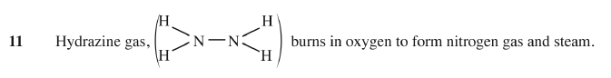
Substance | Solubility g/100g water
 | 10(˚C) | 40 (˚C)
T | 40 | 65
U | 15 | 17

Bond | Bond energy (kJ per mole)
N / N  N-N  N - H  O=O  H - O | 944  163  388  496  463

crystals formed.
9 Aqueous hydrogen chloride reacts with potassium manganate (VII) to produce chlorine gas,
while a solution of hydrogen chloride in methylbenzene has no effect on potassium
manganate (VII). Explain this observation. (2 marks)
10 The table below gives the solubilities of substances T and U at 10˚C and 40˚C.

When an aqueous mixture containing 55g of T and 12g of U at 80˚C was cooled to 10˚C,

(a) Identify the crystals formed. (1 mark)

(b) Determine the mass of the crystals formed. (1 mark)

(c) Name the method used to obtain the crystals. (1 mark)

(a) Write an equation for the reaction. (1 mark)
(b) Using the bond energies given below, calculate the enthalpy change for the reaction
in (a) above. (2 marks)

12 (a) What would be observed if sulphur (IV) oxide is bubbled through acidified potassium
manganate (VII)? (1 mark)
(b) In an experiment, sulphur (IV) oxide was dissolved in water to form solution L.
(i) What would be observed if a few drops of barium nitrate solution
were immediately added to solution L? (1 mark)

84

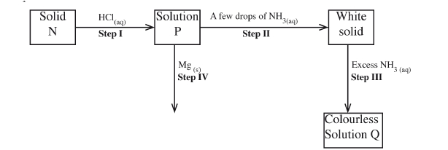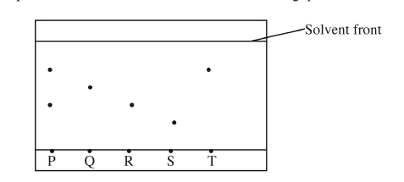
(ii) Write an ionic equation for the reaction that occurred between solution L and
aqueous barium nitrate in (b)(i) above. (1 mark)
13 The scheme below shows some reaction sequence starting with solid N. Study it and answer
the questions that follow.

(a) Write the formula of the complex ion in solution Q. (1 mark)
(b) Write an equation for the reaction in step IV. (1 mark)
14 (a) State the Charles’ law. (1 mark)
(b) A certain mass of gas occupies 146 dm3 at 291 K and 98.31 kPa.
What will be its temperature if its volume is reduced to 133 dm3 at 101.325 kPa?
(2 marks)
15 The chromatogram below was obtained from a contaminated food sample P. Contaminants
Q, R, S and T are suspected to be in P. Use it to answer the following questions.

(a) Identify the contaminants in mixture P. (1 mark)
(b) Which is the most soluble contaminant in P? (1 mark)

85

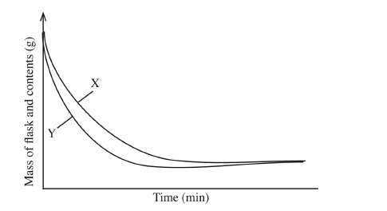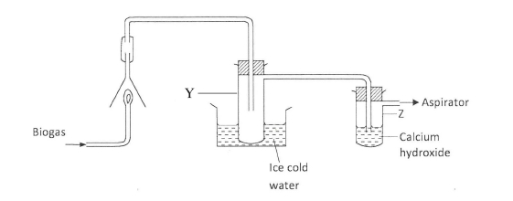
16 The curves below represent the change in mass when equal masses of powdered zinc and zinc
granules were reacted with excess 2M hydrochloric acid. Study them and answer the question
below.

Which curve represents the reaction with zinc granules? Explain your answer. (3 marks)
17 When fuels burn in the internal combustion engine at high temperature, one of the products
formed is nitrogen(II) oxide.
(a) Write the equation for the formation of nitrogen(II) oxide. (1 mark)
(b) Give a reason why nitrogen(II) oxide is not formed at room temperature. (1 mark)
(c) Describe how formation of nitrogen (II) oxide in the internal combustion engine
leads to gaseous pollution. (1 mark)
18 The set-up below was used to investigate the products of burning biogas (methane). Study it
and answer the questions that follow.

(a) What product will be formed in test-tube Y? (1 mark)
(b) State and explain the observations which would be made in Z. (2 marks)
19 (a) Diamond and graphite are allotropes of carbon. What is meant by an allotrope?
(1 mark)
(b) Explain why graphite can be used as a lubricant while diamond cannot.
(2 marks)
86

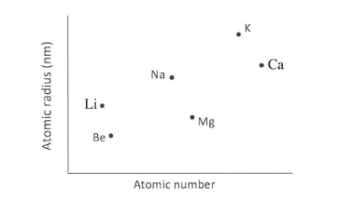
20 The plots below were obtained when the atomic radii of some elements in groups I and II
were plotted against atomic numbers.

Explain:
(a) the trend shown by Li, Na and K. (1 mark)
(b) why the atomic radii of elements Be, Mg and Ca are lower than those of Li, Na and K.
(2 marks)
21 On heating a pale green solid K, carbon (IV) oxide gas and a black solid M were formed.
On reacting K with dilute hydrochloric acid, carbon (IV) oxide gas and a green solution
S were formed. When excess aqueous ammonia was added to solution S, a deep blue solution
was formed.
(a) Identify the cation in solid K. (1 mark)
(b) Identify the two anions in solution S. (2 marks)
22 (a) Name two ores from which copper is extracted. (1 mark)
(b) During extraction of copper metal, the ore is subjected to froth flotation. Give a reason
why this process is necessary. (1 mark)
(c) Name one alloy of copper and state its use. (1 mark)
Alloy
Use
23 When 15cm3 of a gaseous hydrocarbon, P, was burnt in 100cm3 of oxygen, the resulting
gaseous mixture occupied 70cm3 at room temperature and pressure. When the gaseous
mixture was passed through potassium hydroxide solution, its volume decreased to 25cm3.
(a) What volume of oxygen was used during the reaction? (1 mark)
(b) Determine the molecular formular of the hydrocarbon. (2 marks)

87

Experiment | Substance | State
1 | Potassium Carbonate | Solid
2 | Copper (II) sulphate | Solution
3 | Sugar | Solution
4 | Lead (II) iodide | Molten

Acid | Rise in temperature (ΔT) K
M | 4
N | 2

24 A solution was made by dissolving 8.2g of calcium nitrate to give 2 litres of solution.
(Ca = 40.0; N = 14.0; O = 16.0).
Determine the concentration of nitrate ions in moles per litre. (3 marks)
25 State and explain what would happen if a dry red litmus paper was dropped in a gas jar of dry
chlorine. ( 2 marks)
26 By using aqueous sodium chloride, describe how a student can distinguish calcium ions from
lead ions. (2 marks)
27 A student investigated a property of acids M and N by reacting equal volumes of acid M and N
of the same concentration with equal volumes of 2M potassium hydroxide. The results were
recorded in the table below.

(a) Which of the acids is likely to be a weak acid? Explain. (2 marks)
(b) Write the equation for the reaction between ethanoic acid and potassium
hydroxide. (1 mark)
28 A student investigated the effect of an electric current by passing it through some substances.
The student used inert electrodes, and connected a bulb to the circuit. The table below shows
the substances used and their states.

(a) In which experiments did the bulb not light? (1 mark)
(b) Explain your answer in (a) above. (2 marks)

1 2
29 A sample of hydrogen gas was found to be a mixture of two isotopes, H .
H and
·
H
1 1
Determine the relative molecular masses of the molecules formed, when each of these
isotopes is burnt in oxygen. (O = 16.0)
1
1

(2 marks)

·
2
1
H

88


Element | State of oxide at  room temperature | Type of oxide | Bonding in oxide
U | Solid | Acidic | Covalent
W | Solid | Basic | Ionic
X | Liquid | Neutral | Covalent
Y | Gas | Neutral | Covalent

3.6.2 Chemistry Paper 2 (233/2)
1 (a) The grid given below represents part of the periodic table. Study it and answer the
questions that follow. The letters do not represent the actual symbols of elements.

M N P T

R
(i) Select a letter which represents an element that loses electrons most readily.
Give a reason for your answer. (2 marks)
(ii) Explain why the atomic radius of P is found to be smaller than that of N.
(2 marks)
(iii) Element M reacts with water at room temperature to produce 0.2 dm3 of gas.
Determine the mass of M which was reacted with water. (Molar gas volume at
room temperature is 24 dm3, Relative atomic mass of M = 7). (3 marks)
(b) Use the information in the table below to answer the questions that follow.
(The letters are not the symbols of the elements)

Identify a letter which represents an element in the table that could be calcium,
carbon or sulphur. Give a reason in each case.
(i) Calcium: ................................................................................................. (2 marks)
Reason ........................................................................................................
(ii) Carbon: ................................................................................................... (2 marks)
Reason ........................................................................................................
(iii) Sulphur: .................................................................................................. (2 marks)
Reason ........................................................................................................

89

Volume of hydrochloric  3  acid (cm ) | 5 | 10 | 15 | 20 | 25 | 30 | 35 | 40 | 45
Volume of sodium  3  hydroxide (cm ) | 45 | 40 | 35 | 30 | 25 | 20 | 15 | 10 | 5
Highest temperature of  mixture (℃) | 27.2 | 29.4 | 31.6 | 33.8 | 33.6 | 31.8 | 30.0 | 28.4 | 26.6

H2(g) + O2(g) H2O(l); ∆H = -286 kJ mol-1
2 (a) (i) What is meant by the term ‘Enthalpy of formation’? (1 mark)
(ii) The enthalpies of combustion of carbon, methane and hydrogen are indicated
below:
C(s) + O2(g) CO2(g); ∆H = -393 kJ mol-1
1
2
Enthalpy of combustion of CH4 = -890 kJ mol-1
I Draw an energy cycle diagram that links the enthalpy of formation of
methane to enthalpies of combustion of carbon, hydrogen and methane.
(2 marks)
II Determine the enthalpy of formation of methane. (2 marks)
(b) An experiment was carried out where different volumes of dilute hydrochloric acid
and aqueous sodium hydroxide both at 25℃ were mixed and stirred with a
thermometer. The highest temperature reached by each mixture was recorded in the
table below:

90


(i) On the grid provided, plot a graph of highest temperature (vertical axis) against
volume of hydrochloric acid (horizontal axis). (3 marks)

(ii) Using your graph, determine the:
I highest temperature reached; ( 21 mark)
II volume of acid and base reacting when highest temperature is
reached; ( 21 mark)
(iii) Calculate the amount of heat liberated during the neutralisation process.
(Specific heat capacity is 4.2 J g-1K-1 and the density of solutions is 1.0 g cm-3).
(2 marks)

91

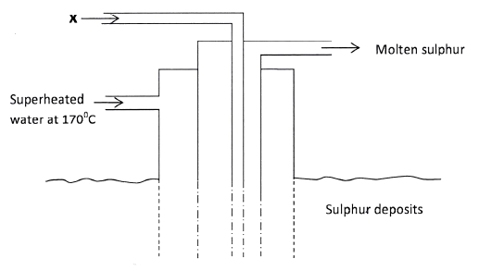
(c) The molar enthalpy of neutralisation between hydrochloric acid and ammonia solution
was found to be -52.2 kJ mol-1, while that of hydrochloric acid and sodium hydroxide
was -57.1 kJ mol-1. Explain the difference in these values. (2 marks)
3 (a) The diagram below shows the Frasch process used for extraction of sulphur.
Use it to answer the questions that follow.

(i) Identify X. (1 mark)

(ii) Why is it necessary to use super heated water in this process? (1 mark)

(iii) State two physical properties of sulphur that makes it possible for it to be
extracted by this method. (2 marks)

92

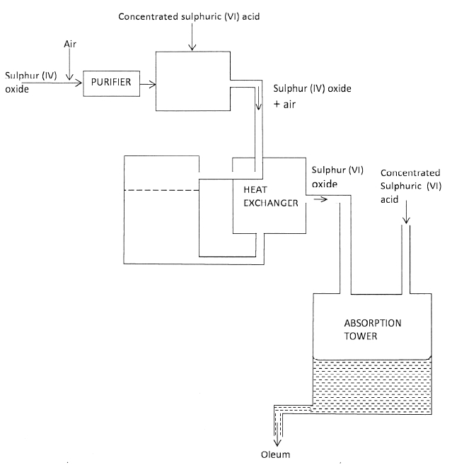
(b) The diagram below shows part of the processes in the manufacture of sulphuric (VI)
acid. Study it and answer the questions that follow.

CHAMBER A

CATALYTIC
CHAMBER B

(i) Write an equation for the formation of sulphur (IV) oxide from sulphur.

(1 mark)

(ii) What is the role of concentrated sulphuric (VI) acid in chamber A? (1 mark)
(iii) Name two catalysts that can be used in the catalytic chamber B. (2 marks)
(iv) State two roles of the heat exchanger. (2 marks)

(c) Explain one way in which sulphur (IV) oxide is a pollutant. (1 mark)

93

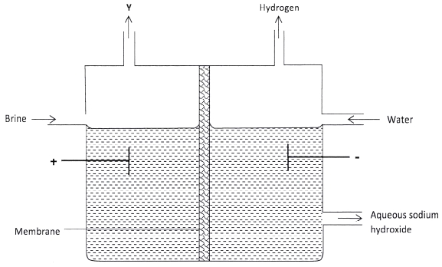
Half reactions Electrode potential E V
(iii) Why is it not advisable to store a solution containing E+ ions in a container
(d) What observation will be made when a few drops of concentrated sulphuric (VI) acid
are added to crystals of sugar? Explain your answer. (1 mark)
4 (a) The set up below can be used to produce sodium hydroxide by electrolysing brine.

(i) Identify gas Y. (1 mark)
(ii) Describe how aqueous sodium hydroxide is formed in the above set-up.
(2 marks)
(iii) One of the uses of sodium hydroxide is in the manufacturing of soaps.
State one other use of sodium hydroxide. (1 mark)
(b) Study the information given in the table below and answer the questions that follow.
i
D2aq) + 2e $ D(s) -0.13
( +
(
( + ( +
( +
( +
(
E+aq) + e $ E(s) +0.80
F3aq) + e $ F2aq) +0.68
G2aq) 2e $ G(s) -2.87
H2aq) + 2e $ H(s) +0.34
J+aq) + e $ J(s) -2.71

(i) Construct an electrochemical cell that will produce the largest emf. (3 marks)
(ii) Calculate the emf of the cell constructed in (i) above. (2 marks)

made of H? (2 marks)

94

5 (a) Describe one method that can be used to distinguish between sodium sulphate
and sodium hydrogen sulphate. (2 marks)
(b) Describe how a pure sample of lead (II) sulphate can be prepared in the laboratory
starting with lead metal. (3 marks)
(c) Study the flow chart below and answer the questions that follow:
NH4Cl(s)
Step I,
heating

NH3(g) HCl(g)

Nitric (V) acid
Fe(s)

NH4NO3(s) H2O(l) FeCl2 (aq)
Step II, Step III,
heat H2O2
Substance X + H2O(l) Substance Z
NaOH(aq)

Step IV
Heat

Fe2O3(s)

Steam

Step V
Carbon, heat
Fe(s)
(i) Write an equation for the reaction in:
I step II; (1 mark)
II step IV. (1 mark)
(ii) State the observation made in step III. Explain. (2 marks)
(iii) Name another substance that can be used in step V. (1 mark)
6 (a) Distinguish between a neutron and a proton. (1 mark)
(b) What is meant by a radioactive substance? (1 mark)

(c) State two dangers associated with radioactive substances in the environment.

95

(2 marks)

1D + 1T $ bY + 0n
hydrogen? (1 mark)
Cl2(g)

(d) The two isotopes of hydrogen, deuterium ^12Dh and tritium ^13Th react to form element
Y and neutron particles, according to the equation below:
2 3 a 1

(i) What is the atomic:
(I) mass of Y; (1 mark)
(II) number of Y. (1 mark)
(ii) What name is given to the type of reaction undergone by the isotopes of

(e) (i) What is meant by half-life of a radioactive substance? (1 mark)
(ii) 288g of a radioactive substance decayed to 9g in 40 days. Determine the
half-life of the radioactive substance. (2 marks)

7 (a) Give the systematic names for the following compounds:
(i) CH3CH2COOH; (1 mark)
(ii) CH3CH2CH2CHCH2; (1 mark)
(iii) CH C CH2CH3. (1 mark)

(b) Study the flow chart below and use it to answer the questions that follow:
Prop-l-ene M
step I

Propan-1-01
step II
sodium metal
step III
Products

CH3CH2COOH(aq)
Na2CO3(S)

CH3CH2COONa(aq) CO2(g) H2O(l)
mixture of NaOH and Ca(OH)2
(sodalime)
organic compound K

(i) Identify the organic compound K. (1 mark)

96

(ii) Write the formula of M. (1 mark)
(iii) Give one reagent that can be used in:
(I) step I; (1 mark)
(II) step II. (1 mark)
(iv) Write the equation of the reaction in step III. (1 mark)

(c) The structure below represents a type of a cleansing agent.

R SO-3 Na+

Describe how the cleansing agent removes grease from a piece of cloth. (3 marks)

97


Time (Min.) | 0 | 1 | 2 | 3 | 4 | 5 | 6 | 7
0
Temperature ( C)

3.6.3 Chemistry Paper 3 (233/3)
1 You are provided with:
· solution A, aqueous copper (II) sulphate;
· solid B, iron powder;
· 0.02 M acidified potassium manganate (VII), solution C.
You are required to determine the molar heat of displacement of copper by iron.
Procedure I
Using a burette, place 50.0 cm3 of solution A in a 100 ml beaker. Measure the temperature of
the solution and record it in table 1 below. Add all of solid B provided at once and start a stop
watch. Stir the mixture thoroughly with the thermometer and record the temperature of the
mixture after every one minute in the table. Retain the mixture for use in procedure II below.
Table 1

(3 marks)
(a) (i) Plot a graph of temperature (vertical axis) against time in the grid provided.
(3 marks)

(ii) From the graph, determine the;
(I) highest change in temperature, ΔT; (1 mark)

98

(II) time taken for reaction to be completed. ( 1 mark)

2
(iii) Calculate the heat change for the reaction. (Specific heat capacity of solution is
4.2 Jg-1 K-1; Density of the solution is 1 gcm-3). (2 marks)
Procedure II
Carefully decant the mixture obtained in procedure I into a 250 ml volumetric flask. Add
about 10 cm3 of distilled water to the residue in the 100 ml beaker. Shake well, allow
the mixture to settle and carefully decant into the volumetric flask. Immediately, add about
50 cm3 of 2 M sulphuric (VI) acid to the mixture in the volumetric flask. Add more distilled
water to make 250.0 cm3 of solution. Label this as solution D.
Fill a burette with solution C. Using a pipette and a pipette filler, place 25.0 cm3 of solution D
into a 250 ml conical flask. Titrate solution D against solution C until the first permanent
pink colour is obtained. Record your results in table 2 below. Repeat the titration two more
times and complete the table. Retain the remaining solution C for use in question 3.
Table 2
I II III
Final burette reading
Initial burette reading

Volume of solution C used (cm3)

(4 marks)

2
(a) Determine the average volume of solution C used. ( 1 mark)
(b) Calculate the number of moles of:
(i) aqueous potassium manganate (VII) used; (1 mark)
(ii) iron (II) ions in 25.0 cm3 of solution D. (1 mole of MnO-4 reacts with 5 moles
of Fe2+). (1 mark
(iii) iron(II) ions in 250 cm3 of solution D. (1 mark)
(c) Calculate the molar heat of displacement of copper by iron. (2 marks)

2 You are provided with solid E. Carry out the following tests and write your observations and
inferences in the spaces provided.
(a) Place all of solid E in a boiling tube. Add about 10 cm3 of distilled water and shake
thoroughly. Filter the mixture into another boiling tube. Retain the filtrate for use in
test 2(b) below. Dry the residue using pieces of filter papers.

99

(i) Transfer about half of the dry residue into a dry test-tube. Heat the residue
strongly and test any gas produced using a burning splint.

Observations Inferences

(1 mark) (1 mark)
(ii) Place the rest of the residue in a dry test-tube. Add 4 cm3 of 2M hydrochloric
acid. Retain the mixture for test (iii) below.

Observations Inferences

(1 mark) (1 mark)
(iii) To 2 cm3 of the solution obtained in (ii) above, add 6 cm3 of aqueous ammonia
dropwise.

Observations Inferences

(1 mark) (1 mark)

(b) (i) To 2 cm3 of the filtrate obtained in (a) above, add about 3 cm3 of aqueous
ammonia (Excess).
Observations Inferences

(1 mark) (1 mark)
(ii) To 2 cm3 of the filtrate, add about 2 cm3 of 2M hydrochloric acid.
Observations Inferences

(1 mark) (1 mark)
(iii) To 2 cm3 of the filtrate, add one or two drops of barium nitrate solution.
Observations Inferences

(1 mark) (1 mark)

100’
]
3 You are provided with solid G. Carry out the tests in (a) and (b) and write your observations
and inferences in the spaces provided. Describe the method used in part (c).
(a) Place about one third of solid G on a metallic spatula and burn it in a Bunsen burner
flame.
Observations Inferences

(1 mark) (1 mark)

(b) Dissolve all of the remaining solid G in about 10 cm3 of distilled water in a boiling
tube. Use the solution for tests (b)(i), (ii) and (c).
(i) Place 2 cm3 of the solution in a test-tube and add 2 drops of acidified potassium
manganate (VII); solution C.

Observations Inferences

(1 mark) (1 mark)
(ii) To 2 cm3 of the solution, add all of solid sodium hydrogen carbonate provided.

Observations Inferences

(1 mark) (1 mark)
(c) Determine the pH of the solution obtained in (b) above.

Method used Inferences

(2 marks) (1 mark)

