3.13 HOME SCIENCE (441)

3.13.1 Home Science Paper 1 (441/1)
SECTION A (40 marks)
Answer all the questions in this section in the spaces provided.
1 List four favourable conditions for the growth of micro-organisms in food spoilage. (2 marks)
2 Name two types of beriberi. (1 mark)
3 Why is breakfast considered the most important meal of the day? (1 mark)
4 Give two reasons for covering food while cooking. (2 marks)
5 State two disadvantages of boiling foods. (2 marks)
6 Differentiate between perishable and non perishable foods. (2 marks)
7 State three advantages of advertising on a Bill-board. (3 marks)
8 State three benefits of breast-feeding to a mother. (3 marks)
9 List four items in a first-aid-kit that can be used to manage a sprain. (2 marks)
10 State two good grooming habits that can prevent skin diseases. (2 marks)
11 Name two factors that influence the frequency of cleaning a house. (2 marks)
12 State two advantages of electricity as a form of lighting. (2 marks)
13 State two factors to consider when renting a house. (2 marks)
14 Identify two characteristics of a plastic laundry basin. (2 marks)
15 State two limitations of dry cleaning in laundry work. (2 marks)
16 Name two textile fibres of plant origin. (1 mark)
17 Give two uses of facing in clothing construction. (2 marks)
18 Name four areas in a garment where diagonal tacking can be used. (2 marks)
19 State two points to observe when taking body measurements. (2 marks)
20 Give one reason why acetone is not a suitable stain remover on acetate fabrics. (1 mark)

138

(b) Outline the procedure for laundering a loose coloured cotton T-shirt. (7 2 marks)
(c) Describe how you would clean a plain wooden chopping board. (4 2 marks)
21 Identify the correct direction to press the following darts during garment construction:
(i) front shoulder dart; ............................................................................................................
(ii) bust dart; ............................................................................................................................
(iii) elbow dart; .........................................................................................................................
(iv) back waist dart. ..................................................................................................................
(2 marks)
SECTION B (20 marks)
(Compulsory)
Answer question 22 in the spaces provided.
22 Your parents are away for the weekend and have asked you to clean the house thoroughly.
(a) Describe how you would clean an oil painted wall in the sitting room. (8 marks)

1

1

SECTION C (40 marks)
Answer any two questions from this section in the spaces provided after question 25.
23 (a) Giving a reason in each case, state four advantages of using a refrigerator in the home.
(8 marks)
(b) Explain four points to consider when planning meals for an invalid who is bedridden.
(8 marks)
(c) Giving a relevant example in each case, differentiate between substitute and
complimentary products. (4 marks)

139

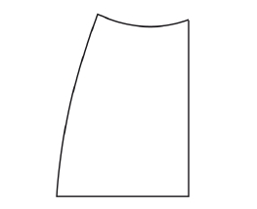

24 Use the sketch of the skirt below to answer the following questions.

(a) (i) State six methods of disposing fullness in the skirt sketch shown above.
(3 marks)
(ii) Apart from the disposal of fullness symbols, indicate three pattern markings on
the sketch above. (3 marks)
(b) Describe how to attach a lace onto the lower edge of a skirt using the overlaid seam.
(6 marks)
(c) Explain four finishing processes carried out during laundry. (8 marks)
25 (a) Identify six qualities of aluminium that make it suitable for making kitchen utensils.
(6 marks)
(b) Highlight six signs of a child suffering from marasmus. (6 marks)
(c) Explain four factors to consider when selecting a baby’s clothes. (8 marks)
...

140

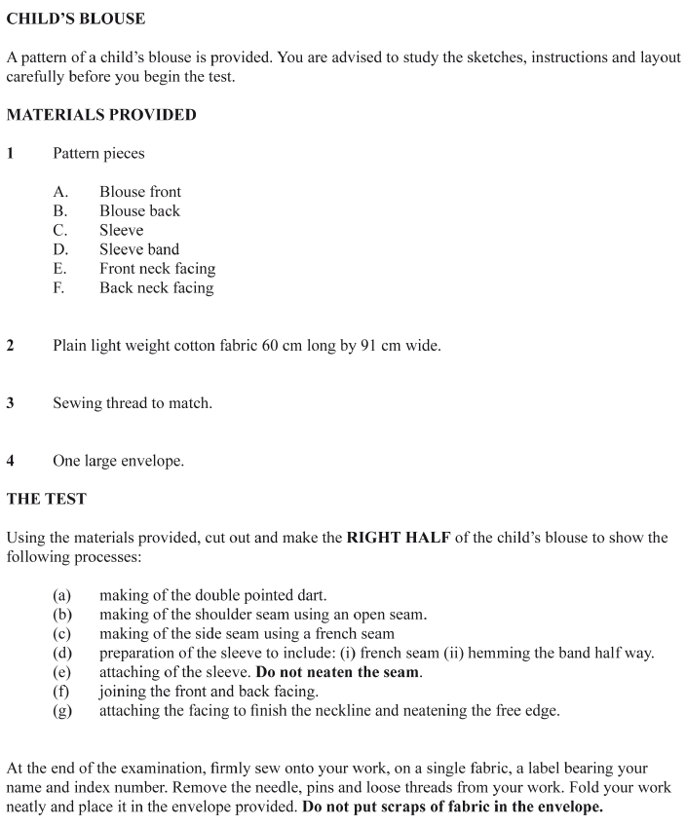
3.13.2 Home Science Paper 2 (441/2)

141

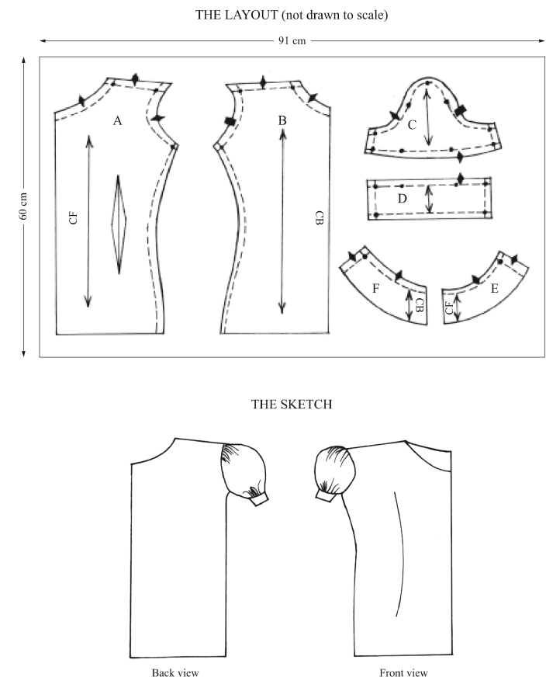

142

3.13.3 Home Science (Food and Nutrition) Paper 3 (441/3)

