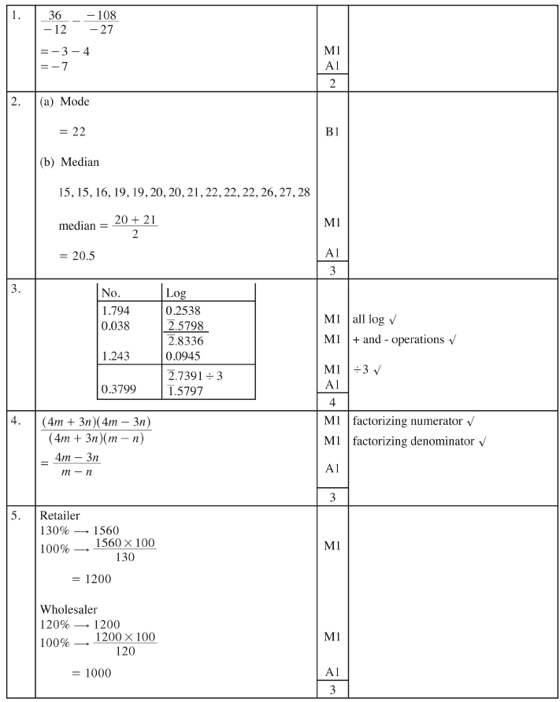
4.3 MATHEMATICS (121 AND 122)

4.3.1 Mathematics Alternative A Paper 1 (121/1

292

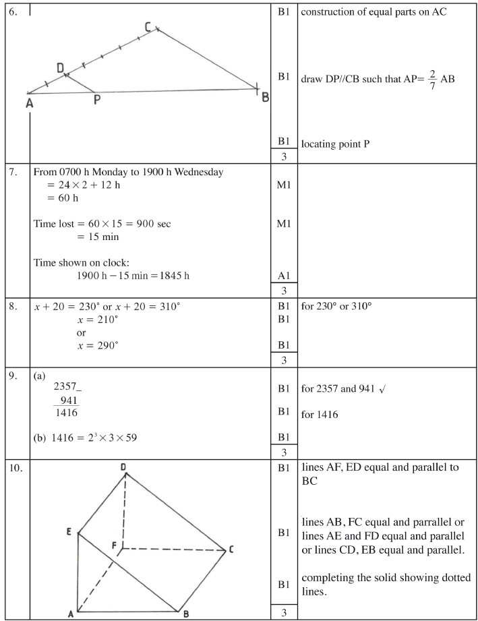

293

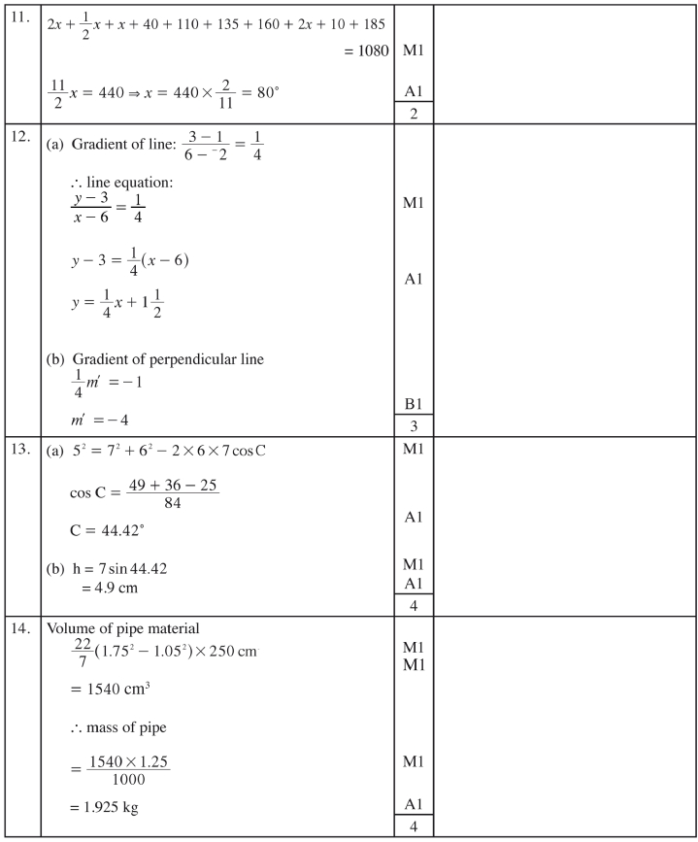

294

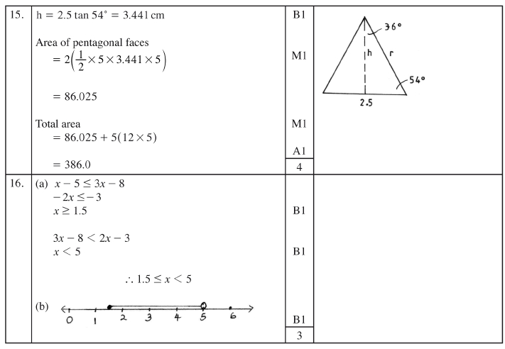

295

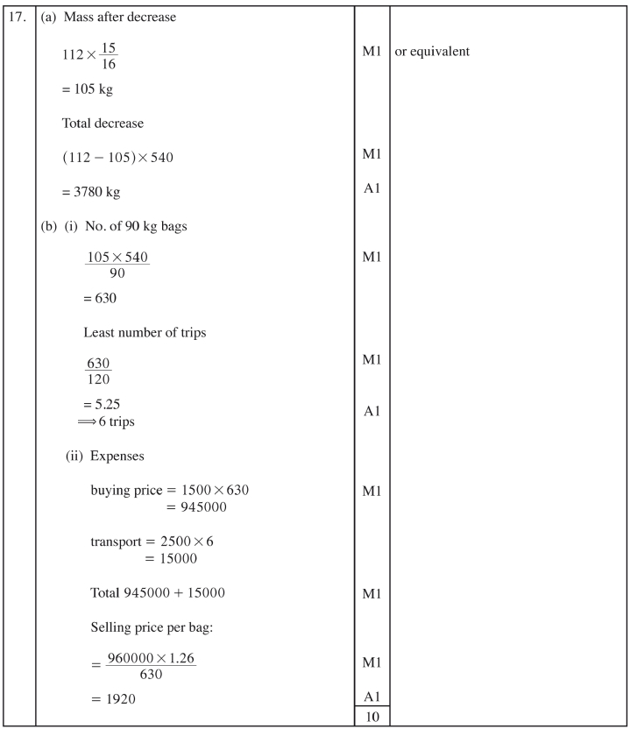

296

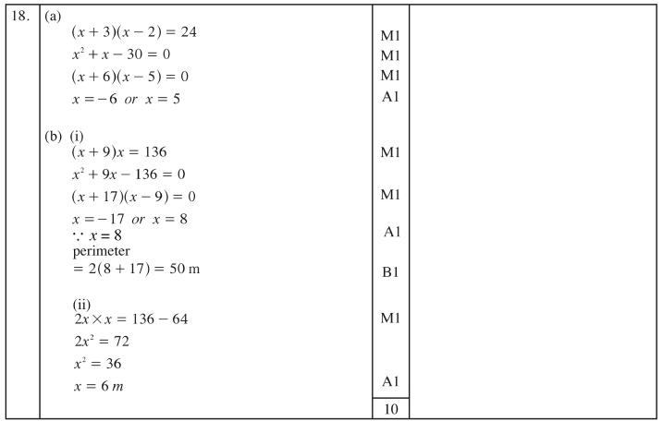

297

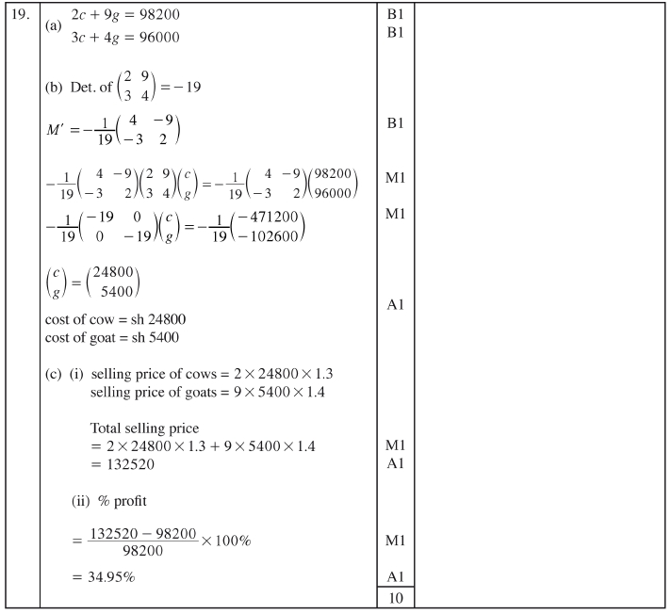

298

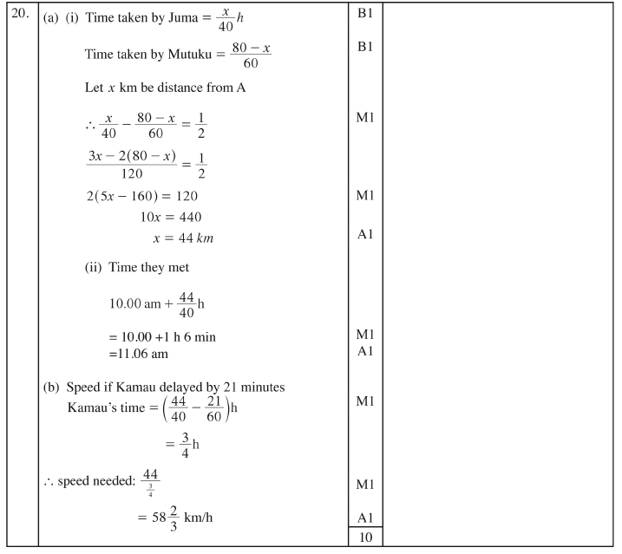

299

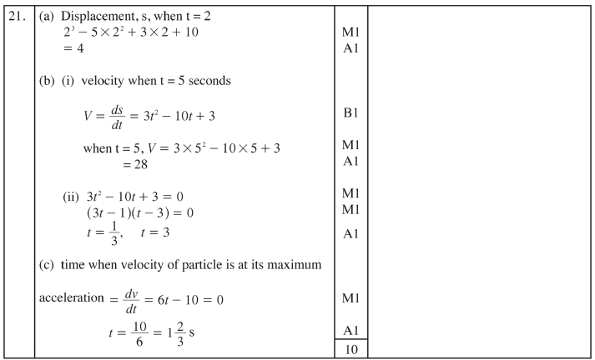

300

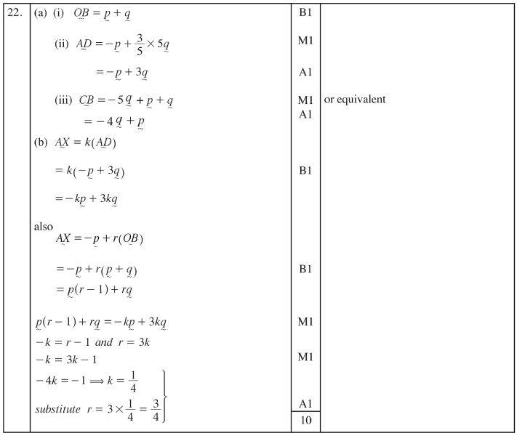

301

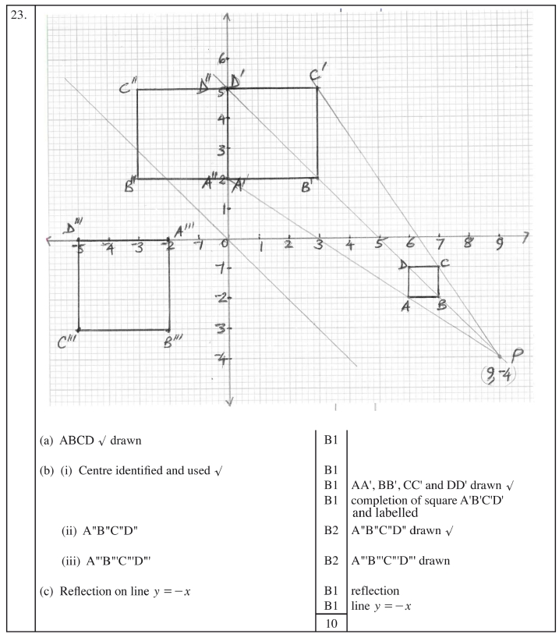

302

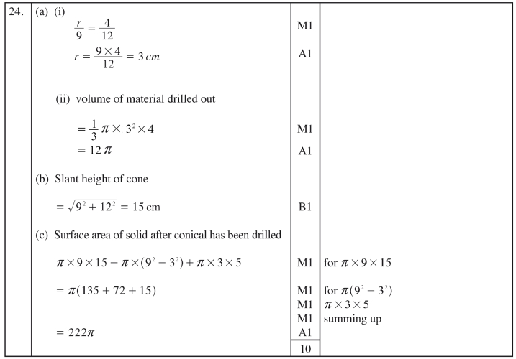

303

1. | st  1 term, a = 3; common difference, d = 6  n  7500 = "2 # 3 + (n - 1) # 6,  2  2  3n = 7500  n = 2500 = 50 | B1  M1  A1
1. |  | 3
2. | y = (x + 2)(x - 1)  2  y = x + x - 2 | M1  A1
2. | y = (x + 2)(x - 1)  2  y = x + x - 2 | 2
3. | 1 2 qd2  P = mn -  2 n  2  qd 1 2  = mn - P  n 2  1 3  2 2 mn - nP  d = q  1 3  d = 2 mn - nP  q | M1  M1  A1
3. |  | 3
4. | 2  x 2  Log = log 3  c (x - 2) m  x2  x - 2 = 9  2  x - 9x + 18 = 0  (x - 6)(x - 3) = 0  x = 6 or x = 3 | M1  M1  A1
4. |  | 3

4.3.2 Mathematics Alternative A Paper 2 (121/2)

304

5. | (a)  (b) radius = 3.1 | B1  B1  B1  B1 | extending YX and YZ  bisecting +s VXZ and  XZW  escribed circle drawn  allow ± 0.1
5. | (a)  (b) radius = 3.1 | 4
6. | Completing square on L.H.S.  2 2  x + 4x + 4 + y - 2y + 1 = 4 + 4 + 1  2 2  (x + 2) + ( y - 1) = 9  ` centre of circle : (-2, 1)  radius of circle: 3 units 4 | B1  B1  B1
6. |  | 3
7. | 5 2 3 4 5  (a) (1 - x) = 1 + 5(-x) + 10(-x) + 10(-x) + 5(-x) + (-x)  2 3 4 5  = 1 - 5x + 10x - 10x + 5x - x  5 5  (b) (0.98) = (1 - 0.02) & x = 0.02  5 2 3  ` (0.98) = 1 - 5(0.02) + 10(0.02) - 10(0.02)  = 1 - 0.1 + 0.004 - 0.00008  = 0.90392 | B1  M1  A1
7. |  | 3

305

8. | - 1 4  h+ = 4 + (- 1) f+ + 4 + (- 1) g+  - 1 4  = f + g  3 + 3 + | M1  A1
8. |  | 2
9. | P(defective) : M " 0.6 # 0.05 = 0.03  N " 0.4 # 0.03 = 0.012  P(defective) 0.03 + 0.02 = 0.042 | M1  M1  A1 | For 0.6 # 0.05 or 0.4 #  0.03  0.95 good  M  0.6 0.05 defective  0.4 0.97 good  N  0.03 defective
9. |  | 3
10. | (a) Fraction filled if A and R are open for 5h  1 1 5  5 # - =  c 3 6 m 6  5 1  Fraction of tank still empty = 1 - =  6 6  (b) Fraction filled if A, B and R are open for 1h  1 1 1 2  + - =  3 2 6 3  1 2 1 3  Time taken to fill the tank = ' = #  6 3 6 2  1  = h or 15 min  4 | B1  B1  M1  A1
10. |  | 4
11. | 48 4 3 ^ 5 - 3 h  =  5 + 3 ^ 5 + 3 h^ 5 - 3 h  4 3 ^ 5 - 3 h  = 5 - 3  = 2 3 ^ 5 - 3 h  = 2 15 - 6 | M1  M1  A1
11. |  | 3

306

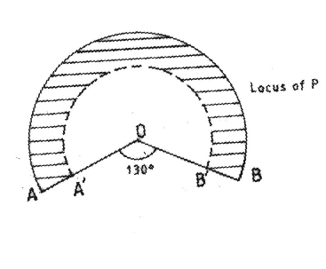
12. | +AOB = 130c  arc AB - solid curve  arc A´B´ - broken curve  region shown | B1  B1  B1  B1
12. |  | 4
13. | 9680 # 0.1 = 968  9120 # 0.15; 9120 # 0.2; 4580 # 0.25  = 1368 = 1824 = 1145  Net tax  = (968 + 1368 + 1824 +1145) - 1056  = 4249 | M1  M1  M1  A1
13. |  | 4
14. | 2  6(1 - sin x) + 7 sin x - 8 = 0  2  6 - 6 sin x + 7 sin x - 8 = 0  2  6 sin x - 7 sin x + 2 = 0  (3 sin x - 2) (2 sin x - 1) = 0  2 1  sin x = or sin x =  3 2  x = 41.81° or x = 30° | M1  M1  M1  A1
14. |  | 4

307

15. | Distance between towns K and S  = 2π # 6370 cos 2° # 37.4 - 30  360  = 822.2121281  = 822 km | M1  A1
15. |  | 2
16. | 1  a b 1 4 3 2 2 23  =  c c dmc2 2 4m c 1 1 2m  a + 2b = 21  4a + 2b = 2  3 1  3a = & a =  2 2  1 1  + 2b = & b = 0  2 2  c + 2d = 1  4c + 2d = 1  3c = 0 & c = 0  0 + 2d = 1 & d = 21  1  ` M = 2 0  c 0 12m | M1  M1  A1 | : formation and solution  of simultaneous equations  : formation and solution  of simultaneous equations
16. |  | 3
17. | (a) (i) 276000 - 60000  18  = 12 000  (ii) 276000 # 0.9  = 248400  (b) 248400 # 0.95  = 235980  235980 # 1.22  = 339811.2  (c) 339811.2 - 276000  63811.2 # 100  276000  = 23.12 % | M1  A1  M1  A1  M1  M1  A1  M1  M1  A1
17. |  | 10

308

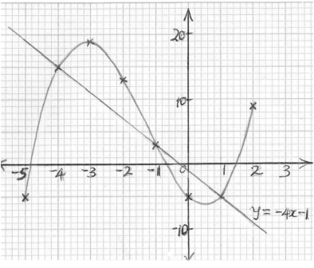
18. | (a) +QPR = 90° - 72° = 18°  +PQR = 90° - angle subtended by diameter  (b) +PQS = 180° - 2(72) = 36°  +PSQ = 72° - angle subtended at the circumference by  chord PQ equal and base +’s of isosceles ∆QPS = 72°  (c) +OQS = 36° - 18° = 18°  base angles of isosceles ∆ OPQ = 18°  (d) +RTS = 180 - (36 + 18) = 126°  extension angle RTS equal to sum of opposite interior  angles TSP and TPS  (e) +RSV = 90° - 36° = 54°  +RSV = +RPS - angle in alternate segment. | B1  B1  B1  B1  B1  B1  B1  B1  B1  B1 | or equivalent
18. |  | 10 | or equivalent
19. | (a)  (b)  (c) (i) x = -4.8, -0.7, 1.5  (ii) y = -4x - 1  Solutions  x = -4, -1, 1. | B2  S1  P1  C1  B2  P1  L1  B1 | allow B1 for 4 correct  Suitable scale  All correctly plotted  ±0.1 allow B1 for 2  values : plotting for line
19. |  | 10

x | -5 | -4 | -3 | -2 | -1 | 0 | 1 | 2
y  3 2  =x +4x -5x-5 | -5 | 15 |  | 13 | 3 |  | -5 | 9

309

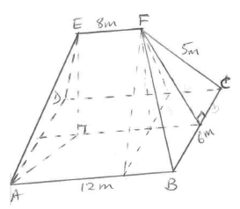
20. | (a) = distance of EF from place ABCD  slant height from F to BC  2 2  = 5 - 3  =4  ` = distance of EF from plane ABCD  2 2  = 4 - 2  = 12 = 3.46 m  (b) (i) angle between planes  ADE and ABCD  = tan-1 12  2  = 60°  (ii) angle between line AE  and plane ABCD  = sin-1 12  5  = 43.9°  (iii) angle between planes  ABFE and DCFE  = 2 tan-1 3  c 12 m  = 81.8° | M1  M1  A1  M1  A1  M1  A1  M1  M1  A1 | or equivalent  or equivalent  -1 3  tan or equivalent  12  doubling
20. |  | 10

310

21. | (a)  (b)  (c) (i) 2 sin (x + 20) = 3 cos x  x = 30°  and x = 210°  (ii) amplitude difference  2 - 1.7 = 0.3 | B1  B1  S1  P1  P1  C1  C1  B1  B1  B1 | suitable scale used  plotting 2 Sin (x + 20)  plotting 3 cos x  curve for 2 sin x + 20  curve for 3 cos x
21. |  | 10

x | 0 | 40 | 80 | 120 | 160 | 200 | 240
y=  2 sin x + 20 |  | 1.7 |  | 1.3 |  | -1.3
y=  3 cos x |  |  | 0.3 |  | -1.6 |  | -0.9

311

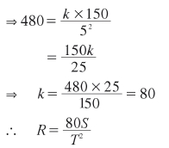
22. | S kS  (a) R \ 2 & R = 2  T T  R = 480 whe n S = 150 and T = 5  (b) (i) 80 # 360  R = 2  (1.5)  = 80 # 360  2.25  = 12800  (ii) S2 = 1.05s, T2 = 0.8T  80 # 1.05S  R2 = 2  (0.8T)  80 # 1.05 S  = 2 # 2  (0.8) T  S  R2 = 131.25 2  T  J S 80S N  131.25 2 - 2  R2 - R K T T O  # 100% = # 100%  c R m K S O  K 80 2 O  T  L P  S 2  T 131.25 - 80  = # 100  S  T2 c 80 m  = 64.0625  = 64.06 % | B1  M1  A1  B1  M1  A1  B1  M1  M1  A1
22. |  | 10

312

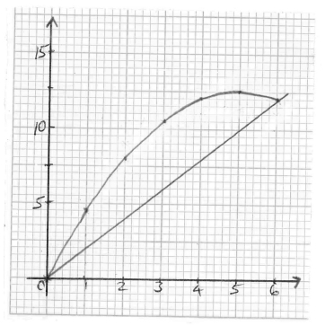
23. | (a)  (b) 6  1 2  #0 c5x - 2 x m dx  5 2 1 3 6  = x - x  ; 2 2 # 3 E0  2  5 # 6 1 3  = - # 6 - 0 - 0  ; 2 6 E 6 @  = 90 - 36 - 0 = 54  6 @ 6 @  (c) (i) Drawing line y = 2x  1  (ii) Area of ∆ : # 6 # 12  2 = 36  ` Bounded area = 54 - 36 = 18 | B1  P1  C1  M1  M1  A1  L1  M1  A1  B1 | table may be implied  : plotting  : curve  : integral  : substitution
23. |  | 10

x | 0 | 1 | 2 | 3 | 4 | 5 | 6
y  = 5x- 21 x2 | 0 | 4.5 | 8 | 10.5 | 12 | 12.5 | 12

313

24. | (a)  (b) (i) cfs  (c) (i) Identification of median  = 57.5 ± 0.5  (ii) Identification of upper quartile mark  = 66.5 ± 0.5 | B1  B1  B1  S1  P1  C1  B1  B1  B1  B1 | : marks class column  : frequency column  : scale  : plotting  : curve
24. |  | 10

Marks | Frequency | cf
25-34 | 4 | 4
35-44 | 5 | 9
45-54 | 8 | 17
55-64 | 12 | 29
65-74 | 9 | 38
75-84 | 3 | 41
85-94 | 1 | 42

314

1. | - 3^- 5 - + 7h '+ 2^- 3 + - 6h  = - 3^- 12h ' 2^- 9h  = 36 '- 18  =- 2 | M1  M1  A1
1. |  | 3
2. | (a) Number is 7532  (b) Total value of hundreds digit = 500 | B1  B1
2. | (a) Number is 7532  (b) Total value of hundreds digit = 500 | 2
3. | 2 27 3 18 23 13  # - 2 = - =  3 5 10 5 10 10  3 1 3 3 2 8 26  ' 4 + 1 = # + =  5 2 5 5 9 5 15  13 26 13 15 3  ` ' = # =  10 15 10 26 4 | M1  M1  A1
3. |  | 3
4. | Nekesa: Mwita: Auma = 600 : 750 : 650  = 12 : 15 : 13  Amount Mwita got more than Nekesa  15 12  = # 1200 - # 1200  40 40  = 450 - 360 = 90 | B1  M1  A1 | 3  = # 1200  40  = 90
4. |  | 3 | 3  = # 1200  40  = 90
5. | h = 3r - 1 ( h = 3 # 2 - 1 = 5  2 2  7r + 2rh 7 # 2 + 2 # 2 # 5  ` =  4h - 2r 4 # 5 - 2 # 2  = 28 + 20  16  = 48  4  = 12 | M1  M1  A1
5. |  | 3

4.3.3 Mathematics Alternative B (122/1)

315

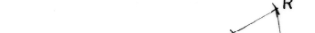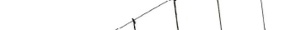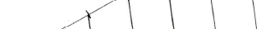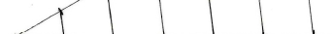
6. | 1176  Area of each face = = 196  6  Length of side 196  = 14 | M1  M1  A1
6. | 1176  Area of each face = = 196  6  Length of side 196  = 14 | 3
7. |  | B1  B2 | Line, PR, drawn and divided into  six (6) equal parts.  Joining QR and drawing five lines  parallel to QR intersecting with  PQ.
7. |  | 3
8. | 3 4  sin x = and cos =  5 5  3 4  ` 2 sin x - cos x = 2 # -  5 5  6 4 2  = - =  5 5 5 | B1  M1  A1
8. |  | 3
9. | 5x + 6x^10h = 2600  5x + 60x = 2600  x = 2600  65  = 40  Total number of coins:  = 40 + 6 # 40 = 280 | M1  M1  A1  B1
9. |  | 4
10. | 3  -2 -2 2#3  2  3 # 81 3 # 3  -3 1 =  3  4 ' 8 1  26 ' 2  4 7  = 3 # 2  = 10368 | M1  M1  A1  B1 | √ powers of 3  √ powers of 2
10. |  | 4 | √ powers of 3  √ powers of 2

316

11. | Marked price = 5750 # 1.12 = 6440  % discount = 6440 - 6118 # 100  6440  = 5% | M1  M1  A1
11. |  | 3
12 | 2  2 16 2 4  9a - 2 2 = ^3ah - 2  b c ^bch  4 4  = 3a + 3a -  c bc mc bc m | M1  A1
12 |  | 2
13. | (a)  12 28 54  2 6 14 27  2 3 7 27  3 1 7 9  3 1 7 3  3 1 7 1  7 1 1 1  2 3  The height (LCM) = 2 # 3 # 7  = 756  756  (b) Number of books = = 63  12 | M1  M1  A1  B1 | : factorization
13. |  | 4 | : factorization
14. | Let number of sides ben  ` ^2n - 4h # 90 = 1260  2n # 90 = 1260 + 360  1620  n = = 9  180  1260  Size of each angle = = 140c  9 | M1  A1  B1
14. |  | 3

317

15 | 7.5  L.S.F = = 1.5  5  2  ` A.S.F = 1.5 = 2.25  Area of smaller triangle = 22 .5  2.25  2  = 10 cm | B1  M1  A1
15 |  | 3
16. | 2 22 45  r # # = 77  7 360  r = 77 # 360 # 7  45 # 22  = 14  Circumference = 2 # 14 # 22  7  = 88 cm | M1  A1  M1  A1
16. |  | 4
17. | (a) (i) Volume of prism = Area of crosssection # L  1 22 2  = 1.4 # 0.8 - # # ^0.7h # 2  ; 2 7 E  = 0.35 # 2  = 0.7 m3  (ii) Total S.A  22  = 0.8 # 2 # 2 + 2 # 1.4 += 0.7 # # 2  ^rectangularh 7  ^semicircularh  =+ 0.35 # 2  ^sectionh  = 6 + 4.4 + 0.7  = 11.1 m2  (b) = 6 # 100  6 + 4.4 + 2^0.35h  = 54.05405405%  =- 54.1% | M1  M1  M1  A1  M1  M1  M1  A1  M1  A1 | Multiplication by length  rectangular  triangular  cross section
17. |  | 10

318

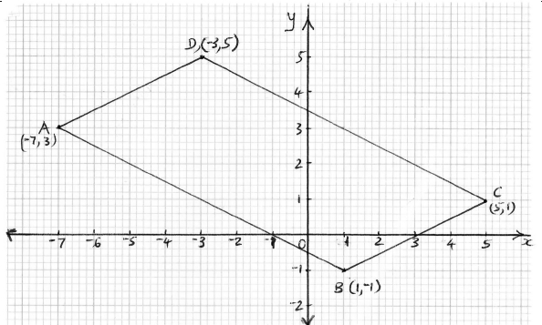
18.

(a)
(b) (i) grad AB = 3 - - 1

- 7 - 1
=- 1
2

B1
B1
M1

A1

plotting vertices A, B and C.
identifying vertex D (-3, 5) and
competing parallelogram.

(ii)
= - 1 or
y - 3
x -- 7 2
y -- 1
x - 1
=- 1
2
M1

7 1
y = - 1 x - + 3 or y = - 1 x + - 1
2 2 2 2

y =- 1 x - 1
2 2
(c) (i) Let grad L be m

` - 1 m = - 1 ( m = 2
2
A1

B1

equation of line
y - 3
x - 1

= 2
M1

y - 2x = 1

(ii) y - intercept: when x = 0
y = 2 # 0 + 1 = 1
A1

` co-ordinates ^0, 1h

319
B1
10

19. | 1  (a) c x - 2 m^x + 1h = 0  2 1 1  x + x - x - = 0  2 2  2 1 1  x + x - = 0  2 2  2  2x + x - 1 = 0  (b) (i) ^2y + 1h^ yh = 55  ^2y + 11h^y - 5h = 0  1  y = - 5 or y = 5  2  ` price of one mango Sh 5  (ii) no. of mangoes Karau got  95 + 55  mangoes bought = = 30  5  30  ` extra mangoes = = 5  6  Total mangoes = 30 + 5 = 35 | B1  M1  A1  B1  M1  A1  B1  M1  A1  B1 | or equivalent
19. |  | 10 | or equivalent

320

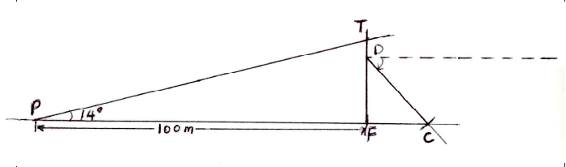
20.

(a) : use of scale
angle of elevation 14° : drawn
completion of scale drawing
(b) height of mast " 2.5 ! 0.1

= 2.5 # 10

= 25 m

B1
B1
B1
B1

B1

(c) position of cable drawn

(d) (i) + of depression of C from D

48c ! 1c

(ii) Distance from P to C

^10 + 1.8 ! 0.1h # 10

= 118 ! 1 m

321
B1
B1

B1

M1
A1
10
: positions of C and D
cable CD shown

21. | (a) + ROP = 2 # 64c = 128c  angle subtended at centre is twice angle  subtended at O circumference.  (b) + PSR = 180c - 64c = 116c  opposite angles of cyclic  quadrilateral add up to 180°.  (c) + ORP = 90c - 64c = 26c  angle in semicircle (+ QRP) = 90°  and base angles of isosceles triangle equal.  (d) + TRP = 64°  angle in alternate segment.  (e) + RTP = 180 - 2^64h = 52c  + TRP = 64° angle in alternate segment and  sum of angles in triangle PRT = 180°. | B1  B1  B1  B1  B1  B1  B1  B1  B1  B1 | allow other valid reasons
21. |  | 10 | allow other valid reasons

322

22. | 2 2  (a) (i) r = 15 - 12  = 9  (ii) Volume of cone:  1  = r # 9 # 9 # 12  3  = 1017.87602  - 1017.88  h 6  (b) (i) =  12 9  12 # 6  h = = 8  9  (ii) volume of smaller cone  1  = r # 6 # 6 # 8  3  = 301.5928947  - 301.59  (iii) Volume of frustum  1017.88 - 301.59  = 716.29 | M1  A1  M1  A1  M1  A1  M1  A1  M1  A1
22. |  | 10

323

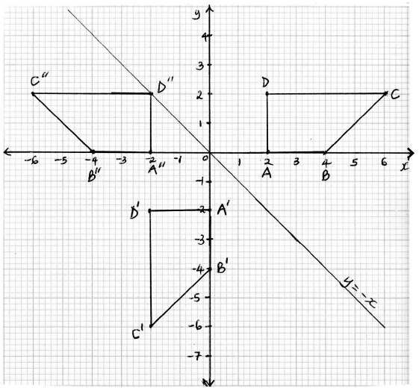
23

(a) (i) trapezium ABCD : drawn

B1

(ii) line of reflection y = - x drawn
trapezium A'B'C'D' : drawn
(iii) points A"B"C"D" plotted
trapezium A"B"C"D" drawn
(b) transformation which maps
A"B"C"D" onto ABCD
reflection
on line x = 0
(c) directly congruent pair
A'B'C'D' and A"B"C"D"
oppositely congruent pairs
ABCD and A'B'C'D'
ABCD and A"B"C"D"

324
B1
B1
B1
B1

B1
B1

B1
B1
B1
10
may be implied by : image

or y - axis

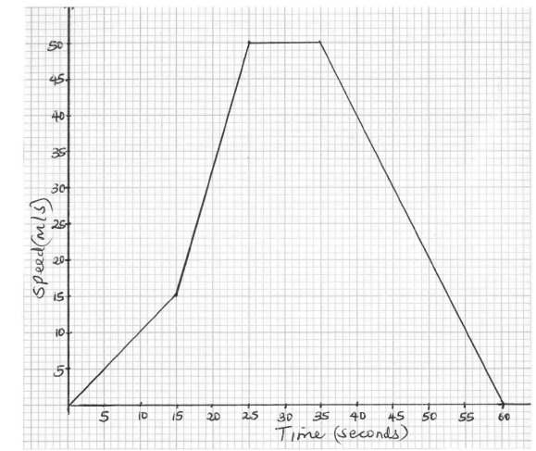
24

(a) : scale
(b) (i) deceleration = 50
acceleration parts
constant speed
deceleration

25
= 2 m/s2
(ii) Total distance

S1
B1
B1
B1
M1
A1

=

1
2

^15 # 15h + 1 ^15 + 50h # 10 + 10 # 50 + 1 ^25 # 50h
2 2
= 112.5 + 325 + 500 + 625 = 1562.5
M1 or equivalent

A1

(iii) Average speed

= 1562.5
60
= 26.0416 = 26.0 m/s

325
M1
A1
10

1. | 4.957 4.96  =  0.2638 - 0.0149 0.263 - 0.015  = 20 | B1  B1
1. | 4.957 4.96  =  0.2638 - 0.0149 0.263 - 0.015  = 20 | 2
2. | AB = 2 4 2 3  c3 0mc 1 1m  = 8 10  c6 9m  8 10 10 15  AB - 5B = -  c6 9m c 5 5m  = - 2 - 5  c 1 4 m | B1  M1  A1 | : Substraction and multiplica-  tion by 5
2. |  | 3 | : Substraction and multiplica-  tion by 5
3. | A: B: C A: B: C  4: 3 ( 4: 3  1: 2 3: 6  combined ratio A:B:C = 4:3:6  6  mass of type C = # 52  13  = 24 | B1  M1  A1
3. |  | 3
4. | 5  ar 96  (a) 3 =  ar 24  2  r = 4 $ r = !2  (b) when  3 24  r = 2 ( a # 2 = 24 ( a = = 3  8  when  3 24  r = - 2 ( a # ^- 2h = 24 ( a = = - 3  - 8 | M1  A1  B1  B1
4. |  | 4

4.3.4 Mathematics Alternative B Paper 2 (122/2)

326

5. | (a)  (b) P^6 1 x 1 10h  15 5  = =  36 12 | B2  B1 | : probability space
5. | (a)  (b) P^6 1 x 1 10h  15 5  = =  36 12 | 3 | : probability space
6. | (a) 2 4  OB = +  + c5m c4m  = 6  c9m  (b) co-ordinates of M  3  OM = OA + AB  + + +  4  2 4  = + 3  c5m 4 c4m  2 3 5  = + =  c5m c3m c8m  ` coordinates of M are (5, 8) | M1  A1  M1  A1
6. |  | 4
7. | Let angle APT = xc  ` 3x + 75 = 180c  x = 35c  angle BAP = angle BPR = 2 # 35c  = 70° | B1  B1
7. |  | 2
8. | 2 cos^x - 30hc = - 0.9  cos^x - 30hc = - 0.45  -1  ^x - 30hc = cos - 0.45  = 116.74c  x = 146.74c | M1  A1  B1
8. |  | 3

+ | 1 | 2 | 3 | 4 | 5 | 6
1 | 2 | 3 | 4 | 5 | 6 | 7
2 | 3 | 4 | 5 | 6 | 7 | 8
3 | 4 | 5 | 6 | 7 | 8 | 9
4 | 5 | 6 | 7 | 8 | 9 | 10
5 | 6 | 7 | 8 | 9 | 10 | 11
6 | 7 | 8 | 9 | 10 | 11 | 12

327

9. | 0 1 - 1 0  c 1 0mc 0 - 1m  = 0 - 1  c- 1 0m  0 - 1 1 1 - 1  c- 1 0mc 3 7 4m  = - 3 - 7 - 4  c - 1 - 1 1 m  ` coordinates:  Rl ^- 3, - 1h, Sl ^- 7, - 1h and Tl ^- 4, 1h | M1  M1  A1
9. |  | 3
10. | 2  2x + 8x = 15  2  x + 4x = 7.5  2 2  2 4 4  x + 4x + = 7.5 +  c 2 m c 2 m  x + 2 = 11.5  = !3.4  = 1.4 or - 5.4 | M1  M1  A1
10. |  | 3
11. | radius = 2.4 ! 0.1 | B1  B1  B1 | bisecting 2 or 3 angles  constructing radius and com-  pleting circle
11. | radius = 2.4 ! 0.1 | 3

328

12. | Fraction of food per person per day 1  2000 # 90  Fraction for 2000 persons for 20 days  = 2000 # 20  2000 # 90  = 2  9  Remaining fraction of food = 7  9  No of days to feed 2000 + 500 persons  7 1 # 2500  = '  9 180000  7 72  # = 56  9 1 | M1  A1  M1  A1
12. |  | 4
13. | 2 2 2  cos P = 75 + 80 - 40  2 # 75 # 80  10425  = = 0.86875  12000  P - 30c  SR 40 40 sin 68  = ( SR =  sin 68 sin 30 sin 30c  = 74 m | M1  M1  A1
13. |  | 3
14. | 1st bracket $ 10164 # 10 = 1016.4  100  nd 15 _  2 bracket $ ^19740 - 10164h # = 1436.4  100 bb  `  rd 20  3 bracket $ ^21820 - 19740h # = 416  100 bb  a  Net tax = ^1016.4 + 1436.4 + 416h - 1162  = 1706.8 | M1  M1  M1  A1
14. |  | 4
15. | 2p + 3r = 66..... (i)  7p + 2r = 129...(ii)  4p + 6r = 132..(iii)  21p + 6r = 317.....(iv)  17p = 255  p = 15 | M1  M1  A1
15. |  | 3

329

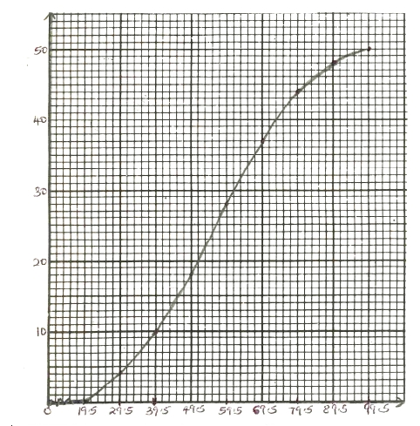
16

Graph

cf: 4, 10, 18, 28, 37, 44, 48, 50 B1
P1
C1
3

330

can be implied

17. | (a) 300000 # 0.18  = 54000  (b) (i) 300000 + 54000 - 134000  = 220000  (ii) 220000 # 1.18 - 134000  = 125600  (c) 125600 # 1.18  = 148208  (d) Total interest charged:  ^300000 + 22000 + 125600h # 0.18  = 54000 + 39600 + 22608  = 116208 | M1  A1  M1  A1  M1  A1  M1  A1  M1  A1 | or equivalent  134000 # 2 + 148208 -  = 116208
17. |  | 10 | or equivalent  134000 # 2 + 148208 -  = 116208
18. | 2  (a) (i) U10 = 10 - 10 + 3  = 93  (ii)  2 2  U30 - U20 = ^30 - 30 + 3h - ^20 - 20 + 3h  = 873 - 383  = 490  2  (iii) n - n + 3 = 243  2  n - n - 240 = 0  ^n + 15h^n - 16h = 0  n = - 15 or n = 16  n = 16  (b) (i) Number after t hours  = 180 # 3t  (ii) Number to the nearest million after 20 hours  180 # 312  = 95659380  = 96000000 | M1  A1  M1  A1  M1  M1  A1  B1  M1  A1
18. |  | 10

300000

331

19. | (a) Modal class: 4 - 5  8  (b) # 360c  36  = 80c  (c) mid values  0.5, 1.5, 2.5, 3.5, 4.5, 5.5, 6.5, 7.5  fx = 1, 6, 7.5, 17.5, 36, 33, 32.5, 22.5  / fx = 1 + 6 + 7.5 + 17.5 + 36 + 33 + 32.5 + 22.5  ` mean = 156  36  = 4 1  3  (d) | B1  M1  A1  M1  M1  M1  A1  S1  B2 | : scale and labelling  8 bars :  (allow B1 for 5 - 7 bars :)
19. |  | 10 | : scale and labelling  8 bars :  (allow B1 for 5 - 7 bars :)

332

20. | (a)  (b)  (c) (i) Roots of equation  x = 0.5  or  x = 3  (ii) tangent line : drawn  gradient: 5 - - 1  2 - 0  =3 | B2  S1  P1  C1  B1  B1  B1  M1  A1
20. |  | 10

x | -1 | 0 | 1 | 2 | 3 | 4
y | -12 | -3 | 2 | 3 | 0 | -7

333

21. | (a) (i) AB+ = OB+ - OA+ = 3i + 5j - ^- 2i + jh  = 3i + 5j + 2i - j  = 5i + 4j  (ii) CD+ = OD+ - OC+ = 2i - 4j - ^- 8i - 12jh  = 2i - 4j + 8i + 12j  = 10i + 8j  (b) mid point of vector AD  - 2i 2i 0  1 1  = + =  2 'c j m c- 4jm1 2 c- 3jm  = 0  c- 1.5jm  ` coordinates of mid point is  (0, -1.5)  (c) BC+ = OC+ - OB+ = - 8i - 12j - ^3i + 5jh  = 11i - 17j  2 2  ` BC = 11 + 17  +  = 121 + 289 - 20.2 | M1  A1  M1  A1  M1  A1  B1  M1  M1  A1
21. |  | 10
22. | (a) (i) Longitude difference = 12° + 60°  = 72°  72 22  Distance PR = # 2 # # 6370  360 7  = 8008 km  72  (ii) Time difference = h  15  = 4 h 48 min  Local time at Q:  = 9.00 pm - 4 h 48 min  = 4.13 pm  (b) Distance travelled in 2 h  = 1001 # 2 = 2002 km  i 22  ` # 2 # # 6370 = 2002  360 7  i = 2002 # 360 # 7  2 # 22 # 6370  = 18°  Position of T: (18°N, 60°W) | M1  M1  A1  M1  M1  A1  B1  M1  A1  B1
22. |  | 10

334

23. | 2 2  C kC  (a) (i) R \ ( R =  T T  R = 30, C = 62 and T = 2.4  ( 30 = k6  2.4  30 # 2 .4  k = = 2  36  2C2  (ii) ` R = T  (b) (i) when R = 402 and C = 8  T = 2 # 8  40  = 3.2  2  2 # ^0.9 # 8h  (ii) New R = 1.08 # 3.2  = 30  % change in R  40 - 30  = # 100  40  = 25% | B1  M1  A1  B1  M1  A1  M1  A1  M1  A1
23. |  | 10

335

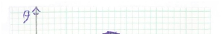
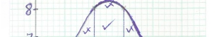
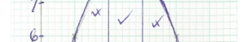
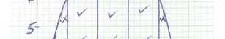
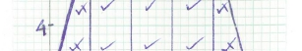
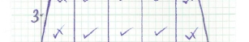
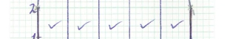
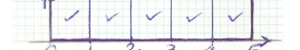
24. | 1 1  (a) (i) 24 + ^13h = 30  2 2  1  (ii) # 1"2 + 2 + 2^6 + 8 + 8 + 6h,  2  1  = ^60h  2  2  = 30 cm  30 56 - 30  (b) (i) % error = 5 # 100  30 6  = 2 26  37  = 2.7  (ii) 1 cm / 120 m  2 2  1 cm / 14400 m  5 2 144000 185  ` 30 6 cm / #  10000 6  =44.4 ha | M1  A1  B1  M1  A1  M1  A1  B1  M1  A1 | whole square and part square  ordinates 2, 6, 8, 8, 6, 2  substitution into formula  simplification
24. |  | 10

336

