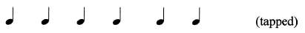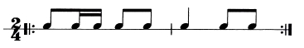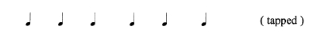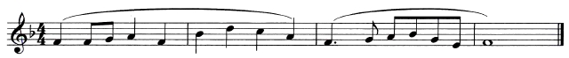
3.27 MUSIC (511)

3.27.1 Music Paper 2 (511/2)
TEST ONE: RHYTHM ON MONOTONE
Test 1 (a): Drum Rhythm
You are to write on monotone the rhythm of the following repetitive drum pattern.
You are require to add time signature and bar lines and also group the notes. The
rhythm pattern will be played four times.
Here is the crotchet pulse followed by the first play through.
(Pause: 2 seconds)

( = 80)
(Pause: 3 seconds)

(Silence: 30 seconds)
Here is the second play through
(Silence: 30 seconds)
Here is the third play through
(Silence: 30 seconds)
And now, the fourth and last play through
(Silence: 60 seconds)
Test 1 (b): Rhythm of a melody in simple time.
You are the write the rhythm of the following melody on monotone, adding the time
signature. It begins on the first beat of the bar.
The melody will be played four times.
Here is the crotchet pulse followed by the first play through.
(Pause: 2 seconds)
( = 80)
(Pause: 3 seconds)

(Silence: 30 seconds)
Here is the second play through
(Silence: 30 seconds)
239

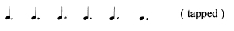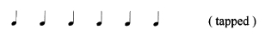
Here is the third play through
(Silence: 30 seconds)
And now, the fourth and last play through
(Silence: 60 seconds)
Test 1 (c): Rhythm of a melody in compound time.
You are to write the rhythm of the following melody on monotone. It begins on the last
beat of the bar. The melody will be played four times.
Here is the dotted crotchet pulse followed by the first play through.
(Pause: 2 seconds)

( = 66)
(Silence: 3 seconds)

(Silence: 30 seconds)
Here is the second play through
(Silence: 30 seconds)
Here is the third play through
(Silence: 30 seconds)
And now, the fourth and last play through
(Silence: 60 seconds)
TEST TWO: MELODY
Test 2 (a): Melody in a major key
You are to write the following melody in the key of A major. The melody will be
played through once, then the first phrase will be played twice and the second phrase
twice. Finally the whole melody will be played right through once again. Write the
treble clef and the key signature of A major now.
(Silence: 10 seconds)

The melody is in

4
4
time. Write the time signature now.

(Silence: 10 seconds)
The melody begins on the first beat of the bar. Here is the crotchet pulse.
(Pause: 2 seconds)
( = 80)

240

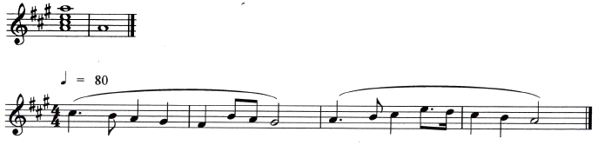
Here is the tonic chord of A major and the key note followed by the whole melody.
(Pause: 2 seconds)

(Silence: 40 seconds)
And now, here is the tonic chord and key-note again followed by the first phrase.
(Silence: 40 seconds)
Here is the first phrase again.
(Silence: 40 seconds)
Now, here is the keynote and the second phrase.
(Silence: 40 seconds)
Here is the first phrase again.
(Silence: 40 seconds)
Now, here is the keynote and the second phrase.
(Silence: 40 seconds)
Finally, here is the tonic chord followed by the whole melody.
(Silence: 60 seconds)
Test 2 (b) Melody in a Minor key
You are to write the following melody in the key of B minor. The melody will be
played through once, then the first phrase will be played twice and the second phrase
twice. Finally the whole melody will be played right through once again. Write the
treble clef and the key signature of B minor.
(Silence: 10 seconds)

The melody is in

6
8
time. Write the time signature now.

(Silence: 10 seconds)
The melody begins on the last beat of the bar. Here is the dotted crotchet pulse.
(Pause: 2 seconds)

( = 80)
Here is the tonic chord of B major and the key note followed by the whole melody.
(Pause: 2 seconds)

241

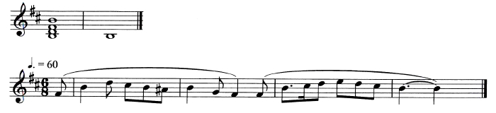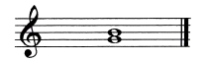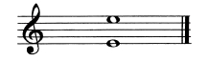

(Silence: 10 seconds)
And now, here is the tonic chord and key-note again followed by the first phrase.
(Silence: 40 seconds)
Here is the first phrase again.
(Silence: 40 seconds)
Now, here is the keynote and the second phrase.
(Silence: 40 seconds)
Here is the first phrase again.
(Silence: 40 seconds)
Now, here is the keynote and the second phrase.
(Silence: 40 seconds)
Finally, here is the tonic chord followed by the whole melody.
(Silence: 60 seconds)
TEST 3: INTERVALS
Two intervals will be sounded harmonically. Each interval will be sounded twice.
You are to describe each of the intervals.
(Pause: 2 seconds)
(i) Here is the first interval.

(Silence: 20 seconds)
Here is the first interval again
(Silence: 20 seconds)
(ii) Here is the second interval.

(Silence: 20 seconds)
Here is the second interval again.
(Silence: 20 seconds)

242

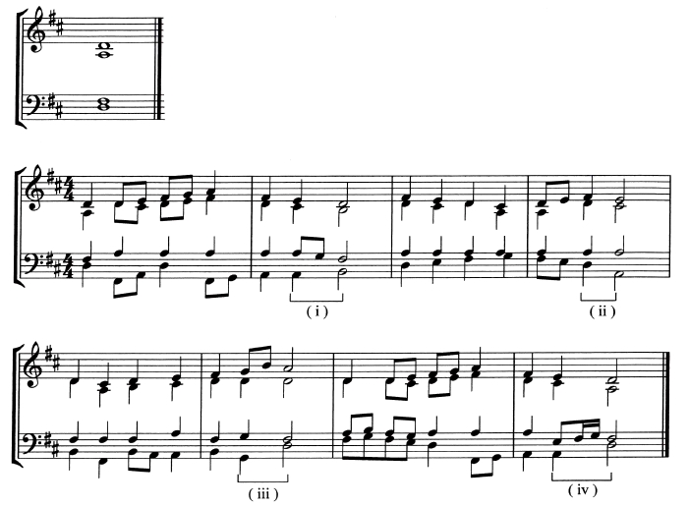
TEST 4: CADENCES
There are four cadences in this passage which will be played with a pause at each
cadential point. You are required to name the cadences in the order in which they occur
in the passage.
Here is the tonic chord followed by the first play through.
(Pause: 2 seconds)

(Silence: 15 seconds)
Here is the second play through
(Silence: 15 seconds)
Here is the third play through
(Silence: 15 seconds)
And finally, the fourth and last play through
(Silence: 20 seconds)

243

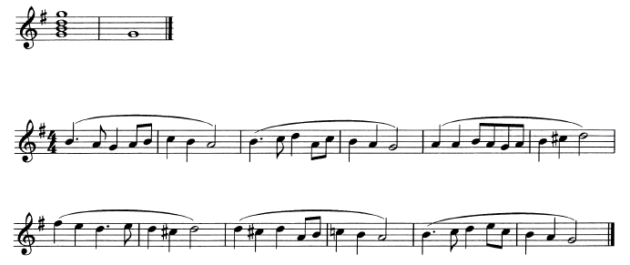

TEST FIVE: MODULATION
Test 5 (a) The following melody is in the key of G Major. It modulates once away from the
tonic key. You are required to name the key to which the melody modulates before
returning to the tonic. The melody will be played three times.
Here is the tonic chord of G Major followed by the first play through.
(Pause: 2 seconds)

(Silence: 15 seconds)
Here is the second play through
(Silence: 15 seconds)
And now, the third and final play through
(Silence: 30 seconds)
Test 5 (b) The following melody is in the key of G Minor. The melody modulates once away
from the tonic key. You are required to name the key to which the melody modulates
before returning to the tonic. The melody will be played three times. Here is the tonic
chord of G Minor followed by the first play through.
(Pause: 2 seconds)

244

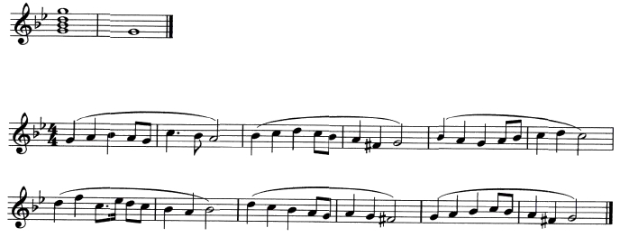

(Silence: 15 seconds)
Here is the second play through
(Silence: 15 seconds)
And now, the third and final play through
(Silence: 30 seconds)
That is the end of the Aural Tests of the Kenya Certificate of Secondary Education Music
examination for the year 2013.
You now have three minutes in which to check your answers before handing in your paper.

245

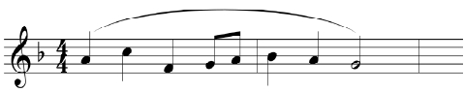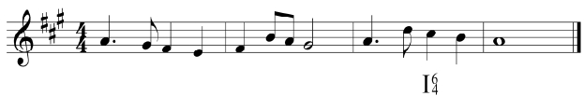
3.27.2 Music Paper 3 (511/3)
Answer questions from all sections.
SECTION A: BASIC SKILLS (32 marks)
1 Either (a) Continue the following opening to make a melody of sixteen bars for voice
introducing modulation to the subdominant and then back to the tonic.
Incorporate dotted rhythm and add phrase marks. (12 marks)

Or (b) Using staff notation, compose a melody and set to it the lyrics below.

(12 marks)

Ujinga kitu kibaya,
heri kumeza mchanga
Ujinga kwa mwanadamu,
si mwendo mwema ujinga.
2 Harmonize the following for Soprano, Alto, Tenor and Bass (SATB). Choose
appropriate chords from the following: I, II, IV, V and VI. Make use of the passing
note in bar 2. (20 marks)

SECTION B: HISTORY AND ANALYSIS (48 marks)
3 AFRICAN MUSIC
(a) (i) What is an idiophone? (1 mark)
(ii) Name two Kenyan traditional melodic idiophones. (1 mark)
(iii) State how each of the instruments named above is played. (2 marks)
(iv) Apart from idiophones, name any other two classes of instruments. (2 marks)
(b) Explain two reasons why music is important in the traditional circumcision
ceremony. (4 marks)

246

(c) Name the instrument played by each of the following Kenyan traditional musicians.
(4 marks)
(i) Swaleh Mwatela;....................................................................................................
(ii) David Mwangi;.......................................................................................................
(iii) Ogola Opot;............................................................................................................
(iv) William Ingosi........................................................................................................
4 WESTERN MUSIC
Answer any two of the following questions (a), (b), (c) and (d)
(a) Thomas Morley
(i) In which period of music history did Thomas Morley live? (1 mark)
(ii) What is madrigal? (2 marks)
(iii) Give the title of the collection of madrigals compiled by Morley in praise of
Queen Elizabeth I. (1 mark)
(iv) Outline any three characteristics of Thomas Morley’s Ballets. (3 marks)
(b) Antonio Vivaldi
(i) For which institution did Vivaldi work for most of his career? (1 mark)
(ii) Outline any two of his duties at the institution. (2 marks)
(iii) Give four sources that influenced Vivaldi’s musical career. (4 marks)
(c) Ludwig Van Beethoven
(i) What type of work is Fidelio? (1 mark)
(ii) For what medium did Beethoven compose the 9th symphony? (1 mark)
(iii) Name the masses composed by Beethoven. (2 marks)
(iv) Outline three ways through which Beethoven earned a living as a freelance
musician in Vienna. (3 marks)

247

(d) Igor Stravinsky
(i) State Stravinsky’s nationality? (1 mark)
(ii) What type of work is “The Rite of Spring”? (1 mark)
(iii) Give any two reasons that caused a riot during the first performance of
“The Rite of Spring”? (2 marks)
(iv) Outline any three features that characterize Stravinsky’s music in terms
of tone colour. (3 marks)
5 PRESCRIBED AFRICAN TRADITIONAL MUSIC
Teso Folksong - From Ngoma za Kenya. PPMC Recording
This performance consists of an introduction and four sections.

(a) Describe the introductory section in terms of voices and instrumentation.

(2 marks)

(b) Give two characteristic features that mark the various sections in the performance.
(2 marks)

(c) Outline four characteristic features of the singing style in the performance.

(4 marks)

(d) State two roles of the instruments in the performance. (2 marks)
6 PRESCRIBED WESTERN MUSIC
Sonata in F minor Op.2 No.1 - lst movement - Ludwig van Beethoven
(a) (i) In what form is the movement? (1 mark)
(ii) Describe the form in terms of the statement of the theme and the key system.
Use bar numbers for reference. (6 marks)

(b) Describe the texture of the music from bars 146 - 152. (1 mark)
(c) With reference to bar numbers identify:
(i) scalic movement; (1 mark)
(ii) a trill. (1 mark)

248

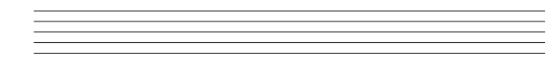

SECTION C: GENERAL MUSIC KNOWLEDGE (20 marks)
7 (a) State the meaning of each of the following terms:
(i) Unison; (1 mark)
(ii) Discord; (1 mark)
(iii) Contralto; (1 mark)
(iv) Tutti; (1 mark)
(v) Score. (1 mark)
(b) (i) Explain two differences between a harp and a lyre. (4 marks)
(ii) Name a Kenyan traditional harp. (1 mark)
(c) The concertmaster is an important member of the orchestra.
(i) Name the instrument he plays. (1 mark)

(ii) Where is he/she positioned in the sitting arrangement of the orchestra?

(1 mark)

(iii) State two of his duties in the orchestra. (2 marks)
(d) Write the following music in staff notation. (6 marks)
Doh is G. Time 34
{|s:-.f:m|l:-:s|f.m:r:t1|d:-:-||

249

