COMPETENCE BASED ASSESMENT
GRADE 1 YEAR 2020
(MONITORING LEARNERS PROGRESS)
ENGLISH ACTIVITIES TIME:
NAME:
DICTATION
- ______________________
- ______________________
- ______________________
- ______________________
- ______________________
Name the pictures
- 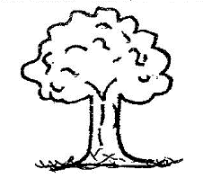__________________
- _________________
- 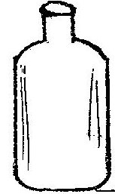_______________________
- 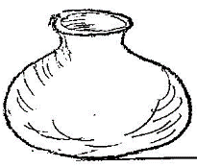______________________

- __________________

Write in small letters
- STEP _____________________
- COMB_____________________
- ZEBRA_____________________
- COME_____________________
- NEAR_____________________
Write the Plural
One Many
- Cup _______________
- Ball _______________
- Ruler _______________
- Pen _________________
- Desk _________________
Write doing words (ing)
Play playing
- talk _______________
- draw _______________
- eat _______________
- sing _______________
- jump _______________
Use of a, an
- ________________ teacher
- ________________ desk
- ________________umbrella
- ________________boy
- ________________elephant.

Use of ed
- I_______________ my dirty clothes.
(washes, washed)
- We ______________ yesterday evening.
(bathes, bathed)
- Sam ______________ his teeth. (brush, brushed)

