COMPETENCE BASED ASSESMENT
GRADE 3 YEAR 2020
(MONITORING LEARNERS PROGRESS)
HYGIENE AND NUTRITION ACTIVITIES TIME:
NAME:
LEARNER UPI: GENDER: BOY GIRL
No. of questions correct
Performance level

SCHOOL NAME

ANSWER ALL QUESTIONS IN THE SPACES PROVIDED
- We should brush our teeth after every _______________ (tea, meal)
- Taking sweet can make our teeth to? ________________( decay, smell good)
- ________________ is a healthy habit?
(urinating in bed, eating balance diet)
- We should visit the dentist when we have a problem with our?
(eyes, teeth)
- We sleep at night in order to _______________(dream, rest)
- We take medicine when we are?
_________________(healthy, sick)
- How many meals do we take in a day?__________(2, 3)
- We go to the hospital when we are _______________( hungry, sick)
Name the following parts of the body
- 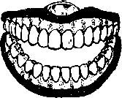

- 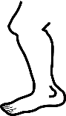

- 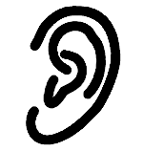
(ear, teeth, leg)
- Wounds found in the mouth are called?__________(mouth sores, wounds)
- Name the item below
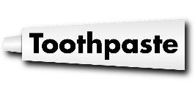
- We use ______________ to clean our house. (duster, broom)
- What type of dirt will be on a plate that had chicken soup?______________________ (oily stain, starchy stain)
- Draw a picture of yourself cleaning a plate with an improvised material.

- We should keep medicine a way from___________( insects, children)
Name the following items
Syrup tablets ointment

- 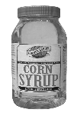

- 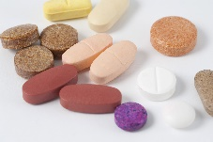

- 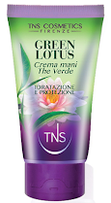

- We keep our body fit by ____(Exercising, eating)

- We can get diseases if we drink _____________water.(dirty, clean)

- We do not get _________________ when we drink safe water. (thirsty, illness)

- We can improvise _______________to make toothbrush. (plastic, stick)

