COMPETENCE BASED ASSESMENT
GRADE 3 YEAR 2020
(MONITORING LEARNERS PROGRESS)
KISWAHILI ACTIVITIES TIME:
NAME:
LEARNER UPI: GENDER: BOY GIRL
No. of questions correct
Performance level

SCHOOL NAME

JIBU MASWALI YOTE KWENYE NAFASI ZILIZOACHWA WAZI
IMLA

Weka alama (!), (?) au (.) mwishoni mwa sentensi hizi.
- Je, wanafunzi walizuru mbuga gani_________
- Kwa nini unapenda Kiswahili______________
- Mama alininunulia kalami, kitabu na wino______
Ziandike upya sentensi hizi ukitenganisha maneno
- Tuliendashuleni_____________________
- Mamaanapikachakula
__________________________________________
- Sisiniwanafunzi_____________________________
- Mkulimaanalimashamba
__________________________________________

Andika sentensi zifuatazo kwa umoja
- Wanafunzi walinunua kalamu.
_________________________________________
- Maganda yalitupwa
____________________________________
- Wageni waliketi
_____________________________________
Tumia vimilikishi ifaavyo kujaza pengo
- Kiatu________________kimeharibika (changu, yangu)
- Mwalimu________________ananipenda. (yangu, wangu)
- Chumba____________ ni kizuri. (yetu, chetu)
- Gari___________limeegeshwa. (letu, yetu)
Ambatanisha Jina na picha.
Picha | Jina
- 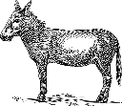 | ngombe
- 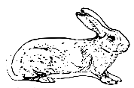 | punda
- 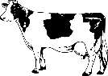 | sungura
Andika vinyume vya maneno vifuatavyo
- Lala____________________
- Cheka___________________
- Simama__________________

