Name: ……………………………………………………… Index No.…………………………….......
School: ………………………………………………………. Class …………………………………..
Date: ……………………
233/1
CHEMISTRY THEORY
PAPER 1
TIME: 2 HOURS
KASSU JET EXAMINATIONS
JANUARY 2021
Instructions to Candidates
(a)Write your name and index number in the spaces provided above.
(b) Sign and write the date of examination in the spaces provided above
(c) Answer ALL the questions in the spaces provided in the question paper
- KNEC Mathematical tables and electronic calculators may be used for calculations
- All working MUST be clearly shown where necessary
- This paper consists of 12 printed pages
- Candidates should check the question paper to ascertain that all the pages are printed as indicated and that no questions are missing
- Candidates should answer the questions in English

FOR EXAMINER’S USE ONLY

Question | Maximum score | Candidate’s score
1 – 29 | 80

This paper consists of 12 printed pages. Candidates should check to ascertain that all pages are printed as indicated and that no questions are missing.
1. Study the diagram below then use it to answer the questions that follow.

a) Draw the wooden splint at the end of the experiment. If it was slipped then removed. (1 mark)

b) Explain the appearance of the wooden splint in (a) above. (2 marks)
${}_{\text{83}}^{\text{210}}{}$………………………………………………………………………………………………………………………………………………………………………………………………………………………………………………………………………………………………………………………………………………
2. (a) The half-life of M is 7 days. Determine the mass of remaining if 100g decayed in
35 days. (1 mark)
………………………………………………………………………………………………………………………………………………………………………………………………………………………………
(b) The diagram below shows the radiations emitted by a radioactive sample.
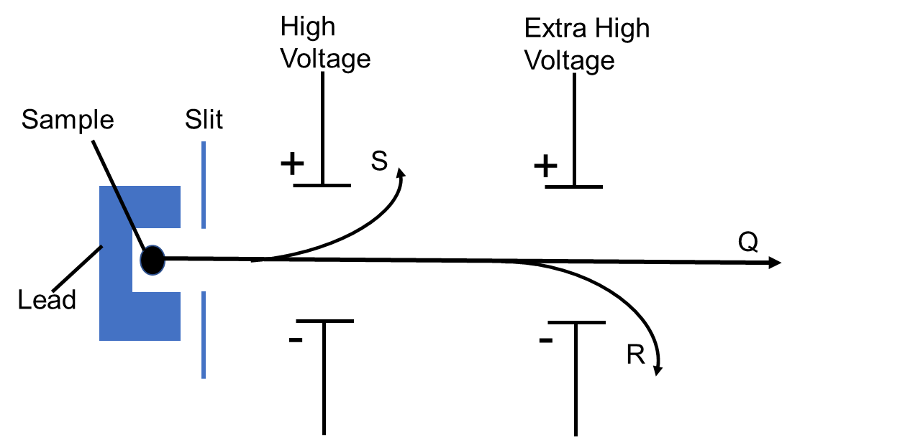
- Identify radiation particles S and R. (1 mark)
S……………………………………………………
R……………………………………………………

- Which emission causes most harm to human cells. Give a reason. (1mark)
………………………………………………………………………………………………………………………………………………………………………………………………………………………………
3. a) Starting with copper metal, describe how a solid sample of copper (II) carbonate
can be prepared. (3 marks)
……………………………1……………………………………………………………………………………………………………………………………………………………………………………………………………………………………………………………………………………………………………………………………………………………………………………………………………………………………………………………………………………………………………………………………………………………………………………………………………………………………………………………………………………………………………………………………………………………………………
4. The set-up below was used to obtain a sample of iron.
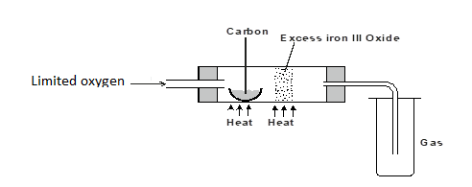
Write two equations for the reactions which occur in the combustion tube. (2 marks)
………………………………………………………………………………………………………………………………………………………………………………………………………………………………………………………………………………………………………………………………………………

5. Below are the bond dissociation energies of some elements.
Bond | Bond dissociation energy
C – C | 343 kJ mol⁻¹
C – H | 414 kJ mol⁻¹
H – H | 435 kJ mol⁻¹
C = C | 612 kJ mol⁻¹

Use this information to calculate the heat of reaction for (3 marks)
$C_{2}H_{4_{(g)}}+H_{2(g)}→C_{2}H_{6(g)}$

6. Sulphur (IV) oxide is oxidized catalytically to sulphur (VI) oxide in the reaction.
a) What information about the reaction is given by ∆H = -197kJ ? (1 mark)
………………………………………………………………………………………………………………
b) Name one catalyst that can be used in this reaction. (1 mark)
………………………………………………………………………………………………………………
7. Study the scheme below and answer the questions that follow.
FeSO_{4 (aq)}

a) Write the formula of the cation present in solution D. (1 mark)
………………………………………………………………………………………………………………
b) What property of chlorine is shown in step 1. (1 mark)
………………………………………………………………………………………………………………
c) Write an equation for the reaction which occurred in step III. (1 mark)
………………………………………………………………………………………………………………
8. 0.63g of lead powder were dissolved in excess nitric (V) acid to form lead (II) nitrate solution. All the lead (II) nitrate was then reacted with sodium sulphate solution.
a) Write an ionic equation for the reaction between sodium sulphate solution and lead (II) nitrate solution. (1 mark)

.………………..………………………………………………………………………………………..……
b) Determine the mass of the lead salt formed in the reaction in (a) above (Pb = 207, S = 32, O = 16) (2 marks)
………………..……………………………………………………………………………………………
………………..……………………………………………………………………………………………
………………..……………………………………………………………………………………………
………………..……………………………………………………………………………………………

9. Use the cell representation below to answer the questions that follow.
a) Write an equation for the cell reaction. (1 mark)
………………………………………………………………………………………………………………
b) If the emf of the cell is 0.30V and the E⁰ value for Fe²⁺ / Fe_{(S)} is -0.44V. Calculate the E⁰ value for Cr_{(s)} / Cr³⁺_{(aq)} (2 marks)

10. An element Q has a relative atomic mass of 88. When a current of 0.5A was passed through the fused chloride of Q for 32 minutes and 10 seconds, 0.44g of Q were deposited at cathode. Determine the charge on the ion of Q. (1 Faraday = 96500 coulombs) (3 marks)

11. The table below gives three experiments on the reaction of excess sulphuric (VI) acid and 0.5g Zinc done under different conditions. In each case the volume of gas liberated was recorded at different time intervals.
Experiment | Form of Zinc | Sulphuric (VI) acid
I | Powder | 0.8M
II | Powder | 1.0M
III | Granules | 0.8M

On the axes below, draw and label the three curves that would be obtained from the results above.
(3 marks)

12. a) Starting with red roses, describe how a solution containing the red pigments may be prepared? (2 marks)
………………………………………………………………………………………………………………………………………………………………………………………………………………………………………………………………………………………………………………………………………………
b) How can the solution be shown to be an indicator. (1 mark)
………………………………………………………………………………………………………………

13. The table below provides data on the successive ionisation energies of carbon.
Ionisation numbers | 1st | 2nd | 3rd | 4th | 5th | 6th
Ionisation energy (kJ/mol) | 1090 | 2350 | 4610 | 6220 | 37800 | 47300

a) Explain why each ionisation energy increase in nature. (2 marks)
………………………………………………………………………………………………………………………………………………………………………………………………………………………………
b) Write an equation for the 5th ionisation energy of carbon. (1 mark)
……………………………………………………………………………………………………………
14. The figure below was set by a student to investigate the reaction between chlorine gas and hydrogen sulphide gas.

a) Write an equation for the reaction that took place in the flask. (1 mark)
………………………………………………………………………………………………………………………………………………………………………………………………………………………………
b) What observation was made in the flask ? (1 mark)
………………………………………………………………………………………………………………
c) What precaution should be taken in carrying out the experiment ? (1 mark)
………………………………………………………………………………………………………………………………………………………………………………………………………………………………
${\text{QCO}}_{3(S)}+2{\text{HCl}}_{(\text{aq})}→{\text{QCl}}_{2(\text{aq})}+{\text{CO}}_{2(g)}+H_{2}O_{(l)}$15. A certain carbonate, QCO₃, reacts with dilute hydrochloric acid according to the equation given below.

If 1g of the carbonate reacts completely with 20cm³ of 1M hydrochloric acid. Calculate the relative atomic mass of Q.(C = 12.0, O=16.0) (3 marks)

16. When bismuth (III) chloride is added to water, a reaction occurs and a white precipitate forms as shown below.
BiCl_{3(aq)} + H₂O_{(l)} BiOCl_{(s)} + 2HCl_{(aq)}

What would be the effect on the amount of the precipitate formed if sodium hydroxide solution is added to the equilibrium mixture? Explain your answer. (2marks)
………………………………………………………………………………………………………………………………………………………………………………………………………………………………………………………………………………………………………………………………………………
- (a) State the Gay Lussac's Law. (1 mark)
……………………………………………………………………………………………………………………………………………………………………………………………………………………
(b) 10cm³ of a gaseous hydrocarbon, C₂H_{X} required 30cm³ of oxygen for complete combustion. If steam and 20cm³ of carbon (IV) oxide were produced, what is the value of X? (2 marks)

- (a) Give Bronsted and Lowry definition of an acid (1mk)
………………………………………………………………………………………………………………
……………………………………………………………………………………………………………….
- Differentiate between a strong acid and a concentrated acid (2mks)
………………………………………………………………………………………………………………
………………………………………………………………………………………………………………
………………………………………………………………………………………………………………
- When a hydrated sample of CaSO₄.xH₂O was heated until all water was lost, the following data was recorded
Mass of crucible = 30.296 g
Mass of crucible + hydrated salt = 33.111 g
Mass of crucible + anhydrous salt = 32.781 g
Determine the empirical formula of the hydrated salt. (CaSO₄=136,H₂O=18). (3marks) .……………………………………………………………………………………………………………………………………………………………………………………………………………………..………………………………………………………………………………………………………………………………………………………………………………………………………
- Describe a chemical test used to distinguish butane from butene in the laboratory. (2marks)
.………………………………………………………………………………………………………………
…………………………………………………………………………………………………………………………………………………………………………………….…………………………………………
- The table below gives the atomic numbers of elements W, X, Y and Z.
Element | W | X | Y | Z
Atomic number | 14 | 17 | 16 | 19
- Name the type of bonding that exist in the compound formed when X and Z reacts. (1mark)
.………………………………………………………………………………………………………………………………………………………………………………………………………………
b) Select the letter representing the strongest reducing agent. Give a reason for your answer. (2mks)
.………………………………………………………………………………………………………………………………………………………………………………………………………………………………………………………………………………………………………………………
- In an electrochemical cell, the standard hydrogen electrode uses platinized platinum. State three functions of the platinized platinum. (3 marks)
………………………………………………………………………………………………………………………………………………………………………………………………………………………………………………………………………………………………………………………………………………………………………………………………………………………………………………………………
- The flowchart below shows the scheme for extraction of Hydrogen from hydrolysis of natural gas, study it and answer the questions that follow.
Steam
Natural gas
Separation chamber
Purification chamber
Step 1

step II
Water gas
Air Step III
H_{2 ,} CO₂

Step IV
H₂ gas
          - In step II water gas is formed. State one use of water gas. (1marks)
………………………………………………………….…………………………………………
          - When air is added in step III CO is converted to CO₂ name one chemical substance that can be used to separate CO₂ from H₂ in step IV (1marks)
……………………………………………………………………………………………………
          - State one large scale use of Hydrogen gas formed. (1marks)
…………………………………………………………………………..…………………………
- Aluminium is obtained from the ore with the formula Al₂O₃. 2H₂O. The ore is first heated and refined to obtain pure aluminium oxide (Al₂O₃). The oxide is then electrolysed to get Aluminium and oxygen gas using carbon anodes and carbon as cathode.

  - Give the common name of the ore from which aluminium is extracted. (1 mark)
......................................................................................................................................................................... ii) What would be the importance of heating the ore first before refining it ? (1 mark)
.........................................................................................................................................................................
iii) The refined ore has to be dissolved in cryolite first before electrolysis. Why is this necessary? ……………………………………………………………………………………………. (1 mark)
iv) Why are the carbon anodes replaced every now and then in the cell for electrolysing aluminium oxide? (1 mark)
................................................................................................................................................................................................................................................................................................................................................
26. Nylon polymer has the structure below.
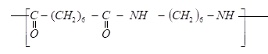
i) Determine the structures of the monomers. (2mks)
……………………………………………………………………………………………………………………………………………………………………………………………………………………………………………………………………………………..………………………………………………………………………………………
ii) State the type of polymerization. (1mk)
……………………………………………………………………………………………………………..… ………………………………………………………………………………………………………..
27. (a) Define the term solubility. (1 mark) ………………………………………………………………………………………………………………………………………………………………………………………………………………………………
b) The following were the results obtained in an experiment to determine solubility of potassium
nitrate at room temperature.
Mass of evaporating dish = 14.32 g
Mass of evaporating dish + saturated solution = 35.70 g
Mass of evaporating dish + salt (residue) = 18.60 g
Calculate the solubility of potassium nitrate from the above results. (2 marks) ……………………………………………………………………………………………………………………………………………………………………………………………………………………………………………………………………………………………………………………………………...........................................…………………………………………………………………………………………..…

28. Describe a simple laboratory experiment that can be used to distinguish between sodium sulphide and sodium carbonate. (2mks)
……………………………………………………………………………………………………………………………………………………………………………………………………………………………………………………………………………………………………………………………………...........................................…………………………………………………………………………………………..…

29. (a)Give one reason some of the laboratory apparatus are made of ceramics.
(1 mark)
……..........................………………………………………………………………………………………….
(b) Name two apparatus that can be used to measure approximately 75 cm³ of dilute sulphuric (VI) acid. (2 marks)

…………………………………………………………………………………………………………………………………….
…………………………………………………………………………………………………………………………………….

Last Printed Page

