OPENER EXAMINATION YEAR 2021 TERM 2
NAME:………………………………………………………………….CLASS:…………..ADM NO:..…
AGRICULTURE MARKING SCHEME
FORM 1

70MKS

INSTRUCTIONS

Answer all the questions in the spaces provided.

- Differentiate between floriculture and olericulture. (2mks)
- Olericulture:- is the growing of vegetables while floriculture is the growing of flowers.
- State three characteristics of large scale farming system. (3mks)
- It involves the use of large tracts of land
- Requires heavy capital investment.
- Requires highly skilled labour.
- Requires high level of management.
- Mainly carried out for commercial purpose.
- List three methods of farming. (3mks)
- Mixed farming
- Nomadic pastoralism
- Shifting cultivation
- Organic farming
- Agroforestry

- State five ways in which agriculture has contributed to the economic development of Kenya. (5mks)
- Food supply
- Source of employment
- Provision of foreign exchange
- Source of raw materials for industries
- Provision of market for industrial goods
- Source of money/income/capital
- State four human factors influencing Agriculture. (4mks)
- Level of education and technology
- Health
- Economy
- Government policy
- Transport and communication
- Cultural practices and religious beliefs.
- Market forces.
- State how each of the following factors affects Agriculture. (6mks)
- Decomposers
- They cause rotting of plant and animal materials forming manure.
- Pollinators
- They cause crops pollination helping in the production of new and improved varieties of crops for the following generation.
- Parasites
- They suck blood from animals and irritate them by biting their skin.
- State three main aspects of light that are important to crop growth. (3mks)
- Light intensity
- Light duration
- Light wavelength
- List four factors influencing soil formation. (4mks)
- Parent rock material
- Climate
- Topography
- Time
- The diagram below represents a soil profile. Study it and answer questions that follow.
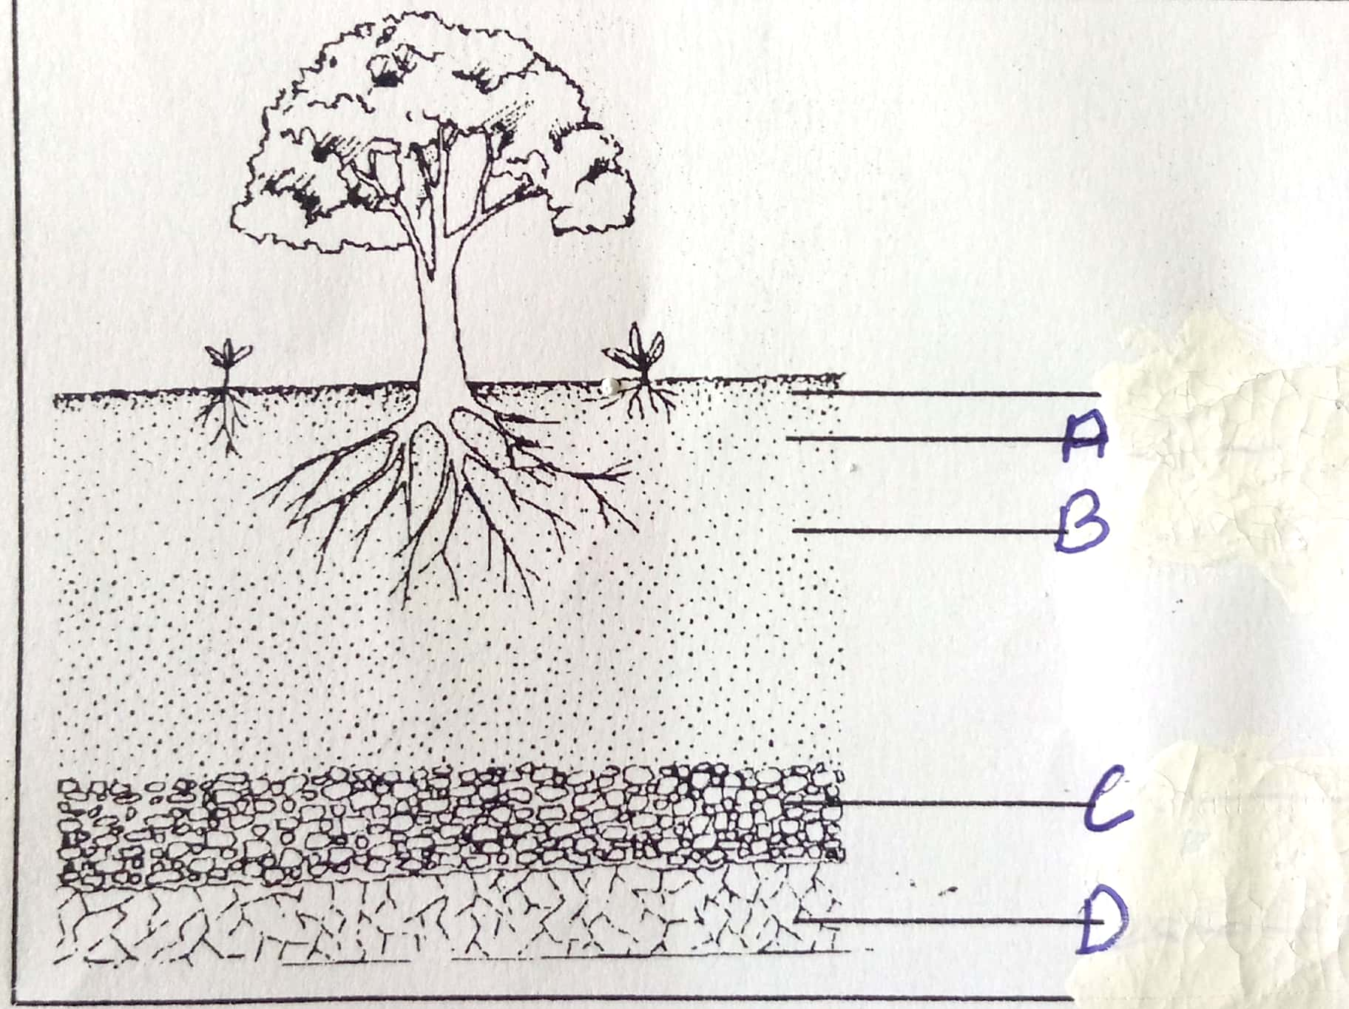
- Name the horizons. (4mks)
A – Top soil
B – Sub- soil
C – Weathered rock / substratum
D – parent rock / bed rock
- Give two characteristics of horizon A. (2mks)
- It is darker than other layers due to high humus content.
- It is well aerated.
- Contains active living organisms
- Most plant roots are found here
- Well aerated
- Contains most of plant nutrients
- State two effects of hard pans. (2mks)
- It impedes drainage
- Prevents root penetration
- It impedes soil aeration
- List four soil constituents. (4mks)
- Soil mineral matter
- Soil organic matter
- Soil air
- Soil water
- Soil living organism
- Outline three types of soil structures. (3mks)
- Single grained
- Crumby
- Granular
- Prismatic
- Platy
- Blocky
- Give two characteristics of clay soils. (2mks)
- Have high capillarity
- Have poor drainage
- Have high water retention/holding capacity
- They are sticky and crack easily when dry.
- They have small air spaces.
- They are usually smooth
- The set-up below illustrates an experiment to study a certain physical aspect of different types of soils. Study it and answer questions that follow.

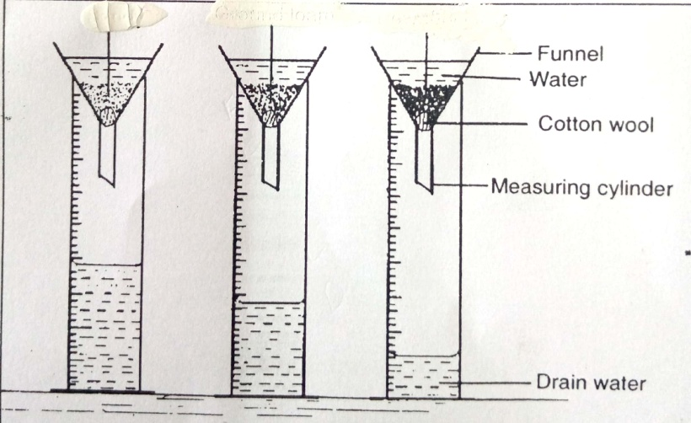
R
Q
P

- Name soils: (3mks)
P – Sandy
Q – Loam
R – clay
- What was the aim of the experiment? (1mk)
- To compare the porosity and water holding capacity of 3 soil types.
- How can the structure of soil P be improved? (1mk)
- By adding organic manure.

- State two ways by which soil of pH3 can be raised to a pH of 6. (2mks)
- Application of basic fertilizers
- Application of lime
- Give four effects of high temperature in crop production. (4mks)
- Increases rate of evaporation leading to wilting of crops.
- Hastens maturity of a crop.
- Improves the quality of crops such as pineapples and oranges.
- Increase incidences of diseases infection and pest infestation in crops.
- List four physical agents of weathering. (4mks)
- Moving ice
- Water
- Wind
- Temperature
- State five categories at farm tools and equipment. (5mks)
- Garden tools and equipment
- Workshop tools and equipment
- Livestock production tools and equipment.
- Masonry tools and equipments
- Plumbing tools and equipments.
- State three maintance practices of a wheelbarrow. (3mks)
- Grease the wheel and axle
- Proper storage
- Clean after use
- Replace worn out wheel and axle.

