GEOGRAPHY FORM THREE marking scheme

1a)i)Differentiate between indigenous and exotic forests (2mks)
Indiginous forests are made up of trees that are native to a country while exotic forests are made of trees that are alien to a country or region.
ii)Give three western rainforests found in Kenya (3mks)
-Mount elgon forest
-Kakamega forest
-North and south Nandi forests
-Gwasi hills forest
b)i)State three measures which have been taken to conserve forests in Kenya (3mks)
-planting trees where some have been cut down (reafforestation progammes)
-Planting trees where non existed(Afforestation)
-Setting up presidential commission
-Setting up of Nyayo tea zones
-Intercropping of crops with trees (agroforestry)
-creation of forests reserves community participation
ii)Explain two factors which favour the development of soft wood in Canada (4mks)
-heavy rainfall on the windward slopes of the mountain ranges of British Columbia encourages forest growth
-low population density that has left land available for the establishment of forests.
-some areas have rugged and steep landscape this discouraging agriculture and settlement hence land is available for the establishment of trees
-Canada experiences cool to cold climate which favours the growth of trees
iii)Compare the softwood forests in Kenya and Canada, under the following sub- headings (6mks)
a)Maturity- Growth of trees in Canada matures slowly due to low temperatures while growth of trees in Kenya matures faster due to high temperatures
b)Transport of logs
-In Kenya, workers are transported daily to the logging sites while in Canada logging involves setting up a settlement for the workers within a region to be harvested.
- transportation of logs in Kenya is by tractors and lorries while in Canada are transported by floating them on water (river)
c)Type of forest
Softwood forest in Kenya are mainly planted while softwood forest in Canada are natural
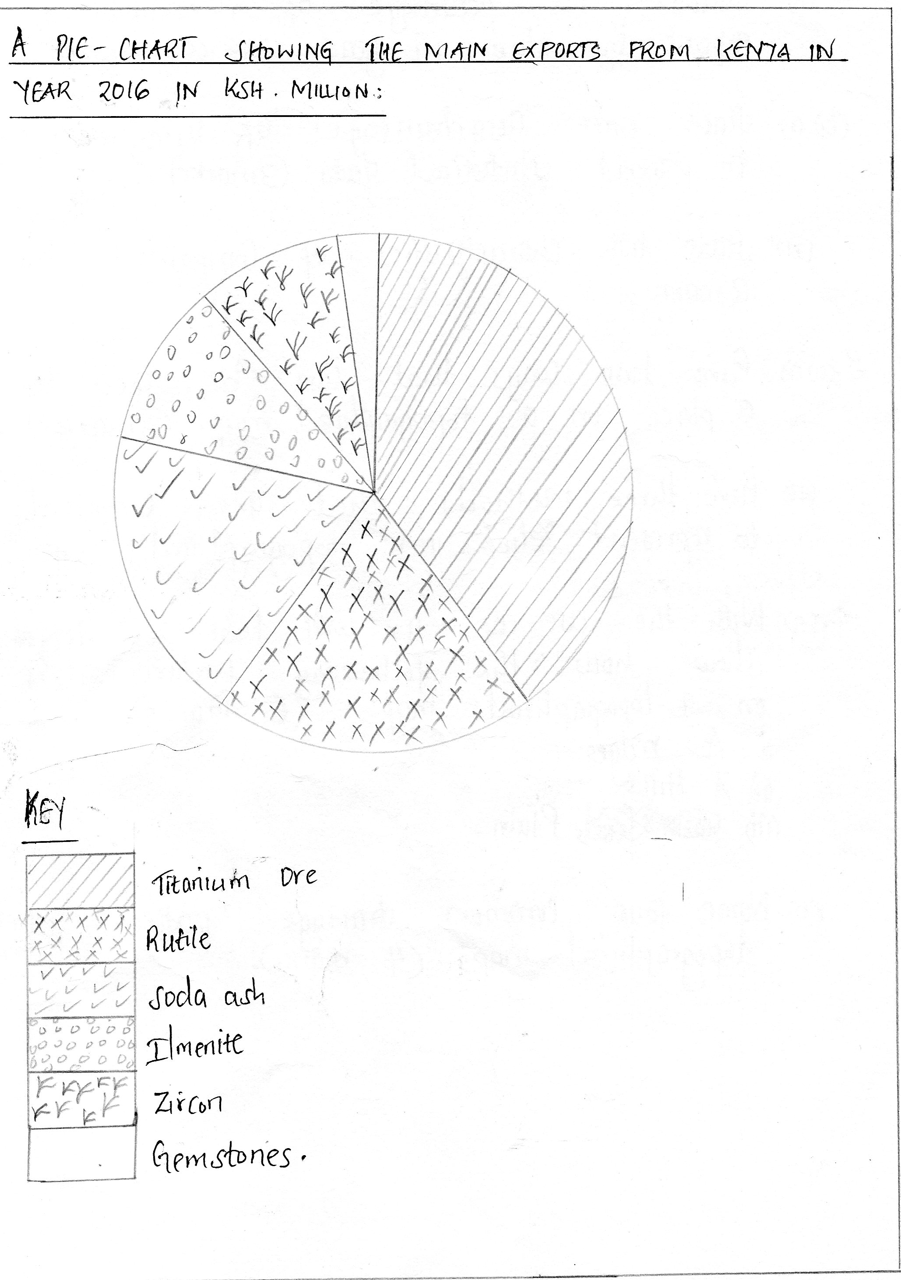
iv)Calculate the percentage of leading mineral export by value in year 2016 (2mks)
leading x 100 13300-930 =12370
original
12370 x 100 = 93%
13300

b)i)State three disadvantages of using pie charts to present statistical data (3mks)
- are time consuming due to calculation and measurement of angles

-pie charts having very small values may be difficult to accurately represent
-actual values represented by each component cannot be known.
ii)State two characteristics of compound bar graphs (2mks)
-are made of two or more bars drawn vertically
-bars are subdivided into various segments
-different variables can be presented on one bar
3.a.i)Give two ways that can be used to locate a place on a topographical map (2mks)
-use of place names
-use of direction, bearing and distance
-Use of latitudes and longitudes
-Use of grid references
b)Give three methods that are commonly used to represent relief on topographical map (2mks)
-spot heights
-trigonometric stations
-Contours and form lines
4a)

b)Name four common drainage patterns on topographical maps (4mks)
-topographical maps
-dendritic drainage pattern
-trellis drainage pattern
-radial drainage pattern
-fault guided drainage pattern

