PHYSICS FORM TWO

NAME………………………………...……………ADM NO….................CLASS…………

- Express each of the following volumes in SI unit giving your answer in standard form(2marks)
- 25000cm³

- 0.5675cm³

- State the law of magnetism. (1mark)

- The figure shows an electromagnet. State the polarities at X and Y.(2 marks)

- Dust particles in air appear to move randomly, explain this observation.(1 marks)

- The diagram below shows a section of a micrometer screw gauge.
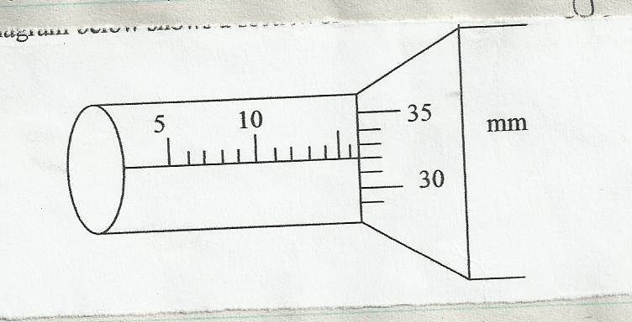

- State the smallest measurement that can be made by the measurement that can be made by the micrometer screw gauge. (1 mark)

- What is the correct reading of the micrometer screw gauge if it has an error of 0.25cm (3 marks)

- State two properties of magnetic field lines (2marks)

- A charge of 180coloumbs flows though a lamp every minute. Calculate the current flowing through the lamp (3marks)

- The figure below shows part of a vernier caliper when the jaws are closed without an object between the jaws
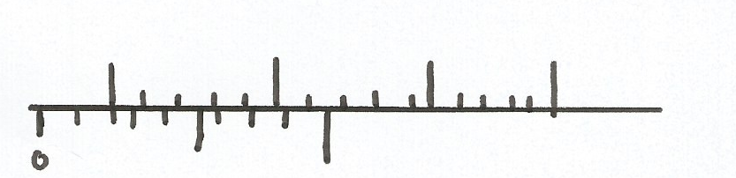

- What is the value of the zero error of the calipers?(1mark)

- A student used the same vernier calipers in (a) above to measure the diameter of a test tube whose actual diameter is 2.15cm. What was the reading shown by the calipers(3marks)

- Explain why repulsion is then sure test for polarity of a magnet(1mark)

- Explain why a gold leaf is electroscope casing is made up of metal(1mark

- Use domain theory to explain the difference between magnetic and non magnetic materials (2marks)

- On the graph provided, sketch a graph of density against Temperature of a given mass of water(2 marks)
Densitynsity
Temperature

- State two properties of a good thermometric fluid (2marks)

- State one application of magnets. (1mark)

- State the laws of reflection (2mks)

