NAME: …………………………………………. INDEX NO: ……………………………….

SCHOOL: ……………………………………… DATE: …………………………………..

SIGNATURE: ……………………………
232 / 2
PHYSICS
PAPER 2
THEORY
TIME: 2 HOURS
CASPA AMUKURA TERM ONE 2021

INSTRUCTIONS TO CANDIDATES:
- Write your Name and Index Number in the spaces provided above.
- Sign and write the date of examination in the spaces provided above.
- This paper consists of two sections A and B.
- Answer all questions in Section A and B in the spaces provided below all questions.
- All working MUST be clearly shown.
- Non-programmable silent electronic calculators and KNEC Mathematical tables may be used.
Take g = 10Nkg⁻¹

FOR EXAMINER’S USE ONLY
SECTION | QUESTION | MAX. SCORE | CANDIDATE SCORE
A | 1 - 12 | 25
B | 13 | 12
B | 14 | 09
B | 15 | 11
B | 16 | 11
B | 17 | 12
TOTAL SCORE |  | 80

SECTION A (25 MARKS)
Answer ALL questions in this section in the spaces provided

- Figure 1 below shows a ray of light incident to the first of the two mirrors inclined at an angle of 60⁰. Complete the path of the ray after reflection from the mirror. (1mk)
Fig. 1
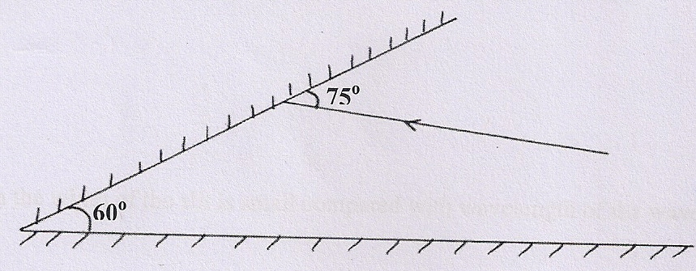
- Figure 2 below shows a positive charge near a plate carrying negative charge. Draw the electric field between them. (2mks)
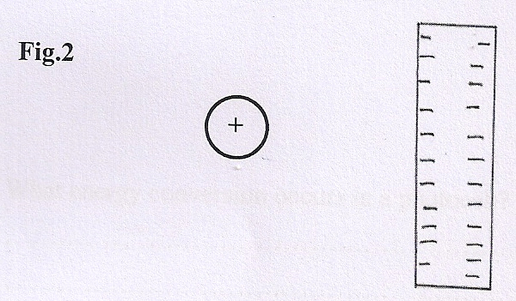
3 Two pins are hanging from a magnet S shown in diagram below figure 3.
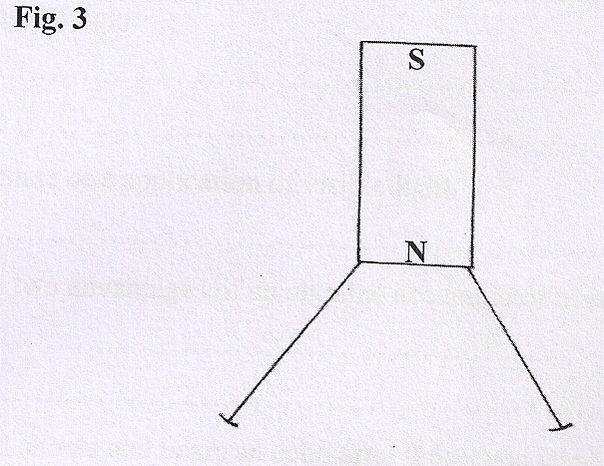
Explain why the nails do not hang vertically downwards. (2mks)

4Draw diagrams to illustrate what happens when plane waves are incident on a slit.
- When the width of the slit is large compared with the wavelength of the waves.
(2mks)

- When the width of the slit is small compared with wavelength of the waves. (2mks)

5(i) Arrange the following waves in order of decreasing wavelength; x-rays, infrared,
microwaves and visible light. (1mk)

(ii) State one application of visible light. (1mk)

6 State one defect of a simple cell and explain how it can be controlled. (2mks)

7 A girl shouts and hears an echo after 0.6 seconds later from a cliff. If velocity
of sound is 330m/s, calculate the distance between her and the cliff. (3mks)

8 Determine the reading of the ammeter in figure 4 below. (2mks)
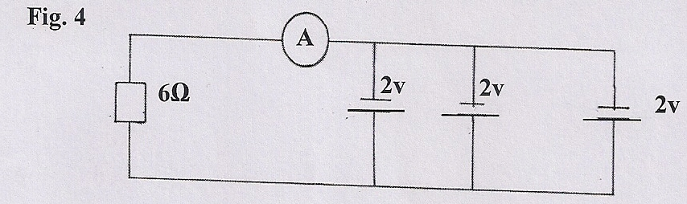

9 A ray of light is incident on a glass-oil interface as shown in fig. 5 below. Determine the value of r. (Take refractive index of glass and oil as ³/₂ and ⁸/₅ respectively) (1mk)
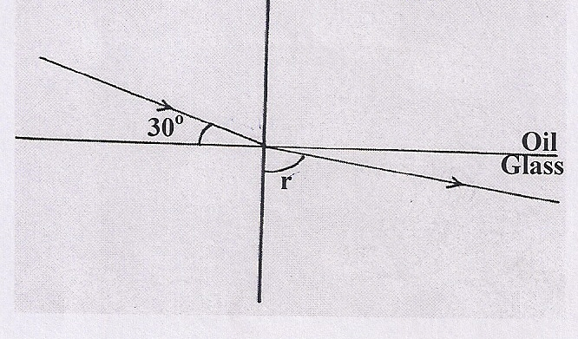

Fig. 5

10 State two factors that affect the capacitance of a parallel-plate capacitor. (2mks)

11 a ) state two advantages of an alkaline accumulators over the
lead acid accumulators 2mks

12 An electric bulb is rated 40W ,240v .what is the resistance of the filament 2mks

SECTION B (55 MARKS)
Answer ALL the questions in this section in the spaces provided

13(a) Study the circuit diagram below and answer the questions that follow.
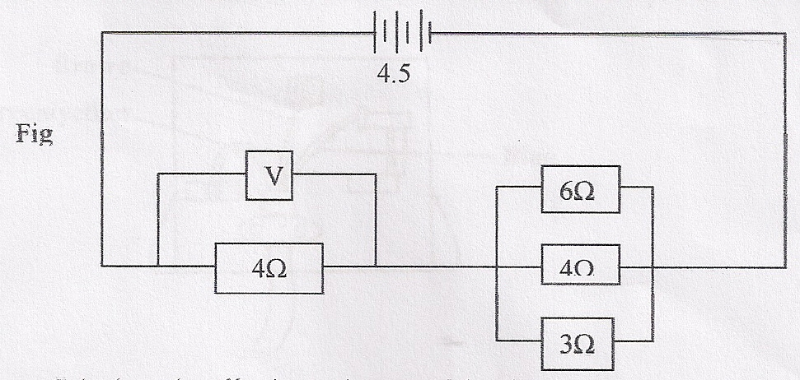
- Calculate the effective resistance of the circuit. (3mks)

- Find the voltmeter reading. (3mks)

(b) A cell drives a current of 3.2A through a 2.8Ω resistor. When it is connected to
1.6Ω resistor, the current that flows is 5A. Find the E.m.f. (E) and internal resistance of the cell. (4mks)

14 Complete the diagram below indicating the rays that will lead to the formation of
the image shown below (3marks)
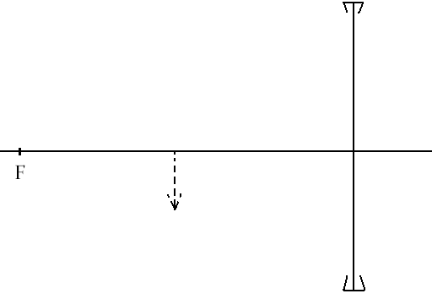

- A compound microscope with an objective lens L_{o} of focal length 1.2cm and an eye piece lens L_{e} of focal length 2.8cm. An object is placed 1.8cm from the objective lens. The system of lenses produces a final image a distance of 12.0cm from L_{e}. Determine the distance of separation of lens L_{o} and L_{e}. (4 MARKS)
…………………………………………………………………………………………………………………………………………………………………………………………………………………………………………………………………………………………………………………………………………………………………………………………………………………………………………………………………………………………………………………………………………………………………………………………………………………………………………………………………………………………………………………………………………………………………………………………………………………
- An object is placed 12cm from a convex lens and it forms a virtual image 36cm from the lens. Calculate the focal length of the lens. (3 MARKS)
………………………………………………………………………………………………………………………………………………………………………………………………………………………………………………………………………………………………………………………………………………………………………………………………………………………………………………………………………………………………………………………………………………………………………………………………

c) The graph below shows the variation of potential difference V with current I for a certain cell.
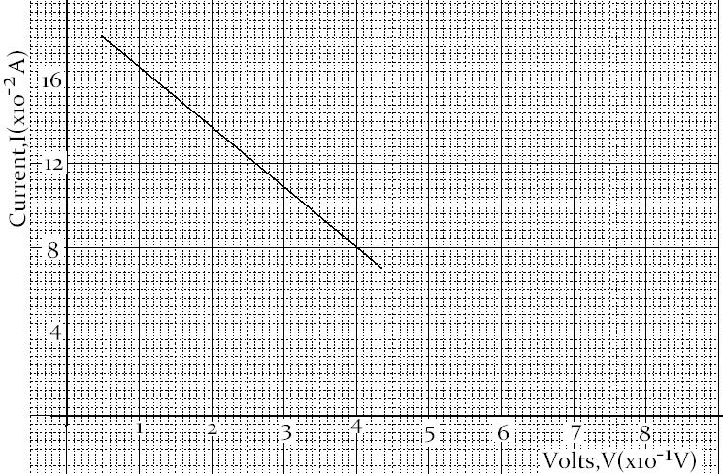
From the graph determine
- The internal resistance of the cell (3 marks)
………………………………………………………………………………………………………………………………………………………………………………………………………………………………………………………………………………………………………………………………………………………………………………………………………………………………………
- The e.m.f of the cell (1 mark)
……………………………………………………………………………………………………………………………………………………………………………………………………………………………………

14 (a) (i) State one cause of energy losses in a transformer and explain how it can
be minimized. (2mks)

(ii) Describe briefly the energy changes involved in the generation of electrical energy at a hydropower station (2mks)

(iii)What are the advantages of transmitting power at:
- Very high voltages (1mk)

- Alternating voltage (1mk)

(b)(i) Explain how electrons are produced in a cathode ray oscilloscope (CRO) (2 mk

- State two functions of the anodes in a CRO. (2mks)

- At what part of the cathode ray oscilloscope would the time base be connected
( 1mk)

- State why the tube is highly evacuated (1mk)

15 a ) Define the term supersonic speed as used applied in sound waves ( 1mark )

b) in an experiment to determine the speed of sound in air, a drum at a point 150 m from
a vertical wall was struck at varying frequencies while listening to the echo .The echo coincided with sound from the drum at a time when 20 successive strikes were made within a time
of 18.5 s.
( I ) Determine the time taken for the echo to heard 3marks

( ii ) Determine the speed of sound in air at the place 2marks

( iii ) What difference would you expect if the experiment was repeated on a colder day
1mark

C ) A boy strikes a railway with a hammer. A railway worker 600 m away hears two sound s ,
One from the railway and the other from the air .If the time intervals between the two
Sounds is 1.65s and the speed of sound in air is 340m/s, determine the speed of in the
Railway line. 4 marks

16 a) define the term eclipse of the moon 1 mark

b) differentiate between umbra and penumbra as used in the eclipse 2marks

c ) an incident ray forms an angle of 45 degrees with the mirror at point of incidence .If
The position of the incident ray is kept constant while the mirror is rotated at an angle of
20 degrees .Find the angle through which the reflected ray is rotated 2 marks

d) A tree 25 m high stands , 50 m in front of a pinhole camera whose screen is 30 cm behind
the pinhole. What is the height of the image of the tree formed on the screen . 3mks

