Name………………………………………………………. Adm No……………..

Class ……………………

101/2
ENGLISH
Paper 2
(Comprehension, Literary Appreciation, Grammar)
December 2021
2 ½ Hours

MOMALICHE 4 CYCLE 8 JOINT EVALUATION- 2021
Kenya Certificate of Secondary Education (K.C.S.E)

INSTRUCTIONS TO CANDIDATES

- Write your name and the date in the spaces provided
- Answer all the questions in this paper in the spaces provided

For examiner’s use only

Question | Maximum | Score
1 | 20
2 | 25
3 | 20
4 | 15
Total | 80

1. COMPREHENSION

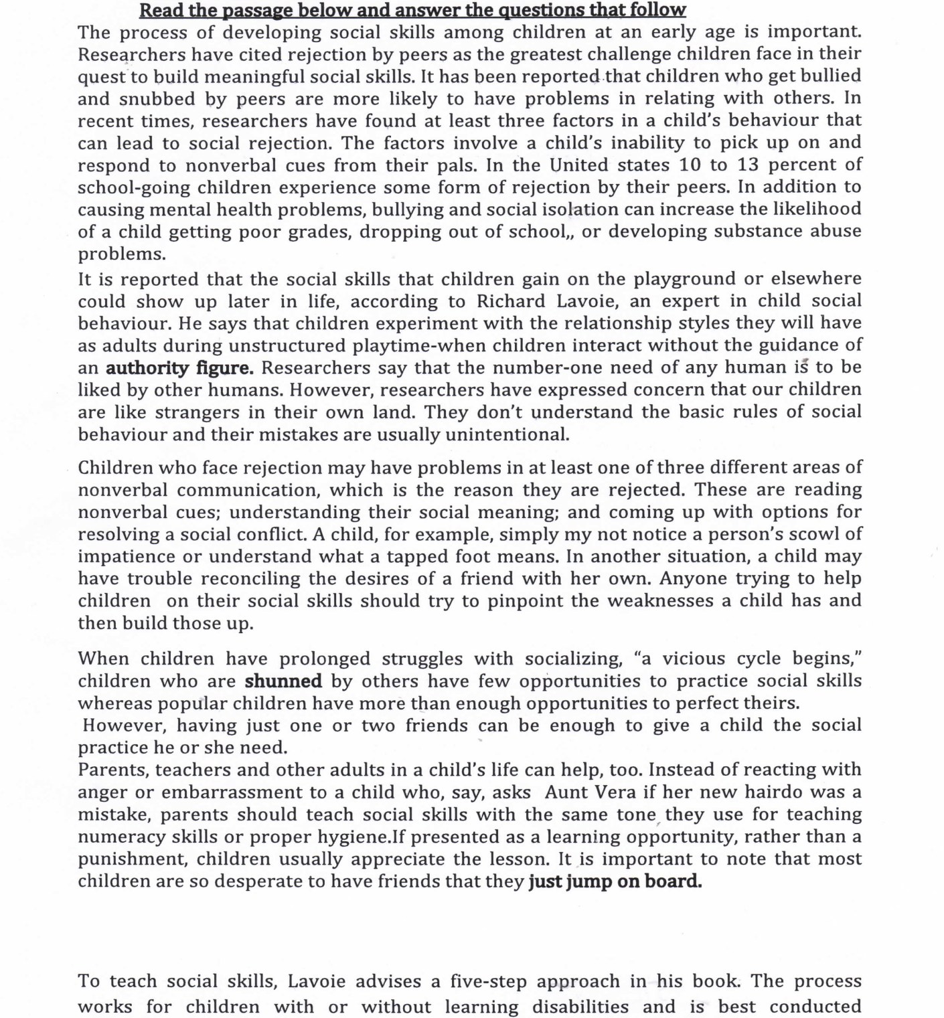

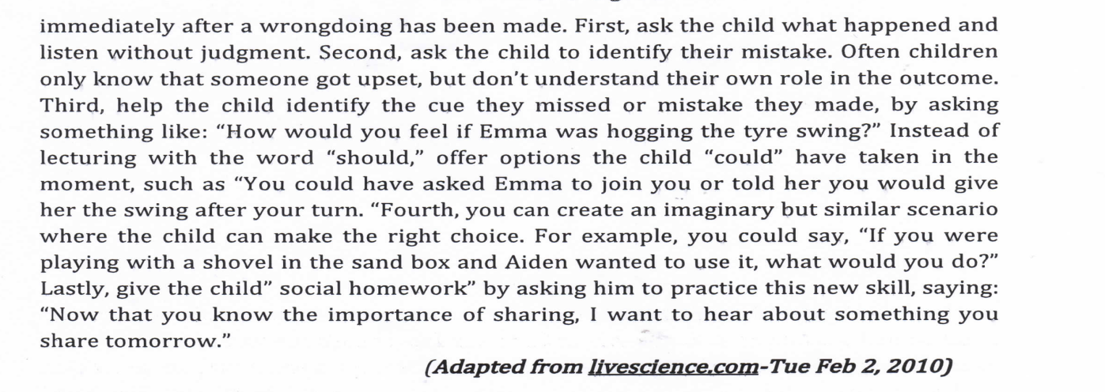

Questions
a) In one sentence, explain what this passage is talking about? (2mks)
…………………………………………………………………………………………………………………………………………………………………………………………………………………………………………………………………………………………………………………
b) What is the number one need of any human being? (1mk)
……………………………………………………………………………………………………………………………………………………………………………………………………………
c) What are cited as the causes for social rejection according to the passage (2mks)
……………………………………………………………………………………………………………………………………………………………………………………………………………
………………………………………………………………………………………………………
d) What is social rejection likely to lead to (2mks)
……………………………………………………………………………………………………………………………………………………………………………………………………………
………………………………………………………………………………………………………
e) What vicious cycle is referred to in this passage? (2mks)
……………………………………………………………………………………………………………………………………………………………………………………………………………
………………………………………………………………………………………………………
f) How can a parent make children appreciate the lesson on social skills? (2mks)
……………………………………………………………………………………………………………………………………………………………………………………………………………
………………………………………………………………………………………………………
g) “How would you feel in Emma was hogging the tyre swing?” Re-write in reported speech. (1mk)
……………………………………………………………………………………………………………………………………………………………………………………………………………

h) Make notes on the five-step approach to teach children social skills (5mks)
…………………………………………………………………………………………………………………………………………………………………………………………………………………………………………………………………………………………………………………………………………………………………………………………………………………………………………………………………………………………………………………………………………………………………………………………………………………………………………………………………………………………………………………………………………………………………………………………………………………………………………………………………………………………………………………………………………………………………………………………………………………………………………………………………………………………………………………………………………………………………………………………………………………………………………………………………………………………………………………………………………………………………………………………………………………………………………………………………………

i) Explain the meaning of the following words and phrases as used in the passage (3mks)
- Authority figure
……………………………………………………………………………………………
- Shunned
……………………………………………………………………………………………
- Jump on board
…………………………………………………………………………………………..

2. Read the excerpt below and then answer the questions that follow. (25 marks)
Mrs. Linde: Listen to me Nora you are still very like a child in many things, and I am older than you in many ways and have a little more experience. Let me tell you this-you ought to make an end of it with Doctor Rank.
Nora: What ought I to make an end to?
Mrs. Linde: Of two things I think. Yesterday you talked some nonsense about a rich admirer who was to leave you money-
Nora: An admirer who doesn’t exist, unfortunately! But what then?
Mrs. Linde: Is Doctor Rank a man of means?
Mrs. Linde: And comes here every day?
Nora: Yes, I told you so.
Mrs. Linde: But how can this well-bred man be so tactless?
Nora: I don’t understand you at all.
Mrs. Linde: Don’t prevaricate, Nora.do you suppose I don’t guess wholent you the two hundred and fifty pounds?
Nora: Are you out of your senses? How can you think of such a thing? A friend of ours, who comes here every day! Do you realize what a horribly painful position that? would be?
Mrs. Linde: Then it really isn’t he?
Nora: No, certainly not. It would never have entered into my head for a moment. Besides, he had no money to lend then; he came into his money afterwards.
Mrs. Linde: Well I think that was lucky for you, my dear Nora.
Nora: No, it would never have come into my head to ask Doctor Rank. Although I am quite sure if I had asked him-
Mrs. Linde: But of course you won’t.
Nora: Of course not. I have no reason to think it could possibly be necessary. But I am quite sure that if I told Doctor Rank-
Mrs. Linde: Behind your husband’s back?
Nora: I must make an end of it with the other one, and that will be behind his back too, I must make an end of it with him.
Mrs. Linde: Yes, that is what I told you yesterday, but-
Nora: (walking up and down) a man can put a thing like that straight much easier than a woman.
Mrs. Linde: One’s husband, yes.
Nora: Nonsense! (Standing still) When you pay off a debt you get your bond back, don’t you?
Mrs. Linde: Yes, as a matter of course.
Nora: And can tear it into a hundred thousand pieces and burn it up- the nasty dirty paper.
Mrs. Linde: (looks hard at her, lays down her sewing and gets up slowly.) Nora you are concealing something from me.
Nora: Do I look as if I were?
Mrs. Linde: Something has happened to you since yesterday morning. Nora, what is it?

Questions
- Briefly explain what happens before and after the events in this extract. (4marks)
………………………………………………………………………………………………………………………………………………………………………………………………………………………………………………………………………………………………………………………………………………………………………………………………………………………
- Explain why Mrs. Linde says “…I am older than you in many ways and have a little more experience? (2mrks)
…………………………………………………………………………………………………………………………………………………………………………………………………………………………………………………………………………………………………………………

- What is Mrs. Lindes’ view about Doctor Rank and Nora’s relationship? (2marks)
………………………………………………………………………………………………………………………………………………………………………………………………………………………………………………………………………………………………………………
- From the dialogue, what do we learn about Nora’s character? (4 marks)
……………………………………………………………………………………………………………………………………………………………………………………………………………………………………………………………………………………………………………………………………………………………………………………………………………………
- Identify and explain the use of hyperbole in this excerpt. (3 marks)
………………………………………………………………………………………………………………………………………………………………………………………………………………………………………………………………………………………………………………………………………………………………………………………………………………………
- What is the attitude of Mrs.Linde towards Nora (2mrks)
……………………………………………………………………………………………………………………………………………………………………………………………………
- What is the prevailing in this excerpt (2mrks)
……………………………………………………………………………………………………………………………………………………………………………………………………
- What does Mrs. Linde think Nora is concealing from her? Is Mrs. Lindes right? (3 marks)
………………………………………………………………………………………………………………………………………………………………………………………………………………………………………………………………………………………………………………………………………………………………………………………………………………………
- Explain the meaning of the following words as used in the extract. (3 marks)
- A man of means
- Prevaricate
- nasty

3. Read the oral poem below and answer questions that follow (20mrks)
Is the chief greater than the hunter?
Arrogance! Hunter? Arrogance!
The pair of beautiful things on your feet,
The sandals that you wear,
How did it all happen?
It is the hunter that killed the duyker:
The sandals are made of hide of the duyker.

Does the chief say he is greater than the hunter?
Arrogance! Hunter? Arrogance!
The noisy train that leads you a way,
The drums that precede you,
The hunter killed the elephant,
The drum head is the ear of the elephant.
Does the chief say he is greater than the hunter?
Arrogance! Hunter? Arrogance!
(Source: Akan Oral Literature: Oral Literature in Africa by Ruth Finnegan)

Questions:
- What occasion would be suitable for the performance of this oral material? (2mrks)

- For what purpose has the speaker employed many questions in this poem?(3mrks)

- How does the performer of this piece bring the superiority of the hunter?(2mrks)

- ‘Does the chief say is greater than the hunter?’ What sense is created by this line being repeated?(2mrks)

- Which distinguishing characteristics of oral song are discernible from this piece?(3mrks)

- Give two other examples that can be classified with the one above. (2mrks)

- Explain the meaning of this line:
Arrogance! Hunter? Arrogance! (2mrks)

- How would you describe the attitude of the speaker in this poem towards the chief? (2mrks)

- What mood would be prevalent during the performance of this poem? (2mrks)

4. GRAMMAR (15mrk
(a)Rewrite the following sentences as instructed :(2mrks)
- He ran away .He shouted as he ran.( rewrite to end ….shouting)
- Kamau wrote an article. He posted it on the website. (Join the sentence to begin: Having…)
(b)Use the correct form of the verb in the brackets to fill in the blank spaces. (3mrks)
- The dog ______on the mat.(lie)
- Daily nation newspaper has a humongous______.(read)
- The victim said that the accident was_______ terrible.(explain)
(c)Fill the gaps with an appropriate preposition (3mrks)
- Suddenly, the plane was enveloped________ a dense fog.
- Professor Wangari was an expert _________ conservation of environment.
- The parents are answerable _____________the behavior of their children
(d)Explain the difference in meaning between the following pairs of sentences (2mrks)
- She went and bought herself a skirt.
- She went and bought a skirt herself.
(e)Rewrite the sentences below according to the instructions given after each.(2mrks)
- I thought they were thirsty. I gave them water.(rewrite using present participle phrase)
- He sung so well that everyone was impressed. (Begin: so well…)
(f)In each case, give a phrasal verb that means the same as the word underlined.(3mrks)
- The remorseful suspect confessed after a long interrogation.
- Only irresponsible parents can abandon their children.
- Safaricom Kenya has sacked most of its employees.

MARKING SCHEME

1. COMPREHENSION
a) Dealing with social rejection in the process of developing social skills among children (2mks)
b) The number one need of any human being is the need to be liked by other humans (1mk)
c) The inability to read non-verbal cues; understanding their social meaning and coming up with options for resolving a social conflict (2mks)
d) Social rejection is likely to lead to: (2mks)
– Children getting poor grades
- Dropping out of school
- Developing substance abuse problems
- Problems in relating with others.
e) Children who are shunned by others have few opportunities to practice social skills while those that are popular have more than enough opportunities to perfect theirs.
f) Present it as learning opportunity rather than a punish parents should teach social skills just like they teach numeracy skills (2mks)
g) He/she asked me/him/her how I/he/she would feel if Emma was hogging the tyre swing?. (1mk)
h)–Ask the child what happened and listen without judgment.
– Ask the child to identify their mistake.
– Help the child identify the cue they missed or mistake they made.
- Create an imaginary but similar scenario where the child can make the right choice.
- Give the child “social homework “by asking him to practice this new skill. If not in note form penalize by half the total mark
i) –Authority figure-parent/teacher/growth up
- Shunned–avoided
– Jump on board–eagerly follow the lesson on socials kill

2. Except.
Before
- Mrs. Linde has just visited Nora. Mrs.linde has just started sewing Nora’s dress. Nora informs Mrs. Linde that Dr. Rank suffers from consumption of the Spine√1/ Nora tells Mrs. Linde that Dr. Rank is Torvalds’s most intimate friend/√1 Nora intimates to Mrs. Linde that Dr. Rank is so absurdly fond of her (Nora)

After
Nora requests Mrs. Linde to leave so that she can play with her children .She tells Mrs. Linde Ann will help in dress making

(b) Because Nora seems to be close to Dr. Rank. and Mrs. Linde thinks Nora is naïve. Mrs. Linde has experience in such kind of relationship. She cares for Nora/
(c) She feels the relationship is inappropriate1mrk, since she has a past experience that seems to be closely related to Nora’s1mrk
(d)
- Secretive√1.… she has never told her husband Torvald that she borrowed money. √1.
- Firm/ principled- she did not borrow money from Dr. Rank although she s+ay if she did, he would have definitely lent her. √1.
- Temperamental√1. Nora says she can tear it into a hundred thousand pieces and burn it up- the nasty dirty paper. √1.(accept any appropriate alternative )
e) And can tear it into a hundred thousand pieces and burn it up- the nasty dirty paper; Nora
Cannot possibly do this. .√1 It means she is very annoyed. .√1
f) Contemplative attitude- Christine feels and thinks that Nora is hiding something from her and feels that Nora should seek for alternative way to iron out the discrepancies in her marriage.
(g) Betrayal- Nora tells Mrs. Linde that she will make an end of it behind the husband’s back “….. And that will be behind his back too…” (Accept any appropriate alternative)
h) No.(1mrk)Mrs. Linde is not right since she thinks Nora is hiding the secret relationship with Dr Ranks by (1mrk) which its just fictitious made-believe story and not real (1mrk).
I)
- a rich man/ wealthy√1.
- beat about the bush/ sidestep/dodge/equivocate√1.
Hiding/ withholding

3. Oral Poem.
- Occasion suitable
Can be performed to celebrate hunters in the community to show that their role cannot be underrated or show that each subject contributes to the welfare of even leaders; can also be done to remind leaders not to despise the weaker members of society.
- The oral song alludes to a conflict between leader and his subjects. The questions set the tense mood suitable for such rivalry.
- Superiority of the hunter is brought by showing that the chief benefits from the effort of the hunter; his status is enhanced by products got from the hunter’s efforts. For example the shoes he wears and the drum that heralds his arrival.
- Effect of repetition
“Does the chief say he is greater than the hunter?”
Repetition of this line emphasizes the speaker’s contention that the chief is not greater than the hunter, or that the hunter is the special/it prepares the reader for the reasons he is going to prove that the hunter is more valuable.(accept any appropriate alternative )
- Features of oral poetry evident in poem
-Simplicity of language e.g. the sandals you wear…
-Conversational style e.g. does the chief say?....
f) Other sub-genres in same category
War poem/song
-Initiation song
-Lullabies/children song
-Dirges/funeral songs
-Wedding song
-Work song
(Accept any two for two marks)
- This line means that both the chief and the hunter are filled with arrogance
- Attitude of the speaker

-Critical/censorious for claiming that he is greater than the hunter; he cites items the chief enjoys use of, all courtesy of the hunter.
i) Mood
Mood can be tensed or serious since there seems to be a conflict between the chief and his subject.
(Accept any appropriate illustration /relevant mood)

4. Grammar
- (i)He ran away shouting.

(ii)Having written an article, Kamau posted it on the website.
- (i)lay
(ii) readership

(iii) inexplicably

- (i)in
(ii)in
(iii)to
(d)(i) she bought nothing else to herself but the skirt.

(ii) nobody else bought a skirt for but herself.

(e) (i)Thinking they were thirsty, I gave them water.

(ii) So well did he sing that everyone was impressed.
(f) (i) Owned up, came clean
(ii) Walk out on
(iii) Look down on/upon

