Marking scheme
Name……………………………………………………… Adm Number: ………………
Class ……………
Date……………………….

312/1
GEOGRAPY
PAPER 1
December 2021
2$3/4$HRS

MOMALICHE 4 CYCLE 8
KENYA CERTIFICATE OF SECONDARY SCHOOLS
GEOGRAPHY
PAPER 1

INSTRUCTIONS TO CANDIDATES

- This paper has two sections: A and B
- Answer all the questions in section A.
- Answer question 6 and any other two questions form section B.
- All answers must be written in the answer booklet provided.
- Candidates should check the question paper to ascertain that all pages are printed as indicated and that no questions are missing.
- Candidates should answer the questions in English

SECTION A: answer all questions in this section

- a)What is a natural satellite? (2mks)

- Any heavy body which orbit round planet.

b) State three effects of the spinning of the earth on its own axis . (3mks)

- Day and night
- Deflection of winds and ocean currents.
- Time difference of 1 hr between 15⁰ longitudes.
- Variation in pressure on the earth’s surface.
- Explain three ways through which sedimentary rocks are formed. (6mks)
Mechanically formed sedimentary rocks
- Pre-existing rocks are weathered forming rock particles or sediments.
- The sediments are transported by wind, water or ice.
- The particles are then deposited in layers (strata) in water or on land (former layers)
- New layers are added on as seasons change.
- Finer particles fill in between larger particles cementing them together.
- Over time - the layers are compressed and consolidated into a hard rock.
Chemically formed sedimentary rocks.
- Minerals particles from pre-existing rocks dissolve in water.
- Dissolved minerals are transported by water in solution form and emptied into a large water body
- Mixing of water result in chemical reaction leading to precipitation of sediments.
- The sediments are compressed into a hard rock on the bed of the water body.
Organically formed sedimentary rocks
- Remains of dead plants and animal matter accumulate on the lake or ocean bed.
- They accumulate in layer
- With time the layer are compressed into a hard work by the weight of overlaying materials
or
- Organic remains may be buried in layer with time
- The weight of overlying coastal rocks compress them into hard work
- a) Define ocean water salinity. (1mk)
- Refers to the degree of saltiness of ocean water. (1mk)

b) State three sources of ocean water salt. (3mks)
- Salt added into ocean water by rivers/land
- Salt dissolved directly from rocks beneath the ocea.
- Volcanic materials on the ocean floor
- a)Explain sandblast action of wind erosion. (2mks)
- is the mechanical erosion of rocks by the material carried in wind current
- the particles grind, scrape , smoothen and polish rokc surfaces on their path.
- This leads to smoothening of rock surfaces on the path of wind.
b) State three negative effects of desert features on human activities . (3mks)
- Sand dines may form barriers across transport
- Flash floods along waters may deposit material on rods hindering transport
- Flash floods with water moving at high special/rapidsy may couse death or destroy settlements
- Sand dines migration may destroy rich agricultural farms and threaten human and animal life.
- The diagram below shows underground features in a karst scenery.

a) Name the features labelled i and ii (2mks)
- Stalagmite
- Underground stream
b) Give three importance of ground water . (3mks)

- Underground water forms sources of river
- Forms sources of water used for both domestic and industrial use
- Used in irrigation of land in arid and semiarid
- Regions of occurrence of springs attract settlements
- Hot springs are tapped in some areas providing warmth in housed in cols seasons
- Hot springs from tourist attraction sites which bring in foreign exchange.

6. Study the Map of Kijabe 1:50,000 (sheet 134/3) Provided and answer the following questions
(a) i) Calculate the latitudinal extend of the area covered by the map (2mks)
1⁰00’s to 0⁰35’s
ii) Identify two human-made features found in the grid square 3501 (2mks)
- Settlements
- Dry weather road
- foot path
iii) Measure the distance of the railway line from Nairobi to where it crosses dry weather road (3395) give your answer in Kilometres. (2mks)
- 7.3km + 0.1
(b) Draw a rectangle measuring 8cm by 6cm to represent the area enclosed by easting 30 and 38 and Northing 90 and 96. (1mk)

On the rectangle mark and label
- Railway line (1mk)
- Dry weather road (1mk)
- River upper Ewaso Kedong (1mk)
- Thicket vegetation. (1mk)
ii) Give the scale of the area you have drawn . (2mks)
$\frac{1}{2}$ x $\frac{1}{50000}$ = $\frac{1}{100,000}$ = 1:100,000
(c) Describe how relief has influenced vegetation distribution in the area covered by the map. (6mks)

- Woodland are found in the escarpment
- Scrub vegetation are found in the slopes of Kijabe hill.
- Lowland areas in the south western part of the map are dominated by scrub vegetation
- Eastern part of the map is dominated by forest vegetation because it is gently sloping.

(d) Citing evidence from the map give three social services offered in the area covered by the map.
Social service | Evidence
i) Educational | Schools
ii) Health service | Hospitals
iii) Water supply | Bore holes /water trough
Security | Police station
communication | Post office.
(6mks)
7. a) The diagram below shows the angles of the sun’s rays at different latitudes when the sun is at the equator. Use it to answer question (a) and (b)

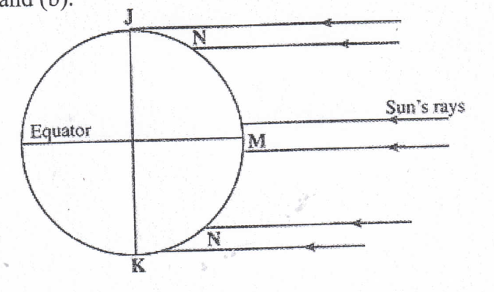
- Name the parts of the earth’s surface marked J and K. (2mks)
J – North pole
K- South pole
- Give two reasons why the intensity of the insolation is higher at M than at N.

- There is a higher concentration of heating at M than at N because the surface area at M is smaller than at N.
- The angle of incidence or inclination of the sun’s rays at M is higher than at N hence the variation in intensity.
- At N the sun’s rays travel over a longer distance than at M thus losing the heat resulting to low intensity. (2mks)
b) Explain how the following factors influence weather.
- Cloud cover (3mks)

- Clouds reduce the amount of solar radiation reaching the earth’s surface and the amount of radiation leaving.
- Heavy cloud cover will moderate both day and night temperatures.
- In hot deserts absence of clouds results in high day temperatures and very low nighyt temperatures. Very humid air absorbs heat during the day and retains it during teh night.

- Local winds
(3mks)

- The sea and land breezes may strengthen the direction or reverse the direction of prevailing winds.
- The sea breeze may also lowers the temperatures of the surroundings areas.
- Sea breeze may also increase precipitation by supplying extra moisture content through evaporation.
c) Use the map below to answer questions (i) and (ii)
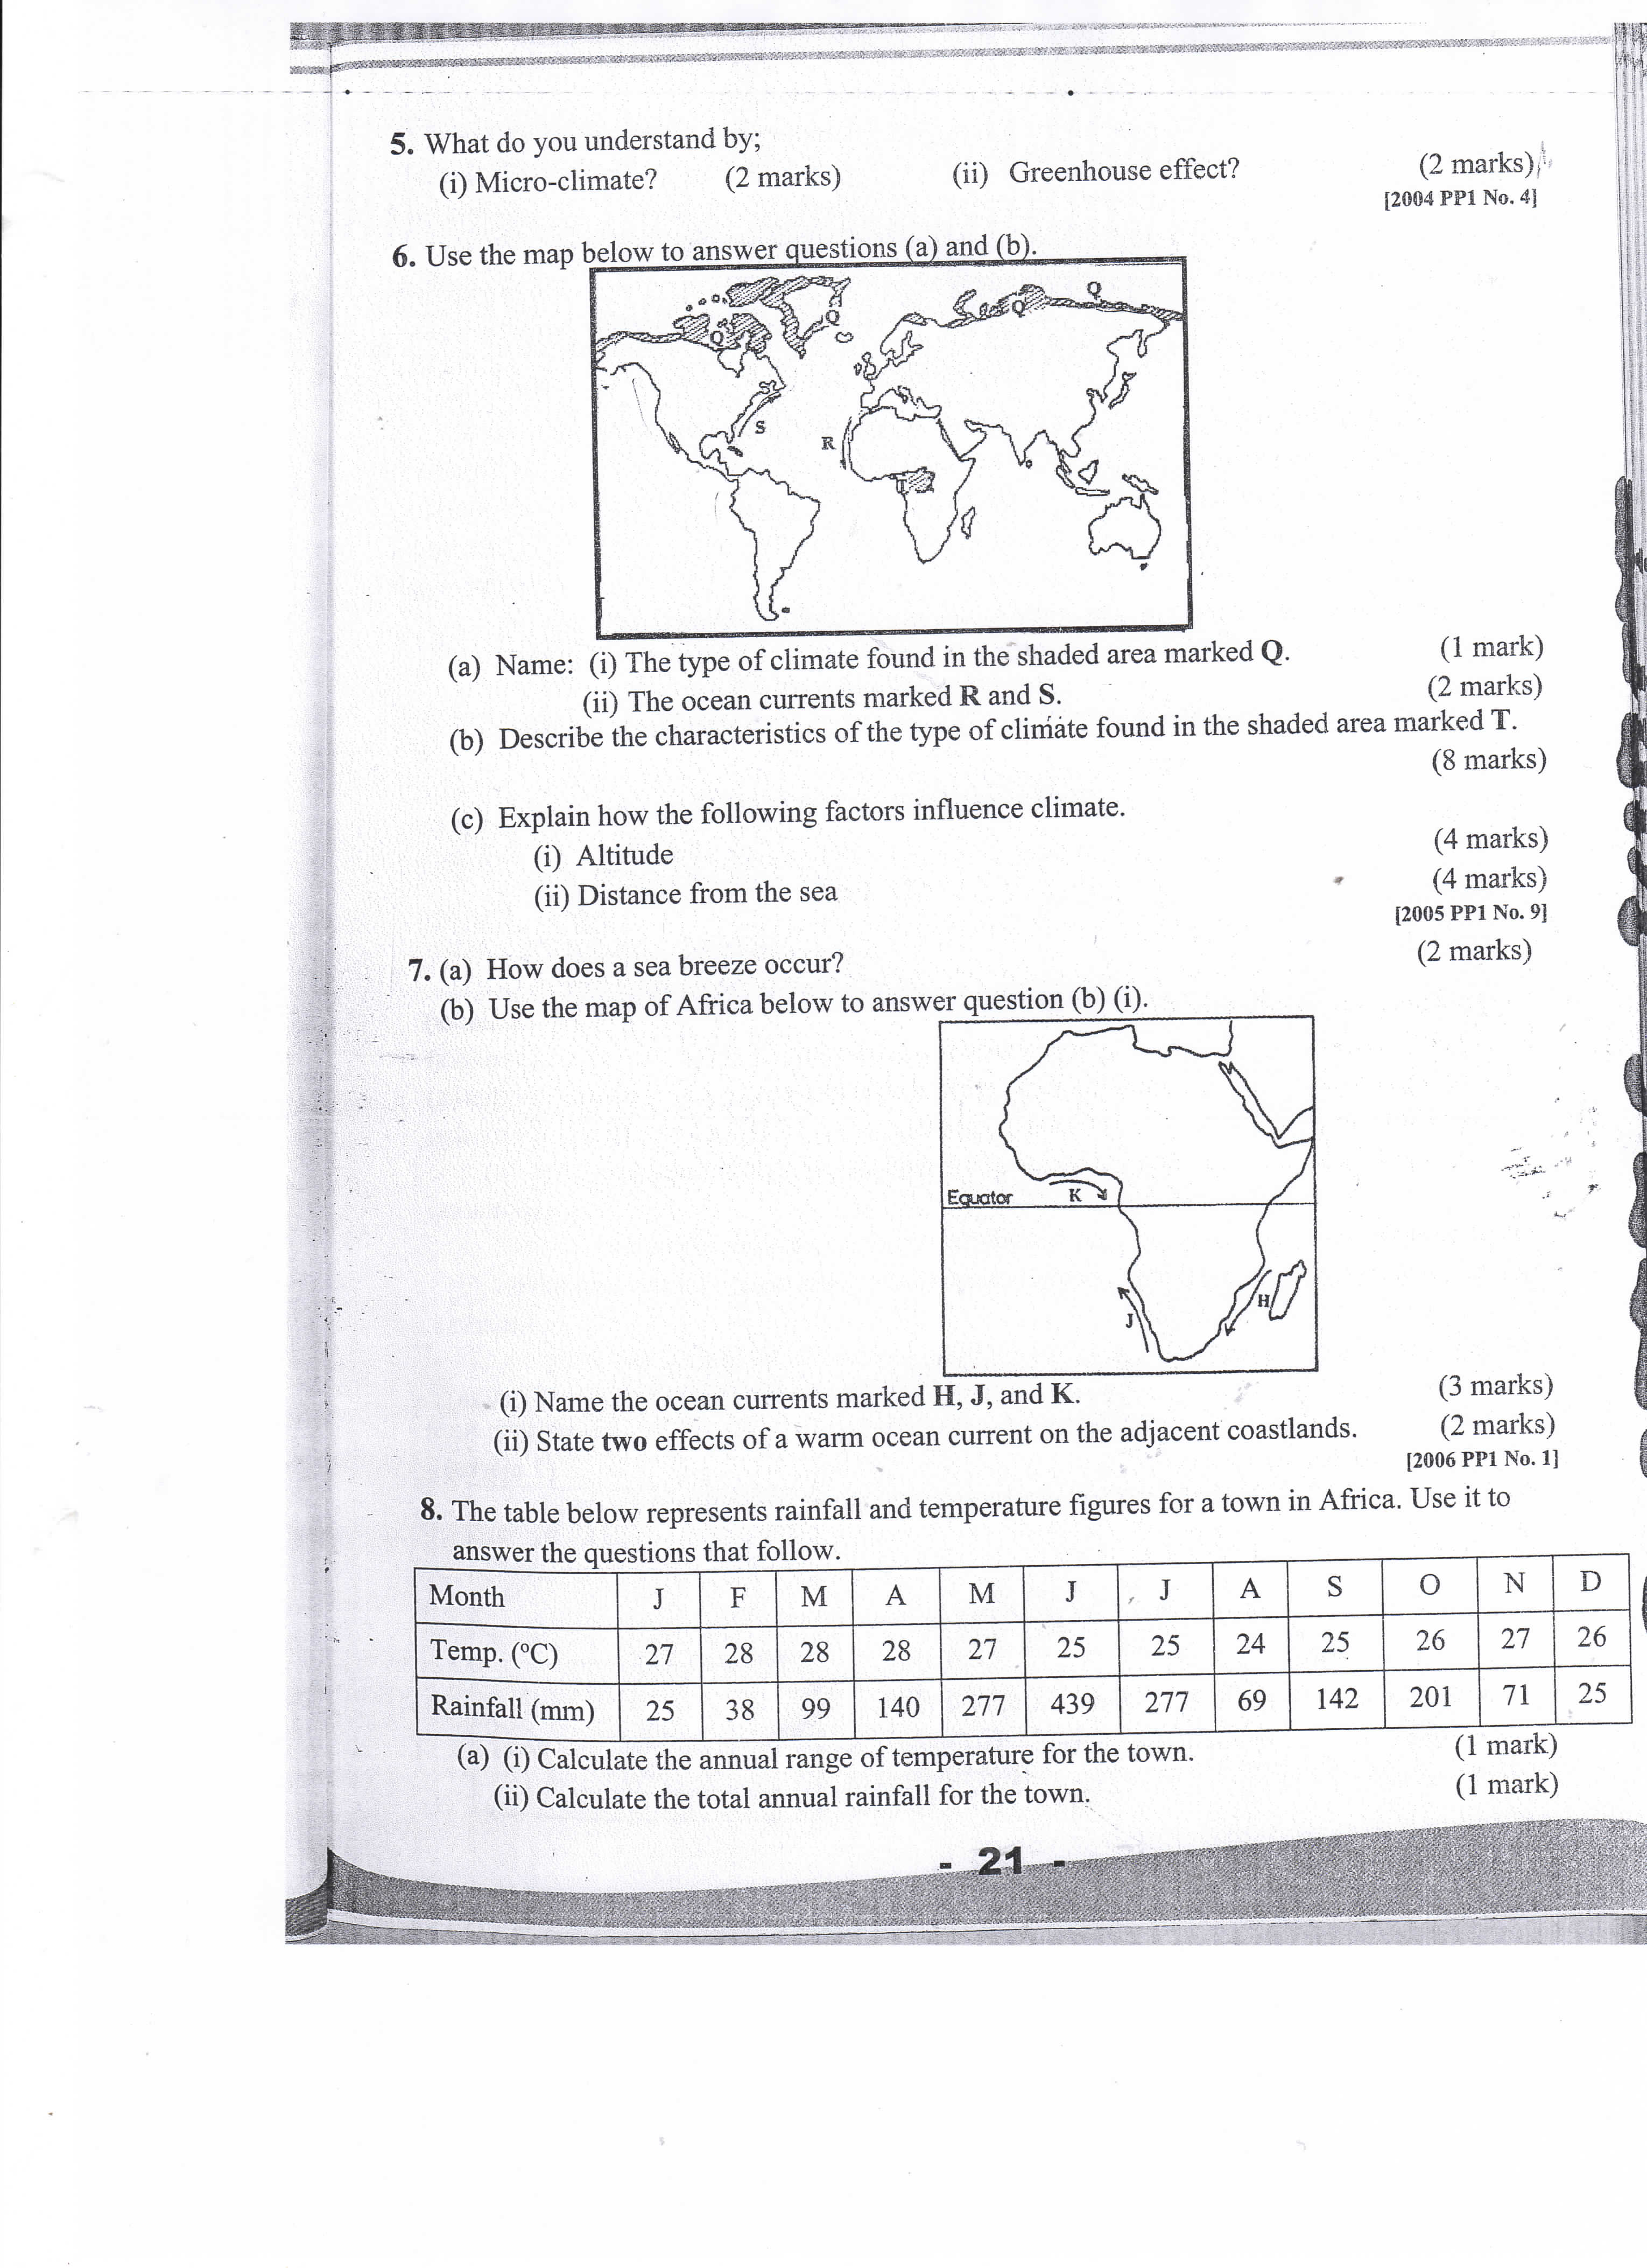

- Name :

- The type of climate found in the shaded area marked Q (1mk)
-Polar cold climate or Tundra climate
- The ocean currents marked R and S (2mks)

R- Canary ocean cold current , S- Gulf stream

- Describe the characteristics of the type of climate found in the shaded area marked T. (6mks)

- Temperatures are high throughout the year (about 27⁰C).
- It experiences high rainfall (1500 mm and 2000mm) evenly distributed throughout the year.
- It experiences a double maximum rainfall .
- The region has high humidity
- Wind experience are South-East and North –East trade winds
- Experiences low pressure
- The rainfall mainly convectional
- Small annual range of temperature
d) Explain how the following factors influence climate
i) Altitude (3mks)

- Temperature decreases with increasing height above sea-level making the higher areas have lower temperatures than lower areas.
- Arise in altitude causes a fall in temperature and a cooling effect which causes condensation. Thus rainfall on the windward side
- Arise in altitude lowers pressure
ii) Distance from the sea. (3mks)

- Areas closer to the sea are weather than those far from the sea due to maritime influence .
- During summer land services are warmer than sea services .
- In winter it is vise versa.

8 a.i) Name two fold mountains in Africa . (2mks)
- Atlas
- Cape ranges
ii) Apart from fold mountains , name four other features resulting from folding. (4mks)
- Synclinal valleys or depression
- Rolling plains
- Ridges
- Intermontane plateaus
- Intermontane basins
b) With the aid of labelled diagram, describe the formation of an over thrust fold. (5mks)
- Layers of rocks of the earth crust are subjected to compressional forces. There’s intense folding in the formation of an over fold and with increased pressure the over fold results in the formation of the recumbent fold. When pressure is very great, a fracture occurs along the axis in the recumbent fold producing a thrust –pane. The upper part of the recumbent fold slides forward over the lower part along the plane resulting to the formation of an over thrust fold.
c) Explain four effects of fold mountains on human activities. (8mks)
- Fold mountains are water catchments area. They trap rainfall which feed rivers that provide water for domestic use or irrigation or industrial use or hydroelectric power production.
- The winward slopes of fold mountain receive heavy precipitation which enhance agriculture activities or forestry. Some fold mountains have exposed valuable mineral deposits which are exploited.
- Fold mountains amu act as barriers to transport and communication lines difficult or expensive. The topographical nature of the landscape may encourage or discourage settlement or agriculture.
d) Students are planning to carry out a filed study on land forms in their District.
i) State four ways in which the students would prepare themselves for the filed study. (4mks)
- Divide themselves into groups
- Identify methods of data collection or presentation.
- Formulate study objectives and hypothesis for study.
- Conduct a pre-visit or reconnaissance to the areas under study
- Prepare a working schedule of activities for the study.
- Seek for permission from relevance authorities.
- Drawing a route map
- Assembling relevant stationery
- Reading relevant information or literature
- Hold class discussions.
ii) Give two advantages of studying landforms through field work. (2mks)
- Fieldwork would enable students get first information on different types of land forms.
- Fieldwork would enable students relate or apply knowledge gained to real situations .
- Fieldwork allows students to develop skills or apply of skills learnt.
- Field work enables students to acquire appropriate attitudes towards the environment
- Fieldwork breaks the classroom monotony for the students and teachers
- Fieldwork enables visual memory of the landscape better than the theory provides in depth or broader learning.

